AMAZON WEB SERVICES (AWS) NOTES

TYPE OF AWS SERVICES
AWS (Amazon Web Services) offers a wide range of cloud services that cater to different business and technical needs. Here’s a breakdown of some key types of AWS services:
1. Compute Services
These services allow you to run virtual servers, manage resources, and scale applications.
- Amazon EC2 (Elastic Compute Cloud):
Amazon EC2 provides virtual servers in the cloud that you can use to run your applications, websites, or other workloads. Instead of buying physical servers, you can rent virtual ones and customize them based on your needs.
What You Can Use Amazon EC2 For:
- Web Hosting:
- Imagine hosting a website or a web app, like an online store or a blog.
- EC2 lets you handle a lot of visitors by automatically adding more servers when needed.
- If one server fails, others in different regions keep your website running.
- Application Hosting:
- You can host big apps like business tools, subscription-based platforms (like Netflix), or your custom-built software.
- EC2 works great for apps that need high speed or handle large amounts of data.
- Big Data Analytics:
- Companies collect a lot of data (like customer purchase history or website clicks).
- EC2 helps analyze this data using tools like Hadoop or Spark and provides more power as the data grows.
- Machine Learning and AI:
- EC2 has powerful instances (special types of servers) for training AI models.
- You can also deploy these AI models so they can make predictions or decisions quickly.

- Batch Processing:
- For tasks like processing videos, rendering images, or running scientific simulations, EC2 is ideal.
- It lets you run these tasks in batches, saving time and money.
- Disaster Recovery and Backup:
- EC2 can act as a backup system if your main infrastructure fails.
- It uses features like snapshots to restore your apps and data quickly.
- Development and Testing:
- Developers can use EC2 to create safe environments for building and testing software.
- These environments can be set up or removed in minutes, keeping costs low.
- E-commerce Platforms:
- If you run an online store, EC2 ensures your site can handle traffic spikes (like during sales).
- It works well with other AWS tools, like databases and content delivery networks.
- Gaming Servers:
- Multiplayer games need servers for players to connect and play.
- EC2 provides low-latency (fast) servers for a smooth gaming experience.
- IoT Backend Processing:
- Internet of Things (IoT) devices (like smart home gadgets) send data.
- EC2 processes this data in real time and stores it for further analysis.
- Media Encoding and Streaming:
- For streaming video or audio, EC2 helps encode and deliver the content efficiently.
- GPU-optimized instances make this process faster.
- Virtual Desktop Infrastructure (VDI):
- Businesses can give employees access to remote desktops.
- These desktops can run on EC2 and scale based on the number of users.

Benefits of EC2:
Scalability: You can add or reduce servers based on how much power you need.
Cost-Effectiveness: Pay only for what you use, with flexible pricing options.
Customization: Choose the server’s size, memory, and storage to match your needs.
Integration: Easily connect EC2 with other AWS services for added features.

Other AWS Services (Simplified):
AWS Lambda:
- Think of it as running your code without worrying about servers.
- You just write the code, and Lambda runs it whenever it’s needed.
- Great for small tasks, like sending emails or processing uploads.
Amazon Lightsail:
- A simpler version of EC2 for beginners.
- Ideal for small websites or apps, like personal blogs or portfolio sites.
Elastic Beanstalk:
- A tool that handles servers for you.
- You just upload your application, and Beanstalk takes care of deployment and scaling.
Amazon ECS (Elastic Container Service):
- Helps you run and manage Docker containers (a way to package apps and their dependencies together).
- Good for building modern apps that need to run consistently anywhere.

2. Storage Services
These services offer storage solutions for data backup, archival, and databases.
- Amazon S3 (Simple Storage Service): Object storage for storing files like images, videos, and backups.
- Amazon EBS (Elastic Block Store): Persistent block storage for EC2 instances (like a hard drive).
- Amazon Glacier: Low-cost cloud storage for data archiving and backup.
- Amazon FSx: Managed file storage (Windows and Lustre file systems).
- Amazon S3 Glacier Deep Archive: Even cheaper option for long-term data archival.
Steps to Use AWS EC2
- Sign In to AWS:
Go to AWS Management Console and log in.
- Navigate to EC2 Service:
  - Click on Services in the top menu.
  - Search for and select EC2.
- Launch an EC2 Instance:
  - Click on Launch Instance.
  - Name your instance.
- Choose an Amazon Machine Image (AMI):
  - Select the operating system (e.g., Amazon Linux, Ubuntu, Windows).
- Select an Instance Type:
  - Choose the size of the virtual machine based on your needs (e.g., t2.micro for free-tier usage).
- Configure Instance Settings:
  - Set network settings or leave them default for now.
- Add Storage:
  - Specify the storage size (default is often sufficient).
- Add Tags (Optional):
  - Add a name or identifier for your instance.
- Configure Security Groups:
  - Set rules to allow or block access (e.g., enable SSH for Linux or RDP for Windows).
- Review and Launch:
- Check your settings and click Launch.
- Select a key pair or create a new one for secure access, then download it.
- Access Your Instance:
- Use a tool like SSH (for Linux) or Remote Desktop (for Windows) to connect.
- Enter the public IP address of your instance and log in with your key pair.
- Manage Your Instance:
- Start, stop, reboot, or terminate your instance from the EC2 dashboard as needed.

Additional Tips
- Use Elastic IPs to assign a fixed IP to your instance.
- Monitor usage with the AWS CloudWatch service.
- Secure your server with strong passwords and updated software.

By following these steps, you can easily set up and manage virtual servers for different tasks in AWS EC2!
Here are hidden or less obvious key points about AWS EC2 that can help deepen your understanding and may come in handy for advanced use cases or exams:

1. EC2 Resource Limits
- Instance Limits: By default, AWS has limits on the number of instances you can run (e.g., t2.micro limit is 20 per region). These limits can be increased by requesting AWS.
- Elastic IP Limits: AWS allows 5 Elastic IPs per region by default.

2. Billing and Pricing Nuances
- Stopped Instances: A stopped instance does not incur compute charges but still incurs EBS storage costs.
- Unused Elastic IPs: Elastic IP addresses not associated with an instance are chargeable.
- Spot Instance Termination: If AWS terminates a Spot Instance due to capacity changes, you are not charged for the last partial hour. However, if you terminate it, you will be charged for the entire hour.

3. Hidden Storage Considerations
- Instance Store: Temporary storage is ephemeral and will be lost if the instance stops or terminates. Use EBS for persistent storage.
- EBS Snapshots: Backing up EBS volumes with snapshots incurs storage costs in S3. Deleting snapshots doesn’t always reduce cost immediately due to shared data blocks.

4. Security Practices
- Key Pair Security: AWS doesn’t store private keys. If lost, you cannot retrieve them and may lose access to your instance unless you set up another key pair in advance.
- IAM Roles for Instances: Attaching IAM Roles to EC2 instances is safer than embedding credentials in your code.
- Port 22 Security: By default, SSH (port 22) is open when creating instances. Limit access to your IP or disable it after setup.

5. Advanced Networking Features
- Elastic Network Interfaces (ENIs): You can attach multiple ENIs to an instance for better networking configurations.
- Placement Groups:
  - Cluster Placement: For low-latency and high-throughput applications.
  - Spread Placement: For high availability, placing instances on separate hardware.
  - Partition Placement: Best for distributed systems like HDFS or Cassandra.
- VPC Endpoint: Use private links to connect EC2 to other AWS services (e.g., S3) without exposing data to the internet.

6. Performance Optimization
- Burstable Instances: Instances like t2.micro accumulate CPU credits during low usage, which can be used during peak performance.
- Elastic Fabric Adapter (EFA): For high-performance computing (HPC) and machine learning workloads requiring low-latency communication.
- Dedicated Hosts vs. Dedicated Instances: Dedicated hosts give visibility and control over the physical server, while dedicated instances just ensure isolation.

7. Backups and Recovery
- Automated Backups: Use AWS Backup for automating EBS snapshots.
- Recovery from Key Pair Loss: Use an existing key pair or user data scripts to regain access by creating a new key pair and injecting it into the instance.

8. Hidden Costs and Efficiency Tips
- Data Transfer Costs:
  - Data transfer between instances in different regions incurs charges.
  - Use private IPs within the same VPC to avoid data transfer costs.
- Reserved Instances vs. Savings Plans: Savings Plans are more flexible as they apply to multiple instance types, unlike Reserved Instances.

9. EC2 Hibernation
- Hibernation Saves State: Supported for specific instance types; it preserves the in-memory state of applications when the instance is stopped. Ideal for long setup times.

10. High Availability and Fault Tolerance
- Auto-Recovery: Enable Auto-Recovery to restart instances automatically in case of hardware failure.
- Cross-AZ Traffic: Ensure you understand cross-AZ data transfer charges when creating a fault-tolerant architecture.

11. Advanced Customization
- Custom AMIs: Create custom AMIs for faster deployment with pre-installed applications and configurations.
- User Data Scripts: Automate tasks like software installation during instance launch using shell or PowerShell scripts.

12. Monitoring and Troubleshooting
- Detailed Monitoring: Enable detailed monitoring in CloudWatch for additional metrics at 1-minute intervals (basic monitoring is at 5-minute intervals).
- EC2 Serial Console: Allows low-level debugging of instance issues when SSH access is not possible.

13. Multi-Tenancy
- Shared Hardware: By default, EC2 instances share hardware with other customers unless you use Dedicated Hosts or Instances.
- Nitro System: Modern EC2 instances are built on the Nitro System, providing better performance and enhanced security.

14. Elastic Load Balancer (ELB) Integration
- ELBs work seamlessly with EC2 to distribute traffic. Ensure health checks are configured to monitor instance health and replace unhealthy instances.

15. Lifecycle Hooks for Auto Scaling
- Use Lifecycle Hooks to pause instance termination or startup for custom tasks like logging, database syncing, or pre-warming applications.

These hidden points enhance your knowledge of EC2 and are particularly useful for managing cost, improving performance, and ensuring security in production environments.

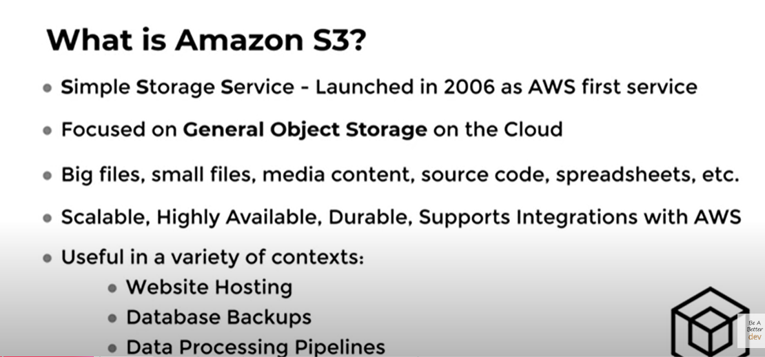
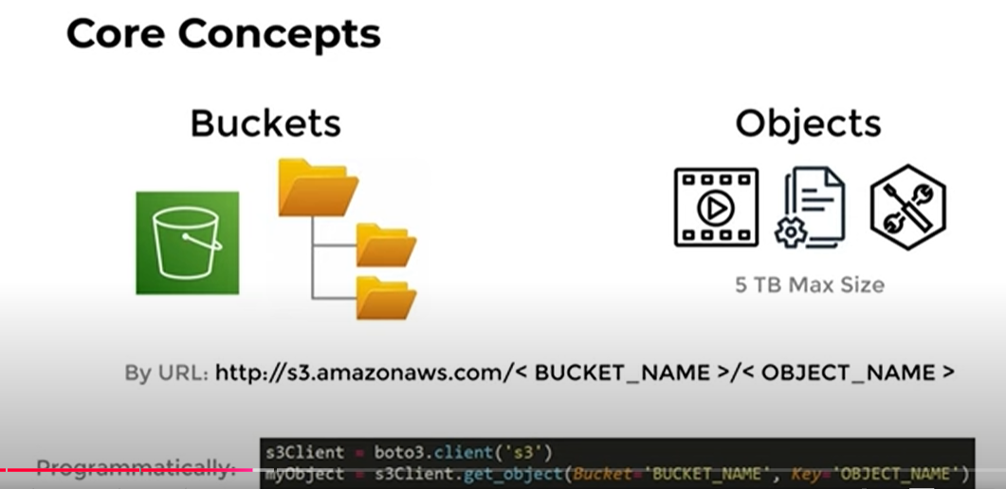
S3 STORAGE CLASSES
- Storage classes allow you to reduce costs, but with certain sacrifices.
- Examples: Standard, intelligent, Infrequent Access, Glacier.
- Each tier has different pricing, latency, availability.
- Standard Tier (Hot Data) -> Infrequent Access -> Glacier (Cold Data).
- Lifecycle rules automate the data movement process.

S3 Storage Classes: Simple and Detailed Explanation
Amazon S3 offers storage classes to store your data based on how often you need to access it and how much you want to spend. Each class balances cost, speed, and availability, so you can pick the one that best fits your needs.

Why Storage Classes?
- Save Costs: Different storage classes help reduce costs by adjusting availability, speed, and access frequency.
- Examples of Classes: Standard, Intelligent-Tiering, Infrequent Access, and Glacier.
- Data Lifecycle Management: You can set rules to automatically move data between classes to save time and money.

Types of S3 Storage Classes
1. S3 Standard (Hot Data)
- Best for: Data you use frequently (e.g., daily or real-time access).
- Features:
  - High durability (11 nines: 99.999999999%).
  - High availability (99.99%).
  - Fast access speed.
- Use Cases:
  - Websites, mobile apps, and real-time data analytics.
- Cost: Highest among all classes but ideal for frequent access.

2. S3 Intelligent-Tiering (Smart Tier)
- Best for: Data with changing access patterns (sometimes used a lot, sometimes rarely used).
- Features:
  - Automatically moves data between frequent-access and infrequent-access tiers based on usage.
  - No performance impact when accessing data.
- Use Cases:
  - Files with unpredictable access patterns.
- Cost: Slightly higher storage cost than Infrequent Access, but saves money if data access changes.

3. S3 Standard-IA (Infrequent Access)
- Best for: Data you use occasionally but still need quickly when required.
- Features:
  - High durability.
  - Lower storage cost than Standard.
  - Small retrieval fee whenever data is accessed.
- Use Cases:
  - Backup files or disaster recovery data.
- Cost: Cheaper than Standard for storage but adds retrieval costs.

4. S3 One Zone-IA
- Best for: Data you access infrequently but don't mind losing in case of a disaster.
- Features:
  - Data stored in a single Availability Zone (not multiple zones).
  - Lower cost than Standard-IA.
- Use Cases:
  - Non-critical data or easily recreatable backups.
- Cost: Cheapest for infrequent access but less durable.

5. S3 Glacier (Cold Data)
- Best for: Data you rarely need (archived for months or years).
- Features:
  - Super low storage cost.
  - Retrieval can take minutes to hours, depending on the option you choose.
- Use Cases:
  - Long-term storage of historical data or archives.
- Cost: Cheapest for long-term storage; retrieval fees apply.

6. S3 Glacier Instant Retrieval
- Best for: Rarely used data that still needs instant access.
- Features:
  - Low cost, but slightly higher than regular Glacier.
  - Millisecond access speed.
- Use Cases:
  - Archives needing quick retrieval, like medical records or legal documents.
- Cost: Low storage cost with small retrieval fees.

Lifecycle Rules
- What They Do: Automate the movement of data between storage classes.
- How It Works:
  - For example, you can set a rule to move files from Standard to Infrequent Access after 30 days, and to Glacier after 90 days.
- Why Use It: Saves money by managing your data storage efficiently without manual intervention.
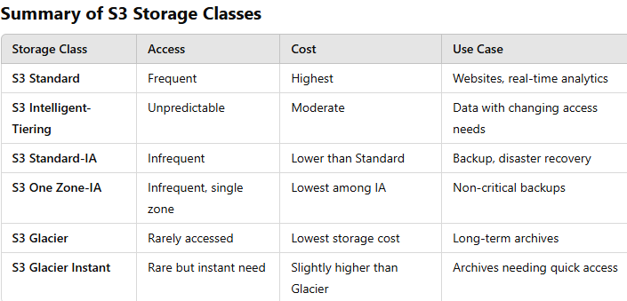

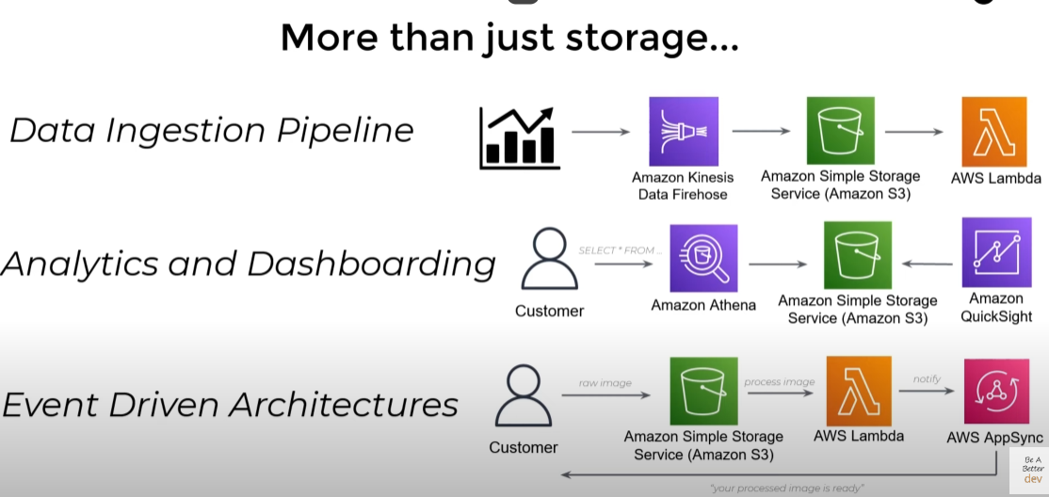
SECURITY
Amazon S3 (Simple Storage Service) ensures your data is secure at all times, whether it is being stored or accessed. Here's an easy-to-understand breakdown of its security features:

1. Public Access is Blocked by Default
- What it Means:
  - By default, your S3 buckets and data cannot be accessed by anyone over the internet.
- How it Helps:
  - Prevents accidental data exposure or unauthorized access unless you explicitly allow it.

2. Data Protection
- Durability and Availability:
  - S3 is designed for 99.999999999% durability, meaning your data is highly protected against loss.
  - High availability ensures you can access your data almost anytime.
- Encryption:
  - In Transit: Data is encrypted while moving between your devices and S3 using HTTPS/SSL.
  - At Rest: Data is encrypted once it’s stored in S3 using AWS-managed keys or customer-provided keys.

3. Access Control
- AWS IAM (Identity and Access Management):
  - Controls who can access your S3 resources and what actions they can perform.
  - Example: Only specific users or services can view, edit, or delete your data.
- Resource-Based Policies:
  - You can define access policies directly on the bucket or object level.
  - Example: Allow specific IP addresses or AWS accounts to access your data.

4. Auditing and Monitoring
- Access Logs:
  - Keep track of who accessed your S3 data and when.
- Action-Based Logs (AWS CloudTrail):
  - Logs every action performed on your S3 bucket, such as uploads or permission changes.
- Alarms (Amazon CloudWatch):
  - Set alerts for specific activities, like unexpected data downloads or changes in settings.

5. Infrastructure Security
- Built on AWS Cloud Infrastructure:
  - S3 operates on AWS’s global infrastructure, which is designed for high security.
  - Includes firewalls, physical security, and constant monitoring to protect against threats.

How All These Work Together
- Default Security: S3 starts secure by default with public access blocked.
- Encryption: Ensures no one can read your data unless they have permission.
- Access Control: Allows you to define who can do what with your data.
- Logs and Alarms: Keep you informed about any suspicious activities.
- Strong Infrastructure: Ensures the physical and network layer of S3 is secure.
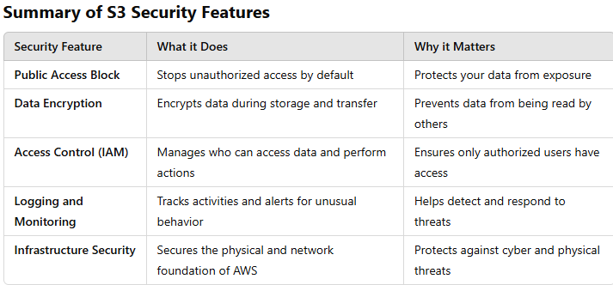
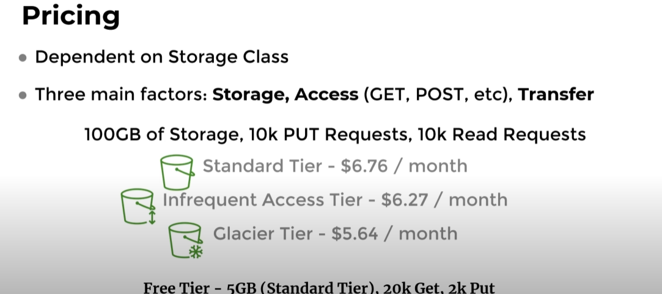
Use Cases for Amazon S3 Glacier
- Data Archival:
  - Long-term storage for regulatory compliance or legal requirements.
  - Backup storage for disaster recovery.
- Media Archives:
  - Storing large media files such as raw footage or completed projects for future use.
- Healthcare Records:
  - Archiving patient records, medical imaging, or other healthcare data for retention policies.
- Scientific Data:
  - Preserving research data, satellite imagery, or simulation data for decades.
- Enterprise Data:
  - Retaining financial records, audit trails, and transaction histories.

3. Database Services
These services allow you to manage and scale databases.
- Amazon RDS (Relational Database Service): Managed SQL database service (supports MySQL, PostgreSQL, SQL Server, etc.).
- Amazon DynamoDB: NoSQL database for applications requiring low-latency data access.
- Amazon Redshift: Data warehouse service for analytics and data querying.
- Amazon Aurora: High-performance, scalable relational database compatible with MySQL and PostgreSQL.
- Amazon DocumentDB: Managed NoSQL document database service, compatible with MongoDB.
4. Networking Services
These services enable you to manage networking, security, and traffic routing.
- Amazon VPC (Virtual Private Cloud): Isolated cloud network to run your resources in a private environment.
- Amazon Route 53: DNS service to route end users to your application (domain registration).
- AWS Direct Connect: Dedicated network connection from your premises to AWS.
- Amazon CloudFront: Content delivery network (CDN) for faster delivery of content globally.
5. Security & Identity Services
These services help manage user identities, permissions, and security.
- AWS IAM (Identity and Access Management): Manage user access to AWS resources securely.
- AWS KMS (Key Management Service): Manage encryption keys for securing your data.
- Amazon GuardDuty: Threat detection service for protecting AWS accounts and workloads.
- AWS WAF (Web Application Firewall): Protects applications from common web exploits.
- AWS Shield: Managed DDoS protection for applications running on AWS.
6. Analytics Services
These services help with analyzing data and gaining insights.
- Amazon EMR (Elastic MapReduce): Big data processing framework for Hadoop, Spark, etc.
- Amazon Athena: Serverless interactive querying of data stored in Amazon S3.
- Amazon QuickSight: Business intelligence tool for creating dashboards and reports.
- Amazon Kinesis: Real-time data streaming and analytics service.
- AWS Glue: Managed ETL (Extract, Transform, Load) service for preparing and loading data.
7. Machine Learning Services
These services provide tools for building and deploying machine learning models.
- Amazon SageMaker: Managed service for building, training, and deploying ML models.
- Amazon Polly: Converts text to speech using deep learning models.
- Amazon Rekognition: Image and video analysis for detecting objects, faces, and text.
- Amazon Comprehend: Natural language processing (NLP) for text analysis (sentiment, entities, etc.).
- AWS Deep Learning AMIs: Pre-configured machine learning environments for deep learning frameworks.
8. Developer Tools
These services assist developers in building, testing, and deploying applications.
- AWS CodeBuild: Build service to compile source code, run tests, and create software packages.
- AWS CodeDeploy: Automated code deployment service.
- AWS CodePipeline: Continuous integration and continuous delivery (CI/CD) service.
- AWS X-Ray: Helps debug and analyze microservices applications.
- AWS Cloud9: Cloud-based integrated development environment (IDE).
9. IoT Services
These services are for managing connected devices and real-time data processing.
- AWS IoT Core: Connects IoT devices to the cloud.
- AWS IoT Greengrass: Extends AWS to local devices for edge processing.
- AWS IoT Analytics: Analyzes IoT data for insights.
- AWS IoT Device Management: Manages fleets of IoT devices.
10. Migration & Transfer Services
These services help in migrating applications and data to AWS.
- AWS Migration Hub: Central place to track migrations to AWS.
- AWS Database Migration Service (DMS): Migrates databases to AWS.
- AWS Snowball: Physical devices for transferring large amounts of data.
- AWS DataSync: Automated data transfer between on-premises storage and AWS.
11. Business Applications
These services are geared towards productivity and collaboration.
- Amazon Chime: Communication service for meetings, video calls, and chat.
- Amazon WorkDocs: Managed document storage and sharing.
- Amazon WorkMail: Managed email and calendar service.
- Amazon WorkSpaces: Virtual desktop infrastructure (VDI) in the cloud.
12. Blockchain Services
These services allow you to build and manage blockchain networks.
- Amazon Managed Blockchain: Managed blockchain network for building and scaling decentralized applications.
- Amazon QLDB (Quantum Ledger Database): Managed ledger database for tracking data changes.
13. AR/VR Services
These services allow you to build augmented reality (AR) and virtual reality (VR) applications.
- Amazon Sumerian: Platform for building and running AR and VR applications.
14. Media Services
These services enable you to process and deliver media content.
- AWS MediaConvert: File-based video transcoding for on-demand video.
- AWS MediaLive: Real-time video processing for live video streams.
- AWS Elemental MediaStore: Storage for media content.
15. Customer Engagement Services
These services help you engage and support customers effectively.
- Amazon Connect: Cloud contact center for customer service.
- Amazon Pinpoint: Marketing automation for targeted campaigns.
Summary:
AWS has a wide array of services that can help with everything from storing data, analyzing big data, developing applications, machine learning, security, networking, to running virtual servers, and more. You can use different AWS services to meet the specific needs of your business or application.
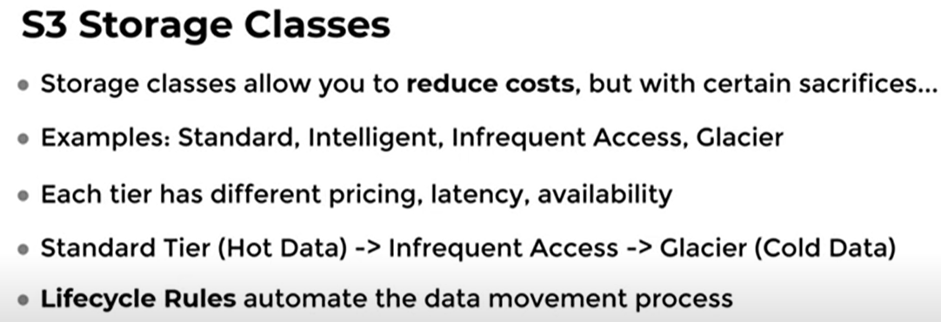
S3 Security
- Public access is blocked by default.
- Data Protection: Highly durable and availability guarantees, encryption in transit and at rest.
- Access: Access and resourced based controls with AWS IAM.
- Auditing: Access logs, action-based logs, alarms.
- Infrastructure security: Built on top of AWS cloud infrastructure.

IAM: IAM (Identity and Access Management) in AWS is like a security guard for your AWS account. It helps you decide:
- Who can use your AWS resources (like servers, databases, etc.).
- What they are allowed to do with them.
Think of it as:
- Users: People who need access, like employees or team members.
- Groups: Teams with similar permissions (e.g., "Developers" or "Admins").
- Roles: Special permissions for services or applications (like giving a robot a key to do its job).
- Policies: Rules that clearly say what actions are allowed or not.
Why it’s important:
- It keeps your AWS resources safe by ensuring only the right people or systems can access them.
- You can customize permissions so everyone has access to just what they need, nothing more.
For example:
- A developer might only get access to code-related tools.
- An admin might get full access to manage everything.
IAM (Identity and Access Management) in AWS is designed to solve the problems of Authentication and Authorization:
1. Authentication: "Who are you?"
- IAM verifies the identity of users, services, or applications trying to access AWS resources.
- Example: When you log in to AWS, IAM checks your username and password (and optionally Multi-Factor Authentication) to ensure you are who you say you are.
2. Authorization: "What are you allowed to do?"
- After confirming who you are, IAM determines what actions you can perform on AWS resources by evaluating the policies attached to your user, group, or role.
- Example: A developer may only be allowed to start or stop an EC2 instance but not delete it.
Key Benefits:
- Secure Access: Only authenticated users or applications can interact with AWS resources.
- Granular Permissions: Define specific actions allowed for each user or service.
- Least Privilege Principle: Ensure users or services have only the permissions they need.
IAM is critical for maintaining security and managing access in AWS environments.
Imagine a DevOps engineer working in AWS. They need to manage cloud resources like virtual servers (EC2), databases (RDS), and storage (S3). IAM helps the engineer do this securely by managing who can access these resources and what they can do.
Example Scenario:
- Creating a User for the DevOps Engineer:
  - The company hires a new DevOps engineer and needs to give them access to AWS.
  - Using IAM, the company creates a new user for the engineer with a specific username (e.g., "JohnDoe").
  - IAM makes sure the engineer can log in securely using their credentials.
- Assigning Permissions (Authorization):
  - The DevOps engineer needs to manage EC2 instances, deploy updates, and monitor logs.
  - The company uses IAM policies to define what the engineer is allowed to do.
    - Example: A policy might allow the engineer to start, stop, or restart EC2 instances but not delete them.
    - Another policy might give them access to S3 buckets to store logs but restrict access to only certain folders.
- Using IAM Roles for Automated Systems:
  - The DevOps engineer sets up a CI/CD pipeline (Continuous Integration/Continuous Deployment) to automatically deploy code updates.
  - IAM is used to give the pipeline temporary roles that allow it to interact with AWS services (like EC2 or Lambda) on behalf of the engineer. These roles have specific permissions, ensuring the system can only perform certain tasks.
- Enforcing Multi-Factor Authentication (MFA):
  - For extra security, the company requires the DevOps engineer to set up Multi-Factor Authentication (MFA).
  - With MFA, when the engineer logs in to AWS, they need not only their username and password but also a code sent to their phone, making access more secure.
Why IAM Helps:
- Security: IAM ensures only the right people and systems can access and modify AWS resources.
- Control: The DevOps engineer gets the necessary permissions, but only for the tasks they need to do. No more, no less.
- Automation: IAM roles enable automated processes like deployments to run without manual intervention, while still maintaining security.
In simple terms, IAM helps the DevOps engineer safely access and manage AWS resources while preventing unauthorized changes or actions.
IAM in AWS has 4 key components—Users, Policies, Groups, and Roles—to help manage and control access to resources in a secure and organized way. Here’s why each one is important:
1. Users: "Who are you?"
- Purpose: A user represents an individual or an application that needs access to your AWS resources.
- Why it’s important: Each person or service needs an identity to log in and interact with AWS. Without users, there would be no way to authenticate who is accessing the resources.
Example: A DevOps engineer, a developer, or an application needs a unique user to log in and work with AWS.
2. Policies: "What can you do?"
- Purpose: Policies are documents that define the permissions (what a user can or cannot do). They specify actions like read, write, delete on specific resources (like EC2, S3, etc.).
- Why it’s important: Without policies, AWS wouldn’t know what a user is allowed to do. Policies ensure that users have only the access they need (following the Principle of Least Privilege).
Example: A policy might say "Allow user X to start EC2 instances but not delete them" or "Allow user Y to access S3 buckets but not modify files."
3. Groups: "How do we organize users?"
- Purpose: A group is a collection of users with similar roles or responsibilities. Groups allow you to manage permissions for multiple users at once.
- Why it’s important: If there are many users (like in a big company), assigning the same permissions to each user individually would be difficult. Groups make it easier by applying policies to the whole group.
Example: You might have a Developers group and an Admins group, where each group gets different permissions. You can apply policies to the whole group instead of setting them individually for each user.
4. Roles: "Who can do what on behalf of whom?"
- Purpose: Roles are used to delegate permissions to AWS services or other accounts. Unlike users, roles don’t have a specific identity tied to them—they are assumed by entities like EC2 instances, Lambda functions, or even other AWS accounts.
- Why it’s important: Roles are useful when services or applications need to temporarily perform actions on your behalf, like accessing other AWS resources.
Example: If an EC2 instance needs to read data from an S3 bucket, you assign a role to that EC2 instance with the necessary permissions, and it can access the S3 bucket on behalf of your account.

Why all four?
- Users allow you to identify who is accessing AWS.
- Policies define what actions they can take.
- Groups help you organize users and apply permissions collectively.
- Roles allow you to delegate permissions to AWS services or other accounts, which is crucial for automation and cross-service interactions.
Together, these components provide a flexible, secure, and scalable way to manage who can access AWS resources and what they can do.
IAM Use Case
IAM (Identity and Access Management) in AWS helps you control who can access your AWS resources and what actions they can perform. It's all about ensuring the right person or service has the right permissions to use AWS services.
IAM Use Case Example:
Imagine you're working for a company that has multiple developers and system admins. You want to ensure that:
- Developers can only deploy and manage applications, but not delete critical resources like servers or databases.
- System admins should have full access to manage everything, including security settings.
Using IAM, you can create different users, groups, and permissions for each role in your company.
How Does IAM Work?
- Users: Individual people or services (like your developers or admins).
- Groups: A collection of users with similar roles (like "Developers" or "Admins").
- Policies: Rules that define what actions a user or group can do, such as "can read from S3," or "can launch EC2 instances."
- Roles: A set of permissions that can be assumed by services or users to perform specific tasks (like allowing an EC2 instance to access an S3 bucket).
Role of a DevOps Engineer in IAM:
A DevOps Engineer is responsible for managing the infrastructure in AWS, and IAM is a big part of this job. Here's what a DevOps engineer does with IAM:
1. Create Users and Groups:
- Example: The DevOps engineer creates an IAM user for each developer, so they can access AWS. They also group these users into a "Developers" group.
- Benefit: Easier to manage access because developers have the same permissions.
2. Assign Permissions:
- Example: The DevOps engineer assigns a permission policy to the "Developers" group, allowing them to access EC2 instances and deploy code but not delete them.
- Benefit: Ensures developers can do their job without risking important resources being deleted.
3. Create IAM Roles for Services:
- Example: The DevOps engineer creates an IAM role for an EC2 instance that allows it to read from an S3 bucket (e.g., for pulling logs or files).
- Benefit: Services can interact with other AWS resources securely without exposing sensitive credentials.
4. Implement Least Privilege Principle:
- Example: The DevOps engineer makes sure that every user and service only gets the permissions they need (nothing more). For instance, a developer doesn’t need access to RDS databases.
- Benefit: Reduces the risk of accidental or malicious misuse of AWS resources.

5. Enable Multi-Factor Authentication (MFA):
- Example: The DevOps engineer ensures that all admins and other sensitive roles are required to use MFA when accessing AWS. This means they need a password plus a code from a mobile app.
- Benefit: Adds an extra layer of security for critical accounts.
6. Monitor and Audit Permissions:
- Example: The DevOps engineer uses AWS tools like CloudTrail to log and track who accessed what resources, when, and why. If something goes wrong, they can quickly review the logs.
- Benefit: Helps in troubleshooting and ensures accountability.
7. Automate IAM Management:
- Example: The DevOps engineer uses tools like AWS CloudFormation or Terraform to automate the creation and management of IAM users, groups, and roles.
- Benefit: Ensures consistency and reduces manual errors when setting up new users or services.
8. Federation (External Users):
- Example: If the company works with third-party contractors, the DevOps engineer can set up identity federation, which lets users log into AWS with their Google or Active Directory credentials.
- Benefit: Makes it easier for external users to access AWS resources without needing separate login credentials.
Summary of DevOps Engineer’s Role in IAM:
- Create and manage IAM users and groups to control who has access to AWS.
- Assign specific permissions to users based on their roles (e.g., developer, admin).
- Use roles to give AWS services like EC2 the permissions they need.
- Follow the principle of least privilege to make sure users only get the permissions they need.
- Ensure security with MFA and monitor IAM usage.
- Automate IAM processes for efficiency and consistency.
By managing IAM, the DevOps engineer ensures that everyone in the organization has secure and appropriate access to AWS resources, helping to prevent unauthorized actions while maintaining operational efficiency.

JIRA is a tool used by teams to manage tasks, bugs, feature requests, and other work items. It helps organize and track progress on projects.
In the Context of AWS:
A JIRA request might refer to any task or action related to managing AWS resources or services that a team needs to complete. For example:
- Creating an AWS Resource: A task in JIRA asking someone to set up an EC2 instance, configure an S3 bucket, or deploy a Lambda function.
- Monitoring AWS Services: A JIRA request might be created to monitor the health of AWS resources, or to investigate and resolve any issues (e.g., a service outage or performance issue in AWS).
- Automation: A JIRA request might involve automating tasks in AWS using tools like AWS CloudFormation or AWS Lambda.
Example of a JIRA Request in AWS:
- Title: "Set up an EC2 instance for the new web application"
- Description: "Please launch an EC2 instance with 4 vCPUs and 16GB RAM to host the new application. It should be configured with the necessary security groups for internet access."
- Assignee: The person responsible for completing the task.
Why JIRA with AWS?
- Tracking: It helps track the progress of cloud-related tasks in AWS.
- Collaboration: Multiple teams (e.g., DevOps, Security, and Developers) can collaborate and stay informed about ongoing tasks or issues related to AWS resources.
So, a JIRA request related to AWS is simply a task or issue related to AWS infrastructure or services that needs to be tracked or resolved using the JIRA tool.

when we talk about users in the context of IAM (Identity and Access Management) in AWS, their access is divided into two key concepts: Authentication and Authorization. These are two important steps to ensure secure access to AWS resources.
1. Authentication: "Who are you?"
- Purpose: Authentication verifies the identity of the user. It ensures that the person or application trying to access AWS is who they claim to be.
- How it works: The user provides credentials (such as a username and password), and AWS checks those credentials to confirm the user's identity.
  - Example: When a user logs into the AWS Management Console, they enter a username and password. AWS then checks the credentials to verify that they match a valid user.
  - MFA (Multi-Factor Authentication) can also be used here, requiring the user to provide an additional authentication factor (like a code from a smartphone app) for extra security.
2. Authorization: "What can you do?"
- Purpose: Authorization determines what actions the authenticated user is allowed to perform on AWS resources.
- How it works: After the user is authenticated, IAM checks the permissions assigned to that user, which are defined by IAM policies.
  - Example: After logging in, AWS checks the user's permissions to determine if they are allowed to access certain resources (like EC2 instances or S3 buckets) and what actions they can perform on those resources (e.g., read, write, or delete).
  - Permissions can be set for specific actions, services, and resources using policies that are attached to the user, group, or role.
Simple Breakdown:
- Authentication = Verifying who the user is.
- Authorization = Defining what the authenticated user is allowed to do.
Example:
Let’s say you have an AWS user "Alice":
- Authentication: Alice logs in with her username and password. AWS checks if these are valid credentials.
- Authorization: After Alice is logged in, IAM checks her assigned permissions (such as allowing her to start EC2 instances or access S3 buckets) to decide what actions she can perform in AWS.
Together, authentication and authorization ensure that only the right people (authenticated) can do the right things (authorized) in AWS.

AWS S3
What is AWS S3?
Amazon Simple Storage Service (S3) is a cloud-based storage service that lets you store and retrieve any amount of data from anywhere in the world. It’s highly scalable, durable, and secure, making it a popular choice for data engineers and developers.

Why is AWS S3 Important for Data Engineering?
- Scalability: Automatically scales to handle large volumes of data.
- Durability: Your data is safe and replicated across multiple locations.
- Flexibility: Handles a variety of file types like text, images, videos, and data backups.
- Cost-Effectiveness: Pay only for the storage you use.

Key Concepts in AWS S3
- Buckets:
  - Think of a bucket as a folder where your data is stored.
  - Each bucket has a unique name globally.
- Objects:
  - Objects are the files you upload to S3 buckets.
  - Each object consists of:
    - Data (the content of the file)
    - Metadata (information about the file)
    - Key (the unique identifier for the object in the bucket)
- Regions:
  - S3 buckets are created in specific regions (like "us-east-1").
  - Choose a region close to your users for faster access.
- Storage Classes:
  - Different classes based on how often you need to access the data:
    - Standard: Frequently accessed data.
    - Intelligent-Tiering: Automatically moves data to the most cost-effective tier.
    - Glacier: For long-term, infrequently accessed data (archival).

Core Features of S3 for Data Engineering
- High Availability:
  - Your data is stored across multiple servers, ensuring it's always available.
- Security:
  - Control access with IAM policies, Bucket Policies, and Access Control Lists (ACLs).
  - Use encryption for secure data storage.
- Versioning:
  - Keeps multiple versions of the same object. Useful for backups.
- Lifecycle Management:
  - Automatically move data to cheaper storage classes or delete it after a set time.
- Event Notifications:
  - Trigger events (e.g., run a Lambda function) when a file is added or modified.
- Data Transfer Options:
  - Upload directly, use the AWS CLI, or tools like AWS Snowball for large datasets.

Use Cases of S3 in Data Engineering
- Data Lake:
  - Store large volumes of raw, structured, and unstructured data.
- ETL Pipelines:
  - Use S3 as a staging area for data before transformation and loading into a data warehouse (e.g., Redshift).
- Backup and Archival:
  - Store backups and old data using Glacier.
- Big Data Analytics:
  - Integrate with tools like Athena, EMR, or Glue for analytics.
- Machine Learning:
  - Use S3 to store datasets for training ML models in services like SageMaker.

How to Use S3 for Data Engineering
- Set Up Buckets:
  - Create buckets for different datasets (e.g., raw data, processed data).
- Upload and Organize Data:
  - Use folders within buckets to organize data by project or date.
- Automate with Lifecycle Policies:
  - Move data from frequently accessed to archival storage automatically.
- Query Data with Athena:
  - Use SQL queries directly on your S3 data without loading it into a database.
- Integrate with ETL Tools:
  - Use tools like AWS Glue or Apache Spark to process data from S3.

Key Tools for S3 Integration in Data Engineering
- AWS CLI: Automate data uploads and downloads.
- AWS SDKs: Integrate S3 into your applications using Python (Boto3), Java, etc.
- AWS Glue: Extract and transform data from S3 to other services.
- Athena: Query S3 data using SQL.
- Redshift: Load processed data into a data warehouse for further analysis.

Advantages of S3 for Data Engineering
- Easy to use and integrate with other AWS services.
- Reliable, with 99.999999999% durability (11 9s!).
- Handles both small files and massive datasets.
- Cost-efficient for various storage needs.

Example: Data Pipeline with S3
- Step 1: Collect data from multiple sources (e.g., IoT devices, databases) and upload it to an S3 bucket.
- Step 2: Use AWS Glue to transform and clean the data.
- Step 3: Store the processed data back in another S3 bucket or load it into Redshift for analysis.
- Step 4: Visualize data using QuickSight or another BI tool.

By mastering AWS S3, you’ll gain a key skill for building efficient and scalable data engineering pipelines!
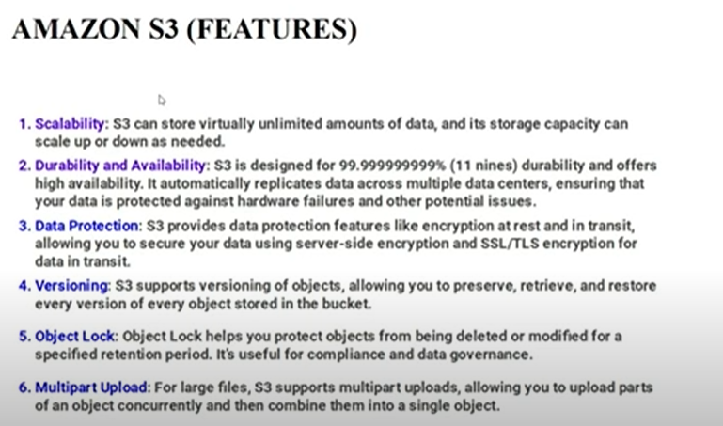

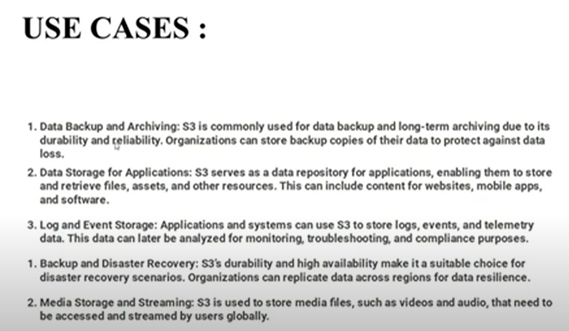
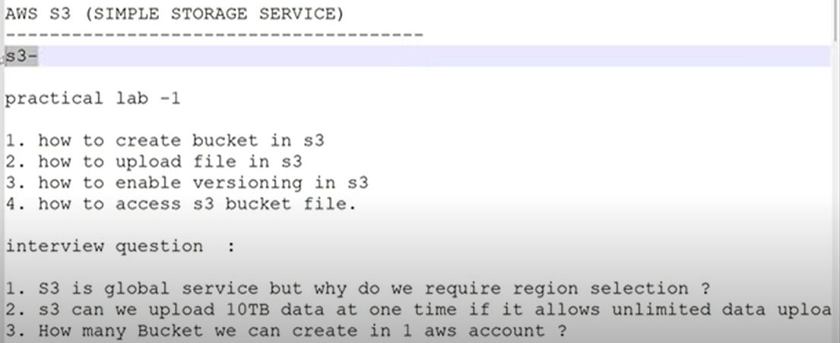
BUCKET: What is a Bucket in AWS S3?
A bucket in AWS S3 is like a folder where you store your files (called objects). It's the main container for your data in S3. Every time you upload something to S3, it goes into a bucket.

Key Points About Buckets
- Unique Name:
  - Each bucket must have a unique name across all AWS accounts because bucket names are global.
  - Example: If you name your bucket "my-awesome-bucket," no one else can use that name.
- Region-Specific:
  - You create a bucket in a specific AWS region (like "us-east-1" or "ap-south-1").
  - Choosing a region close to your users makes data access faster.
- Stores Objects:
  - Buckets don’t store data directly—they store objects, which are your files.
- Organized Using Folders:
  - You can create folders inside a bucket to organize your data.
  - For example: my-bucket/raw-data/2024/ to keep raw data by year.

Features of Buckets
- Access Control:
  - You can control who can access your bucket using permissions:
    - Bucket Policies: Set rules for the entire bucket.
    - IAM Policies: Assign permissions to specific users or roles.
- Versioning:
  - If versioning is enabled, S3 keeps multiple versions of the same object.
  - Useful for restoring previous versions of files.
- Lifecycle Rules:
  - Automate moving files to cheaper storage or deleting old files.
- Logging:
  - You can track all actions in your bucket (like file uploads or downloads).
- Encryption:
  - Protect your data with server-side or client-side encryption.

What Can You Do With a Bucket?
- Upload Files: Store any type of file, like images, videos, documents, or backups.
- Download Files: Retrieve your files whenever needed.
- Set Permissions: Decide who can read, write, or manage your files.
- Automate Actions: Trigger events, like running a function, when a file is added or removed.

Real-World Example
Imagine you're running an e-commerce website. Here's how you could use an S3 bucket:
- Bucket Name: ecommerce-website-media
- Folders Inside the Bucket:
  - images/: Store product photos.
  - logs/: Store server logs.
  - backups/: Store database backups.
- Permissions:
  - Make the images/ folder public so customers can see product photos.
  - Keep logs/ and backups/ private for security.

How to Create a Bucket (Easy Steps)
- Log in to AWS Console.
- Go to S3 Service.
- Click "Create Bucket".
- Provide:
  - A unique bucket name.
  - Choose a region.
- Set Permissions (like public or private access).
- Click "Create".
Your bucket is ready to store data!

Versioning: Versioning in AWS, specifically in the context of data engineering, refers to managing and keeping track of changes made to data or objects stored in services like Amazon S3 (Simple Storage Service). Think of it like a "history log" that allows you to go back and retrieve earlier versions of your data.
Here’s a simple explanation:
What is Versioning?
- Versioning is a feature in Amazon S3 that helps you keep multiple versions of the same file (object) in a bucket.
- When you enable versioning for an S3 bucket, every time you make changes to an object (e.g., update or delete it), AWS saves the new version while keeping the old one intact.
Why is Versioning Useful?
- Accidental Deletion Protection: If someone deletes a file, the earlier versions are still stored and can be recovered.
- Change Tracking: You can view or roll back to a previous version if something goes wrong with an update.
- Data Backup: Acts as a backup system to ensure data isn’t permanently lost.
Example:
- You upload a file called data.csv to an S3 bucket.
- Later, you update data.csv by adding new rows of data.
  - Without versioning: The old file is overwritten.
  - With versioning: AWS creates a new version of data.csv and keeps the old one.
- You can now retrieve or restore any version of data.csv whenever needed.
Key Points:
- Versioning is optional and must be enabled on the bucket.
- Each version of an object gets a unique ID, allowing you to identify and manage versions easily.
- Even when an object is "deleted," its previous versions can still be recovered.
In summary, versioning is like a safety net that helps maintain data integrity, protect against accidental changes, and provide easy recovery of files in AWS data engineering workflows.

AWS S3 STORAGE CLASSES
AWS S3 storage classes are different ways of storing data in Amazon S3 based on how often you access it and how long you want to keep it. These classes are designed to help you manage costs by choosing the right storage option for your needs. Here's an easy-to-understand explanation of each:
In AWS, storage classes are used to define how your data is stored in Amazon S3 (Simple Storage Service) based on how often you access it and how long you need to keep it. Choosing the right storage class helps you save money by matching your storage needs with the right pricing model. Let's look at when and why you should use each of these storage classes in detail:
1. S3 Standard
- When to use:
  - When you need frequent access to your data with low latency.
  - For real-time applications like websites, mobile apps, and applications where data is accessed frequently.
  - For critical data that needs high durability and availability.
- Example:
  - A media website storing images or videos that users frequently view.
  - Active logs, documents, or any files accessed regularly.
- Why use it:
  - High availability and durability (99.999999999% durability).
  - Optimized for low-latency data access.
  - Data is automatically replicated across multiple data centers (availability zones).
2. S3 Intelligent-Tiering
- When to use:
  - When your data's access patterns are unpredictable or you don't know if the data will be frequently accessed or not.
  - Ideal for large datasets where some data might be accessed often, and some only occasionally.
- Example:
  - A large data archive where you don’t know when or how often you will need access to specific files.
  - A data store for analytics where some results are needed frequently, but others may only be needed periodically.
- Why use it:
  - Automatic cost savings by moving data to the cheaper tier if it’s not accessed for a while.
  - It doesn’t require manual intervention to move data between frequent and infrequent access tiers.
  - The system automatically moves data between two access tiers: frequent and infrequent access.
3. S3 Standard-IA (Infrequent Access)
- When to use:
  - When data is not accessed frequently but still needs to be retrieved quickly when required.
  - For backup data, logs, or older files that you still need fast access to but don’t use regularly.
- Example:
  - Archiving old project data that you don’t need all the time but might need quickly in the future.
  - Storing backups or records that need to be restored quickly in case of data loss.
- Why use it:
  - Cost-effective for storing data that’s infrequently accessed.
  - Lower storage costs than S3 Standard, but there are retrieval charges.
  - Offers high availability and durability like S3 Standard but optimized for less frequent access.
4. S3 One Zone-IA (Infrequent Access in One Availability Zone)
- When to use:
  - When you don’t need to store data in multiple availability zones and can tolerate the risk of losing data if an entire data center goes down.
  - Best for data that is infrequently accessed and can be recreated if necessary.
- Example:
  - Temporary data backups or files that can be easily re-generated, like system-generated reports or logs.
- Why use it:
  - It is cheaper than S3 Standard-IA because it stores data in just one availability zone (instead of multiple zones).
  - Useful for less critical data or backups that don’t need to be replicated across multiple locations.
5. S3 Glacier
- When to use:
  - For long-term archival storage of data that you may need to access only very rarely.
  - Ideal for compliance and regulatory data that you need to store for years but don’t expect to access often.
- Example:
  - Archiving old business records, government compliance documents, or historical logs that you may need to retrieve after months or years.
- Why use it:
  - Extremely low-cost storage for data you don’t need to access regularly.
  - Provides data durability (99.999999999%) over long periods.
  - Retrieval can take minutes to hours depending on the speed option you select.
6. S3 Glacier Deep Archive
- When to use:
  - For very long-term storage of data that you may never need to access, or only need to access once or twice a year.
  - Ideal for data retention purposes like compliance archives, or records that must be kept for a specific period (e.g., 7+ years).
- Example:
  - Storing old legal documents, tax records, or any data you want to keep for many years, but only need to retrieve occasionally.
- Why use it:
  - The cheapest option for storing data.
  - Perfect for data that needs to be stored very long-term and can tolerate delayed retrieval (it can take up to 12 hours to retrieve data).
  - Ideal for compliance purposes and archival of large datasets that are not likely to be accessed.

When to Use Each Storage Class:
- S3 Standard: Use for data that’s actively used and needs low-latency access. Example: Website files, databases, or media content.
- S3 Intelligent-Tiering: Use when data access is unpredictable. Example: Analytics data, large datasets that are sometimes accessed, sometimes not.
- S3 Standard-IA: Use for data that’s not accessed often but still needs to be retrieved quickly. Example: Backups, old logs.
- S3 One Zone-IA: Use when you don’t need the resilience of multiple availability zones and can tolerate some risk. Example: Infrequent backups or temporary storage.
- S3 Glacier: Use for long-term archive data that’s rarely accessed but needs to be stored for a long time. Example: Compliance or historical records.
- S3 Glacier Deep Archive: Use for archival storage that’s rarely accessed and can be retrieved very infrequently. Example: Legal documents, tax records.

How to Choose the Right Storage Class:
- Access Frequency: How often will you need the data? If it’s frequent, choose S3 Standard. If it’s rarely accessed, choose S3 Glacier or S3 Glacier Deep Archive.
- Cost Sensitivity: If cost is a key factor, choose S3 Glacier Deep Archive for the lowest cost.
- Retrieval Time: How quickly do you need to access your data? For fast access, use S3 Standard. For slower retrieval (minutes or hours), use S3 Glacier.
In short, storage classes in AWS S3 allow you to optimize your storage costs by choosing the right class based on how often you need to access your data and how long you plan to store it. This helps businesses and developers manage their data efficiently and cost-effectively.

AWS LAMBDA
AWS Lambda is a service by Amazon Web Services (AWS) that lets you run your code without managing servers. It's like a magic box where you put your code, and when something happens (like someone uploads a file, or a time event occurs), Lambda runs your code automatically.
Simple Key Points:
- No Servers to Manage:
  - You don’t need to set up or maintain any servers. AWS Lambda handles all of that for you.
- Event-Driven:
  - Your code runs in response to events. For example:
    - Someone uploads a photo to Amazon S3 (AWS's cloud storage).
    - A message arrives in a queue.
    - A time schedule you set (like every hour or day).
  - You just write your code and link it to an event. When that event happens, Lambda runs your code.
- Automatic Scaling:
  - If more events happen (like more users uploading files), Lambda automatically runs more instances of your code to handle them, without you needing to do anything.
- Pay Only for What You Use:
  - You only pay when your code runs. If there’s no event, there’s no charge. You’re not paying for idle servers.
- Supports Different Programming Languages:
  - Lambda can run code written in several languages like Python, JavaScript (Node.js), Java, C#, and more.
How AWS Lambda Works:
- Write Your Code:
  - You write a small function (code) in your chosen programming language.
- Set a Trigger:
  - You tell Lambda what event should trigger your code. For example, you might say, "Run this code when a new file is uploaded to my storage bucket."
- Lambda Executes the Code:
  - When that event happens, Lambda automatically executes your code.
- No Servers:
  - AWS takes care of the servers running your code and handles scaling if more people trigger your code at the same time.
Examples of Use:
- Image Resizing: When a user uploads a photo, Lambda can resize the image for different screen sizes.
- Sending Emails: Lambda can automatically send an email when a certain event occurs, like when someone signs up on your website.
- Data Processing: Lambda can be used to process data as it arrives, such as analyzing logs or transforming data.
Why Use AWS Lambda?
- No Need to Manage Servers: AWS handles everything, so you don’t have to worry about servers.
- Cost-Efficient: You only pay when your code runs.
- Scalable: It automatically handles more or fewer requests based on demand.
Simple Example:
Imagine a situation where every time someone uploads a file to your storage system, you need to automatically send them a welcome email.
- Someone uploads a file.
- Lambda receives the event (file uploaded).
- Lambda runs the code you wrote to send a welcome email to the user.
- You don’t worry about anything — AWS Lambda takes care of everything behind the scenes.
Conclusion:
AWS Lambda is a tool that allows you to focus just on writing your code and linking it to events. AWS manages everything else, making it simple, scalable, and cost-effective for developers. You don't need to worry about servers, scaling, or maintenance—AWS handles all that automatically!

EC2 VS AWS LAMBDA
EC2 vs AWS Lambda: Here's a simple comparison to help you understand the difference between Amazon EC2 (Elastic Compute Cloud) and AWS Lambda:
1. What Are They?
- EC2 (Elastic Compute Cloud):
  - Think of EC2 like renting a virtual computer or server in the cloud. You can install software, run programs, and manage the machine just like you would with your own server.
  - You manage the server: You decide the configuration (CPU, memory), operating system, and everything that runs on the server.
- AWS Lambda:
  - AWS Lambda is like a magic box where you put your code, and it runs automatically when triggered by events (like uploading a file or receiving an HTTP request).
  - No server management: You don't have to worry about configuring or managing servers. AWS handles all the infrastructure for you.
2. How They Work:
- EC2:
  - You create a virtual machine (VM), install your software, and manage everything yourself.
  - It’s like renting a computer to run your programs whenever you need.
- AWS Lambda:
  - You write a small piece of code and tell Lambda when and how to run it (based on events).
  - AWS automatically runs your code when needed, without you having to manage servers.
3. Use Cases:
- EC2 is great when:
  - You need to run long-running applications or services.
  - You need full control over the server’s configuration, like installing specific software or running a custom environment.
  - Examples: Hosting a website, running a database, running a large application.
- AWS Lambda is perfect when:
  - You need a quick, event-driven solution where your code only runs when an event occurs.
  - You don’t want to manage any infrastructure or servers.
  - Examples: Processing data when a file is uploaded to S3, sending notifications, running small tasks like resizing an image.
4. Scalability:
- EC2:
  - You need to manually scale EC2 instances if more power is needed (for example, adding more servers or adjusting settings).
  - You manage the scaling based on your application’s needs.
- AWS Lambda:
  - Automatically scales with the number of events. If thousands of events happen at once, Lambda automatically runs multiple instances of your function to handle them.
  - No manual scaling needed.
5. Cost:
- EC2:
  - You pay for the whole server whether it's being used or not (usually by the hour).
  - If your server is idle, you still pay for the time it's running.
- AWS Lambda:
  - You pay only when your code is running, and based on how long it runs (measured in milliseconds). No cost for idle time.
  - It's cheaper for sporadic tasks or short-term functions.
6. Flexibility:
- EC2:
  - You have full control of your server and can run any kind of software or process, for any length of time.
  - More flexible but requires more management.
- AWS Lambda:
  - It’s more limited in that you can only run short-lived tasks (up to 15 minutes), and it only works for event-driven applications.
  - Less flexible, but easier to use for simple, quick tasks.
7. Management:
- EC2:
  - You’re responsible for managing everything (server setup, operating system updates, security patches).
  - It can be complex, but it gives you full control over your environment.
- AWS Lambda:
  - AWS handles all the management, scaling, and infrastructure for you.
  - You just focus on your code.
Summary Table:
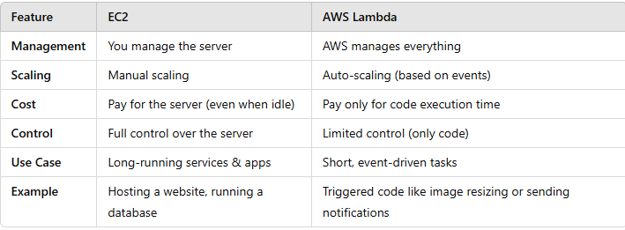

USE CASE OF AWS LAMBDA
AWS Lambda is super versatile, and it can be used for many different tasks. Here are some simple use cases to help you understand how AWS Lambda can make your life easier:
1. Image or Video Processing:
- Example: Whenever someone uploads a photo to your website or cloud storage (like Amazon S3), Lambda can automatically resize the image to different sizes for web use.
- How: Lambda listens for the event (like a file upload) and runs your code to process the file.
2. Real-Time File Processing:
- Example: Suppose you have a system where people upload logs or CSV files. Lambda can instantly process those files to extract important data, and even save results to a database or send a report.
- How: Lambda triggers automatically when the file is uploaded to an S3 bucket or placed in a queue, then processes it without needing any manual intervention.
3. Automatic Data Backup:
- Example: Imagine you need to automatically back up your data from one location to another. Lambda can copy data between storage services at scheduled times or in response to changes.
- How: Lambda can be triggered by events like file uploads or changes to a database, and it can automatically back up the new data.
4. Sending Notifications or Alerts:
- Example: When a specific event happens, like someone making a purchase or an error occurring in your system, Lambda can trigger an email or SMS notification.
- How: Lambda works with services like Amazon SNS (Simple Notification Service) to send alerts based on the events happening in your system.
5. Processing Real-Time Streaming Data:
- Example: Suppose you have sensors that send data in real-time. AWS Lambda can be used to process that data instantly, such as analyzing temperature readings and sending an alert if the temperature exceeds a certain threshold.
- How: Lambda integrates with services like Amazon Kinesis or Amazon DynamoDB Streams to process and respond to real-time data.
6. Web Application Backend:
- Example: Lambda can serve as the backend of a simple website or app. When users perform certain actions (like submitting a form or clicking a button), Lambda can process the request, interact with databases, and send a response.
- How: Lambda integrates with Amazon API Gateway, which lets users make HTTP requests that trigger Lambda functions.
7. Scheduled Tasks:
- Example: If you want a task to run regularly (like cleaning up old data or sending a daily summary), Lambda can run on a set schedule.
- How: You can use Amazon CloudWatch Events to schedule Lambda functions to run at specific times (e.g., every night at midnight).
8. Chatbots or Virtual Assistants:
- Example: You can use AWS Lambda to power simple chatbots or virtual assistants. For example, a customer might ask a bot for their order status, and Lambda can quickly look up the information from a database and reply.
- How: Lambda can work with services like Amazon Lex to understand and process the user’s request, without needing to manage any infrastructure.
9. Security Monitoring:
- Example: Lambda can be used to monitor security events, such as unauthorized logins or changes to sensitive data, and trigger security actions like blocking IPs or logging the event.
- How: Lambda can be triggered by services like Amazon CloudTrail (logs) or AWS Config, helping you keep your system secure by automating responses to potential threats.
10. Data Transformation:
- Example: Lambda can help convert data from one format to another. For instance, converting CSV data to JSON format for further analysis or reporting.
- How: Lambda processes the data when it's uploaded or received and transforms it before storing it in a database or sending it to another service.
11. Cron Jobs:
- Example: Instead of manually running scripts on a server, you can use Lambda to run periodic tasks, such as updating prices on an e-commerce site every hour or cleaning up old logs every day.
- How: Lambda can be scheduled using Amazon CloudWatch Events to run at specific intervals, just like cron jobs in traditional servers.
12. Serverless Webhooks:
- Example: If your app needs to integrate with third-party services (like GitHub or Stripe), Lambda can act as a webhook handler. For instance, when someone makes a payment on your site, Lambda can process the payment confirmation and update your database.
- How: Lambda is triggered by the webhook event (e.g., a payment is processed) and executes code to handle the response.
Conclusion:
In simple terms, AWS Lambda is perfect for automating tasks, responding to events, processing data, sending notifications, and handling backend operations—all without needing to manage any servers. Whether it’s resizing an image, sending an email, or processing real-time data, Lambda takes care of it instantly when needed. You only pay for what you use, making it both cost-efficient and scalable!
AWS Trigger Event
AWS Lambda functions can be triggered by various AWS services and external events. Here’s how you can set up triggers for an AWS Lambda function:

Step 1: Create a Lambda Function
- Log in to the AWS Management Console.
- Navigate to the Lambda service.
- Click on Create Function:
  - Choose Author from scratch.
  - Provide a function name.
  - Select a runtime (e.g., Python, Node.js, etc.).
  - Configure permissions as needed.

Step 2: Add a Trigger
- In the Function Overview section of the Lambda console, click on Add trigger.
- Select the service or event source that will trigger your Lambda function. Common triggers include:
  - API Gateway: For creating RESTful APIs.
  - S3: For events like object uploads or deletions.
  - DynamoDB: For stream-based events.
  - CloudWatch Events/Logs: For scheduled or monitoring-based events.
  - SNS/SQS: For messaging-based triggers.
  - EventBridge: For event-driven workflows.
- Configure the trigger:
  - For example, if you choose S3, specify the bucket name and event type (e.g., "Object Created").
  - For API Gateway, select whether you want a REST or HTTP API, and integrate it with your Lambda.
- Click Add to save the trigger configuration.

Step 3: Test the Trigger
- Create a test event:
  - In the Lambda console, go to the Test tab.
  - Click Create test event, and select a template matching your trigger source.
  - Customize the event payload if needed.
  - Click Save and Test.
- Verify the Lambda execution:
  - Check the Execution Results.
  - Navigate to CloudWatch Logs to inspect the logs and verify that your Lambda was triggered correctly.
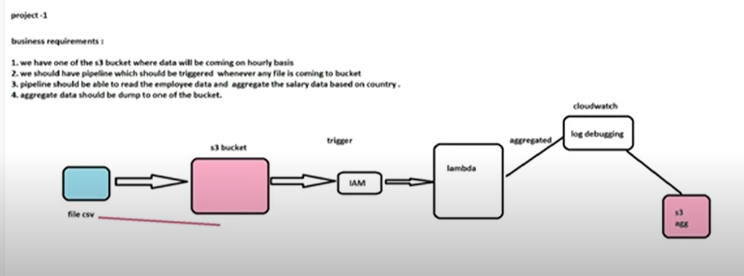
CloudWatch Logs
CloudWatch Logs is a service in AWS that helps you monitor, store, and access log files from your AWS resources like EC2, Lambda, or S3. It’s like a diary for your applications, storing all the important events or errors in one place.
- Why use it?
  - Track errors or unusual activity.
  - Monitor application performance.
  - Set alarms when something goes wrong (e.g., when errors increase suddenly).
- How it works:
  - Logs from services (like Lambda) are sent to Log Groups in CloudWatch.
  - Each Log Group contains Log Streams, which are like individual log files.

Roles in AWS
A Role is like a temporary identity in AWS that lets services or applications do specific tasks securely.
- Why Roles?
  - Imagine a Lambda function needs to read files from an S3 bucket. Instead of sharing your account credentials, you give the Lambda function a Role with permission to access only that S3 bucket.
- How it works:
  - Create a Role in AWS.
  - Attach permissions policies (rules about what the Role can do, like "read files from S3").
  - Assign the Role to a service (e.g., EC2 or Lambda).

Add Permission in AWS
Adding permissions means giving your AWS resource (e.g., a Lambda function or EC2 instance) access to do specific tasks.
- Steps to Add Permissions:
  - Go to IAM (Identity and Access Management) in the AWS Console.
  - Find the Role or User you want to update.
  - Click Add Permissions.
  - Select the required policy or create a new one. Example:
    - AmazonS3ReadOnlyAccess: Lets the resource read data from S3.
    - CloudWatchFullAccess: Allows full access to CloudWatch services.

Example
- A Lambda function is set up to process files in S3.
  - You create a Role with permissions:
"Read files from the S3 bucket".
  - Assign the Role to the Lambda function.
- CloudWatch Logs captures all Lambda errors or activities:
  - "Lambda processed 10 files successfully."
  - "Error: File not found."
By combining Roles, CloudWatch Logs, and Permissions, AWS ensures your resources work together securely and efficiently.

1. Code
In AWS, "Code" typically refers to the logic or script you write to run your applications or services.
- Example:
  - In AWS Lambda, "code" is the actual function you write (e.g., Python or Node.js) that performs tasks like processing data, sending emails, or interacting with a database.
  - You upload this code to Lambda, and it executes automatically when triggered.

2. Text
"Text" in AWS refers to input or content used in services.
- It could be:
  - Logs captured in services like CloudWatch.
  - Messages in SQS or SNS.
  - Configuration files in plain text uploaded to S3.
Think of it as any human-readable content that AWS processes or displays.

3. Monitor
"Monitor" in AWS means tracking the health and performance of resources (like servers, databases, or applications).
- AWS provides tools like CloudWatch to:
  - Keep an eye on metrics (e.g., CPU usage, memory, or errors).
  - Set alarms (e.g., alert you if a server goes down).
  - View logs for debugging.
Why important?
Monitoring helps ensure your applications run smoothly and lets you act quickly when issues arise.

4. Configuration
Configuration in AWS refers to settings and rules you define for resources.
- Examples:
  - In EC2, configuration includes instance type, storage size, and network settings.
  - In Lambda, configuration includes memory allocation, timeout limits, and environment variables.
Think of it as setting up the "behavior" of your resource to fit your application's needs.

5. Aliases
Aliases in AWS are friendly names for specific versions of your resources, usually Lambda functions.
- Why use aliases?
  - Make it easier to manage different environments (like development, testing, and production).
  - Instead of pointing directly to a specific version, you use an alias like prod or dev.
Example:
- Alias prod points to Lambda version 3 (your stable version for production).
- Alias dev points to Lambda version 5 (your latest for testing).

6. Versions
Versions in AWS track different iterations of your resources, usually in Lambda.
- Every time you make a change and publish your function, it creates a new version.
Why important?
- You can go back to an older version if something breaks.
- Allows testing new updates without affecting the existing stable version.
Example:
- Version 1: Your Lambda function sends emails.
- Version 2: Now it can also log data.
Both versions are stored, so you can roll back to Version 1 if needed.

Summary Example (Lambda Context):
- Code: A Python script that sends emails.
- Text: Log data (e.g., "Email sent to user@example.com").
- Monitor: CloudWatch tracks how many emails are sent and errors, if any.
- Configuration: The Lambda timeout is set to 30 seconds, with 128 MB memory.
- Aliases:
  - Alias prod points to Version 1 (stable release).
  - Alias test points to Version 2 (new functionality being tested).
- Versions:
  - Version 1: Sends basic emails.
  - Version 2: Adds logging for email delivery.

EC2 (ELASTIC COMPUTE CLOUD)
Amazon EC2 (Elastic Compute Cloud) is a service provided by Amazon Web Services (AWS) that allows you to run virtual computers in the cloud. In simple terms, it gives you the ability to create and manage servers over the internet, without needing to own physical hardware.
Here’s an easy-to-understand breakdown of EC2:
What is EC2?
EC2 allows you to rent virtual machines (VMs), called instances, to run applications and services. These instances are like regular computers, but they exist in Amazon’s cloud, and you can access them from anywhere.
Key Features of EC2:
- Elastic: EC2 is scalable, meaning you can increase or decrease the number of instances based on your needs. If your website gets more traffic, you can quickly add more instances to handle it. This flexibility is known as elasticity.
- Compute Power: EC2 gives you the power of compute capacity (processing power). You can choose how powerful your virtual machine should be, depending on the task you want to run.
- On-Demand: You only pay for the computing power you use. If you need an instance for a few hours, you pay for those few hours. This is great for startups and small businesses as it cuts down on upfront costs.
- Variety of Instances: There are different types of instances that are optimized for various tasks:
  - General purpose: For normal applications.
  - Compute optimized: For CPU-intensive tasks (like running simulations).
  - Memory optimized: For memory-heavy applications (like databases).
  - Storage optimized: For high storage needs (like big data applications).
- Customizable: You can choose the operating system (Linux, Windows, etc.), storage type, security settings, and more when setting up an EC2 instance. It gives you a lot of control over your server's configuration.
How EC2 Works:
- Launch an Instance: You start by launching an EC2 instance, which is basically setting up a virtual server. You can select from pre-configured templates or choose your own settings, like the type of instance (small or large), operating system (Linux, Windows), and storage options.
- Access Your Instance: Once your EC2 instance is running, you can access it remotely via the internet. For Linux instances, you typically connect using SSH (secure shell), and for Windows instances, you can use Remote Desktop Protocol (RDP).
- Store Data: EC2 instances can be connected to cloud storage services like Amazon S3 or Amazon EBS (Elastic Block Store) to store data that needs to persist beyond the instance’s life cycle.
- Scaling: You can adjust the size or number of instances running depending on your needs. For example, if your website gets more visitors, you can automatically launch more EC2 instances to handle the load. This process is often automated using Auto Scaling.
- Security: You can control who accesses your EC2 instance using Security Groups (firewall rules) and Key Pairs (for secure login). AWS also provides options for encryption and other security measures.
Use Cases for EC2:
- Web Hosting: EC2 can be used to host websites and web applications. It scales easily to handle sudden spikes in web traffic.
- Running Applications: You can use EC2 to run software applications, from small tools to large enterprise-level applications.
- Data Processing: For data analysis, simulations, or running machine learning models, EC2 provides the compute power needed.
- Backup Servers: You can set up EC2 instances as backup servers or for disaster recovery.
Example:
Imagine you are running an online store. Normally, your website gets a few visitors each day. But during a special sale, you expect a large number of visitors. You can use EC2 to quickly add more virtual servers to handle the increased traffic. Once the sale is over, you can remove the extra servers, saving costs.
Conclusion:
Amazon EC2 is a flexible, scalable, and cost-effective solution for running virtual servers in the cloud. Whether you’re hosting a simple website or running a complex application, EC2 provides the compute resources needed to scale and grow, with the added benefit of paying only for what you use.

COLLECTION (Moving data into AWS)
- Real Time- Immediate Action
- Kinesis Data Streams (KDS)
- Simple Queue Services (SQS)
- Internet of things (IoT)
- Near-Real Time- Reactive Actions
- Kinesis Data Firehose (KDF)
- Database Migration Service (DMS)
- Batch-Historical Analysis
- Snowball
- Data Pipeline

AWS KINESIS OVERVIEW
- Kinesis is a managed alternative to Apache Kafka
Yes, Amazon Kinesis is considered a managed alternative to Apache Kafka for real-time data streaming and processing. Both Kinesis and Kafka serve the purpose of handling large volumes of streaming data, but there are key differences in how they operate and their use cases.

Amazon Kinesis:
Amazon Kinesis is a fully managed service provided by AWS that allows you to collect, process, and analyze real-time data streams. It is designed to simplify the process of building applications that work with streaming data. Kinesis is great for application logs, metrics, IoT, clickstreams. Kinesis is great for real time big data. It is great for streaming processing frameworks (Spark, NiFi etc..). In kinesis Data is automatically replicated synchronously to 3AZ which means In Amazon Kinesis, your data is automatically copied to three different Availability Zones (AZs) within the same region at the same time. This ensures that your data is safe and highly available, even if one AZ experiences an issue.
Key Features:
- Fully Managed: No need to worry about infrastructure setup, scaling, or maintenance.
- Integration with AWS Ecosystem: Seamlessly integrates with other AWS services like Lambda, S3, Redshift, and EMR.
- Pay-as-You-Go: You only pay for the data you stream and process.
- Subcomponents:
  - Kinesis Data Streams: Real-time streaming of data.
  - Kinesis Data Firehose: Automatically loads streaming data into AWS services like S3, Redshift, or Elasticsearch.
  - Kinesis Data Analytics: Allows SQL-based real-time analysis of streaming data.
• Logs:
Logs are records of events or actions that occur in your systems, applications, or devices. For example, when a user logs in, an error happens, or a server starts, a log entry is created. AWS services like CloudWatch collect and monitor these logs to help track activity and troubleshoot issues.
• Metrics:
Metrics are numerical measurements of performance or activity over time, like the CPU usage of a server, the number of active users, or the speed of a network. AWS helps you collect, analyze, and visualize these metrics using tools like CloudWatch.
• IoT (Internet of Things):
IoT involves devices like smart sensors, cameras, or thermostats that connect to the internet to send or receive data. AWS IoT Core helps manage this data in real-time, enabling applications like monitoring a smart home or controlling industrial machines.
• Clickstreams:
Clickstreams are records of user actions on a website or app, like which buttons they click, pages they visit, or items they view. AWS services can process this data in real-time to improve user experiences or target ads.
• Real-Time Streaming Data:
This refers to data that is continuously generated and needs to be processed as it arrives. Examples include stock prices, weather updates, or live game scores. AWS offers services like Kinesis and MSK to handle this real-time data efficiently.

Apache Kafka:
Apache Kafka is an open-source distributed event streaming platform. It’s highly customizable but requires significant effort to set up and maintain. It’s ideal for organizations needing more control over their streaming system.
Key Features:
- Highly Configurable: Offers fine-grained control over clusters, topics, and partitions.
- Open-Source: No licensing costs; community-supported.
- Broad Ecosystem: Includes Kafka Streams for stream processing and Kafka Connect for integrations.
- Requires Management: You need to manage scaling, fault tolerance, and updates unless you use a managed service like Confluent Cloud.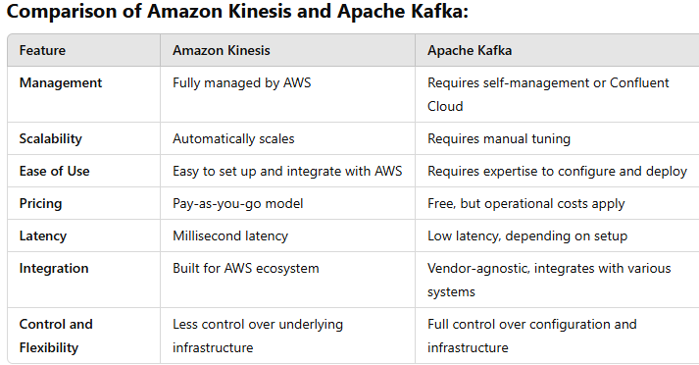

When to Choose Amazon Kinesis:
  - You want a fully managed service and don’t want to deal with infrastructure management. That means If you don’t want to worry about setting up or maintaining servers, Kinesis is managed by AWS for you.
  - You need seamless integration with AWS services like S3, Lambda, or Redshift. If you already use AWS services (like S3 for storage, Lambda for processing, or Redshift for analytics), Kinesis integrates easily with them.
  - You have dynamic workloads and require on-demand scaling. Kinesis can automatically adjust to handle sudden increases or decreases in data flow without much effort.
  - You prefer a pay-as-you-go pricing model with no upfront costs. You only pay for what you use, so there’s no need to pay upfront or commit to big expenses.

- When to Choose Apache Kafka:
  - You need complete control over your streaming system, including custom configurations. If you need to fine-tune or control every detail of your streaming system (e.g., settings, performance), Kafka gives you that flexibility.
  - You want a vendor-agnostic solution that works outside the AWS ecosystem. If you don’t want to be locked into AWS and need a tool that works across different environments (cloud providers, on-premises, etc.), Kafka is a better choice.
  - Your organization has the expertise and resources to manage Kafka clusters or you’re using a managed service like Confluent Cloud. If your team knows how to manage Kafka or you use a managed service like Confluent Cloud, Kafka can be a great option for more advanced use cases.

- Kinesis is great for application logs, metrics, IoT, clickstreams
Amazon Kinesis is perfect for handling real-time data streams like:
- Application Logs: Tracks what's happening inside apps (e.g., errors or activities).
- Metrics: Monitors performance data like CPU usage or server health.
- IoT: Manages data from devices like sensors, smart gadgets, or machines.
- Clickstreams: Captures user actions on websites (e.g., clicks, scrolls).
In short, Kinesis helps you process live data instantly, so you can react fast, like identifying trends or fixing issues.

- Kinesis is great for real time “big data”
- Kinesis is great for streaming processing frameworks (Spark, NiFi etc.)
- In Kinesis Data is automatically replicated synchronously to 3AZ:
In Amazon Kinesis, your data is automatically copied to three different Availability Zones (AZs) at the same time. This ensures that your data is always safe, highly available, and protected from failures in any single zone.

There are 3 types of Kinesis
  - Kinesis Streams: Low latency streaming ingests at scale.
  - Kinesis Analytics: Perform real-time analytics on stream using SQL.
  - Kinesis Firehose: Load streams into S3, RedShift, Elastic Search, & Splunk.
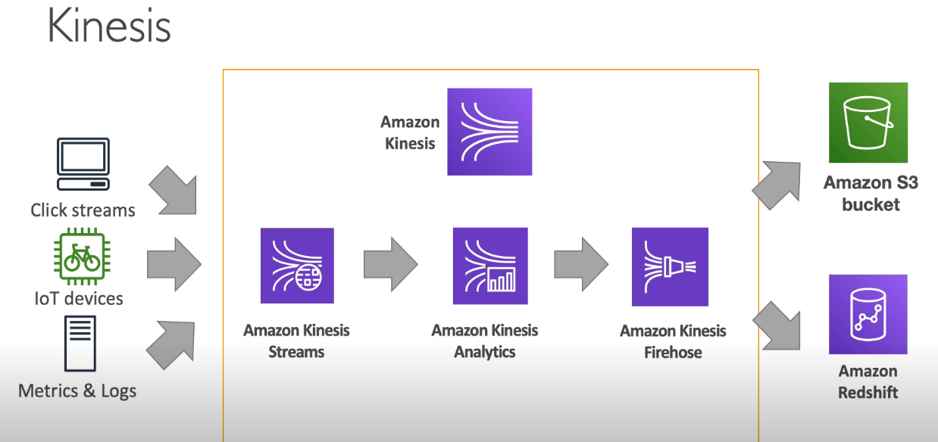
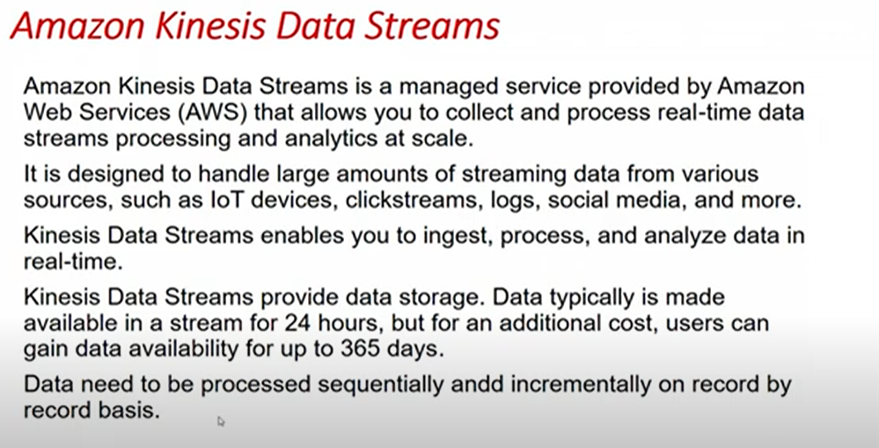
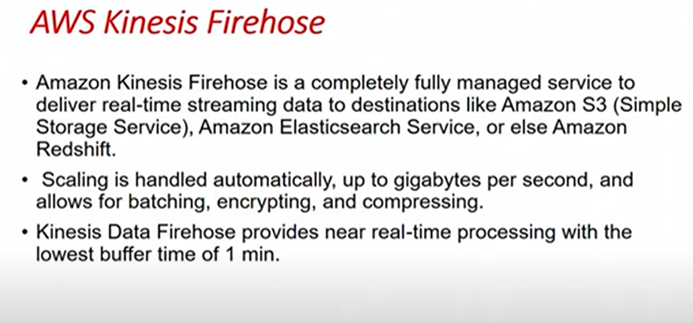
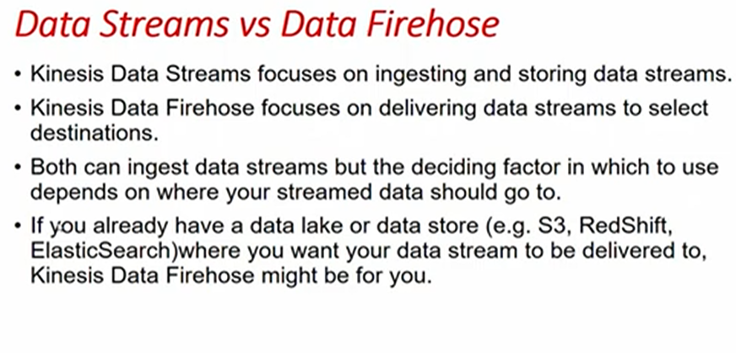
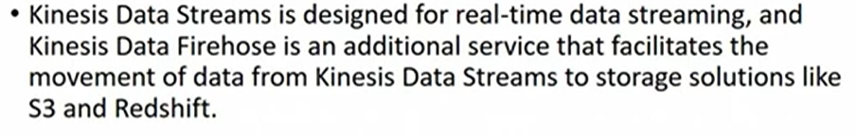

Kinesis Stream Overview
- Streams are divided in ordered shards/Partitions: Data is split into small, ordered pieces (shards) to manage efficiently.
Streams Have Shards: A stream is divided into smaller parts called shards to organize and manage data better.
Billing by Shard: You pay based on how many shards you use. You can add as many shards as needed.
Batching or Message Calls: Data can be sent in groups (batching) or one at a time (message calls).
Change Shards Over Time: Shards can be split (reshard) or combined (merge) as your needs change.
Ordered Data in Shards: Data in each shard is always stored in order.
In short, shards help organize, scale, and process your data streams efficiently.

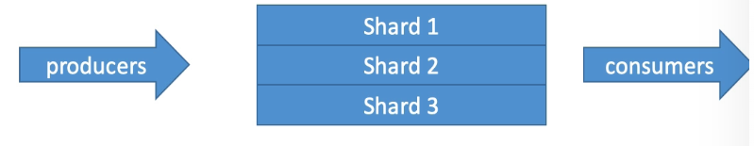
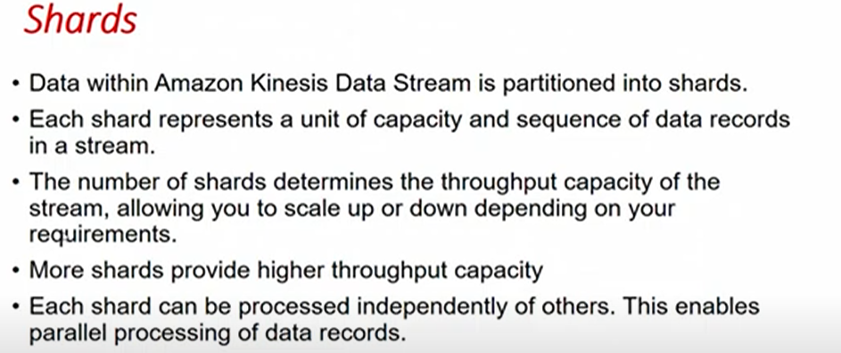
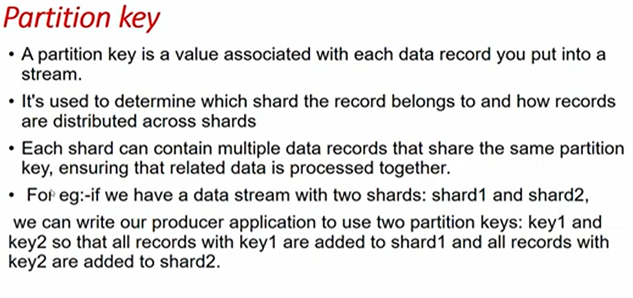
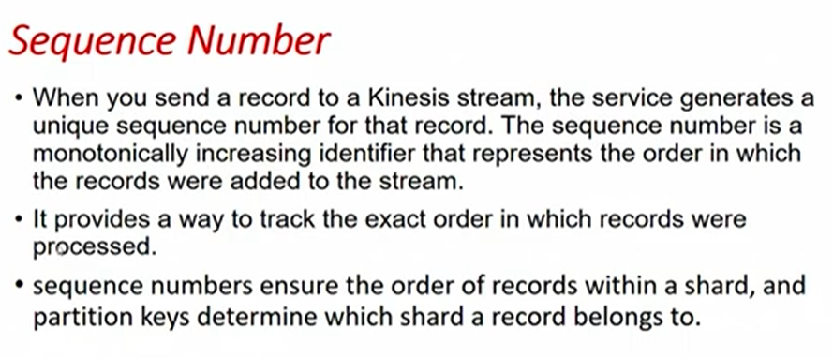
- Data retention in 24 hours by default and can be extend up to 7 days: Data is stored for 24 hours by default but can be kept for up to 7 days.
- Ability to reprocess and replay the data: You can access and process old data again if needed.
- Multiple applications can consume the same stream: Different apps can read and use the same data stream simultaneously.
- Real-time processing with scale of throughput: Handles data instantly and can scale to handle large amounts of data.
- Once data is inserted in Kinesis, it can’t be deleted (immutable)

In short, Kinesis Streams make it easy to process, store, and re-use live data quickly and efficiently.

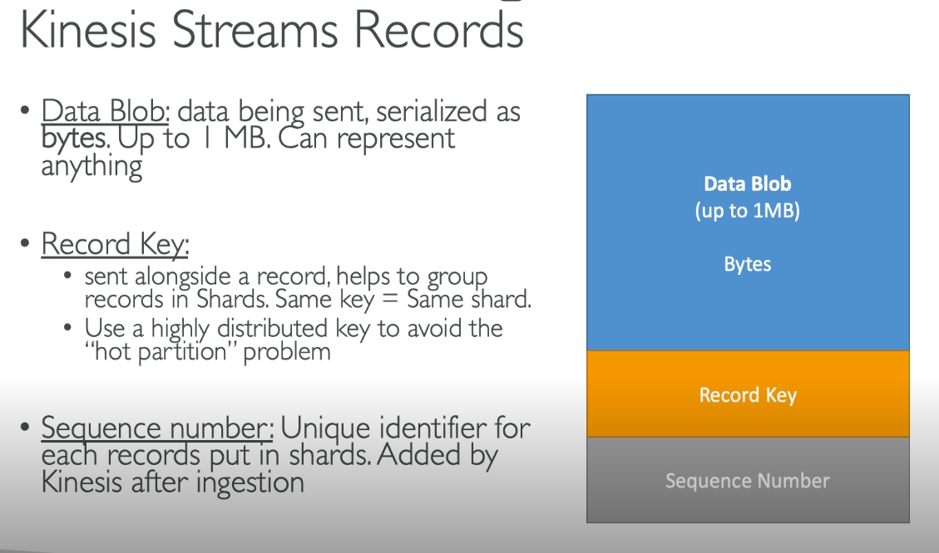
This diagram explains how Kinesis Streams Records are structured and how they work with shards in Amazon Kinesis. Let’s break it down in simple terms:
- Data Blob (Blue Section):
  - This is the actual data being sent to Kinesis. Think of it as the "payload" of your record.
  - The size of the data blob can be up to 1 MB.
  - It can represent anything—logs, sensor data, events, etc.

- Record Key (Orange Section):
  - The record key is an extra piece of information you attach to a record.
  - It’s used to group records into specific shards. If two records have the same key, they will always go to the same shard.
  - Why this matters: If one shard receives too much data (a "hot partition"), performance can drop. To avoid this, you should use a well-distributed key (e.g., hashing user IDs).
- Sequence Number (Gray Section):
  - This is a unique number assigned by Kinesis to each record after it’s ingested into a shard.
  - The sequence number helps you track the order of records within the shard.
Relationship to Shards:
- Shards are like lanes in a highway, and each record needs to be routed to the right lane (shard).
- The record key decides which shard the data will go to.
- If you don't manage the record key properly, one shard can get overloaded (hot partition problem), while others remain underused.
Example:
Imagine you’re streaming data from sensors in a factory:
- Data Blob: Sensor readings (e.g., temperature, pressure).
- Record Key: Sensor ID (so all data from the same sensor goes to the same shard).
- Sequence Number: Assigned by Kinesis to maintain the order of readings from each sensor.
By structuring the data this way, Kinesis ensures the data is organized and processed efficiently.

KINESIS DATA STREAM LIMITS TO KNOW
- PRODUCER
  - 1 MB/s or 1000 messages/s at write per Shard.
  - “ProvisionedThroughputException” otherwise.
- CONSUMER CLASSIC
  - 2MB/s at read per shard across all consumers.
  - 5 API call per second PER SHARD across all consumers.
- Consumer Enhanced Fan-Out
  - 2MB/s at read PER SHARD, PER ENHANCED CONSUMER.
  - No API call needed (Push model)

- Data Retention
  - 24 hours data retention by default
  - Can be extended to 7 days.
API Call: An API call in AWS is like sending a command to AWS to perform a specific task or action.
For example:
- When you tell AWS to create a server (EC2 instance), list files in storage (S3), or fetch data from a database (DynamoDB), you are making an API call.
Think of it like this:
- You ask: "Hey AWS, create a new server for me!"
- AWS responds: "Sure, your server is ready."
These commands are sent over the internet using AWS's Application Programming Interface (API).
In short: API calls are requests you make to AWS to do something for you.
Amazon Kinesis Data Streams allows you to capture and process real-time data. There are limits that you need to know from both the Producer (the one sending data) and Consumer (the one reading data) perspectives.
1. Producer (The Sender):
From the producer perspective, you’re the one sending data into the Kinesis stream. Here are the key limits you should know:
a) Shard Limit:
A shard is the basic unit of throughput in Kinesis. When you create a stream, you define how many shards it should have, and this determines how much data can be pushed to the stream.
- Ingest (Write) Limit: Each shard allows you to send:
  - 1,000 records per second (1,000 individual pieces of data) OR
  - 1 MB per second of data (whichever limit you reach first).
So, if you're pushing lots of data, you need to add more shards to handle higher throughput.
- Record Size:
  - Each record (a single unit of data) sent into the stream can be up to 1 MB in size. If your record exceeds this, you need to split the data or reduce the size.
- Put Records:
  - When sending data, a "PutRecord" request is used for sending one record at a time.
  - A "PutRecords" request allows you to send multiple records in a batch (up to 500 records at once), but the total size of these records should not exceed 5 MB.
b) Data Retention:
- By default, data in Kinesis Data Streams is kept for 24 hours. After this period, the data is automatically deleted.
- You can extend the retention period to 7 days if needed, which means your data will stay available longer for consumers to read.
c) Shard Scaling:
- If you need to handle more data, you can increase the number of shards in the stream. More shards mean higher capacity for data ingestion.
- You can also split or merge shards to adjust for the load. For example, if your data volume decreases, you might want to reduce the number of shards.
2. Consumer (The Receiver):
From the consumer perspective, you’re the one reading or processing the data that the producers have sent into the Kinesis stream. Here are the key limits for consumers:
a) Read (Transaction) Limits:
- Each shard allows consumers to perform up to 5 read transactions per second.
  - A read transaction happens when a consumer reads data from the stream (e.g., pulling the latest records).
- Read Throughput:
  - Each shard allows up to 2 MB per second to be read by consumers.
  - If your consumers need more data than this, you can add more shards to the stream.
b) Number of Consumers:
- You can have multiple consumers reading from the same Kinesis stream. Each consumer will read from the stream independently, and each will have the same set of data to process.
c) Consumer Types:
There are different ways consumers can access data from the stream:
- Classic Consumers: These are traditional consumers that use the Kinesis API directly to read from the stream.
- Enhanced Fan-Out: This is a feature that allows consumers to read from the stream with dedicated throughput (up to 2 MB per second per consumer). This avoids throttling between multiple consumers.
d) Processing Data:
Consumers process the data by reading records in a shard iterator. A shard iterator is a pointer to a specific record within a shard. It moves forward as data is read, ensuring that consumers process records in sequence.
Key Summary of Limits:
Producer Side:
- Shards: Each shard can handle 1,000 records/second or 1 MB/second.
- Record size: Each record can be up to 1 MB in size.
- Write Requests: Use PutRecord (one record) or PutRecords (up to 500 records in one request, but not exceeding 5 MB).
- Retention: Data is stored for 24 hours, extendable to 7 days.
Consumer Side:
- Read Transactions: 5 read transactions/second per shard.
- Throughput: 2 MB/second per shard for reading.
- Multiple Consumers: You can have multiple consumers reading from the stream at the same time.
- Enhanced Fan-Out: Allows dedicated throughput for each consumer (2 MB/second per consumer).
In Simple Terms:
- Producer: If you're sending data, you can send a lot of data, but how much depends on the number of shards you have. If you have more shards, you can send more data.
- Consumer: If you're reading data, you can read up to 2 MB/second from each shard. If you need to read more, you need more shards or use Enhanced Fan-Out.
By understanding these limits, both producers and consumers can adjust their usage and ensure that they don't exceed the capacity of the stream, which could cause delays or data loss.
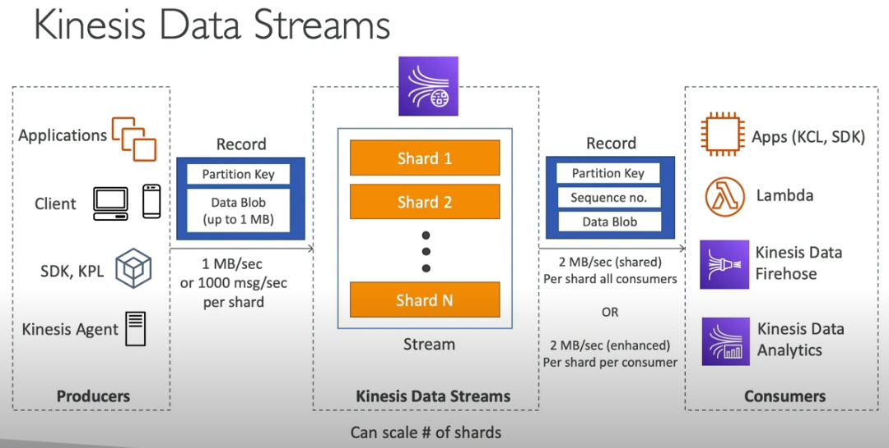

FEATURES OF KINESIS DATA STREAMS
  - Retention between 1 day – 365 days.
  - Ability to reprocess (replay) data.
  - Once data is inserted in Kinesis, it can’t be deleted (immutability).
  - Data that shares the same partition, goes to the same shard (ordering).
  - Producers: AWS SDK, Kinesis Producer Library (KPL), Kinesis Agent.
  - Consumers:
- Write your own: Kinesis Client Library (KCL), AWS SDK.
- Managed: AWS Lambda, Kinesis Data Firehose, Kinesis Data Analytics.
KINESIS DATA STREAMS – CAPACITY MODES
- Provisioned Modes:
- We chose the number of shards provisioned, scale manually or using API.
- Each shard gets 1MB/s in (or 1000 records per second).
- Each shard gets 2MB/s out (classic or enhanced-fan-out consumer).
- We pay per shard provisioned per hour.
- On – demand Mode:
- No need to provision or manage the capacity.
- Default capacity provisioned (4 MB/s in or 4000 records per second).
- Scaled automatically based on observed throughput peak during the last 30 days.
- Pay per stream per hour & data in/out per GB.
KINESIS DATA STREAM SECURITY
Kinesis Data Streams Security: Simplified Explanation
Amazon Kinesis Data Streams is a service that allows you to collect, process, and analyze real-time data. Here’s a breakdown of the security features in simple language:

1. Control Access/Authorization Using IAM Policies
- What it means: You can use AWS Identity and Access Management (IAM) to decide who can access your Kinesis Data Stream and what they can do with it (e.g., read, write, or delete data).
- Why it’s important: This ensures that only authorized users or applications can interact with the data in the stream, reducing the risk of unauthorized access.

2. Encryption in Flight Using HTTPS Endpoints
- What it means: Data sent to and from Kinesis Data Streams is encrypted while it's being transferred using HTTPS (a secure version of HTTP).
- Why it’s important: This protects the data from being intercepted by attackers while it’s traveling between your application and Kinesis.

3. Encryption at Rest Using KMS
- What it means: Data stored in the Kinesis Data Stream is encrypted using the AWS Key Management Service (KMS). KMS provides a secure way to encrypt and manage keys.
- Why it’s important: Even if someone gains access to your stored data, encryption ensures they can’t read it without the proper decryption key.

4. Client-Side Encryption/Decryption
- What it means: You can add an extra layer of encryption by encrypting your data before sending it to Kinesis and decrypting it after retrieving it. This is done on your side (client side).
- Why it’s important: This provides more control over encryption but is harder to implement because you need to manage encryption and decryption yourself.

5. VPC Endpoints for Private Access
- What it means: You can use Virtual Private Cloud (VPC) Endpoints to access Kinesis Data Streams securely without using the public internet.
- Why it’s important: This ensures the communication between your application and Kinesis stays within a private network, reducing the risk of exposure to external threats.

6. Monitor API Calls Using CloudTrail
- What it means: AWS CloudTrail records all API calls made to your Kinesis Data Streams (like who accessed it, what action they took, and when).
- Why it’s important: This helps you track and audit any suspicious or unauthorized activities, ensuring accountability.

Key Components in the Diagram
- Shards:
  - These are individual parts of the Kinesis Data Stream. Think of them like pipelines where data flows in real time.
  - Each shard handles a portion of the data.
- Encryption at Rest:
  - Data stored in the shards is encrypted using AWS KMS.
- Private Subnet and VPC Endpoint:
  - The EC2 instance communicates securely with the Kinesis Data Stream through a private network (VPC Endpoint).
- HTTPS Communication:
  - Data sent between the EC2 instance and Kinesis is encrypted during transit using HTTPS.

Why Kinesis Data Streams Security Matters
- It protects sensitive real-time data from unauthorized access and breaches.
- Provides multiple layers of encryption (in transit and at rest).
- Ensures secure and private communication through VPC.
- Enables accountability and tracking through CloudTrail.
This security ensures that your real-time data processing environment remains safe and reliable.

KINESIS PRODUCERS
Amazon Kinesis Producers are applications or services that send (or "produce") data to Amazon Kinesis data streams. They act as the starting point of the data pipeline, feeding the data streams with real-time information that can be processed or analysed further.
Key Components:
- Producer Applications:
These are the apps or services that generate data. Examples include:
  - IoT sensors sending temperature data.
  - Social media platforms sending user activity.
  - Log generators from servers or websites.
- Kinesis Producer Library (KPL):
A pre-built library provided by AWS that simplifies the task of sending data to Kinesis streams. It handles:
  - Data batching: Groups multiple records to optimize efficiency.
  - Retries: Automatically retries if data transmission fails.
  - Error handling: Detects and resolves issues during data transfer.
- AWS SDK:
An alternative to KPL, the AWS SDK allows developers to directly interact with Kinesis using programming languages like Python (via boto3) or JavaScript.
- Kinesis Agent:
A lightweight Java-based application installed on servers. It's a simple way to collect and send log files or system data.
These are the three main tools under Kinesis Producers that help send data to Amazon Kinesis Data Streams. Here's an easy and summarized explanation:
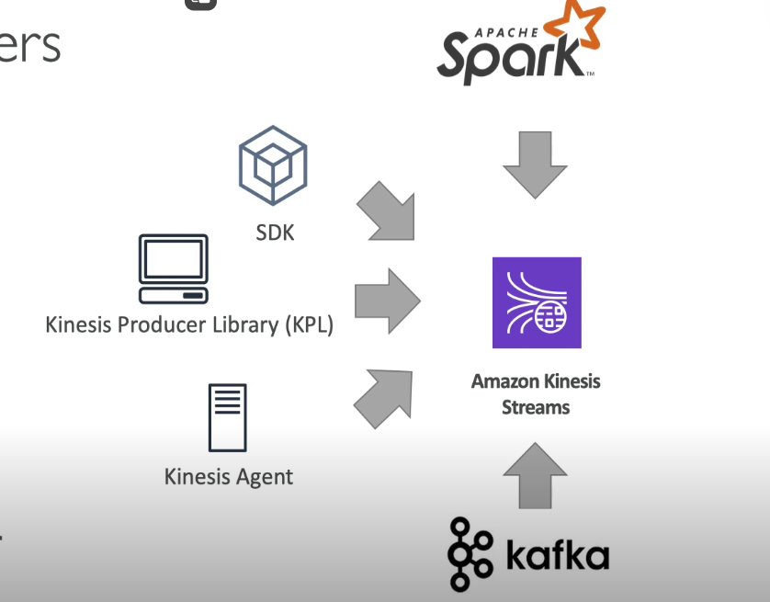

1. Kinesis SDK (Software Development Kit):
- What it is: A programming toolkit for developers to manually write code to send data to Kinesis streams. API that are used in Kinesis SDK are PutRecord (one) and PutRecords (many records)
Here's the simple difference:
- PutRecord:
  - Sends one piece of data (called a record) to the stream at a time.
  - You specify the data and an optional "partition key" to decide which shard it goes to.
- PutRecords:
  - Sends multiple pieces of data (records) to the stream in one go.
  - Useful when you have a batch of records to send together, which is faster and more efficient.
Think of PutRecord as mailing one letter and PutRecords as sending a bundle of letters in one package.

- How it works: You can use languages like Python (boto3), Java, or JavaScript to build custom solutions.
- Pros:
  - High flexibility to design custom workflows.
  - Direct integration with AWS APIs.
- Use Case: When you need fine-grained control over how data is sent or want to build advanced, customized producer applications. Producer SDK is used when there is low throughput, higher latency, simple API, AWS lambda.
Mangaed AWS sources for Kinesis data streams:
- Cloud Watch Logs
- AWS IoT
- Kinesis Data Analytics
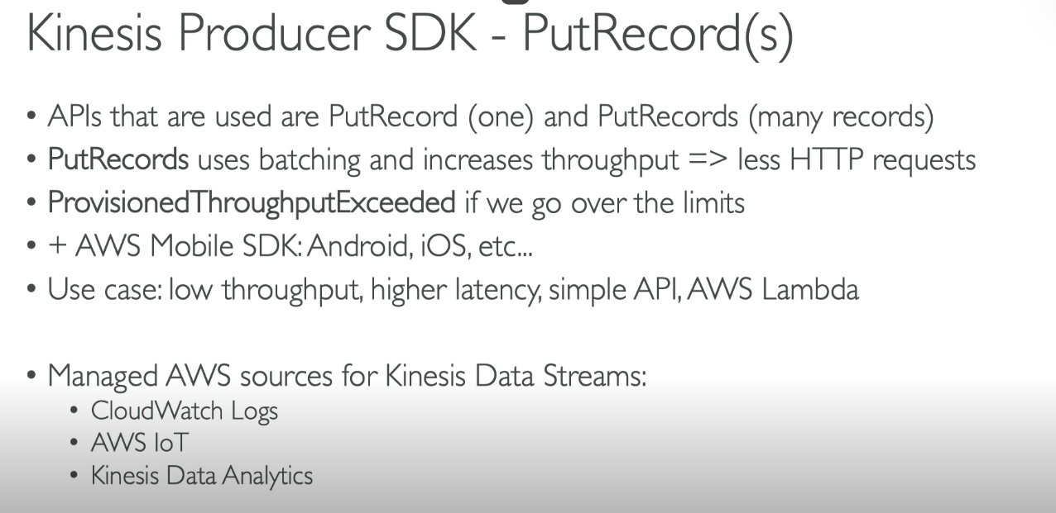
Here’s a simple summary of the points in the image:
- PutRecord and PutRecords:
  - PutRecord sends one record at a time to Kinesis.
  - PutRecords sends multiple records together in a batch, reducing the number of HTTP requests and improving performance.
- ProvisionedThroughputExceeded :
  - If you send data faster than the stream’s capacity, you might hit this error. It means the stream is overloaded.
- AWS Mobile SDK:
  - Tools for integrating Kinesis with mobile apps on platforms like Android and iOS.
- Use Case:
  - These APIs are suitable for applications with low data flow, higher latency tolerance, and simple use cases, such as AWS Lambda functions.
- Managed AWS Sources:
  - Kinesis can directly integrate with other AWS services like CloudWatch Logs (to stream log data), AWS IoT (for IoT data), and Kinesis Data Analytics (to analyze data in real-time).
This image explains how Kinesis handles data production and its integration with other AWS tools.
AWS KINESIS API- EXCEPTIONS
- Provisioned Throughput Exceed Expectations
- Happens when sending more data (exceeding MBs or TPS (Transactions Per Second) for any shard).
- Make sure you don’t have a hot shard (such as your partition key is bad and too much data goes to that partition key).
- Solutions
- Retries with backoff.
- Increase Shards (Scaling)
- Ensure your partition key is good one.

2. Kinesis Producer Library (KPL):
- What it is: A pre-built library by AWS that simplifies sending data to Kinesis streams.
- How it works:
  - Automatically batches small data records for efficiency.
  - Retries sending data if there's a network issue.
  - Optimizes throughput with less developer effort.
- Pros:
  - Handles complex tasks like data batching and retries for you.
  - Optimized for high-speed, real-time data streaming.
- Use Case: When you need a high-performance producer but don’t want to write complex code.
Some important point of KPL
- Easy to use and highly configurable C++/Java
- Used for building high performance and long running producers.
- Automated and configurable retry mechanism
- Synchronous or Asynchronous API (better performance for async)
- Submits metrics to CloudWatch for monitoring
- Batching (both turned on by default) – increase throughput, decrease cost:
- Collect records and write to multiple shards in the same Putrecord API call
- Aggregate – increased latency
Capability to store multiple records in one record (go over 1000 records per second limit)
Increase payload size and improve throughput (maximize 1MB/s limit)
- Compression must be implemented by the user
- KPL records must be de-coded with KCL or special helper library.

BATCHING
Batching in KPL means grouping multiple small data records together into a single, larger request before sending it to a Kinesis data stream. This helps optimize performance and reduce costs.

How It Works:
- Data Accumulation: KPL collects small records produced by your application.
- Batch Creation: Combines these records into a single request.
- Efficient Transmission: Sends the batch to Kinesis as one unit, reducing the number of requests.

Why Batching is Useful:
- Improves Performance: Fewer requests reduce overhead and improve throughput.
- Lowers Costs: AWS charges per request, so batching reduces the number of requests.
- Reduces Latency: By sending larger chunks of data at once, it minimizes delays.

Example:
If your app generates 100 small data records per second, instead of sending 100 requests, KPL batches them into 1-2 requests based on size, making the process faster and cheaper.

Key Point:
Batching in KPL is automatic, so developers don’t need to manually group records—it just works behind the scenes to optimize efficiency.

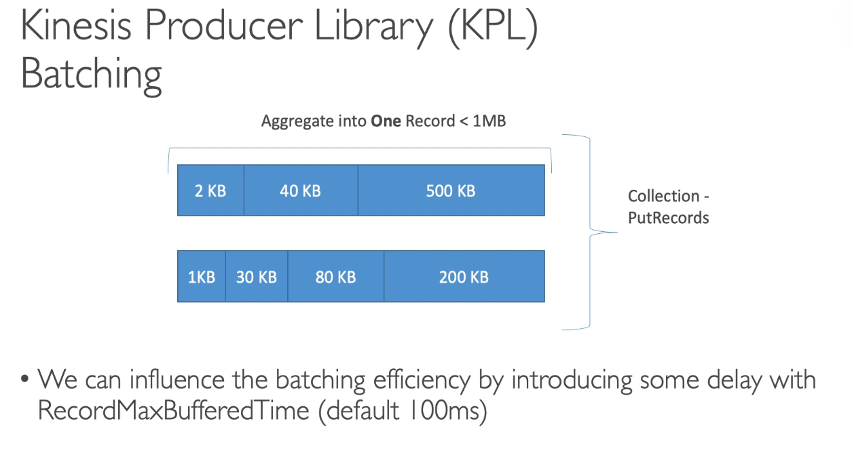
Record Max Buffered Time in the Kinesis Producer Library (KPL) is the maximum amount of time that a record can stay in the KPL's memory buffer before being sent to the Kinesis Data Stream.
Key Points:
- Purpose:
  - It helps the KPL batch multiple records together to improve efficiency and reduce the number of API calls to Kinesis.
- Default Value:
  - The default is 100 milliseconds (0.1 seconds). This means a record will wait up to 100ms in the buffer before being sent, even if the batch is not full.
- How It Works:
  - If enough records are collected before the max buffer time is reached, they are sent immediately.
  - If not, the records are sent after the max buffer time expires, ensuring no unnecessary delay.
- Tuning:
  - A lower value reduces latency but increases API calls.
  - A higher value improves batching efficiency but might increase the time taken for a record to reach the stream.
Example:
If Record Max Buffered Time is set to 500ms, a record will wait up to 0.5 seconds in the buffer. During that time, the KPL tries to gather other records to send as a batch. After 0.5 seconds, the record is sent, even if the buffer isn’t full.

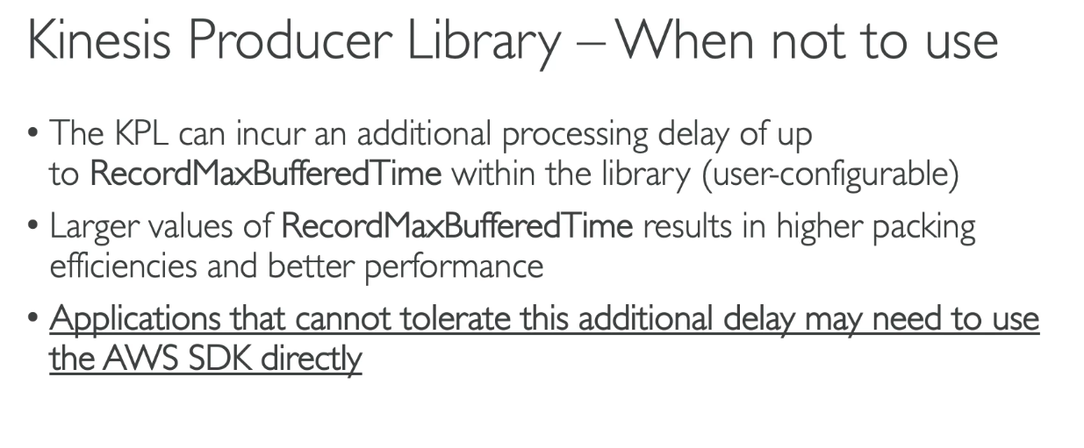

3. Kinesis Agent:
- What it is: A lightweight app installed on servers to collect and send data to Kinesis streams.
- Install in Linux – based server environments.
- JAVA – based agent, built on top of KPL.
- How it works:
  - Automatically reads data from sources like log files.
  - Sends the data in real-time to Kinesis.
  - Easy to configure with minimal coding required.
- Pros:
  - Simple setup and use.
  - Best for collecting system logs or server data.
- Use Case: When working with server logs or system metrics and need an easy, automated solution.

SOME IMPORTANT POINTS OF KINESIS AGENT
- Monitor log files and sends them to Kinesis Data Streams
- Java-based agent and built on top of the KPL.
- Install in Linux based server environments.
FEATURES:
- Write from multiple directories and write to multiple streams.
- Routing feature based on directory / log file.
- Pre-process data before sending to streams (csv to Json, single line, log to Json..).
- The agent handles the file rotation, checkpointing and retry upon failures.
- Emits metrics to CloudWatch for monitoring.

AWS Kinesis API – Exceptions
- Provisioned ThroughPut exceeded exceptions
- Happens when sending more data (exceeding MB/s or TPS for any shard)
- Make sure you don’t have a hot shard (such as your partition key is bad and too much data goes to that partition).
Solutions:
- Retries with backoff
- Increase shards (scaling)
- Ensure your partition key is good one.

KINESIS AGENT
- Monitor Log files and sends them to Kinesis Data streams.
- Kinesis Agent is JAVA based agent, built on top of KPL.
- It can only be installed in Linux-based server environments
KINESIS AGENT FEATURES
- Write from multiple directories and write to multiple streams.
- Routing feature based on directory / log file.
- Pre-process data before sending to streams (single line, csv to Json, logs to Json..).
- The agent handles file rotation, checkpointing, and retry upon failures.
- Emits metrics to CloudWatch for monitoring.

KINESIS CONSUMER – CLASSIC
- KINESIS SDK
Key Points:
- Shards and Data Throughput:
  - Each shard in Kinesis Data Streams can handle 2 MB per second of data (aggregate throughput).
  - Multiple consumer applications can read data from the same shard.
- GetRecords API:
  - Consumers use the GetRecords () API to retrieve data from the shards.
  - Each GetRecords call can:
    - Return up to 10 MB of data or 10,000 records at a time.
    - If these limits are hit, the API throttles for 5 seconds before allowing another call.
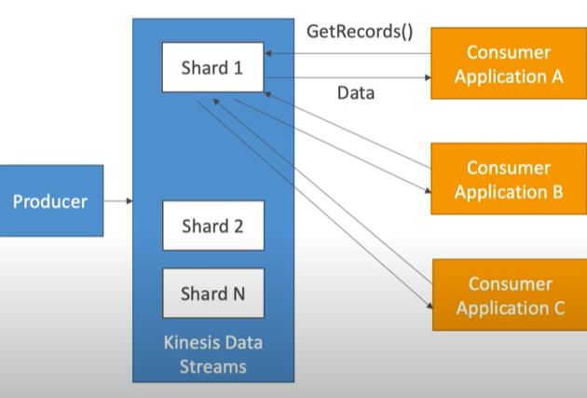
- Rate Limits:
  - Each shard allows up to 5 GetRecords API calls per second, meaning there’s a 200 ms latency between calls.
  - If multiple consumers (e.g., A, B, and C) share the same shard:
    - They need to split the throughput. For instance, if 5 consumers are reading from the same shard, each can only get 400 KB/s on average.
- Polling Mechanism:
  - Consumer applications poll (request data) from shards to process it.
  - Sharing a shard among multiple consumers reduces the data each consumer can retrieve.

How It Works in Practice:
- A producer sends data to Kinesis Data Streams, distributing it across multiple shards.
- Consumer applications (like A, B, and C) use the GetRecords API to fetch this data from the shards.
- Depending on the number of consumers and shards, data retrieval speeds and throughput are divided among the consumers.

Example in Simple Terms:
- Think of a shard as a water tap with a flow of 2 liters per second (2 MB/s).
- If one person (consumer) uses the tap, they get all the water.
- If 5 people share the tap, each gets less water (about 400 milliliters per second).
- If someone takes too much water (e.g., more than 10 liters at once), the tap pauses for a while before allowing more water to flow.

This mechanism ensures data is delivered efficiently, even with multiple consumers.

- KINESIS CLIENT LIBRARY (KCL)
- Multi-Language Support:
Initially developed for Java but now supports other languages like Python, Golang, Ruby, Node.js, and .NET.
- De-Aggregation:
Reads data from Kinesis streams produced by KPL and separates batched records.
- Shard Sharing:
Allows multiple consumers to share and process data from multiple shards within the same consumer group.
- Checkpointing:
Tracks progress in data processing, allowing consumers to resume from the last processed record if interrupted.
- DynamoDB Integration:
Uses DynamoDB for coordination and checkpointing, with one DynamoDB row per shard for tracking.
- Capacity Provisioning:
Requires sufficient Write Capacity Units (WCUs) and Read Capacity Units (RCUs) in DynamoDB to handle the processing load.
- Record Processors:
Dedicated components in KCL that process data records from shards.

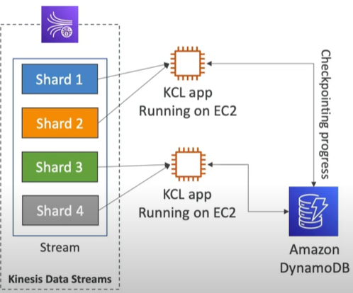
This diagram shows how AWS Kinesis Client Library (KCL) works with Kinesis Data Streams, EC2 instances, and Amazon DynamoDB. Here's a simple explanation:

Key Components:
- Kinesis Data Streams:
  - The stream is divided into multiple shards (like lanes in a highway).
  - Each shard holds part of the data flowing into the stream.
- KCL App:
  - A program running on EC2 instances (virtual servers).
  - These apps read data from the shards of the Kinesis stream.
  - Multiple KCL apps can run simultaneously to process data faster.
- Amazon DynamoDB:
  - A database used to track progress (checkpointing).
  - It remembers which part of the data the KCL app has already processed so it doesn’t repeat.

How It Works:
- Data in Shards:
  - The Kinesis stream splits incoming data into different shards (e.g., Shard 1, Shard 2, etc.).
- KCL App Reading Data:
  - A KCL app is deployed on an EC2 instance.
  - Each KCL app reads data from one or more shards.
  - For example:
    - One KCL app reads Shard 1 and Shard 2.
    - Another KCL app reads Shard 3 and Shard 4.
- Checkpointing in DynamoDB:
  - As KCL apps process data, they save their progress (called checkpointing) in DynamoDB.
  - This ensures:
    - If an app crashes, it knows where to restart.
    - Multiple apps don’t process the same data twice.

Why This Design?
- Parallel Processing: Splitting data into shards allows multiple KCL apps to work in parallel, making it faster.
- Resilience: Checkpointing ensures progress is saved even if there’s a failure.
- Scalability: You can add more shards or KCL apps as the amount of data grows.

In Simple Terms:
Think of this as a factory assembly line:
- Kinesis shards are like different conveyor belts with raw materials (data).
- KCL apps are workers picking and processing items from the conveyor belts.
- DynamoDB is the supervisor noting which items each worker has finished, so work is not repeated.

Key Benefit:
KCL simplifies managing shard coordination, record processing, and fault tolerance for Kinesis stream consumers.

- KINESIS CONNECTOR LIBRARY
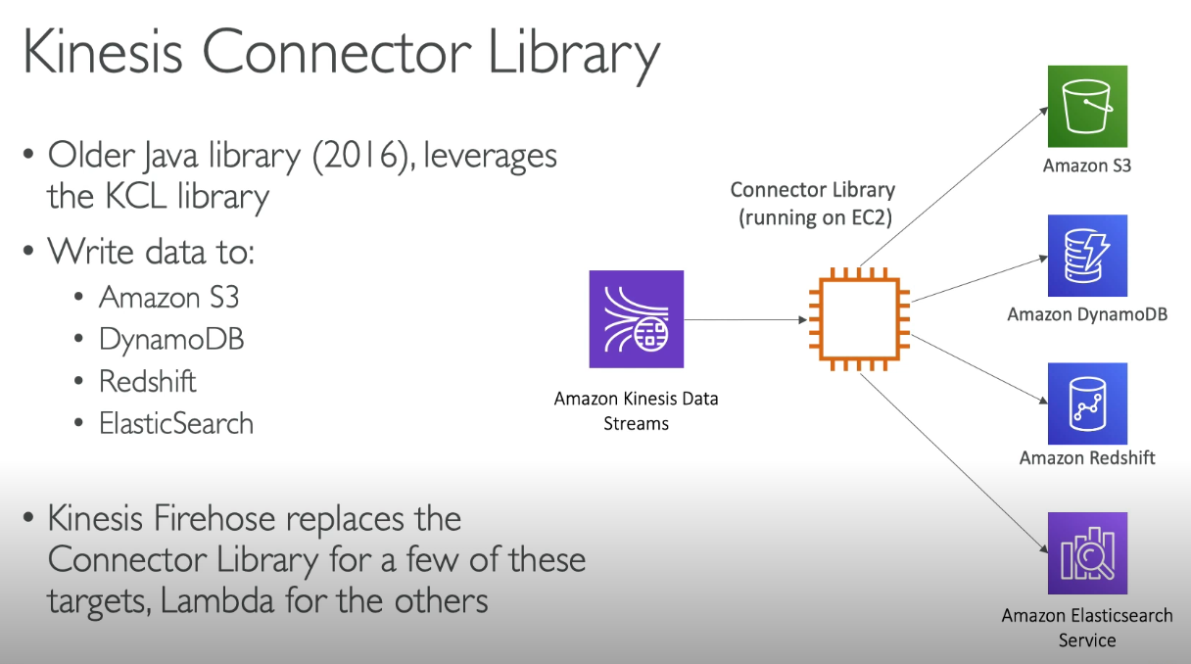
- 3rd PARTY LIBRARIES: Spark, Log4J, Appenders, Flume, Kafka
- KINESIS FIREHOSE
- AWS LAMBDA
- AWS Lambda can source records from Kinesis Data Streams.
- Lambda Consumer has a library to de-aggregate record from the KPL.
- Lambda can be used to run lightweight ETL to:
    - Amazon S3
    - Dynamo DB
    - Redshift
    - Elastic Search
- Lambda can be used to trigger notifications / send email in real time.
- Lambda has a configurable batch size (more in Lambda section)

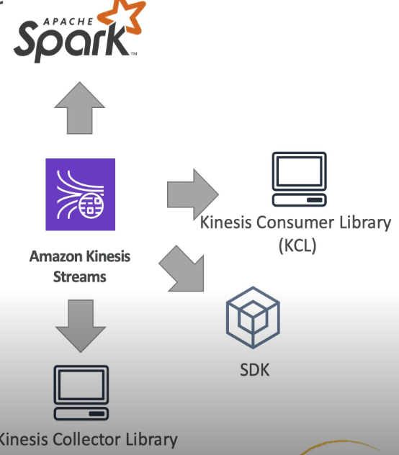
AWS LAMBDA SOURCIG FROM KINESIS
- AWS Lambda can source records from Kinesis Data Streams.
- Lambda consumer has a library to de – aggregate record from the KPL.
- Lambda can be used to run the Light weight ETL to:
- Amazon S3
- Dynamo DB
- RedShift
- Elastic Search
- Anywhere you want
- Lambda can be used to trigger notifications / send emails in real time.

KINESIS ENHANCED FAN OUT
Kinesis Enhanced Fan-Out (EFO) is a feature that improves data delivery to multiple consumer applications in real-time.

How It Works:
- Dedicated Data Streams:
Each consumer gets its own private connection to the Kinesis stream.
  - No shared bandwidth with other consumers.
  - Each consumer gets up to 2 MB/second per shard.
- Fast Data Delivery:
EFO delivers records to consumers immediately as they arrive in the stream (push model), reducing latency compared to the standard polling method.
- Unlimited Consumers:
Unlike the standard method where multiple consumers compete for the same shard bandwidth, EFO allows an unlimited number of consumers to independently process data without affecting each other.

Why Use EFO?
- High-Speed Applications: Ideal for real-time use cases like analytics, machine learning, or monitoring.
- No Data Sharing Limits: Each consumer can process up to 2 MB/s per shard without affecting others.
- Low Latency: Data is pushed directly to consumers, avoiding delays from polling.

Example Scenario:
Imagine a video streaming platform using Kinesis:
- Standard Fan-Out: All analytics and monitoring apps share the same bandwidth, slowing data delivery.
- Enhanced Fan-Out: Each app (e.g., viewer stats, error monitoring) gets its own fast connection, processing data instantly without competition.

Key Advantage:
EFO ensures fast, isolated, and scalable data delivery for multiple real-time applications.
ENHANCED FAN-OUT VS STANDARD CONSUMERS
STANDARD CONSUMERS:
- Low number of consuming applications (1,2,3..)
- Can tolerate ~200ms latency
- Minimize cost
Enhanced Fan-Out Consumers
- Multiple consumer application for same stream
- Low latency requirements ~70ms
- Higher costs
- Default limit of 5 consumers using enhanced fan-out data stream
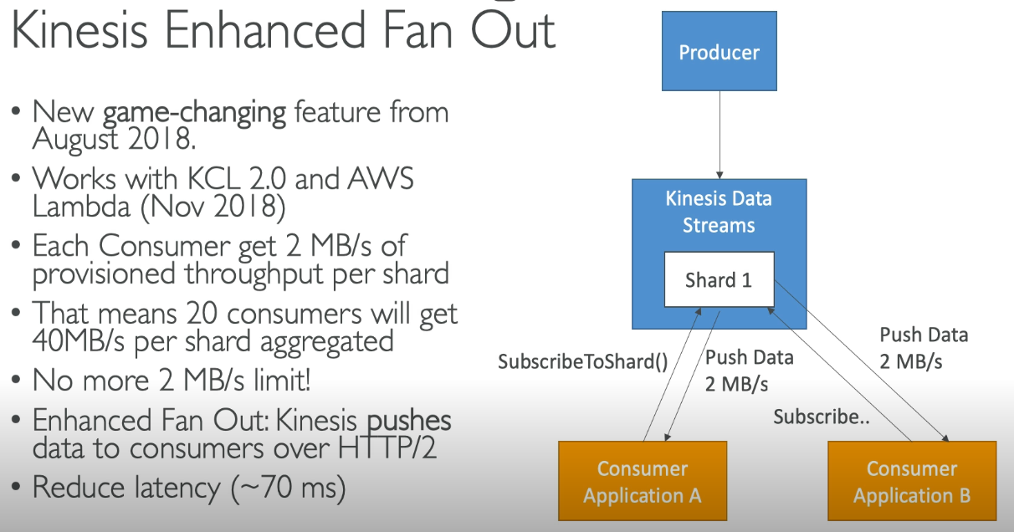

KINESIS OPERATIONS – ADDING SHARDS
- Also called ‘Shard Splitting’.
- Can be used to increase the stream capacity (1MB/s data in per shard)
- Can be used to divide a ‘hot shard’.
- The old shard is closed and will be deleted once the shard is expired

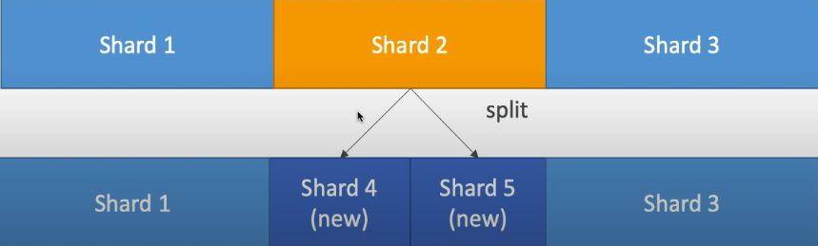

KINESIS OPERATIONS – MERGING SHARDS
- Decrease the stream capacity and save costs.
- Can be used to group two shards with low traffic.
- Old shards are closed and deleted based on data expiration
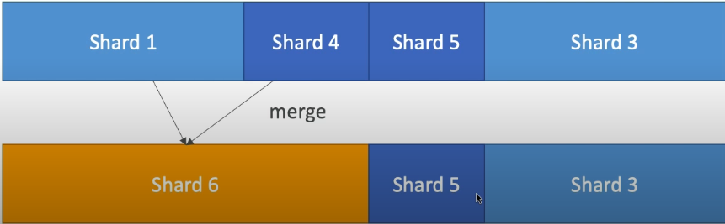

Resharding: Resharding is the process of redistributing data across different storage units or servers to improve performance, scalability, or balance the load.
In simple terms, when a system has too much data or uneven data distribution, resharding helps spread that data out more evenly across servers, ensuring no server gets overloaded and the system can handle more users or data efficiently.
For example, imagine a library where books are stored on different shelves. If one shelf becomes too full, books can be moved to other shelves (resharded) to make sure all shelves are evenly filled and the library runs smoothly.

OUT-OF-ORDER RECORDS AFTER RESHARDING
When you do resharding in AWS, you’re spreading your data across different storage units (or servers). This can sometimes cause out-of-order records—meaning the data arrives in a different sequence than expected.
Why does this happen?
- Data split across multiple servers: When you break the data into smaller parts (called shards), each part might be processed at different times or by different servers, causing some records to arrive later than others.
- Multiple processes working at the same time: Many operations might be happening at once, and this can cause records to be mixed up or come in different orders.
- Delays in data movement: The data might take different paths or times to travel across servers, causing delays in some records arriving faster than others.
How to fix it?
- Use timestamps: Attach time stamps to each record so that even if the order is mixed up, you can still figure out when each record should be processed.
- Reorder the records: After resharding, you can use these timestamps to arrange the records in the right order.
- Wait for all data to sync: In distributed systems, sometimes it takes a little time for everything to line up, so the data will eventually be in the correct order.
In short, out-of-order records can happen when data is spread out across servers, but you can fix this by using timestamps or sorting the data afterward.
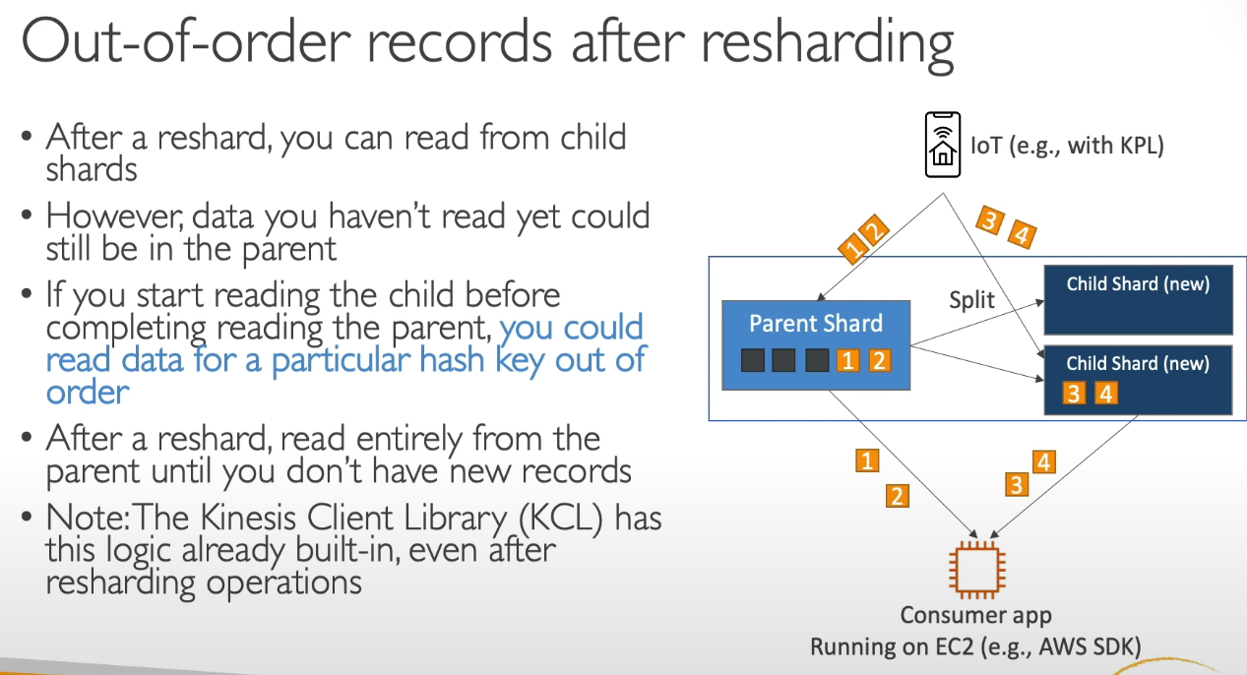

AUTO-SCALING IN KINESIS
Auto Scaling means the system can automatically increase or decrease its resources (like computing power or storage) based on demand, without you needing to do it manually. This is especially useful in Kinesis, where the amount of data being processed can change quickly.
Here's how auto-scaling works in Kinesis:
- Shards and Throughput: Each shard in Kinesis handles a certain amount of data. If there’s too much data, Kinesis might need more shards (bigger capacity). If there’s less data, it will reduce the number of shards (smaller capacity).
- Auto Scaling with Kinesis Data Streams: You can set up auto-scaling policies to automatically add or remove shards based on the traffic (data volume). For example:
  - If more data is being put into the stream (higher traffic), Kinesis can add more shards to handle the load.
  - If data volume decreases (lower traffic), Kinesis can remove extra shards to save costs.
- How Auto Scaling Works: Auto scaling works by setting limits on how much traffic can flow through a stream. If the system detects that the data volume exceeds or falls below a set threshold, it automatically adjusts the number of shards. This ensures the system doesn’t get overwhelmed or underutilized.
Benefits of Auto Scaling in Kinesis
- Cost-Efficient: You only pay for the resources you use. If traffic goes down, Kinesis reduces resources, saving you money.
- No Manual Intervention: The system automatically adjusts without you having to monitor or manually change the settings.
- Handles Traffic Spikes: When traffic increases, Kinesis adds more capacity (shards) to handle the extra load, ensuring the system doesn’t get overwhelmed.
Key Takeaways
- Kinesis helps you process and analyze real-time streaming data.
- Operations like putting, getting, and tracking data flow help manage the data.
- Auto Scaling automatically adjusts the capacity of your Kinesis streams to match data volume, so you don’t have to manually add or remove resources.
In simple words, AWS Kinesis handles large amounts of data in real-time and can automatically adjust the amount of resources needed based on how much data is flowing through the system, ensuring efficient and cost-effective processing.

LIMITATIONS OF AUTO-SCALING
1. Scaling Delay
- What happens: Auto-scaling takes time to detect changes in traffic and adjust the resources (like adding or removing shards).
- Limitations: There can be a delay in responding to sudden changes in data volume. For example, if there’s a sudden spike in data, the system may not immediately scale up to handle it, leading to temporary performance issues.
2. Shard Limits
- What happens: Kinesis uses shards to manage data. Each shard can handle a certain amount of data.
- Limitations: There are limits on the number of shards you can have in a stream. If your data volume increases rapidly, you might hit the maximum shard limit and cannot scale further unless you request a limit increase from AWS.
3. Manual Adjustment May Be Needed in Some Cases
- What happens: Auto-scaling is automatic, but sometimes the system might not scale in a way that's ideal for your needs.
- Limitations: In certain cases, you may still need to manually adjust scaling settings or monitor performance closely. For example, if there are multiple applications competing for resources, auto-scaling may not be perfect for your specific requirements.
4. Cost Implications
- What happens: Auto-scaling adjusts resources based on demand, which can save costs when traffic is low.
- Limitations: However, if auto-scaling continuously increases the number of resources (shards) to handle high data volumes, this can lead to unexpected costs. You could end up paying more if your data usage spikes frequently.
5. Performance Bottlenecks
- What happens: Even though auto-scaling adjusts the number of shards, the overall performance still depends on how efficiently data is processed.
- Limitations: If your application logic or data processing pipeline isn't optimized, auto-scaling might not solve performance issues. It will scale the system, but if the bottleneck is in processing, the system may still face delays.
6. Auto-Scaling for Only Specific Resources
- What happens: Auto-scaling in Kinesis generally applies to the number of shards or capacity units. It doesn't automatically scale all resources in the system.
- Limitations: Some components, like downstream processing systems (e.g., data analytics, consumers), may require manual adjustments or other scaling mechanisms that auto-scaling doesn't handle.
7. Complex Configuration
- What happens: To enable auto-scaling, you need to define scaling policies and thresholds.
- Limitations: Setting the right thresholds for auto-scaling can be complex. If you set them incorrectly, auto-scaling may not behave as expected, either scaling too much or not enough. This requires careful configuration and ongoing tuning.
8. Latency During Shard Resizing
- What happens: When you scale the number of shards up or down, Kinesis has to redistribute data to the new shards.
- Limitations: This resizing can cause brief latency or interruptions in data processing. While Kinesis tries to handle this smoothly, it may still result in temporary delays during scaling operations.
9. Regional Limits
- What happens: AWS services like Kinesis operate in specific regions.
- Limitations: Auto-scaling is region-specific. If you have global workloads or need cross-region scaling, you may have to manually manage scaling across multiple regions.

KINESIS DATA STREAMS – HANDLING DUPLICATES
- Producer retries can create duplicates due to network timeouts
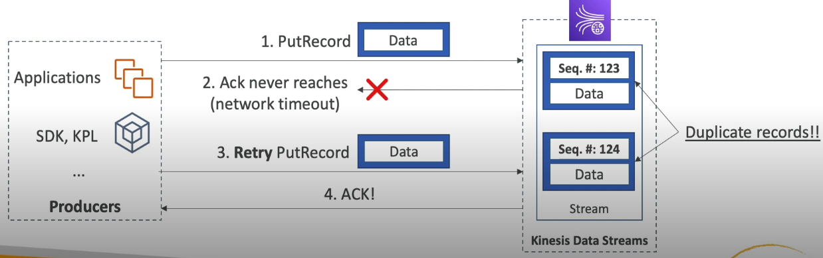

- Although the two records have identical data, they also have unique sequence number.
- Fix: Embed unique record id in the data to de-duplicate on the consumer side.
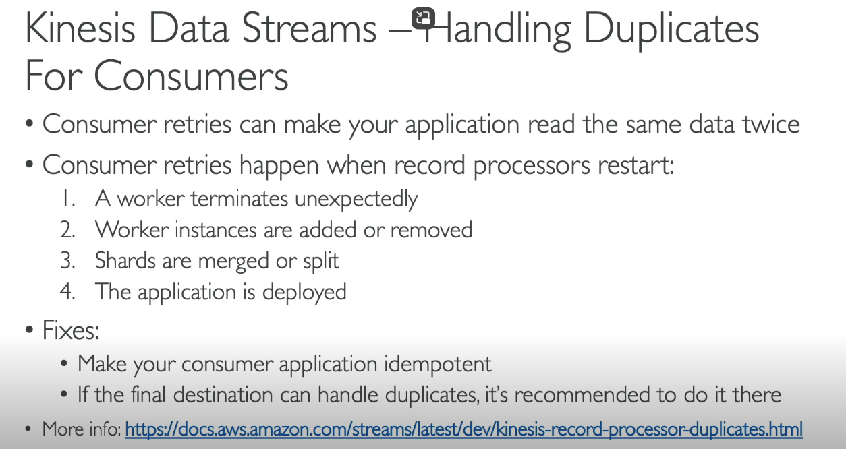

AWS KINESIS DATA FIREHOSE
- Fully managed service, no administration.
- Near Real time (60 seconds latency minimum for non-full batches)
- Load data into Redshift / Amazon S3 / Elasticsearch / Splunk
- Automatic Scaling
- Supports many data formats.
- Data conversion from Json to Parquet / ORC (only for S3)
- Data transformation through AWS Lambda (ex. CSV => Json).
- Supports compression when target is amazon S3 (GZIP, ZIP and SNAPPY)
- Only GZIP is the data further loaded into RedShift.
- Pay for the amount of data going through firehose.
- Spark / KCL do not read from KDF.
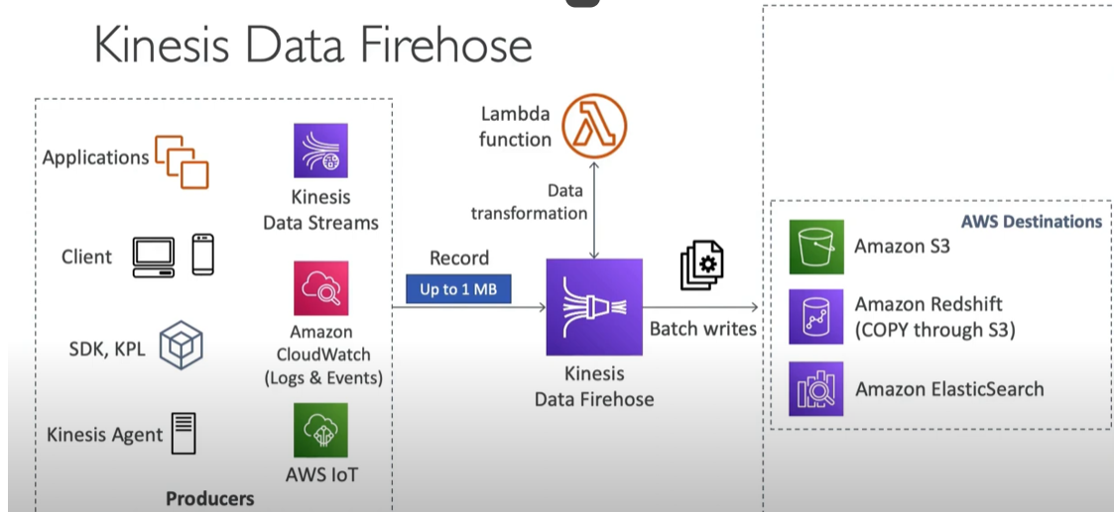
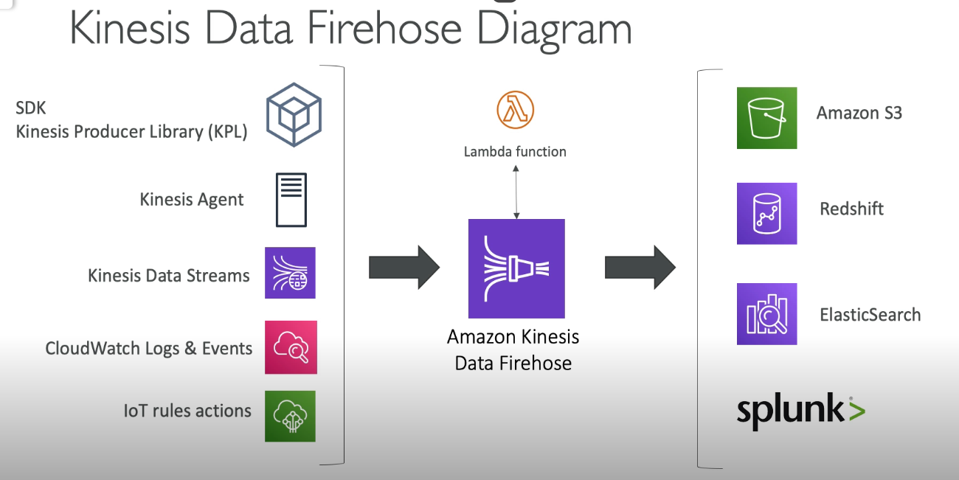
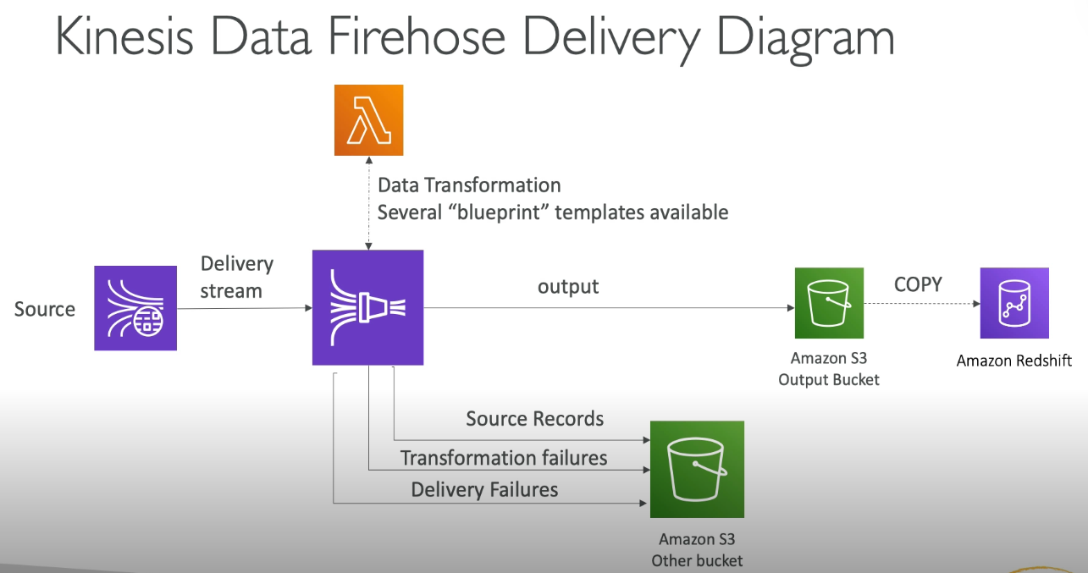
This diagram tells that, we don’t lose data if data passes through Kinesis Data Firehose, whether it’s the case of Transformation or delivery failures, data gets stored in Amazon S3 bucket.
THROUGHPUT: In AWS, throughput refers to the amount of data that can be processed or transferred per unit of time, typically measured in bytes per second. It is a key performance metric for services like Amazon S3, EBS, RDS, or DynamoDB, indicating how efficiently data can be read from or written to a resource. Higher throughput ensures faster data processing, which is critical for applications requiring high performance and scalability.
For example:
- In Amazon S3, throughput measures the speed of data transfer.
- In EBS (Elastic Block Store), it reflects the data transfer rate between the storage and the instance.

FIREHOSE BUFFER SIZING
- Firehose accumulates records in a buffer.
- The buffer is flushed based on time and size rules.
- Buffer size (ex. 32MB): if that buffer size is reached, its flushed.
- Buffer time (ex. 2 minutes): if that time is reached, its flushed.
- Firehose can automatically increase the buffer size to increase throughput.
- High Throughput => Buffer size will be hit
- Low throughput => Buffer time will be hit
- Min buffer size is 60 sec and max buffer size is 900 sec
Think of Firehose as a bucket that collects data before sending it to its destination (like S3 or Redshift). The bucket has two rules for when it gets emptied (or "flushed"):
- Buffer Size Rule: If the bucket fills up to a certain size (like 32MB), it gets emptied.
- Buffer Time Rule: If the bucket hasn’t been emptied for a certain amount of time (like 2 minutes), it gets emptied anyway, even if it’s not full.
How It Works
- If a lot of data is flowing in (high throughput), the bucket fills up quickly, and it gets emptied because the size limit is reached.
- If only a little data is flowing in (low throughput), the bucket doesn’t fill up, but it still gets emptied after the time limit to avoid delays.
In AWS Kinesis Data Firehose, buffer sizing refers to how data is temporarily stored before being delivered to its destination (e.g., S3, Redshift). Firehose uses buffer size and buffer interval to control delivery:
- Buffer Size: The amount of data (1 MB to 128 MB) Firehose accumulates before delivering it.
- Buffer Interval: The maximum time (60 seconds to 900 seconds) Firehose waits before delivering data, even if the buffer size isn't full. Minimum Buffer Interval is 60 seconds while maximum buffer interval is 900 seconds.
Firehose delivers data when either condition is met (size or time). Proper sizing optimizes cost and latency based on your use case. For example:
- Larger buffers: Reduce delivery frequency, saving costs.
- Smaller buffers: Enable near real-time delivery at higher cost.

Automatic Buffer Adjustment
Firehose can increase the bucket's size automatically if more data is flowing in to handle the higher load efficiently.
Key Points
- High Data Flow (High Throughput): The size limit is reached first, so the bucket is emptied because it’s full.
- Low Data Flow (Low Throughput): The time limit is reached first, so the bucket is emptied even though it’s not full.
In short, Firehose makes sure your data isn’t delayed by flushing it either when the bucket is full or after a set amount of time, whichever happens first.
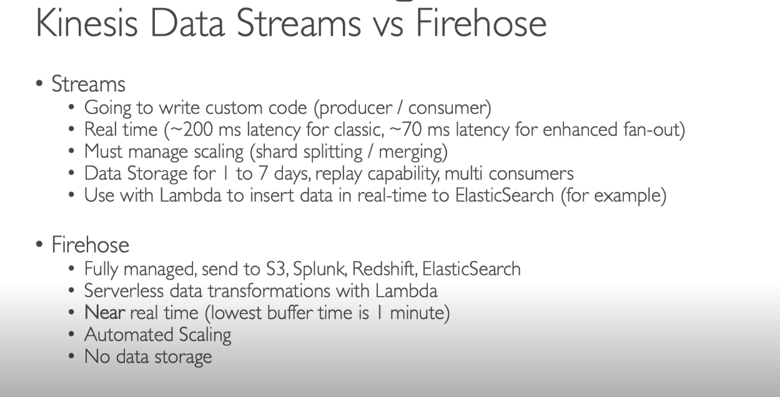
Kinesis Data Stream is for real time data while Kinesis Firehose is for Near Real time data

CLOUD WATCH LOG SUBSCRIPTION FILTERS
CloudWatch Log Subscription Filters: A Simple Overview
Amazon CloudWatch is a service provided by AWS to monitor and manage the performance and health of AWS resources and applications. One of its features, Log Subscription Filters, helps you stream log data in real-time to other services like Amazon Kinesis, Amazon Lambda, or Amazon Elasticsearch for further processing, analysis, or storage.
Here's a detailed but simple breakdown of how CloudWatch Log Subscription Filters work:

What Are CloudWatch Log Subscription Filters?
A Log Subscription Filter is a rule that you apply to a CloudWatch Log Group to specify which logs you want to forward or stream to other AWS services. For example, you might want to send only error logs from an application to a Lambda function for real-time alerting.
Key Components of Log Subscription Filters:
- CloudWatch Log Group:
  - A log group is a collection of logs from one or more resources (e.g., EC2 instances, Lambda functions).
  - Each log group contains log streams, which represent log data from a specific resource.
- Subscription Filter:
  - A filter defines which log events (entries) you want to send from a Log Group to other services.
  - The filter can include specific keywords or patterns (e.g., "ERROR") to capture logs that meet your criteria.
- Destination:
  - The destination is where the filtered logs will be sent. This could be:
    - Kinesis Stream: For real-time data processing.
    - Lambda Function: To trigger a serverless function based on log events.
    - Elasticsearch: For advanced log analysis and search capabilities.
    - Amazon S3: For storing logs.
How Do Subscription Filters Work?
- Create a Log Subscription Filter:
  - First, you define the Log Group that you want to stream logs from.
  - Then, specify the filter pattern (e.g., "ERROR") to capture the log entries you're interested in.
- Choose a Destination:
  - Next, select where you want to send the filtered log data (e.g., an Amazon Lambda function or Kinesis stream).
- Real-Time Processing:
  - Once the filter is set, CloudWatch will stream matching log entries to your chosen destination in real-time.
  - For example, if you send logs to Lambda, it can trigger a function immediately whenever logs with "ERROR" appear.
Use Cases of Log Subscription Filters:
- Monitoring and Alerting: Automatically send error or warning logs to Lambda to trigger alerts, notifications, or automated responses.
- Real-Time Log Analytics: Stream logs to Kinesis for processing, analytics, or even integration with other tools like Elasticsearch for advanced search and visualization.
- Log Storage: Stream logs to S3 for long-term storage, compliance, or further processing.
- Security Monitoring: Filter and send logs related to suspicious activity (e.g., unauthorized access) to a security monitoring system.

How to Set Up a Log Subscription Filter:
- Create a Log Group:
  - If you don’t already have a Log Group, you can create one in the CloudWatch Logs dashboard.
- Define the Filter Pattern:
  - You can use simple keywords or regular expressions to create your filter pattern.
    - Example: If you want to capture logs that have the word "ERROR", use the filter pattern "ERROR".
    - You can also create more complex patterns to capture specific log attributes (e.g., timestamps, log severity).
- Choose the Destination:
  - Select where the filtered logs will go. This could be Lambda, Kinesis, or another supported service.
- Configure Permissions:
  - Make sure the destination service (e.g., Lambda or Kinesis) has the correct permissions to receive data from CloudWatch Logs.
- Start Streaming:
  - Once the filter and destination are configured, CloudWatch Logs will start streaming the matching log events to the destination.

Benefits of Using Log Subscription Filters:
- Real-Time Insights:
  - By streaming logs in real-time to services like Lambda or Kinesis, you can gain immediate insights into what's happening with your applications or infrastructure.
- Customizable Alerts:
  - Filter only the logs that matter to you (e.g., errors or warnings), and automatically trigger alerts or actions.
- Automated Responses:
  - Automate responses to certain log entries. For example, you could set up a Lambda function to take action when an "ERROR" log is generated, like restarting a service or notifying an admin.
- Scalability:
  - With integration to scalable services like Kinesis, you can handle large volumes of log data, allowing for more sophisticated processing.

Example of Using a Log Subscription Filter:
Let's say you want to monitor logs for errors in your web application.
- Log Group: ApplicationLogs
- Filter Pattern: "ERROR"
- Destination: Lambda function that sends an email alert whenever an error occurs.
How It Works:
- CloudWatch Logs monitors the ApplicationLogs Log Group for any logs containing the word "ERROR".
- As soon as an error log appears, CloudWatch sends the log data to the Lambda function.
- The Lambda function processes the log and sends an email alert to your team.

Conclusion:
CloudWatch Log Subscription Filters are powerful tools that allow you to stream, process, and act upon log data in real-time. By using them, you can quickly respond to issues, monitor your applications more effectively, and integrate your logs with other AWS services for more advanced processing and analysis.

- We can stream CloudWatch logs into
    - Kinesis Data Streams
    - Kinesis Data Firehose
    - AWS Lambda
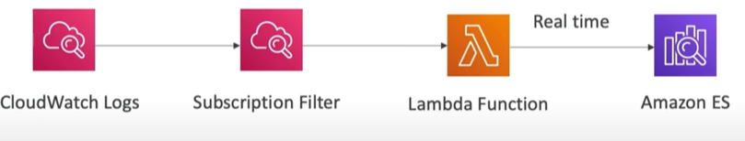
CLOUDWATCH LOGS SUBSCRIPTION FILTER PATTERNS REAL TIME ANALYTICS
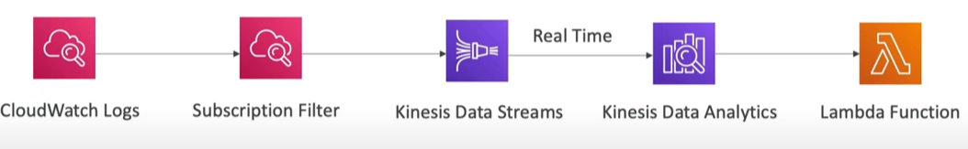
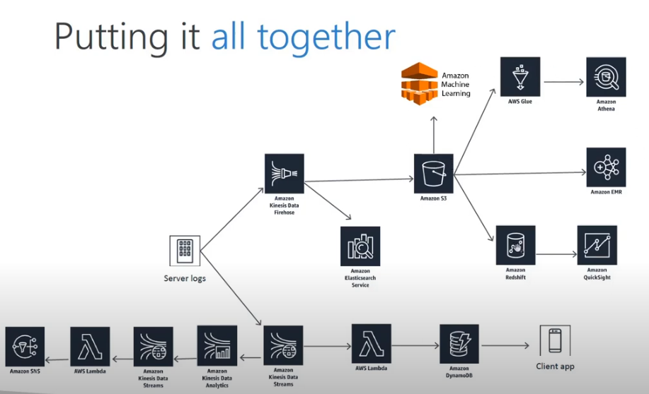

INTERNET OF THINGS (IoT)
The Internet of Things (IoT) in AWS is about connecting everyday devices—like sensors, cameras, machines, or home appliances—to the internet so they can send, receive, and process data. AWS provides services and tools to make it easy to manage these connected devices securely and process the data they generate.
Here’s a simple way to think about it:
Key Points about AWS IoT:
- Connect Devices: Imagine your smart fridge, car, or factory machines being able to send data to the cloud. AWS IoT helps these devices connect to the internet.
- Process Data: Once connected, AWS can collect the data (e.g., temperature readings, movement alerts) and process it in real time or store it for later analysis.
- Take Actions: Based on the data, you can program the system to take actions. For example:
  - If a factory sensor detects high heat, AWS IoT can alert the team or turn off a machine.
  - If your home camera detects motion, AWS IoT can send you a notification.
Services AWS Offers for IoT:
- AWS IoT Core: The main service for connecting and managing IoT devices.
- AWS IoT Greengrass: Extends AWS capabilities to devices, allowing them to run locally without needing constant internet access.
- AWS IoT Analytics: Processes and analyzes the data generated by your devices.
- AWS IoT Device Management: Helps organize, monitor, and remotely update your devices.
- AWS IoT Events: Detects and responds to specific events, like a sensor reading crossing a threshold.
Real-Life Examples:
- Smart Homes: Light bulbs that you can control from your phone or refrigerators that alert you when you're low on milk.
- Health Devices: Wearables like fitness trackers sending health data to the cloud for insights.
- Industrial Use: Machines in factories sending data about performance, helping prevent failures.
Why Use AWS for IoT?
AWS provides a secure and scalable way to connect and manage devices, analyze the data, and build applications around them—all without worrying about the underlying infrastructure.
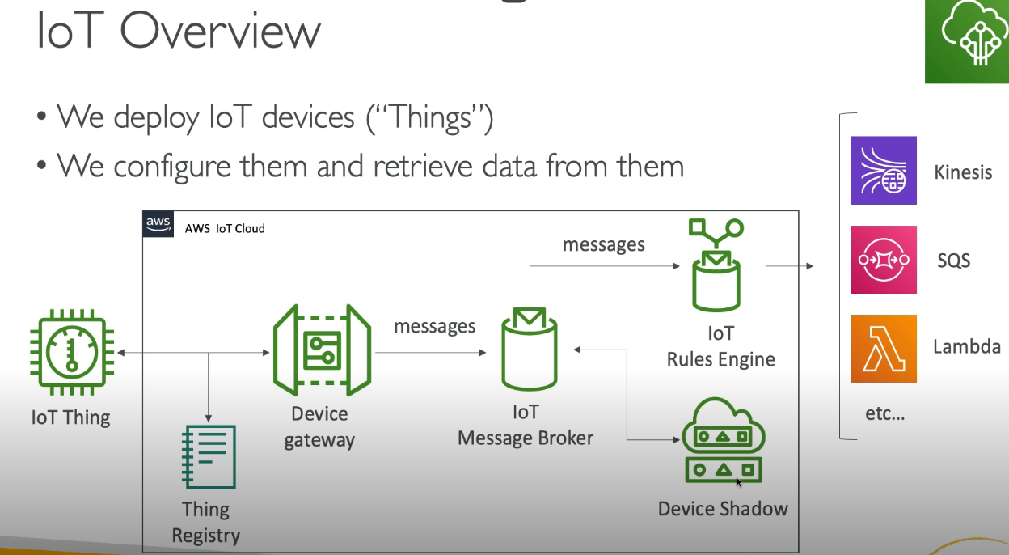
THING REGISTRY: The Thing Registry in AWS IoT is like a phonebook for your IoT devices. It helps you organize and manage all the devices (things) connected to AWS IoT by giving each one a name, description, and details about what it can do.
Key Points in Simple Terms:
- What is a Thing?
  - A "thing" can be any IoT device, like a sensor, light bulb, or car.
  - The Thing Registry keeps a record of all your devices.
- Why Do We Need a Registry?
  - Imagine having hundreds or thousands of IoT devices. The registry helps you keep track of each one and its settings, like its location, type, or purpose.
- What Information is Stored?
  - The device's name or ID.
  - Attributes like its model, color, or where it’s used (e.g., a sensor in Room A).
  - Certificates and security settings to make sure the device communicates securely.
- How Does It Work?
  - When you connect a new IoT device to AWS IoT, you register it in the Thing Registry.
  - The registry gives the device a unique identifier so you can send commands, receive data, or update settings for that specific device.
Example:
Let’s say you’re managing 100 smart thermostats in different rooms of a building. The Thing Registry:
- Lets you name each thermostat (e.g., "Thermostat_Room101").
- Stores information like its location (Room 101) and its temperature range.
- Ensures secure communication between the thermostat and AWS.
Why is the Thing Registry Important?
- Organized Management: Helps you easily find and control your devices.
- Secure Communication: Stores certificates for encrypted data transfer.
- Scalability: Works even if you have thousands of devices.
In short, the Thing Registry is a database to keep track of and securely manage your IoT devices in AWS.

DEVICE SHADOW
A Device Shadow in AWS IoT is like a virtual copy of your IoT device's state stored in the cloud. It lets you track and control your device, even when it’s offline.
Key Points in Simple Terms:
- What is a Device Shadow?
  - Think of it as a "digital twin" of your IoT device. It stores the device's latest state (like its settings or readings) in the cloud.
- Why is it Useful?
  - If your IoT device goes offline, the shadow keeps the last known state.
  - You can update the shadow with a new state, and the device will sync with it once it's back online.
- What Does it Do?
  - Tracks Current State: Records the actual state of the device (e.g., the light is ON).
  - Stores Desired State: Saves what you want the device to do (e.g., turn the light OFF).
  - When the device reconnects, it syncs with the desired state.
- How Does it Work?
  - A smart bulb is connected to AWS IoT.
  - Its shadow says: Current state = ON.
  - You send a command to the shadow to update the state to OFF.
  - Even if the bulb is offline, the shadow holds this "desired state."
  - Once the bulb is back online, it checks the shadow and turns itself OFF.
Example:
Imagine you have a smart thermostat:
- The current state is: Temperature = 22°C.
- You want to change it to 25°C. You update the desired state in the shadow.
- If the thermostat is offline, it won't change immediately.
- When it reconnects, it reads the shadow and adjusts to 25°C.
Why is it Important?
- Offline Support: You can interact with your device, even if it's not online.
- Real-Time Sync: Devices automatically align with the shadow when they reconnect.
- Ease of Control: You can monitor and control devices remotely via the shadow.
In short, a Device Shadow is a handy tool in AWS IoT that keeps a cloud-based record of your device's state, so you can control it anytime, even if the device isn’t currently connected to the internet.

AWS IoT Core is a cloud service that connects devices with AWS services and other devices through its device gateway and message broker.
Devices can publish messages that contain a current or requested state. Devices can subscribe to messages to be notified of changes to the current and requested states of other devices. The AWS IoT Core device gateway receives published messages and the message broker sends them to the devices that have subscribed to them.
The device gateway sends messages to the message broker
When a button is pressed on the control device, it publishes a new requested state message.
The AWS IoT Core device gateway in the cloud receives the published message and sends it to its message broker.
The message broker sends messages to subscribers
The smart lamp subscribes to these messages so the AWS IoT Core message broker send them to the smart lamp.
When the smart lamp receives a new message, it changes its state to match
The message broker processes each message
Each time the desired state changes on the control device, the process repeats.
Device Shadows save system state while a device is offline
When a device is not always connected, AWS IoT Device Shadows store and communicate a device’s desired and last-reported state.
The smart lamp’s Device Shadow that stores the smart lamp’s state while either the control or the smart lamp is off line is shown in the diagram as the light bulb icon
The control device updates the Device Shadow
The control device publishes the desired state to the smart lamp’s Device Shadow.
The Device Shadow notifies the smart device of the new state
The smart lamp’s Device Shadow publishes the desired state information to the smart lamp device.
While the smart lamp is online, it receives the desired state information from the Device Shadow and updates its state to match.
The control device updates the Device Shadow while the smart lamp is offline
The Device Shadow records the desired state of the smart lamp in the Device Shadow document that AWS IoT stores in the cloud.
Device Shadow passes desired state to smart lamp and control device when they come online
After the smart lamp comes online, it queries the Device Shadow for the desired state. The smart lamp sets its state to the desired state and reports its state back to the Device Shadow.
After the control device comes online, it queries the Device Shadow for the reported state of the smart lamp. The Device Shadow sends the reported state to the control device. The device displays the reported state.
Rules route message data to other devices and AWS services
This tutorial demonstrates how a rule can respond to a device message by publishing a new message that turns on the smart bulb.
Motion detector senses movement
Upon detecting movement, the motion detector publishes a motion-detected message.
The AWS IoT rule subscribes to motion-detected messages from a motion sensor and receives the motion detector’s message.
Rule triggered. Rule action publishes desired-state message
After the rule receives a motion-detected message, its rule action publishes a new message to turn on the smart bulb.
Because the smart bulb has a Device Shadow, the update message must go to the Device Shadow instead of the smart bulb. The rule publishes a desired-state message for the Device Shadow with a desired state of ON.
Shadow state updated. Device Shadow publishes an updated-state message
When the Device Shadow updates it’s desired state, it publishes an updated-state message to inform subscribed clients of the change to the Device Shadow’s desired state.
The smart bulb subscribes to Device Shadow updated-state messages.
Upon receiving the updated-state message from the Device Shadow, the smart bulb sets its state to the “desired” value in the update message and turns on.
The control device also subscribes to updated-state messages from the Device Shadow to display the requested change to the smart bulb’s state.
Smart bulb notifies subscribers of its current state
After the smart bulb’s updates its state, it sends a reported-state message to subscribers.
The smart bulb’s Device Shadow receives the message and updates the Device Shadow to show the desired and reported states — which now match.
The control device also subscribes to reported-state messages from the device to update its display to match the devices current state.

SQS QUEUE
Amazon SQS (Simple Queue Service) is a fully managed service by AWS that helps you send, store, and receive messages between different parts of your application in a reliable and scalable way. Think of it as a post office for your applications, where messages are sent, stored, and delivered without getting lost.
Key Concepts of SQS:
- What it does:
  - It acts as a "middleman" for communication between parts of an application.
  - One part (the sender) puts a message in the queue.
  - Another part (the receiver) picks up the message when it's ready to process it.
AWS QUEUE – STANDARD QUEUE
- Oldest offering (over 10 years old).
- Fully managed.
- Scales from 1 message per second to 1000 messages per second.
- Default retention of messages: 4 days, maximum of 14 days.
- No limit to how many messages can be there in queue.
- Low Latency (< 10ms on publish and receive).
- Horizontal scaling in terms of number of consumers.
- Can have duplicate messages (at least once delivery, occasionally).
- Can have out of order messages (best effort ordering).
- Limitations of 256 KB per message sent.
- Why use SQS?
  - Helps parts of your application work independently. For example, if one part of your app is slow or down, the other parts can continue working because the queue stores the messages safely.
  - Handles large amounts of messages efficiently without worrying about infrastructure.
- How it works:
  - Sender: Adds a message (e.g., "Process this order") to the queue.
  - Queue: Holds the messages until a receiver is ready to handle them.
  - Receiver: Retrieves the message from the queue and processes it.
- Two Types of SQS Queues:
  - Standard Queue:
    - Allows unlimited messages.
    - Messages may arrive out of order, and duplicates are possible.
    - Best for use cases where exact order doesn't matter.
  - FIFO Queue (First-In-First-Out):
    - Delivers messages in the exact order they were sent.
    - No duplicate messages.
    - Ideal for use cases where order is important, like processing payments.
- Features:
  - Durability: Messages are stored redundantly across multiple servers.
  - Scalability: Can handle any number of messages, growing as your needs increase.
  - Delayed Delivery: You can schedule when a message should be available for processing.
  - Visibility Timeout: Once a message is picked up for processing, it's hidden from others for a set time so it's not processed twice.
- Real-life Example:
  - Imagine you run an e-commerce website. When a customer places an order:
    - The order details are sent to an SQS queue.
    - A separate system (e.g., warehouse or delivery app) picks up the order details from the queue and processes them at its own pace.
    - If the warehouse system is slow, the order stays in the queue without affecting the rest of the website.
Summary:
Amazon SQS helps make your application more robust and scalable by acting as a buffer between different parts of your system. It ensures that no messages are lost and that components can work independently without being tightly coupled.
Producing messages in Amazon SQS means sending or adding messages to an SQS queue. This is typically done by the producer component of your application, which generates the messages and places them into the queue.
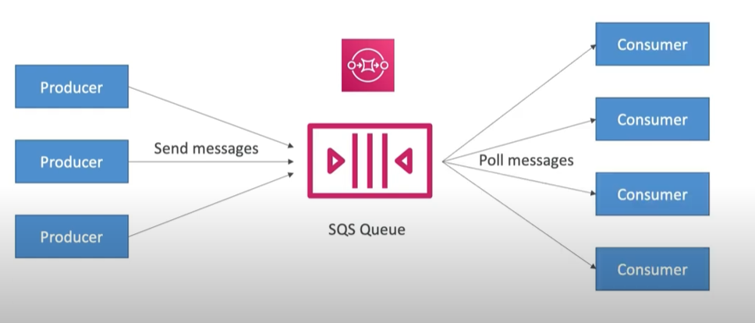

How SQS Produces Messages
- Create an SQS Queue:
  - Before sending messages, you need an SQS queue where messages will be stored.
  - You can create a queue in the AWS Management Console, AWS CLI, or using the AWS SDK.
- Prepare the Message:
  - A message can contain any data (e.g., text, JSON, XML) up to 256 KB in size.
  - Examples of messages:
    - "Order ID 12345 placed"
    - { "userId": 101, "action": "login", "timestamp": "2024-11-26T10:00:00" }
- Send the Message:
  - Use the AWS SDK, AWS CLI, or AWS Management Console to send messages to the queue.
  - Example in AWS SDK (Python) using boto3:
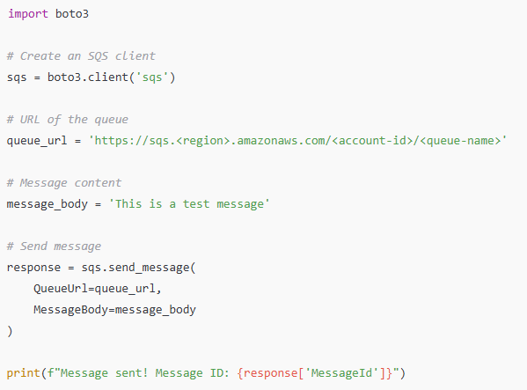
- Optional Configurations:
  - Message Attributes: Add metadata (key-value pairs) to describe the message (e.g., priority, type).
  - Delay Delivery: Specify a delay (up to 15 minutes) before the message becomes visible in the queue.

Key Points About Producing Messages:
- Scalable: Multiple producers can send messages to the same queue simultaneously.
- Durable: Once added, messages are stored redundantly across AWS infrastructure to prevent loss.
- Idempotency: Messages have a unique ID to help track and prevent duplicate submissions.
SQS – PRODUCING MESSAGES
- Define Body
- Add message attributes (metadata – optional)
- Provide Delay Delivery 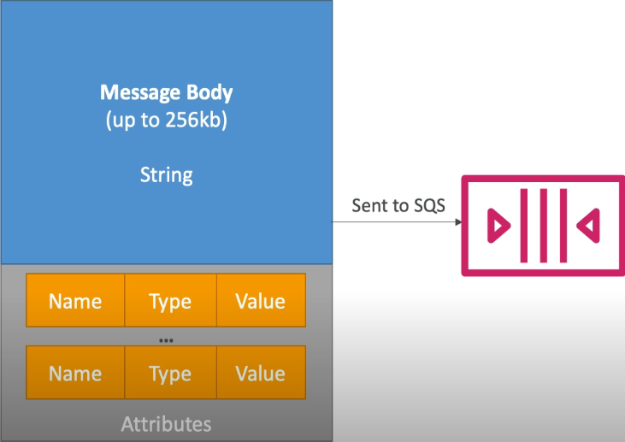

Real-Life Example of Producing Messages
In a ticket-booking system:
- When a user books a ticket, your application (producer) sends a message to an SQS queue:
Message: {"eventId": 123, "userId": 456, "seats": 2}.
- The SQS queue stores this message.
- Another part of your system (receiver) processes this message to reserve the seats.
Producing messages is the first step in enabling asynchronous communication in distributed systems with SQS!

SQS CONSUMING MESSAGES
Consuming messages in Amazon SQS refers to retrieving and processing messages from an SQS queue. This is typically done by the consumer, which is the application or service responsible for handling the messages.

How SQS Consumes Messages
- Connect to the Queue:
  - A consumer must know the URL of the SQS queue to fetch messages.
  - Use the AWS SDK, AWS CLI, or AWS Management Console to interact with the queue.
- Receive Messages:
  - Consumers fetch messages using the ReceiveMessage API.
  - Example in AWS SDK (Python) using boto3:
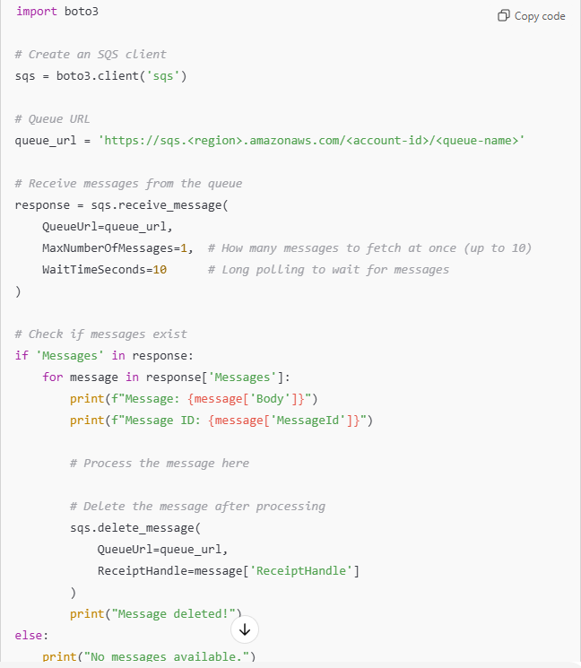
- Processing Messages:
  - Once a message is retrieved, the consumer processes it (e.g., saving data to a database, sending an email, etc.).
  - Messages are temporarily hidden (visibility timeout) to prevent other consumers from picking them up during processing.
- Delete Messages:
  - After successful processing, the consumer must delete the message from the queue using its ReceiptHandle.
  - If not deleted, the message reappears after the visibility timeout, potentially being reprocessed.

Key Features for Consuming Messages
- Long Polling:
  - Waits for messages to arrive in the queue instead of checking repeatedly.
  - Reduces costs and unnecessary API calls.
- Visibility Timeout:
  - Ensures no other consumer picks up the message while it's being processed.
  - If processing fails, the message becomes visible again for retry.
- Batch Retrieval:
  - Up to 10 messages can be fetched in a single call, improving efficiency.
- Dead Letter Queue (DLQ):
  - Messages that fail to process multiple times are sent to a Dead Letter Queue for debugging or analysis.

Real-Life Example of Consuming Messages
In a ticket-booking system:
- When a booking message ({"eventId": 123, "userId": 456, "seats": 2}) is placed in the SQS queue:
  - A consumer retrieves the message.
  - It reserves the seats in the database and sends a confirmation email to the user.
- Once the processing is complete, the consumer deletes the message to avoid duplication.

Summary
Consuming messages from SQS allows applications to handle tasks asynchronously, ensuring scalability, fault tolerance, and efficient message processing. With features like long polling and visibility timeout, SQS ensures reliability and prevents message loss or duplication.

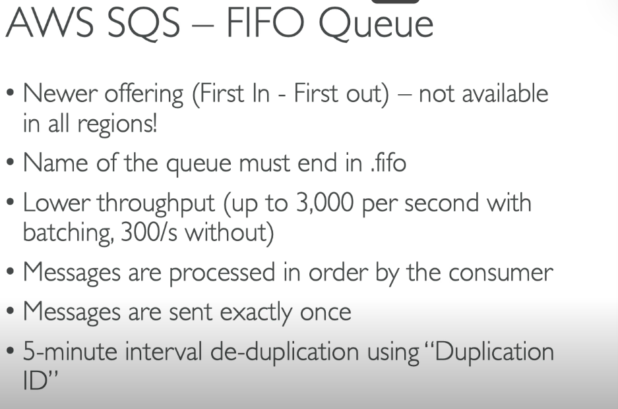
Amazon SQS FIFO Queue (First-In-First-Out) ensures that messages are processed in the exact order they are sent and guarantees that each message is delivered exactly once. This makes it ideal for use cases where maintaining the order of operations is critical, such as financial transactions, inventory updates, or message logs.

Key Features of SQS FIFO Queues
- Order Preservation:
  - Messages are delivered and processed in the same order they are sent.
- Exactly-Once Processing:
  - Messages are delivered only once and are not duplicated in the queue.
- Message Grouping:
  - Messages can be grouped using a Message Group ID to ensure strict ordering within a group, while allowing parallel processing of different groups.
- High Durability:
  - Messages are stored redundantly across multiple AWS availability zones for reliability.

WHEN TO USE KINESIS DATA STREAM VS WHEN TO USE SQS DATA STREAM
Amazon Kinesis Data Streams and Amazon SQS are AWS services for managing data and messages, but they serve different use cases. The choice between them depends on the requirements of your application, such as message ordering, throughput, retention, and processing logic.

When to Use Kinesis Data Streams
Kinesis Data Streams is ideal for real-time data streaming scenarios, where data must be continuously ingested and processed by multiple consumers simultaneously.
Key Scenarios:
- Real-Time Data Processing:
  - Applications need to process and analyze data streams in real-time, such as clickstreams, IoT telemetry, or application logs.
- High Throughput and Scalability:
  - The workload involves large volumes of data (gigabytes per second).
  - Kinesis allows you to scale throughput by adding shards.
- Multiple Consumers:
  - Data needs to be processed by multiple consumers concurrently.
  - Example: Analyzing the same stream for different purposes (e.g., fraud detection and analytics).
- Data Replay and Extended Retention:
  - You need the ability to replay data for debugging, analytics, or reprocessing.
  - Retention period: 1 to 365 days.
- Advanced Data Processing:
  - Use cases requiring partition keys to control data routing within shards for granular processing.
Examples:
- Monitoring application logs in real-time.
- Streaming financial transactions for fraud detection.
- Aggregating and analyzing live IoT sensor data.

When to Use SQS
Amazon SQS is a message queuing service designed for asynchronous communication between application components. It’s ideal for decoupling systems and ensuring reliable message delivery.
Key Scenarios:
- Simple Queueing:
  - Applications need to send, store, and retrieve messages reliably.
- Order Is Not Critical:
  - Use Standard Queues for high throughput without guaranteed ordering.
  - Use FIFO Queues for guaranteed ordering but lower throughput.
- Point-to-Point Communication:
  - Messages are consumed by a single consumer (worker) for processing.
- Task Processing:
  - Applications need to decouple producers and consumers, with consumers processing tasks asynchronously.
- Limited Retention:
  - Messages are retained for up to 14 days, which is sufficient for many workflows.
- Cost-Effective for Basic Needs:
  - SQS is simpler and more cost-effective for lightweight or intermittent workloads.
Examples:
- Sending email notifications asynchronously.
- Decoupling microservices to ensure fault tolerance.
- Managing a queue of tasks for background processing.

When to Choose Kinesis Data Streams
- Real-time, high-throughput, parallel data processing.
- Analytics, machine learning, or data pipeline workflows.
- Need for data retention and replay.
When to Choose SQS
- Decoupling services with simple message delivery.
- Background tasks and job queues.
- Use cases where message retention is short-term.

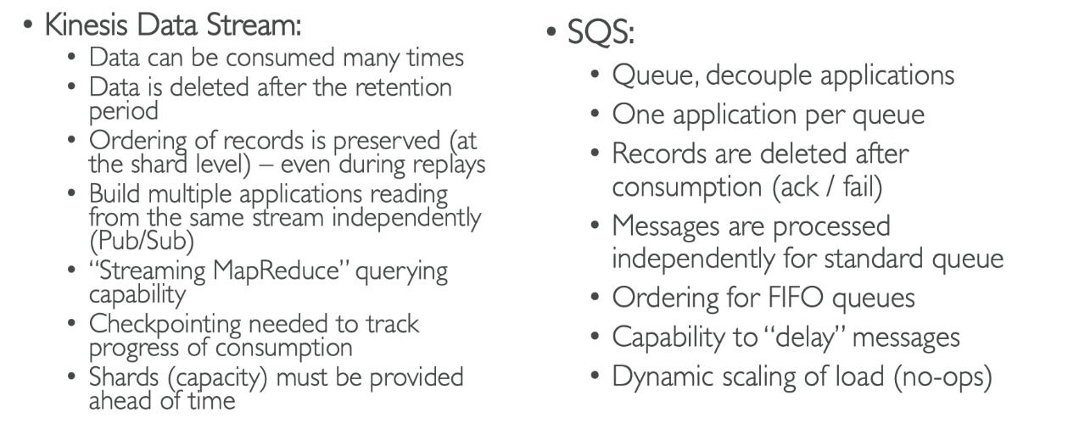
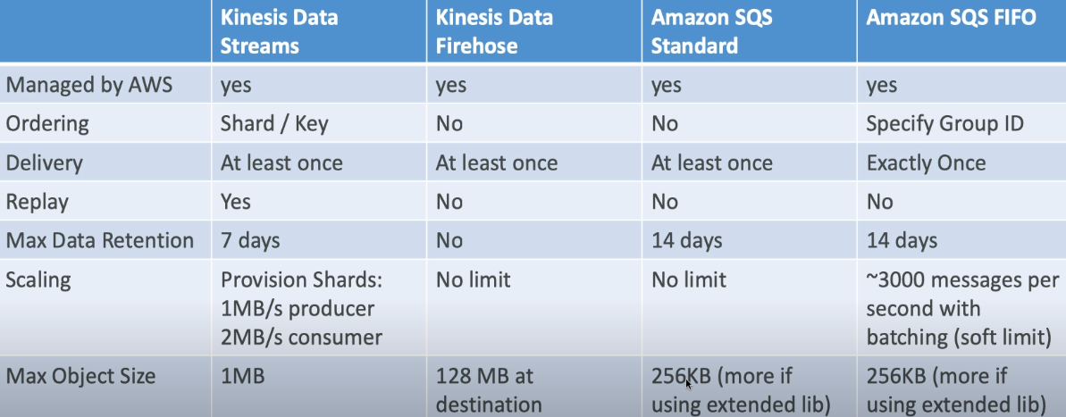

SQS VS KINESIS USE CASES
- SQS USE CASE:
  - Order Processing
  - Image Processing
  - Auto scaling queue according to messages.
  - Buffer and Batch messages for future processing.
  - Requests Offloading

- AMAZON KINESIS DATA STREAM USE CASES
  - Fast log and event data collection and processing
  - Real time metrics and report
  - Mobile data capture
  - Real time data analytics
  - Gaming data feed
  - Complex Stream Processing
  - Data feed from ‘Internet of Things’
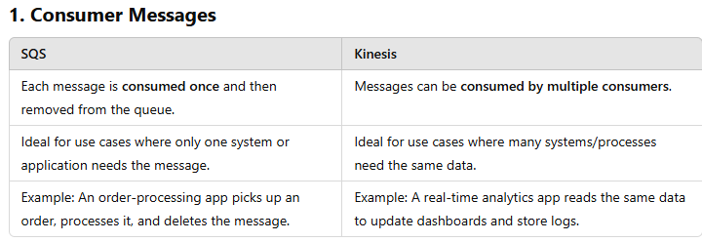
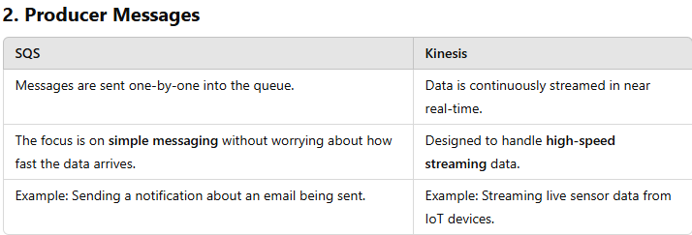
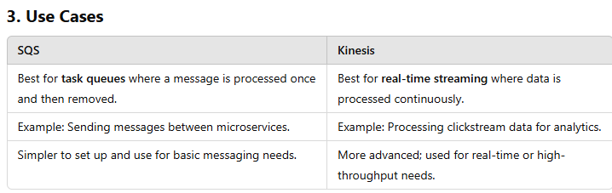
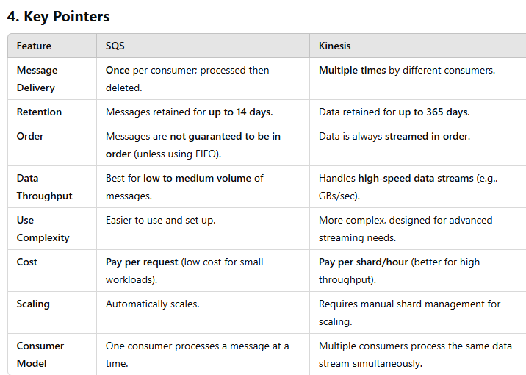

Which to Choose?
- SQS:
  - For simple message delivery.
  - If your application processes each message only once.
  - Use cases: Email queues, task management, order processing.
- Kinesis:
  - For real-time, high-speed, or multiple consumers.
  - If your application needs streaming data (e.g., IoT, analytics).
  - Use cases: Real-time data analytics, event streaming, logs processing.
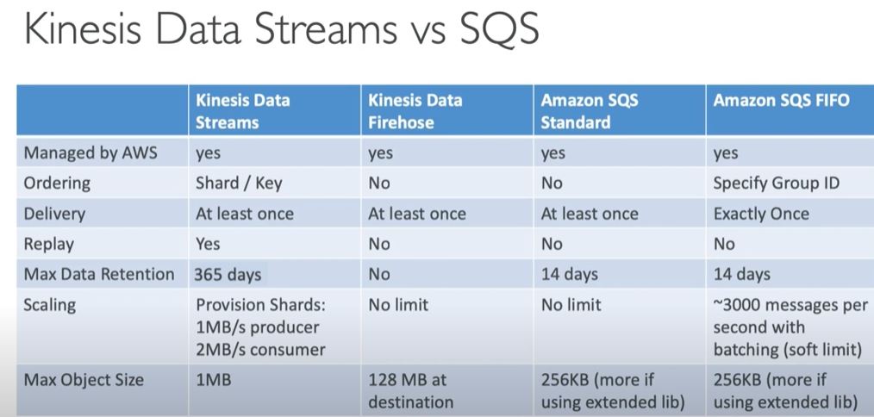

INTERNET OF THINGS (IoT)
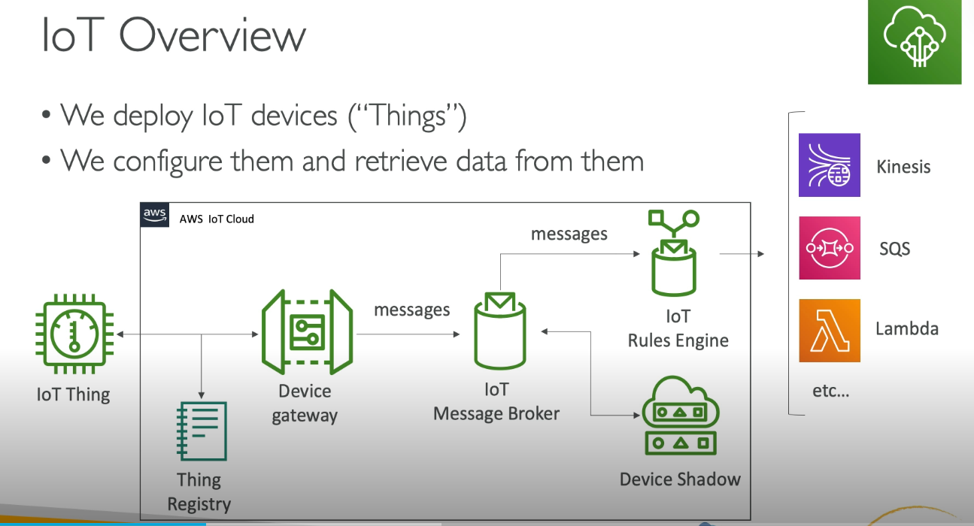
This diagram provides an overview of how AWS IoT works, connecting devices (called "Things") to the cloud and enabling communication, configuration, and data processing. Here's a breakdown of the components in simple terms:

1. IoT Thing
- What it is: These are physical devices like sensors, actuators, or smart appliances that collect or act on data.
- What it does: Sends and receives data over the internet.

2. Thing Registry
- What it is: A directory of all your IoT devices.
- What it does: Helps manage and organize your devices, giving each one a unique identity to track and communicate with them easily.

3. Device Gateway
- What it is: A communication channel between your IoT devices and AWS.
- What it does: Securely receives messages from IoT devices and routes them to other AWS services or back to the device.

4. IoT Message Broker
- What it is: A messaging system that allows devices and services to talk to each other.
- What it does: Routes messages between your IoT devices and the cloud using lightweight protocols like MQTT or HTTPS.

5. IoT Rules Engine
- What it is: A service that processes and reacts to the messages coming from devices.
- What it does:
  - Analyzes incoming data.
  - Triggers actions based on predefined rules, such as saving data to a database, sending alerts, or invoking AWS services like Lambda for custom actions.

6. Device Shadow
- What it is: A virtual copy of your IoT device in the cloud.
- What it does:
  - Stores the last known state of the device (e.g., "light is ON").
  - Allows applications to interact with devices even when they are offline.

7. AWS Services (Kinesis, SQS, Lambda, etc.)
- What they are: AWS services that integrate with IoT to enable additional functionality.
- What they do:
  - Kinesis: Processes and analyzes real-time streaming data from devices.
  - SQS (Simple Queue Service): Queues messages for later processing.
  - Lambda: Runs custom code in response to IoT events without managing servers.
  - Other services: Store data in databases, create dashboards, or trigger machine learning workflows.

How It Works Together
- Data Flow:
  - IoT devices (Things) send messages to AWS through the Device Gateway.
  - The messages are processed and routed by the IoT Message Broker.
- Data Processing:
  - The IoT Rules Engine applies predefined rules to incoming data (e.g., save data, trigger alerts).
  - Devices can update or retrieve their state using the Device Shadow.
- Integration:
  - The data is forwarded to other AWS services (like Kinesis or Lambda) for further processing, analysis, or action.

Example Use Case
- Scenario: A smart thermostat (IoT Thing) sends temperature readings to AWS.
  - The Device Gateway receives the readings.
  - The IoT Message Broker forwards them to the IoT Rules Engine.
  - The Rules Engine decides:
    - To save the data in a database.
    - Trigger an alert if the temperature is too high by invoking a Lambda function.
This setup ensures your IoT solution is scalable, secure, and capable of complex automation.

IoT Device Gateway in AWS
In AWS, the IoT Device Gateway is part of the AWS IoT Core service. It helps IoT devices connect to the AWS Cloud securely and efficiently.
What It Does in AWS:
- Connects IoT Devices: Devices can use protocols like MQTT, HTTP, or WebSocket to communicate with the gateway.
- Manages Large-Scale Connections: It can handle millions of devices connecting at the same time.
- Security: Ensures data is encrypted and devices are authenticated before communicating.
- Protocol Handling: Converts data sent by devices into a format AWS services can process.
Example:
Imagine a smart factory with hundreds of sensors monitoring equipment. These sensors send data (like temperature, pressure, etc.) to the AWS IoT Device Gateway, which forwards it to AWS IoT Core. From there, AWS services (like Lambda or DynamoDB) can analyze or store the data.

IoT Message Broker in AWS
The AWS IoT Message Broker is also a part of AWS IoT Core. It’s a service that ensures messages from one device or application reach the right destination in the AWS IoT system.
What It Does in AWS:
- Manages Message Delivery: Uses the MQTT protocol to send messages between devices, applications, and cloud services.
- Topics for Communication: Devices and apps publish or subscribe to "topics" (like mailing lists). Messages on a topic are delivered to all subscribers.
- Efficient and Scalable: It can handle large amounts of messages reliably and quickly.
- Retained Messages: Ensures devices that reconnect can retrieve the latest messages on a topic.
Example:
In a smart home, temperature sensors publish temperature readings to a topic like home/kitchen/temperature.
- The Message Broker delivers this data to a subscribed app or service, like a dashboard on your phone, without the sensor knowing where the data is going.

Simplified Explanation:
- The AWS IoT Device Gateway connects IoT devices to AWS securely and translates their data into a usable format.
- Serves as the entity point for IoT devices connecting to AWS.
- Allows devices to securely and efficiently communicate with AWS IoT.
- Supports the MQTT, WebSocket, and HTTP 1.1 protocols.
- Fully managed and scales automatically to support over a billion devices.
- No need to manage any infrastructure.
- The AWS IoT Message Broker ensures that messages from devices (or apps) are delivered to the right place using topics like a messaging system.
- Pub/Sub (publishers/subscribers) messaging pattern – low latency.
- Devices can communicate with one another this way.
- Messages sent using the MQTT, WebSocket, and HTTP 1.1 protocols.
- Messages are published into topics (just like SNS).
- Message Broker forwards messages to all clients connected to the topic.
Both works together to make IoT devices and AWS services communicate seamlessly!
AWS IoT Authentication and Authorization
AWS IoT ensures secure communication between IoT devices and AWS services through two critical mechanisms: Authentication (proving who you are) and Authorization (ensuring you can only do what you’re allowed to do).

1. Authentication
Authentication verifies the identity of a device, user, or application before allowing it to interact with AWS IoT Core. AWS IoT supports multiple authentication methods:
Authentication Methods:
- X.509 Certificates (Common for Devices):
  - Devices use X.509 certificates to authenticate with AWS IoT Core.
  - AWS issues or imports certificates for devices, ensuring secure, encrypted communication.
  - The certificate must match the private key stored on the device.
- AWS SigV4 (Signature Version 4) (Common for Apps and Services):
  - AWS applications (like Lambda or DynamoDB) use AWS Identity and Access Management (IAM) credentials to authenticate with IoT Core.
  - These credentials include access keys and secret keys.
- Amazon Cognito (For Users):
  - Provides secure user authentication via username/password or social login (Google, Facebook, etc.).
  - Commonly used for mobile or web apps interacting with IoT devices.
- Custom Authentication:
  - Supports custom token-based or challenge-response authentication for specialized use cases.

AUTHENTICATION METHOD FOR ‘THINGS’ (IoT DEVICES)
IoT devices are gadgets connected to the internet, like smart bicycles, thermostats, or security cameras. To ensure these devices are secure, they need proper authentication methods. The picture lists three ways to authenticate them:
- X.509 Certificates:
  - A type of digital certificate used to prove the identity of the device.
  - The certificate is securely stored on the device and acts like a passport that ensures the device is trusted.
  - When the device connects to the system, it shows this "passport" for mutual verification.
- AWS SigV4:
  - This stands for "AWS Signature Version 4."
  - A method where the device securely signs requests before sending them to a server (AWS services).
  - The signature ensures the request is coming from the right device and hasn't been tampered with.
- Custom Tokens with Custom Authorizers:
  - Custom tokens are unique codes that devices use for authentication.
  - Custom authorizers are programs that verify these tokens and decide if the device can access the system.

2. For Mobile Apps
Mobile apps can also connect to the same system. Their authentication works differently:
- Cognito Identities:
  - A service by AWS that helps users log in to mobile apps.
  - It can connect with popular login options like Google, Facebook, or others.
  - This allows app users to use their existing accounts for easy login.

3. For Web/Desktop/CLI (Command-Line Interface)
These are for users accessing the system through a browser, desktop app, or command-line tools. Their authentication uses:
- IAM (Identity and Access Management):
  - IAM manages user access and permissions.
  - Users are assigned roles or permissions to access only specific parts of the system.
- Federated Identities:
  - Allows users to log in with accounts from other systems, like Google or Facebook, and still access AWS services securely.

4. Mutual Authentication
- What it is: Both the IoT device and the server (like AWS Device Gateway) verify each other's identities.
- Why it's important: It ensures that the device is genuine, and it is connecting to the correct system (not a hacker's system).

Illustration in the Picture:
- The IoT Device communicates securely with the Device Gateway using mutual authentication methods (like X.509 certificates or AWS SigV4).
- The keys in the diagram represent security certificates or tokens exchanged between the device and the gateway.

2. Authorization
Authorization ensures that authenticated devices, users, or apps can only perform specific actions or access specific resources.
Authorization Mechanisms:
- IoT Policies:
  - AWS IoT Core uses policies to control what authenticated entities (devices, users, or apps) can do.
  - Policies are JSON documents defining permissions (e.g., publish, subscribe, connect).
Example IoT Policy:
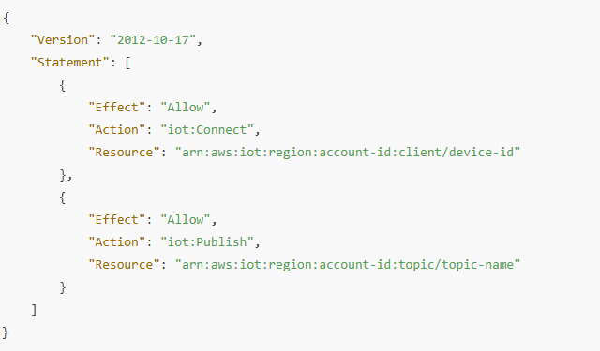
- IAM Policies:
  - AWS services or applications use IAM roles and policies to define permissions for accessing AWS IoT resources.
- Thing Groups and Attribute-Based Access Control (ABAC):
  - Devices are grouped, and permissions are assigned based on group attributes or tags.
- Fine-Grained Topic Authorization:
  - Control which devices or users can publish or subscribe to specific MQTT topics.

Workflow Example
- A device connects to AWS IoT Core using an X.509 certificate for authentication.
- AWS checks the IoT Policy attached to the certificate to ensure the device can connect.
- The device publishes data to a topic like sensors/temperature.
- AWS verifies the policy permissions for the topic to ensure the device is allowed to publish.
- If authorized, the message is processed and forwarded to its destination.

Best Practices:
- Use X.509 certificates for devices: It provides secure, mutual authentication.
- Minimize permissions: Use the principle of least privilege to restrict actions and resources.
- Rotate and revoke credentials: Replace expired or compromised certificates and keys.
- Enable logging: Use AWS IoT Device Defender to monitor and secure your IoT environment.
AWS IoT Authentication and Authorization ensure that your devices, users, and apps interact securely and only as allowed.

IoT THING REGISTRY = IAM OF IoT
- All connected IoT devices are represented in the AWS IoT registry.
- Organizes the resources associated with each device in the AWS cloud.
- Each device gets a unique ID.
- Supports meta data for each device (ex-Celsius vs Fahrenheit, etc..).
- Can create X.509 certificate to help IoT devices connect to AWS.
- IoT groups: group devices together and apply permissions to the group.

STORAGE
AWS S3
- Amazon S3 allows people to store objects (files) in “buckets” (directories).
- Buckets must have a globally unique name.
- Buckets are defined at region level.
- Naming convention
    - No uppercase
    - No underscore
    - 3-63 characters long
    - Not an IP
    - Must start with lowercase number or letter

AWS S3 OVERVIEW – OBJECTS
- Objects and Keys:
  - Every file stored in Amazon S3 is called an object.
  - Each object has a unique identifier called a Key, which is the full path to the file. For example:
    - <my_bucket>/my_file.txt refers to a file called my_file.txt.
    - <my_bucket>/my_folder/another_folder/my_file.txt refers to a file inside nested "folders."
- No Real Folders:
  - S3 doesn't have actual "directories" like a computer does. It just uses long key names with slashes (/) to look like folders in the interface.
- Object Values:
  - The content of the file is called the object value.
  - Maximum file size is 5 TB.
  - If the file is larger than 5 GB, you need to upload it in parts (called multi-part upload).
- Metadata:
  - Objects can have metadata, which are extra details stored as key-value pairs. These can be system or user-defined.

- Tags:
  - You can add up to 10 tags to an object (like labels or categories), which can be used for security or lifecycle rules.
- Version ID:
  - If versioning is enabled on a bucket, every object has a unique version ID. This allows you to keep track of and restore previous versions of the file.

AMAZON S3 – CONSISTENCY MODEL
The Amazon S3 Consistency Model defines how quickly data changes (like uploads, updates, or deletes) are visible in the system. Here's a simple breakdown:
- Strong Consistency for Writes and Updates:
  - When you upload a new object or update an existing one, the change is immediately visible.
  - Example: If you upload a file to S3 and then try to read it, you'll get the most recent version right away.
- Strong Consistency for Deletes:
  - If you delete an object, it will be immediately invisible (as if it's gone), even if you try to access it right after deletion.
- No "Eventual Consistency" Anymore:
  - Earlier, some operations in S3 used to take time to become visible (like updates or deletes), but now Amazon S3 provides strong consistency for all read and write operations.
This means you don't have to wait for changes to propagate—you always see the latest version of your data.

- Strong Consistency Since December 2020:
  - Starting in December 2020, Amazon S3 guarantees strong consistency for all operations.
- After a Successful Write (New PUT):
  - When you add a new file (object) to S3, it will immediately be available for reading.
- After Overwriting or Deleting an Object (PUT or DELETE):
  - If you update or delete an existing object, the changes will be immediately visible. No delay.
- For Any Subsequent Read:
  - When you try to read the file after writing or updating it, you’ll always get the latest version right away (Read-after-Write Consistency).
- For Any Subsequent List:
  - If you list the files in the bucket (e.g., viewing all objects), the changes will immediately show up (List Consistency).
In summary, whatever change you make (write, update, or delete) is instantly reflected when you access or list objects.

S3 STORAGE CLASSES
Amazon S3 (Simple Storage Service) offers storage classes to store data in the cloud based on its access patterns, durability, and cost requirements. Here's an easy-to-understand breakdown of these classes:

1. S3 Standard
- What it’s for: Frequently accessed data.
- Features:
  - High availability and durability.
  - Low latency and high performance.
  - Suitable for active data like websites, apps, or real-time analytics.
- Cost: Highest among the classes since it’s optimized for frequent access.
Use Cases:
- Hosting static websites or application data.
- Storing active logs or event data.
- Frequently accessed datasets like real-time analytics.
Important Points:
- Designed for 99.99% availability: Ensures your data is almost always accessible.
- Supports multipart upload for large files, improving upload efficiency.
- Default storage class in S3.

2. S3 Intelligent-Tiering
- What it’s for: Data with changing or unknown access patterns.
- Features:
  - Automatically moves your data between frequent and infrequent access tiers based on usage.
  - Optimized for cost savings without requiring manual management.
- Cost: Slightly higher than infrequent tiers but saves costs for unpredictable access.
Use Cases:
- Storing user-uploaded content where access patterns vary.
- Backup solutions where you may need frequent access to recent data but less frequent access to older versions.
- Machine learning datasets where access frequency changes unpredictably.
Important Points:
- Automatic tiering mechanism: Monitors and optimizes storage costs without manual intervention.
- No retrieval fees: Data retrieval costs are predictable.
- Ideal for datasets with unpredictable spikes in access.

3. S3 Standard-IA (Infrequent Access)
- What it’s for: Data you don’t access often but need immediately when required.
- Features:
  - Lower cost compared to S3 Standard.
  - Still provides high durability and quick access.
  - Best for backups, disaster recovery, or older files.
- Cost: Cheaper storage but with additional retrieval fees.
Use Cases:
- Disaster recovery copies of data that need immediate access when required.
- Infrequent financial transaction records for compliance purposes.
- Older project files you don’t access often but still need.
Important Points:
- 99.9% availability: Lower than Standard but still reliable.
- Retrieval costs apply, so it’s not suited for frequently accessed data.
- Provides low-cost storage for critical but rarely accessed data.

4. S3 One Zone-IA
- What it’s for: Infrequently accessed data stored in a single availability zone.
- Features:
  - Lower cost than Standard-IA.
  - Suitable for non-critical or easily reproducible data.
  - Risk: If the availability zone is disrupted, data might be lost.
- Cost: Lowest cost for infrequent data that doesn’t need multiple-zone durability.
Use Cases:
- Secondary backups that are easily reproducible.
- Data that doesn’t require multiple-zone resilience, such as media files.
- Analytics data outputs that can be regenerated if lost.
Important Points:
- Stored in a single Availability Zone: Cheaper than Standard-IA but less durable.
- Not recommended for data requiring high fault tolerance or critical recovery SLAs.
- Suitable for data where loss due to zone failure is acceptable.

5. S3 Glacier
- What it’s for: Archiving data that you rarely access.
- Features:
  - Very low cost.
  - Retrieval time ranges from minutes to hours depending on the retrieval option.
  - Good for compliance archives, older data, or data you need to keep but don’t use.
- Cost: Lowest cost per GB with retrieval charges.
Use Cases:
- Storing archived medical records or research data.
- Historical data for auditing purposes or compliance.
- Large datasets for occasional analysis or regulatory storage.
Important Points:
- 3 retrieval tiers: Expedited (1-5 minutes), Standard (3-5 hours), and Bulk (5-12 hours).
- Optimized for low-cost archiving, not frequent access.
- Good for data with compliance requirements for retention but not real-time access.
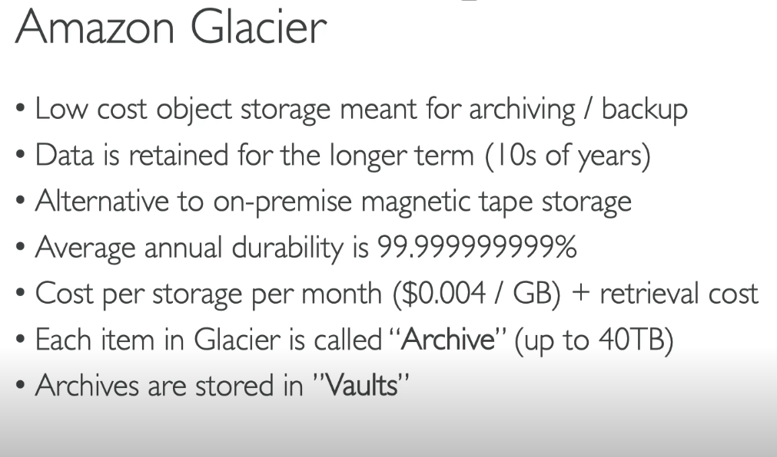

Amazon Glacier has 3 retrieval options:
The retrieval option in Amazon Glacier lets you decide how quickly you want to get your stored files back. Since Glacier is meant for long-term storage of rarely used data, there are different speeds (and costs) for retrieving files:
- Expedited (1 – 5 minutes)
- Costs more.
- Use it when you urgently need something.
- Best for: Emergency retrieval of small amounts of data.
- Standard (3 – 5 hours)
- Costs less than expedited.
- Good for normal access when you're not in a rush.
- Best for: Regular access to archived data where retrieval speed is not urgent.
- Bulk (5 – 12 hours)
- Cheapest option.
- Best for getting a lot of data when time isn't important.
- Best for: Archiving and retrieving large volumes of data that are infrequently needed.
Minimum storage duration of Amazon Clacier is 90 days.

- S3 Glacier Deep Archive
Amazon Glacier Deep Archive is a very low-cost storage service in AWS designed for long-term archiving of data that you rarely access. Just like Amazon Glacier, it allows you to store data for long periods (even decades), but Glacier Deep Archive is even cheaper and is meant for data that is almost never needed.
- What it’s for: Long-term data archiving (think years or decades).
- Features:
  - Cheapest storage option in S3.
  - Retrieval time: Hours.
  - Ideal for data that is rarely accessed but needs to be preserved, like regulatory archives.
- Cost: Nearly 75% cheaper than Glacier.
Use Cases:
- Storing legal or tax documents that need retention for decades.
- Archiving digital media like film masters or long-term storage of media files.
- Historical datasets rarely accessed but retained for strategic purposes.
Important Points:
- Longest retrieval time: 12+ hours for bulk retrieval.
- Designed for durable, low-cost, long-term storage.
- Good for "cold storage" use cases, where data isn’t accessed often.

Minimum storage duration of Deep Archive is 180 days
When you need to retrieve data from Amazon Glacier Deep Archive, you have different retrieval options that control how quickly you can get your data back and how much it costs. Here’s a simple explanation of these options:
1. Expedited Retrieval:
- How it works: This option is for when you need your data very quickly, like in an emergency.
- Time to get data: Your data will be available in 12 hours or less.
- Cost: This is the most expensive retrieval option.
- Use case: If you need a small amount of data quickly, like a legal document or critical file, you use this option.
2. Standard Retrieval:
- How it works: This is for when you can wait a little longer but still need data in a reasonable amount of time.
- Time to get data: Your data will be available in 1-5 hours.
- Cost: This option is cheaper than expedited retrieval but more expensive than bulk retrieval.
- Use case: This is suitable if you need data in a few hours but it’s not an urgent situation, like pulling archived records for a project.
3. Bulk Retrieval:
- How it works: This is the best option if you don't need your data quickly and you want to save money.
- Time to get data: Your data will be available in 12-48 hours.
- Cost: This is the cheapest option and is ideal for large volumes of data.
- Use case: If you have a huge amount of data (like old backups) and can afford to wait, this is the most cost-effective way to retrieve it.
Why These Options Matter:
- Cost vs. Speed: Glacier Deep Archive is designed to be very cheap, but retrieving data takes longer than regular storage services. These options let you balance how fast you need your data against how much you're willing to pay.
- Choosing the right option:
  - Expedited is for emergencies (small, quick retrievals).
  - Standard is for typical access (reasonable speed for moderately urgent needs).
  - Bulk is for large data with no time pressure (very cheap for large volumes of data).

7. S3 Reduced Redundancy Storage (Deprecated)
- What it’s for: Non-critical data that doesn’t need full durability.
- Features:
  - Focused on cost-saving with reduced redundancy.
  - Amazon now recommends other storage classes for better reliability at lower costs.

How to Choose the Right Class:
- Frequently Used Data: Go for S3 Standard.
- Unpredictable Access Patterns: Use S3 Intelligent-Tiering.
- Rarely Accessed but Important: Opt for S3 Standard-IA or One Zone-IA.
- Archival Data:
  - Choose S3 Glacier for occasional retrieval.
  - Use S3 Glacier Deep Archive for long-term storage.
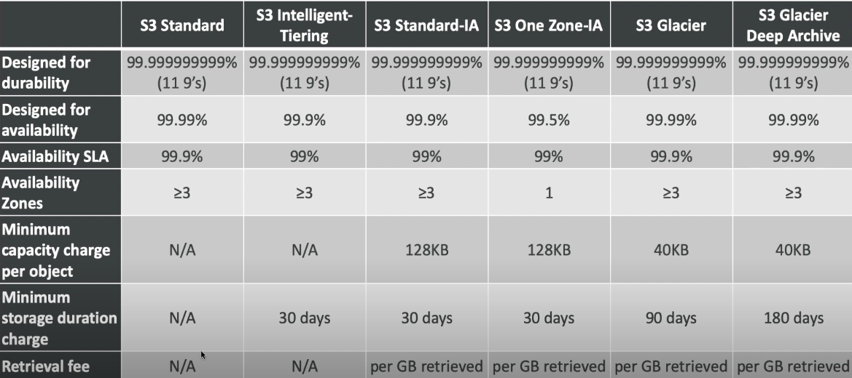
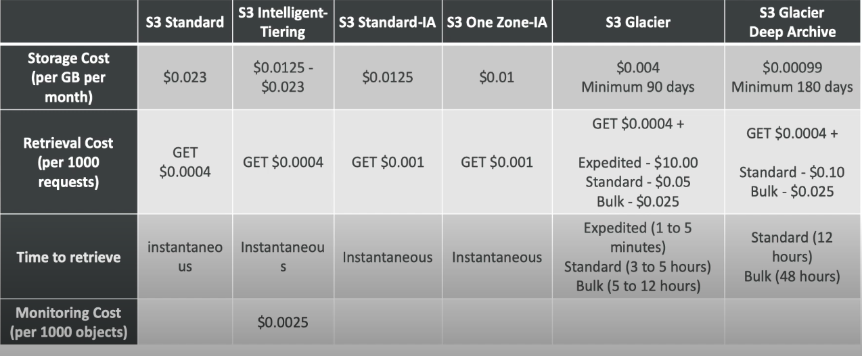

S3 – MOVING BETWEEN STORAGE CLASSES
- We can transition objects between storage classes.
- For infrequently accessed object, move them to standard IA.
- For archive objects, you don’t need in real-time, Glacier or Deep-Archive.
- Moving objects can be automated using a lifecycle configuration.

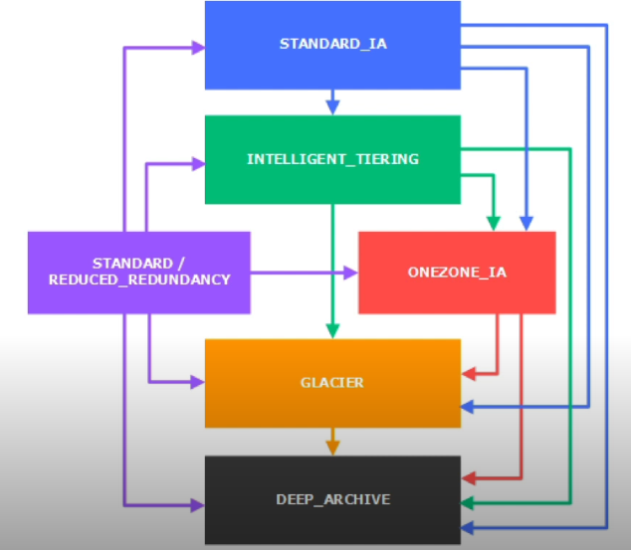
S3 – LIFECYCLE RULES
Amazon S3 allows you to set rules to manage how your data is stored or deleted automatically. These rules are divided into Transition actions and Expiration actions:

Transition Actions
- This tells S3 when to move files to cheaper storage types to save money.
- Example 1: Move files to a "cheaper but slower" storage class (Standard IA) 60 days after they are created.
- Example 2: Archive files to Glacier (even cheaper storage, used for long-term backup) after 6 months.

Expiration Actions
- This tells S3 to delete files after a certain time to save space.
- Example 1: Automatically delete access log files after 1 year (365 days).
- Example 2: Remove old versions of files if you've enabled versioning (keeping track of multiple file versions).
- Example 3: Delete incomplete file uploads if someone started uploading but never finished.

Rules for Specific Folders
- You can apply these rules to specific folders or file groups in your bucket.
  - Example: Apply rules only to files in 
- Rules can be created for certain object tags (ex: Department: Finance)
This system helps save costs and manage storage more efficiently!

S3 LIFECYCLE RULES – SCENARIO 1
Your application on EC2 creates image thumbnails after profile photos are uploaded to Amazon S3. These thumbnails can easily be recreated and only need to be kept for 45 days. The source image should be able to be immediately retrieved for these 45 days, and afterwards the user can wait up to 6 hours. How would I design this?

- S3 source image can be on STANDARD, with a lifecycle configuration to transition them to GLACIER after 45 days.
- S3 thumbnails can be on ONEZONE_IA with a lifecycle configuration to expire them (delete) after 45 days

SCENARIO 2
A rule in your company states that you should be able to recover your deleted S3 objects immediately for 15 days, although this may happen rarely. After this time, and for up to 365 days, deleted objects should be recoverable within 48 hours.
- You need to enable S3 versioning in order to have object versions, so that “deleted objects” are in fact hidden by a “delete marker” and can be recovered.
- You can transition these “non-current versions” of the object to S3_IA.
- You can transition afterwards these “non-current versions” to DEEP ARCHIVE.
Problem Statement:
Your company has a policy that requires:
- Immediate recovery of deleted files for the first 15 days (as it may happen rarely).
- Recovery within 48 hours for up to 365 days after deletion.
You need to manage this without permanently losing any data.

Solution: Using S3 Versioning and Lifecycle Rules
To achieve this, you can follow these steps:
- Enable S3 Versioning:
  - With versioning enabled, when you "delete" a file, it is not erased completely.
  - Instead, a "delete marker" is created. This hides the file but allows you to recover it.
- Transition Old Versions to Cheaper Storage:
  - Files that are deleted (but not permanently erased) are called non-current versions.
  - After 15 days, you can move these non-current versions to S3 Infrequent Access (S3-IA).
    - This storage class is cheaper but still allows quick recovery (within minutes).
- Archive for Long-Term Storage:
  - After 365 days, you can move the non-current versions to Glacier Deep Archive.
    - This is a much cheaper storage option but has slower recovery times (up to 48 hours).

How It Works Step-by-Step:
- First 15 Days:
  - The original object or non-current version stays in S3 Standard for immediate recovery.
- Day 16 to Day 365:
  - The non-current versions are transitioned to S3-IA, saving costs while maintaining relatively fast recovery.
- After 365 Days:
  - The non-current versions are transitioned to Glacier Deep Archive, where recovery is slower but very cost-efficient.

Outcome:
- For the first 15 days, deleted objects are recoverable immediately.
- From day 16 to day 365, deleted objects are still recoverable quickly (from S3-IA).
- After 365 days, deleted objects are archived at minimal cost and recoverable within 48 hours (from Glacier Deep Archive).
This lifecycle policy ensures your company meets its recovery requirements while minimizing storage costs.

Scenario 3: Reducing Costs for Old, Rarely Accessed Files
Problem Statement:
Your application generates daily reports that are accessed frequently for the first month but rarely after that. Keeping them in S3 Standard storage becomes expensive over time.
Solution:
Use lifecycle transition rules to move files to cheaper storage classes.
- Store the reports in S3 Standard for the first 30 days.
- Automatically move them to Standard-IA (Infrequent Access) after 30 days.
- Archive them to Glacier after 6 months.
Outcome:
- You save costs by using cheaper storage classes for older files.
- Retrieval speed decreases for archived files, but they are still accessible if needed.

Scenario 4: Automatically Deleting Log Files
Problem Statement:
Your web application generates log files every day. These logs are useful for debugging for only the first year, and storing them beyond that increases your costs unnecessarily.
Solution:
Use expiration rules to automatically delete files after a set period.
- Keep logs in S3 Standard for 365 days.
- Delete the logs automatically after 1 year.
Outcome:
- Old, unnecessary files are deleted without manual effort.
- You save space and reduce storage costs.

Scenario 5: Managing Old File Versions
Problem Statement:
You enabled versioning in your S3 bucket to track changes to files. Over time, this creates multiple versions of files, which increases your storage costs unnecessarily.

Solution:
Use expiration rules for non-current file versions to delete older versions.
- Keep the most recent file version active.
- Delete all older versions after 30 days.
Outcome:
- The latest version of each file is retained while old, unneeded versions are removed.
- Storage is optimized by keeping only the necessary data.

Scenario 6: Cleaning Up Incomplete Uploads
Problem Statement:
Users upload large files, but some uploads fail or are abandoned midway. These incomplete uploads occupy storage unnecessarily.
Solution:
Use expiration rules for incomplete multipart uploads to automatically clean up.
- Set a rule to delete incomplete uploads after 7 days.
Outcome:
- Partially uploaded files are removed automatically.
- You avoid wasting storage on incomplete data.

Scenario 7: Managing Data in Specific Folders
Problem Statement:
Your bucket contains different types of files, such as images, videos, and logs. You want to manage storage differently for each file type:
- Images should be stored for long-term access.
- Videos should be archived after 6 months.
- Logs should be deleted after 1 year.
Solution:
Use prefix-based lifecycle rules to apply different rules to different file types.
- Apply transition rules to the images/ folder to move images to Standard-IA after 30 days.
- Apply transition and expiration rules to the videos/ folder to archive videos to Glacier after 6 months and delete after 2 years.
- Apply expiration rules to the logs/ folder to delete logs after 1 year.
Outcome:
- Each type of data is managed according to its usage patterns.
- Costs are minimized, and the bucket stays organized.

Scenario 8: Long-Term Archival of Rarely Used Files
Problem Statement:
Your organization must keep legal documents and audit logs for 7 years due to compliance requirements, but these files are rarely accessed.
Solution:
Use transition rules to archive data for long-term storage.
- Keep files in S3 Standard for the first 30 days.
- Move files to Glacier Deep Archive after 30 days for long-term storage.
Outcome:
- Files are stored at a very low cost.
- They remain accessible when needed, but retrieval takes more time.

Scenario 9: Data Retention for Compliance
Problem Statement:
Your organization must retain customer data for 3 years to meet regulatory requirements, after which it should be deleted.
Solution:
Use expiration rules to delete data after a specific time.
- Retain files in S3 Standard for 3 years.
- Automatically delete files after 3 years to comply with regulations.
Outcome:
- Files are retained as required by law.
- Data is automatically deleted when no longer needed, reducing the risk of compliance violations.

Benefits of S3 Lifecycle Rules:
- Cost Savings: Automatically transition or delete files to reduce storage expenses.
- Automation: No manual intervention needed for file management.
- Compliance: Ensure proper data retention and deletion policies.
- Efficiency: Manage data effectively based on its access patterns.

AMAZON S3 VERSIONING
What is S3 Versioning?
- S3 Versioning is a feature in Amazon S3 that helps keep track of every version of an object stored in a bucket.
- If you upload, update, or delete a file, S3 keeps a history of all the versions of that file.

Key Features of S3 Versioning
- Keep All Versions:
  - Every time you upload or update an object, a new version is created.
  - Old versions are not deleted automatically. They are kept safe.
Example:
  - You upload a file named report.pdf.
  - Later, you update report.pdf with new content.
  - S3 now has two versions of report.pdf — one from the original upload and one from the update.

- Recover Deleted Objects:
  - When you delete an object, it doesn’t actually get deleted. Instead, S3 adds a “delete marker” to the object.
  - You can recover the object by removing the delete marker.
Example:
  - You delete report.pdf. It will appear as if it’s gone, but the old versions are still there.
  - You can recover the file by restoring its previous version.

- Protect Against Accidental Changes:
  - Versioning protects you from accidentally overwriting or deleting important files because you can always revert to an older version.
Example:
  - If someone accidentally changes report.pdf with incorrect data, you can retrieve the correct version easily.

- Enable MFA Delete:
  - With Multi-Factor Authentication (MFA), you can add an extra layer of security for deleting versions.
  - This ensures that even if someone has access to your S3 bucket, they can’t delete files without an additional authentication step.
Example:
  - A hacker tries to delete files but can’t because they don’t have access to the MFA device.

How to Enable S3 Versioning
- Go to the S3 Management Console.
- Select the bucket where you want to enable versioning.
- Click on the Properties tab.
- Under Bucket Versioning, click Enable.

Storage and Cost Implications
- Storage: Every version of an object counts as additional storage. If a file has multiple versions, all versions are stored separately.
- Cost: You will be charged for the storage of all versions. Regularly clean up unnecessary versions to manage costs.

Use Cases for S3 Versioning
- Backup and Recovery:
  - Maintain a backup of files to recover from accidental deletions or overwrites.
  - Perfect for legal or compliance requirements where records must be retained.
- Software or Document Updates:
  - Track changes in files or software updates over time.
  - Revert to an earlier version if needed.
- Disaster Recovery:
  - Protect your data from accidental deletion or unauthorized access.
Important Notes
- Default Setting: S3 Versioning is disabled by default. You need to enable it manually for each bucket.
- Irreversible: Once enabled, you cannot disable versioning, but you can suspend it (which stops creating new versions but keeps old ones).

By enabling S3 Versioning, you add a layer of protection to your data, ensuring that every change or deletion can be undone. This is especially useful for businesses that deal with critical data.

S3 REPLICATION (CRR & SRR)
- Must enable versioning in source and destination.
- Cross Region Replication (CRR)
- Same Region Replication (SRR)
- Buckets can be in different accounts
- Must give proper IAM permission to S3.
1. Cross-Region Replication (CRR):
CRR enables you to replicate data across different AWS regions. This is particularly useful for compliance, low-latency access, and disaster recovery.
Key Features of CRR:
- Data Distribution: Copies objects to a bucket in a different region.
- Compliance: Helps meet legal and regulatory requirements by storing data across geographically distant locations.
- Low-Latency Access: Provides faster access to users in different regions.
- Disaster Recovery: Ensures data availability in case of a region-wide failure.
Example Use Case:
- A company based in North America wants to ensure its data is available in Europe for compliance reasons and to provide better performance to European customers.
How It Works:
- Enable versioning on both the source and destination buckets.
- Set up a replication rule to specify the region and target bucket.
- Objects created in the source bucket are replicated asynchronously to the target bucket in another region.

2. Same-Region Replication (SRR):
SRR enables replication of data within the same AWS region. It helps with data compliance, aggregation, and managing data across multiple accounts.
Key Features of SRR:
- Data Aggregation: Consolidates data into a central bucket within the same region.
- Compliance: Satisfies requirements to store data copies within the same country/region.
- Account Isolation: Replicates data between buckets in separate accounts for better access control.
- Backup: Creates additional data copies for backup purposes within the same region.
Example Use Case:
- A company wants to maintain two copies of its data within the same AWS region to comply with local government regulations while ensuring access control.
How It Works:
- Enable versioning on both the source and destination buckets.
- Configure SRR with the same steps as CRR but specify a bucket in the same region.

Common Features of CRR and SRR:
- Selective Replication: You can define rules to replicate specific objects (e.g., based on prefix or tag).
- Versioning Support: Replication works only if versioning is enabled on both buckets.
- Retention Policies: Use bucket policies to ensure replicated objects have the same or different lifecycle rules.
- Asynchronous Process: Replication is not instant; it happens eventually.
- Encryption: Supports objects encrypted with AWS-managed or customer-managed keys.
Steps to Set Up Replication:
- Enable versioning on both the source and destination buckets.
- Go to the S3 console → Choose the bucket → Select Management tab.
- Create a replication rule:
  - Specify the destination bucket (different for CRR, same for SRR).
  - Add filters (e.g., prefix or tags).
- Specify IAM roles and permissions for replication.
- Save the configuration.

Additional Points to Note:
- Replication Time Control (RTC): Guarantees replication within 15 minutes for CRR.
- Costs: You’re charged for data transferred and storage in the target bucket.
- Deleted Objects: CRR and SRR do not replicate delete markers by default, but you can enable this if needed.

Summary of Use Cases:
- CRR:
  - Disaster recovery between regions.
  - Compliance for storing data in specific geographical regions.
  - Lower latency for global users.
- SRR:
  - Backups within the same region for redundancy.
  - Data aggregation across multiple accounts.
  - Compliance with local laws to keep data within the same region.
Use Cases of Cross-Region Replication (CRR):
- Disaster Recovery:
  - CRR ensures a backup of your data is available in a geographically distant AWS region, helping to restore operations during a region-wide outage.
Example: A company in the US replicates data to an AWS region in Europe to ensure availability in case of a natural disaster in the US.
- Compliance Requirements:
  - Organizations with regulatory needs to store data in specific regions can use CRR to meet these requirements.
Example: A company dealing with European customer data replicates its US-stored data to the European region to comply with GDPR.
- Global Data Distribution:
  - Enables low-latency access for users worldwide by replicating data to regions closer to the end-users.
Example: An e-commerce platform replicates product images to AWS regions in Asia, Europe, and North America to improve customer experience.
- Separation of Workloads:
  - Replicate data to different regions to separate production and development/testing environments.
Example: Replicate production logs to another region for analysis without affecting the live system.
- Data Migration:
  - Helps migrate data gradually from one AWS region to another without downtime.
Example: A company expanding its operations in Asia replicates its data from the US to the Singapore region for a seamless transition.

Use Cases of Same-Region Replication (SRR):
- Data Aggregation:
  - Consolidate data from multiple buckets into a central bucket within the same region for better management.
Example: A company collecting logs from various accounts consolidates them into a single bucket for analytics.
- Compliance with Local Regulations:
  - Some regulations require data to be stored within the same country or region, making SRR essential.
Example: A financial institution in India replicates its data within the Mumbai region to comply with local laws.
- Backup and Redundancy:
  - Create additional backups within the same region to enhance data durability and prevent accidental data loss.
Example: A company replicates its application backups to a separate bucket in the same region for redundancy.
- Multi-Account Access:
  - Organizations with multiple AWS accounts can use SRR to replicate data between accounts in the same region for better access control.
Example: A central analytics team accesses replicated data from a production bucket managed by a different account.
- Separation of Workloads:
  - Replicate data to a different bucket for different processing tasks without impacting the original data.
Example: A media company replicates video files to another bucket for transcoding tasks.
- Bucket Ownership Transfer:
  - SRR can be used to replicate data to a bucket owned by another AWS account within the same region.
Example: A startup replicates its data to a bucket owned by its partner for joint processing while retaining original data ownership.
1. Only New Objects Are Replicated
- When you turn on replication, it will only copy new files (objects) that you upload after turning it on.
- Files that were already in your bucket before replication was turned on will not be copied.
Example:
- You have a bucket with 100 photos.
- You turn on replication today.
- If you upload a new photo tomorrow, that new photo will be copied to the second bucket.
- The 100 old photos will stay in the first bucket and won’t be copied.

2. Delete Operations
This explains what happens when you delete files (or versions of files) in the first bucket:
- Delete Markers Can Be Copied:
If you delete a file, a "delete marker" is added in the bucket. It’s like a note saying, "This file was deleted."
You can set up replication so that the second bucket also gets this "delete marker." This way, the file will look deleted in both buckets.
Example:
  - You delete a file called report.pdf in the first bucket.
  - If replication is set to copy delete markers, the second bucket will also "hide" the file as deleted.
- Deleting a Specific Version Won’t Be Copied:
If you delete an older version of a file, this deletion won’t be copied to the second bucket. This is to stop mistakes or intentional deletions from being spread.
Example:
  - Let’s say you have 3 versions of a file: draft1.doc, draft2.doc, final.doc.
  - If you delete the draft1.doc version from the first bucket, it won’t be deleted in the second bucket.

3. No Chaining of Replication
- S3 replication doesn’t work like a domino effect or chain. If you have Bucket 1 → Bucket 2 → Bucket 3, the files from Bucket 1 will only go to Bucket 2. They won’t continue automatically to Bucket 3.
Example:
- You upload a file to Bucket 1.
  - This file gets copied to Bucket 2.
  - But it will not be copied to Bucket 3 unless you set up separate replication from Bucket 2 to Bucket 3.
- If you upload a file directly to Bucket 2, that file will be copied to Bucket 3 (because you set up replication for Bucket 2 → Bucket 3).

Why Do These Rules Exist?
- To prevent mistakes:
S3 wants to make sure your old data isn’t moved accidentally or your important file versions aren’t deleted across buckets.
- To give you control:
You decide exactly what gets copied, deleted, or left behind.

AWS S3-BASELINE PERFORMANCE
• Automatic Scaling: Amazon S3 can handle a lot of requests automatically. It also has a quick response time, typically between 100-200 milliseconds.
• High Request Rates: S3 allows your application to handle:
- 3,500 requests per second for actions like adding, copying, or deleting files.
- 5,500 requests per second for reading files or checking their details.
• Unlimited Prefixes: You can organize your files into unlimited "prefixes" (like folders or paths). There’s no restriction on how many of these you can have in one bucket.
• Prefix Example:
- If your file path is bucket/folder1/sub1/file, the prefix is /folder1/sub1/.
- Each prefix is like a separate "area" within the bucket, allowing S3 to manage traffic better.
• Boosting Performance:
- By spreading requests evenly across different prefixes, you can achieve up to 22,000 requests per second for reading files.

What is a "Prefix"?
- A prefix is like the "path" or "folder structure" of a file in an S3 bucket. It is the part of the file path that comes before the actual file name.
- For example:
  - If the full file path is bucket/folder1/sub1/file, the prefix is /folder1/sub1/.
  - Think of it as how your files are organized in folders on your computer. The prefix groups files under a common "path."
Why is a Prefix Important in S3?
- S3 uses prefixes to manage performance. Each prefix acts like a separate "lane" in a highway where traffic (requests) can flow. This helps S3 handle more requests without slowing down.
- By dividing files into multiple prefixes, you allow S3 to distribute the load more evenly, so it can process requests faster.

S3 – KMS LIMITATION
1. SSE-KMS May Have Limits
- If you use SSE-KMS (Server-Side Encryption with AWS Key Management Service) to encrypt your files in S3, your application might be affected by the limits of KMS.
- KMS can only handle a certain number of requests per second, and if you exceed this limit, you might experience delays.

2. What Happens When You Upload a File?
- When you upload a file to an S3 bucket with SSE-KMS encryption enabled, S3 asks KMS to create a Data Key using the GenerateDataKey API.
- This key is used to encrypt your file before storing it in the bucket.

3. What Happens When You Download a File?
- When you download a file that’s encrypted with SSE-KMS, S3 asks KMS to decrypt the file using the Decrypt API.
- This allows the encrypted file to be readable by the user.

4. Quota for KMS Requests
- The number of requests to KMS per second has a limit, which depends on your AWS region. Common limits are:
  - 5,500 requests/second
  - 10,000 requests/second
  - 30,000 requests/second
- If your uploads/downloads exceed this quota, you might hit the limit and experience delays.

5. Increasing the Limit
- If your application requires more KMS requests per second than the default limit, you can request AWS to increase this limit using the Service Quotas Console.

Visual Summary (from the image):
- Users: Upload/download files.
- S3 Bucket: Stores the files.
- KMS Key: Encrypts/decrypts the files.
  - Upload calls the GenerateDataKey API.
  - Download calls the Decrypt API.
In short, using SSE-KMS adds security but introduces a limit on how many files you can upload/download per second due to KMS request quotas.

S3 – PERFORMANCE
- MULTI-PART UPLOAD:
- Recommended for files > 100MB
Must use for files > 5GB
- Can help parallelize uploads (speed up transfers)
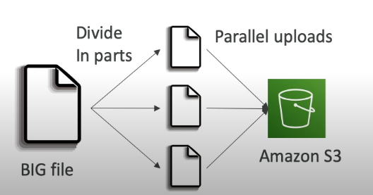

- S3 TRANSFER ACCELERATION
- Increase transfer speed by transferring file to AWS edge location, which will forward the data to the S3 bucket in the target region.
- Compatible with multi-part upload.
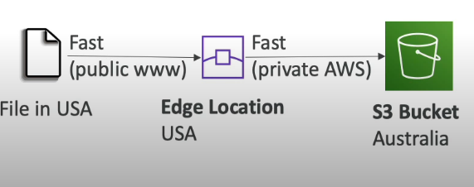
S3 Transfer Acceleration is a feature of Amazon S3 that helps you upload and download files faster, especially if you're far away from the AWS region where your S3 bucket is located. Here's how it works in simple terms:

What is S3 Transfer Acceleration?
- Normally, when you upload or download files to/from S3, your data takes a long path through the internet to reach the AWS data center where your S3 bucket is located.
- With Transfer Acceleration, your data travels through Amazon's global network, which is faster and more optimized compared to the regular internet.

How Does it Work?
- Data enters at the nearest AWS edge location:
  - When you upload a file, the data first goes to the AWS location closest to you (called an edge location). These are spread around the world.
- Data travels through AWS's private network:
  - From the edge location, your data moves quickly through Amazon's high-speed internal network to reach your S3 bucket in its region.
- Download works similarly:
  - When you download files, the process happens in reverse. Data comes from the S3 bucket, travels through Amazon's network, and exits at the edge location nearest to you.

Why is it Faster?
- Amazon's private network is faster and more reliable than the public internet.
- The edge locations are spread globally, so your data doesn’t have to take a long route.

When Should You Use It?
- Use it if:
  - You’re working with large files (like videos or backups).
  - Your team or customers are in different parts of the world and need to upload/download files quickly.
  - You experience slow transfer speeds when uploading to S3.

Is There an Extra Cost?
- Yes, using Transfer Acceleration costs a bit more than normal S3 operations, but it can save time, which might be worth it for certain use cases.

Simple Analogy:
Imagine sending a package across the world.
- Without Transfer Acceleration: The package takes a regular shipping route with possible delays.
- With Transfer Acceleration: The package gets sent via a private, faster courier service, reaching its destination more quickly.

S3 BYTE-RANGE
What is S3 Byte-Range?
S3 Byte-Range allows you to download only a specific part of a file (or object) stored in S3 instead of downloading the whole file. It’s especially useful for working with large files because you can save time, bandwidth, and cost by fetching only the parts you need.

How Does It Work?
- Divide a File into Bytes:
  - Think of a file as a long row of numbered bytes (small chunks of data). For example:
    - A file with 1,000 bytes can be split into ranges like 0–499 and 500–999.
  - Instead of downloading all 1,000 bytes, you can ask for just the range you need.
- Request Specific Ranges:
  - When downloading a file, you can use S3’s API to say, “Give me bytes from 100 to 200.”
  - S3 responds by sending only that specific portion of the file.

Why Use Byte-Range?
- Faster Downloads for Large Files:
  - If you only need a part of a file, it’s much quicker than downloading the entire thing. For example:
    - Need just the first 10 seconds of a 1GB video? Use Byte-Range to fetch only that part.
- Resume Downloads:
  - If a download is interrupted, you can restart from where it stopped instead of starting over. For example:
    - If the first 500MB of a file is downloaded, you can request the remaining bytes (e.g., 500MB to 1GB).
- Parallel Downloads:
  - You can download different parts of a large file simultaneously by requesting multiple byte ranges in parallel. This can make the overall download faster.

Examples:
- A 1GB file is stored in S3.
  - You only need the first 100MB → Use Byte-Range to request bytes 0–104857599.
  - S3 sends only the first 100MB.
- You’re working with a log file that’s 2GB.
  - Instead of downloading the entire file, you can fetch just the last 10MB (e.g., bytes 1990MB to 2000MB) to check the most recent logs.
- Your download stopped at 50% for a 5GB file.
  - Restart the download by requesting bytes 2.5GB to 5GB.

Key Benefits of Byte-Range:
- Efficiency: Download only the data you need.
- Cost Savings: Reduces bandwidth usage and associated costs.
- Flexibility: Ideal for video streaming, large datasets, or log analysis where specific parts of a file are needed.

Simple Analogy:
Imagine a big book with 1,000 pages in a library.
- Without Byte-Range: You’d have to borrow the entire book, even if you only need pages 10–20.
- With Byte-Range: You can photocopy just the pages you need (e.g., pages 10–20) without taking the whole book.

S3 ENCRYPTION FOR OBJECTS
What is S3 Encryption?
S3 Encryption is like putting a lock on your data stored in Amazon S3 so no one can access it without the right key. It ensures your files (objects) are protected, even if someone gains unauthorized access to the S3 storage.

Why Use S3 Encryption?
- To keep your sensitive data private.
- To comply with security policies and regulations.
- To prevent unauthorized access, both during file upload/download and while stored.

Types of Encryption in S3
S3 offers encryption in two stages:
- Encryption in Transit:
  - Protects data while it’s moving between your computer and S3 (e.g., during upload/download).
  - Uses HTTPS (a secure communication protocol).
- Encryption at Rest:
  - Protects data stored in S3.
  - This is what we’ll focus on, and it has four main methods:

1. Server-Side Encryption with Amazon S3 Managed Keys (SSE-S3)
- What It Does:
  - S3 encrypts your files using keys it manages for you.
  - You don’t need to manage or create encryption keys.
- How It Works:
  - When you upload a file, S3 automatically encrypts it.
  - When you download the file, S3 automatically decrypts it.
- Simple Analogy:
  - Think of S3 as a locker system at a gym. S3 provides a lock and manages the key for you.

2. Server-Side Encryption with AWS Key Management Service (SSE-KMS)
- What It Does:
  - S3 encrypts your files using keys managed by AWS Key Management Service (KMS).
  - You have more control over the keys compared to SSE-S3.
- How It Works:
  - AWS KMS generates and manages the keys.
  - You control who can use the keys using AWS Identity and Access Management (IAM) policies.
- Simple Analogy:
  - This is like renting a safety deposit box at a bank. You can control who has access to the box, and the bank helps manage the key.

3. Server-Side Encryption with Customer-Provided Keys (SSE-C)
- What It Does:
  - S3 encrypts your files, but you provide and manage your own encryption key.
- How It Works:
  - Every time you upload or download a file, you provide your encryption key.
  - S3 uses the key to encrypt/decrypt the data but doesn’t store the key.
- Simple Analogy:
  - It’s like using your own lock on a gym locker. You bring your lock and key every time, and the gym doesn’t keep a copy of your key.

4. Client-Side Encryption
- What It Does:
  - You encrypt your files on your own computer before uploading them to S3.
  - The files remain encrypted in S3, and you decrypt them after downloading.
- How It Works:
  - You manage the entire encryption and decryption process using your own tools or AWS SDKs.
- Simple Analogy:
  - It’s like sealing your valuables in a locked suitcase before giving it to a storage facility. Only you know the combination to open the suitcase.
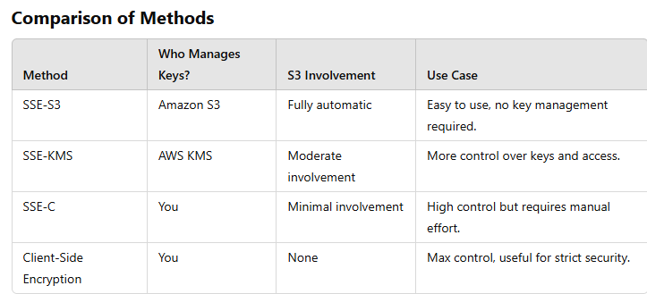
Key Takeaways
- S3 Encryption adds a layer of protection for your data.
- If you want simple encryption, go with SSE-S3.
- If you want more control, use SSE-KMS or SSE-C.
- For maximum security, manage everything yourself with Client-Side Encryption.

S3 SECURITY
Amazon S3 (Simple Storage Service) helps you securely store and manage data. To keep your files safe, S3 provides several features to control access, protect data, and monitor usage. Let’s break it down in simple terms:

1. Controlling Who Can Access Your Data
S3 allows you to decide who can access your files and what they can do with them.
a. IAM (Identity and Access Management)
- You create users and give them specific permissions.
- Example: Allow one user to upload files and another user only to view them.
b. Bucket Policies
- You can write rules for the whole bucket.
- Example: Only let people from your office network access the bucket.
c. Access Control Lists (ACLs)
- These are rules for individual files or folders inside the bucket.
- Example: Allow one person to download a specific file.
d. Block Public Access
- A quick setting to stop the bucket or files from being accessible to anyone on the internet.

2. Protecting Data with Encryption
Encryption means converting your data into a secret code so it’s unreadable without the right key.
a. Server-Side Encryption (SSE)
Amazon S3 encrypts your data for you.
- SSE-S3: S3 handles everything, including managing the keys.
- SSE-KMS: You manage the keys using AWS Key Management Service (KMS).
- SSE-C: You bring your own key, and S3 uses it for encryption.
b. Client-Side Encryption
- You encrypt the data yourself before uploading it to S3.

3. Protecting Data from Accidental Deletions
a. Versioning
- S3 keeps different versions of your files.
- If someone deletes a file, you can restore an older version.
b. MFA (Multi-Factor Authentication) Delete
- To delete something, you need an extra code from your phone. This makes accidental or unauthorized deletion harder.

4. Monitoring and Tracking
S3 helps you keep track of who is doing what with your files.
a. Access Logs
- Record every action on your bucket, like who uploaded or downloaded files.
b. AWS CloudTrail
- Tracks all API calls to your S3, such as who created or deleted a bucket.
c. Amazon GuardDuty
- Detects unusual activity, like someone trying to access your files from a strange location.

5. Network Security
a. HTTPS
- Ensures all data sent to or from S3 is encrypted during transfer.
b. VPC Endpoint
- Keeps S3 traffic private within your AWS Virtual Private Cloud (VPC), so it doesn’t go through the public internet.

6. Extra File Protection with Object Lock
- Object Lock prevents files from being deleted or changed for a specific time.
- Example: Use it for legal documents you must keep for a certain period.

7. Best Practices for S3 Security
- Turn on encryption for all files.
- Block public access unless it’s absolutely necessary.
- Use MFA Delete for critical buckets.
- Regularly audit permissions to ensure only the right people have access.
- Use logs and monitoring tools to keep an eye on activity.

S3 BUCKET POLICIES
- JSON Based Policies
- Resources: Buckets and object
- Actions: Set of API to Allow or Deny
- Effect: Allow or Deny
- Principal: The account or user to apply the policy to
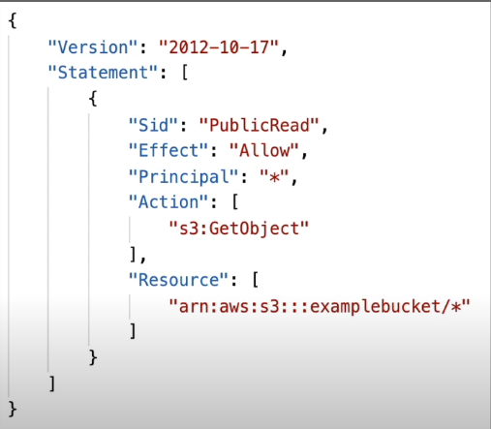
- Use S3 Bucket for policy to:
- Grant public access to the bucket.
- Force objects to be encrypted at upload.
- Grant Access to another account (Cross Account)

S3 SETTINGS FO BLOCK PUBLIC ACCESS
Amazon S3 provides a feature called "Block Public Access" to prevent your files and buckets from being accidentally or intentionally exposed to the public (i.e., anyone on the internet). Let’s break it down step by step:

What is "Block Public Access"?
- It’s a safety feature that stops people from publicly accessing your bucket or files unless you explicitly allow it.
- By default, it blocks public access unless you configure your bucket to be shared intentionally.

Why is it Important?
- Keeps your data private and secure.
- Prevents accidental exposure, especially if you’re handling sensitive data.

Four Main Settings in "Block Public Access"
When you set up Block Public Access, you’ll see these four options:
- Block Public ACLs (Access Control Lists)
  - What it does: Stops anyone from adding rules (ACLs) to make your files or bucket public.
  - Example: Even if someone tries to share your bucket with "everyone," this setting will block it.
- Ignore Public ACLs
  - What it does: Completely ignores any public access rules already applied to your files or bucket.
  - Example: Even if a file is marked as public, this setting will make it private.
- Block Public Bucket Policies
  - What it does: Prevents you from writing a bucket policy that allows public access.
  - Example: If you try to create a rule that says "anyone can download files," this setting will block it.
- Restrict Public Access to Specific IPs
  - What it does: Allows only certain users or IP addresses (like office networks) to access your bucket while blocking others.
  - Example: You can let your team access the bucket while keeping it hidden from everyone else.

How to Enable Block Public Access
- Open your S3 bucket in the AWS Console.
- Go to the "Permissions" tab.
- Under "Block Public Access," click "Edit."
- Turn on all the settings (or only the ones you need):
  - Block public ACLs.
  - Ignore public ACLs.
  - Block public bucket policies.
  - Restrict public access.
- Save the changes.

Can You Allow Public Access for Specific Use Cases?
Yes! If you need to make a bucket public (e.g., hosting a website), you can:
- Turn off "Block Public Access."
- Set up a bucket policy or ACL to allow public access intentionally.

Best Practices
- Always enable Block Public Access unless you absolutely need public access.
- Regularly review your bucket settings to ensure no accidental exposure.
- Use logs and monitoring tools (e.g., CloudTrail) to track who accesses your data.

S3 SECURITY - OTHER
1. Networking Security
This ensures that data can only flow through trusted and safe networks.
Key Features:
- Private Access with VPC Endpoints
  - What it does: Allows S3 to be accessed only through a Virtual Private Cloud (VPC), which is like your private network inside AWS.
  - Example: Your S3 bucket can only be accessed by your company's servers, not the public internet.
- Restrict Access by IP Address
  - What it does: You can create rules that only allow certain IP addresses (like office networks) to access your bucket.
  - Example: If your office IP is 192.168.1.1, you can restrict S3 access to that IP.
- Use HTTPS for Secure Data Transfer
  - What it does: Makes sure data transferred between S3 and users is encrypted while moving, so no one can intercept it.
  - Example: Files sent to S3 are encrypted during upload and download.

2. Logging and Auditing
This helps you track who is accessing your bucket, what they are doing, and when.
Key Features:
- Server Access Logging
  - What it does: Records all requests made to your bucket, such as uploads, downloads, or failed access attempts.
  - Example: You can see if someone tried to access your bucket from an unknown location.
- AWS CloudTrail
  - What it does: Tracks all actions performed on S3 at the account level.
  - Example: If someone changes a bucket's permissions, CloudTrail will log who made the change and when.
- S3 Object-Level Logging
  - What it does: Tracks actions on individual objects, like a specific file being downloaded or deleted.
  - Example: You can monitor who downloaded "file1.txt" on a specific date.

3. User Security
This ensures only the right people or applications can access your bucket.
Key Features:
- Identity and Access Management (IAM) Policies
  - What it does: Controls who can access S3 and what they can do.
  - Example: You can create a rule that only your team can upload files but not delete them.
- Multi-Factor Authentication (MFA) Delete
  - What it does: Requires two levels of security (e.g., a password and a code sent to your phone) to delete objects.
  - Example: Even if someone gets access to your account, they can’t delete files without the second factor.
- Bucket Policies
  - What it does: Allows you to define rules for access at the bucket level.
  - Example: Only users from your company’s domain can access your bucket.
- Access Control Lists (ACLs)
  - What it does: Sets permissions at the object level.
  - Example: A single file in a bucket can be made public while keeping the rest private.
- Temporary Access with Roles
  - What it does: Gives short-term access to applications or users using IAM roles.
  - Example: An app can upload files for 1 hour and lose access afterward.

Best Practices for S3 Security
- Enable "Block Public Access" for buckets that don’t need public access.
- Use VPC endpoints to avoid exposing S3 to the public internet.
- Always use HTTPS for data transfers.
- Enable CloudTrail and Server Access Logging for detailed monitoring.
- Use IAM Policies to grant minimal access (only what’s necessary).
- Turn on MFA Delete to protect against accidental or malicious deletions.

Summary
S3 security is about making sure your data is safe, private, and only accessed by the right people or systems. AWS provides tools for network security (safe connections), logging and auditing (tracking actions), and user security (controlling access). By combining these features, you can protect your S3 buckets and objects effectively!
S3 BUCKET POLICY
An S3 Bucket Policy to Deny Encryption is a set of rules that stop people from uploading files that are encrypted to your S3 bucket. Encryption is the process of protecting data by turning it into a special code, so only people with the right key can read it. If you don’t want encryption on the files in your bucket, you can use this policy to deny uploads with encryption.
Why use this policy?
- Prevent Encryption: This policy ensures that only unencrypted files can be uploaded to your bucket. If someone tries to upload a file with encryption (like AES256), they won’t be allowed to do so.
- Control Data: It helps you make sure that no encrypted data is stored, either for regulatory or other specific reasons.
How does it work?
The policy checks for the encryption setting whenever a file is uploaded. If the file has encryption (for example, AES256), the policy denies the action, which means the file won’t be uploaded.
Here’s a simple breakdown of how the policy works:
- Deny Encryption: The policy says "no" if someone tries to upload a file with encryption (AES256).
- Apply to the Bucket: The policy applies to your S3 bucket and stops anyone from uploading encrypted files.
Simple Example of this Policy:
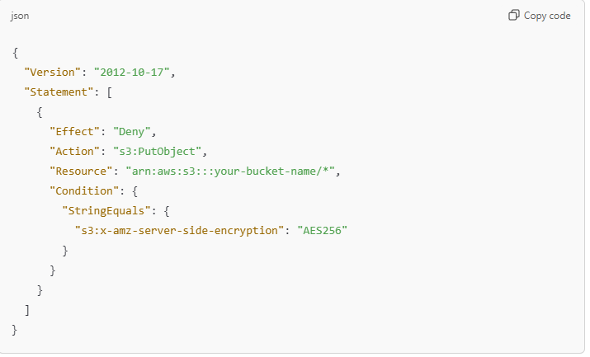
What it means:
- "Deny": This means if the condition matches (i.e., if the file is encrypted with AES256), it will not be allowed.
- "s3: PutObject": This is the action of uploading a file to your S3 bucket.
- "s3:x-amz-server-side-encryption": "AES256": This checks if the file is being uploaded with encryption (AES256).
So, if anyone tries to upload a file with AES256 encryption to your bucket, the policy will deny it, and the file won’t be uploaded.
This is useful when you want to make sure that your bucket only holds unencrypted files.

S3 SELECT AND GLACIER SELECT
S3 Select
S3 Select is a feature in Amazon S3 (Simple Storage Service) that allows you to retrieve only specific data from an object stored in S3, instead of downloading the entire file.
How it works:
- When you store large files (like CSV, JSON, or Parquet) in S3, you might not always need to download the entire file. Instead, you may want to only pull out certain data from within the file, like rows, columns, or specific values.
- With S3 Select, you can query just the part of the file that you need, saving you time and reducing the amount of data transferred.
Example:
- Suppose you have a huge CSV file with customer information. If you want to retrieve just the names of customers from a specific city, you can use S3 Select to query and retrieve only that data, rather than downloading the entire CSV file.
Benefits:
- Faster data retrieval: You don’t need to download the full file, only the part you need.
- Cost-effective: You save on data transfer costs and improve efficiency.

Glacier Select
Glacier Select is similar to S3 Select but works with data stored in Amazon Glacier, which is a storage service used for long-term archival data (typically cold data). Glacier is used to store data that you don't need frequently, but when you do need it, you may still want to access specific parts of the data without having to retrieve the entire file.
How it works:
- Just like S3 Select, Glacier Select allows you to query specific data from files stored in Glacier. However, since Glacier is for long-term storage, the data retrieval process is slower compared to S3, but Glacier Select still allows you to avoid retrieving the entire file.
- Glacier Select works by querying files like CSV, JSON, or Parquet and pulling only the specific data you need.
Example:
- If you have archived financial records stored in Glacier and only need to access transactions from a specific year, you can use Glacier Select to retrieve just that portion of the data.
Benefits:
- Cost-efficient: Only pay for the data you actually query.
- Faster retrieval of specific data: Avoid waiting for the whole file to be retrieved.

Key Differences:
- S3 Select is used for data stored in S3, which is optimized for frequent access, while Glacier Select is used for data stored in Amazon Glacier, which is for archival purposes and has a longer retrieval time.
- S3 Select is faster and more suitable for real-time access, whereas Glacier Select is for situations where you need archived data but still want to extract specific information without retrieving the entire file.
Both of these services help you save time and money by allowing you to retrieve only the data you need from large files.

DYNAMO DB
Amazon DynamoDB is a fully managed NoSQL database service provided by AWS. It is designed for fast and flexible performance, ideal for applications requiring low-latency data access at any scale.

Key Features of DynamoDB
- NoSQL Database:
  - Stores data in a non-relational format (key-value or document).
  - Flexible schema allows you to store different types of data in the same table.
- High Scalability:
  - Automatically scales up or down based on traffic.
  - Can handle millions of requests per second.
- Low Latency:
  - Provides quick data retrieval with single-digit millisecond latency.
- Fully Managed:
  - AWS handles setup, maintenance, backups, and scaling, so you don't need to manage servers.
- Built-in Security:
  - Offers encryption, fine-grained access control, and compliance with data protection regulations.

How DynamoDB Stores Data
- Tables:
  - Data is stored in tables (similar to a spreadsheet or database table).
  - Each table has items (rows) and attributes (columns).
- Primary Key:
  - Every item must have a unique primary key.
  - Types of primary keys:
    - Partition Key: A single unique identifier (e.g., "UserID").
    - Partition Key + Sort Key: Combines two attributes for a unique key (e.g., "UserID" + "Timestamp").
- Attributes:
  - Similar to columns in a table, but DynamoDB doesn't require a fixed schema.
  - Each item can have different attributes.

Core Concepts
- On-Demand or Provisioned Capacity:
  - On-Demand: Automatically adjusts to traffic; pay for what you use.
  - Provisioned: You specify read/write capacity, and DynamoDB ensures it.
- Indexes:
  - Global Secondary Index (GSI): Enables querying data with different attributes.
  - Local Secondary Index (LSI): Allows sorting data using a secondary key.
- Data Consistency:
  - Eventually Consistent Reads: Faster, but data might not be immediately updated.
  - Strongly Consistent Reads: Slower but guarantees updated data.
- Backup and Restore:
  - Automated backups and point-in-time recovery options.
- Streams:
  - Tracks changes to data in a table (insert, update, delete).
  - Useful for triggers or real-time data processing.

Use Cases
- Real-time Applications: Chat apps, gaming leaderboards, or live dashboards.
- E-commerce: Storing product catalogs and user sessions.
- IoT: Managing sensor data and device states.
- Mobile Apps: User profiles and preferences.

How to Use DynamoDB (Simplified Steps)
- Create a Table:
  - Define the table name and primary key.
  - Choose between On-Demand or Provisioned capacity.
- Add Data:
  - Use the AWS Management Console, CLI, or SDK to insert items.
- Query and Scan:
  - Query: Retrieve items based on primary key or index.
  - Scan: Retrieve all items (can be slower).
- Monitor and Optimize:
  - Use Amazon CloudWatch for performance monitoring.
  - Set alarms for capacity usage and optimize indexes.

Advantages
- Easy to use and integrates seamlessly with other AWS services.
- Handles massive traffic spikes without manual intervention.
- Pay only for what you use with On-Demand mode.

DynamoDB is ideal if you want a simple, scalable, and reliable database solution without worrying about infrastructure or maintenance.
- Fully managed, highly available with replication across 3AZ.
- NOSQL database – not a relational database.
- Scales to massive workloads, distributed database.
- Millions of requests per seconds, trillion of rows, 100s of TB of storage.
- Fast and consistent in performance (low latency on retrieval).
- Integrated with IAM for security, authorization and administration.
- Enables event driven programming with Dynamo DB streams.
- Low cost and auto scaling capabilities.
DYNAMO DB – BASICS
- Dynamo DB is made of tables.
- Each table has primary key (must be decided at creation time).
- Each table can have infinite number of items (= rows).
- Each item has attributes
- Maximum size of a item is 400 KB.
- Data types supported are:
- SCALAR TYPES: String, Number, Binary, Boolean, Null.
- DOCUMENT TYPES: List, Map
- SET TYPE: String Set, Number set, Binary set

DYNAMO DB – PRIMARY KEYS
In DynamoDB, the primary key is how the database uniquely identifies each item (or row) in a table. Think of it like a label or a unique ID that ensures no two items in the table are exactly the same. DynamoDB offers two types of primary keys:

1. Partition Key (Simple Primary Key)
- This is a single attribute (column) that uniquely identifies each item.
- Imagine each item in a table is like a book in a library, and the partition key is the unique ISBN number on the book—it helps you find the book in the library.
- Example: If you have a table of users, the user ID (like user123) could be the partition key.

2. Partition Key + Sort Key (Composite Primary Key)
- This combines two attributes:
  - Partition Key: Groups related items together.
  - Sort Key: Sorts the items within that group.
- Think of it like organizing a bookshelf:
  - The partition key is the genre (e.g., "Fiction" or "History").
  - The sort key arranges the books within that genre by title or author.
- Example: In a table of orders, you can use:
  - Partition Key: Customer ID (groups all orders by customer).
  - Sort Key: Order Date (orders are sorted by date within each customer group).

Why Primary Keys Matter
- They ensure that every item in the table can be uniquely identified and accessed.
- DynamoDB uses the partition key to distribute items across storage nodes, making lookups fast.
- If a sort key is added, it allows querying items within a group efficiently.

Key Rules:
- Every item must have a unique primary key.
- The partition key value is mandatory for every item.
- If there’s a sort key, both the partition key and sort key together must be unique.

In summary, the primary key is like an address that tells DynamoDB where to store and find

DYNAMO DB – PROVISIONED THROUGHPUT
In DynamoDB, provisioned throughput refers to the capacity settings for how much data your application can read from and write to a DynamoDB table per second. This is a way to control and optimize performance based on your application's needs.

How Provisioned Throughput Works
When you use provisioned mode, you specify:
- Read Capacity Units (RCUs): The number of reads your table can handle per second.
- Write Capacity Units (WCUs): The number of writes your table can handle per second.

What Are RCUs and WCUs?
Read Capacity Units (RCUs):
- 1 RCU = 1 strongly consistent read of up to 4 KB per second.
- If you use eventually consistent reads, one RCU can handle twice the amount of data (2 reads of 4 KB per second).
- Example:
  - If your table reads 12 KB per second using strongly consistent reads, you need 3 RCUs (12 KB ÷ 4 KB).
  - For eventually consistent reads, you’d only need 1.5 RCUs.
Write Capacity Units (WCUs):
- 1 WCU = 1 write of up to 1 KB per second.
- Example:
  - If your table writes 2 KB of data per second, you need 2 WCUs.

Why Use Provisioned Throughput?
- Predictable Performance: You allocate fixed capacity, so performance is predictable.
- Cost Control: You pay only for the capacity you provision, even if you don’t use it all.
- Good for Steady Workloads: Best for applications with consistent traffic, where you can estimate your throughput needs in advance.

What Happens If You Exceed Provisioned Throughput?
If your application exceeds the allocated RCUs or WCUs:
- Throttling Occurs: DynamoDB rejects the excess requests with a ProvisionedThroughputExceededException.
- Backoff and Retry: Your application can retry these requests using exponential backoff.

Scaling Provisioned Throughput
- You can manually adjust the RCUs and WCUs if your workload changes.
- Alternatively, you can enable Auto Scaling, where DynamoDB automatically adjusts the capacity based on your traffic patterns.

Alternatives: On-Demand Mode
If you’re unsure about traffic patterns, DynamoDB’s on-demand mode lets you pay for what you use without setting provisioned capacity, but it may cost more for high traffic.

Example Scenario
Imagine you have a table for an e-commerce application:
- You estimate the table will handle 50 reads/second of 8 KB data and 10 writes/second of 2 KB data.
- You need:
  - RCUs: 50×⌈8 KB/4 KB⌉=100 RCUs
  - WCUs: 10×⌈2 KB/1 KB⌉=20 WCUs
By provisioning 100 RCUs and 20 WCUs, you ensure the application operates smoothly without throttling.

In summary, provisioned throughput allows you to optimize DynamoDB’s performance and costs by pre-allocating the capacity your application needs for consistent workloads.
- Table must have provisioned read and write capacity units.
- READ CAPACITY UNITS (RCU): throughput for reads
- WRITE CAPACITY UNITS (WCU): throughput for writes
- Option to set up auto-scaling of throughput to meet demand.
- Throughput can be exceeded temporarily using “burst credit”.
- If burst credit are empty, you will get ProvisionedThroughputExpectation.

BURST CREDIT: In DynamoDB, burst credit is like a "reserve fund" of unused capacity that your database saves up when you're not using it heavily. If you suddenly need to handle a lot more requests than usual, DynamoDB uses these saved credits to handle the extra load without slowing down.
Think of it as your database saving energy when it’s resting and using it when it needs to work harder!

DYNAMO DB – WRITE CAPACITY UNITS (WCU)
- One write capacity units represents one write per second for an item upto 1KB in size.
- If the items are larger than 1 KB, more WCU are consumed.
- Example 1: we write 10 objects per second of 2 KB each.
We need 2 * 10 = 20 WCU
- Example 2: we write 6 objects per second of 4.5 KB each
We need 6 * 5 = 30WCU (4.5 gets rounded to upper KB).
- Example 3: we write 120 objects per minute of 2 KB each
We need 120/60 * 2 = 4 WCU

STRONGLY CONSISTENT READ VS EVENTUALLY CONSISTENT READ
Eventually Consistent Read
- Imagine you're writing data to DynamoDB, like saving a file. DynamoDB saves the data in multiple places (replicas) to ensure safety and availability.
- But it takes a little time to copy that data to all those replicas.
- If you try to read the data immediately after writing it, you might get old or incomplete data because the replicas are still syncing up.
- Why use this? It’s faster and uses less capacity, but you sacrifice immediate accuracy.

Strongly Consistent Read
- In this case, DynamoDB ensures that you always get the latest, accurate data, even if you just wrote it.
- It checks the main data source and waits for it to be updated before giving you the result.
- Why use this? You want to be 100% sure you’re reading the latest data. However, it can take a bit more time and capacity compared to an eventually consistent read.

Default Behavior
- DynamoDB uses Eventually Consistent Reads by default because they’re quicker and more efficient.
- But if you need Strongly Consistent Reads, you can request them by using the Consistent Read parameter and setting it to True.

Analogy
Think of this like taking a picture:
- Eventually Consistent Read: You take a picture, and it’s uploading to your photo album in the cloud. If you check too soon, you might see the old photo or nothing at all because the upload isn’t finished.
- Strongly Consistent Read: You wait until the upload is complete and then check your album to see the latest picture.

DYNAMO DB – READ CAPACITY UNITS
- One Read Capacity units represent one strongly consistent read per second, or two eventually consistent reads per second, for an item upto 4KB in size.
- If the items are larger than 4KB in size, more RCU are consumed.
- Example 1: 10 strongly consistent reads per second of 4KB each
we need 10 * 4KB/4KB = 10RCU
- Example 2: 16 eventually consistent reads per second of 12KB each
We need (16/2) * (12/4) = 24RCU
- Example 3: 10 strongly consistent reads per second of 6KB each
We need 10 * 8KB/4 = 20RCU (We have to round up 6KB to 8KB)

DYNAMO DB – THROTTLING
What is Throttling?
- DynamoDB has limits on how many read and write operations you can perform per second. These limits are defined by:
  - RCU (Read Capacity Units): For reading data.
  - WCU (Write Capacity Units): For writing data.
- If you exceed these limits, DynamoDB rejects some of the requests and gives you an error called ProvisionedThroughputExceededException. This is called throttling.

Why does Throttling Happen?
- Hot Keys or Partitions:
  - A "hot key" happens when a specific partition (or item) is accessed too often.
  - Example: Imagine one popular product in an e-commerce app being viewed thousands of times—this overloads the system.
- Very Large Items:
  - If the data you're trying to read or write is very large, it uses up more capacity units (RCU/WCU) and hits the limit faster.

How to Fix Throttling?
- Exponential Back-off:
  - If DynamoDB rejects a request, your app can wait a little longer before retrying.
  - The wait time increases (exponentially) with each failure, helping reduce the load automatically. This feature is already built into many AWS SDKs.
- Distribute Partition Keys:
  - Spread your data across multiple partitions by choosing keys that don’t concentrate traffic on a single item.
  - Example: Use unique user IDs or timestamps as partition keys instead of a general category like "popular_items."
- Use DynamoDB Accelerator (DAX):
  - If you're having trouble with RCU limits, you can use DAX, a caching layer that stores frequently accessed data.
  - It reduces the load on DynamoDB by serving cached data, making reads much faster.

Analogy
Think of DynamoDB as a water pipe:
- The pipe has a fixed flow capacity (RCU/WCU).
- If too much water (data) flows at once, the pipe can’t handle it, and excess water is blocked (throttled).
- To solve this, you can:
  - Let the pipe rest for a moment (back-off).
  - Use more pipes to share the flow (distribute keys).
  - Use a water tank to handle frequent demands (DAX caching).

DYNAMO DB – PARTITIONS INTERNAL
DynamoDB Partitions form the foundation of how data is stored, distributed, and managed. Here's a breakdown of what DynamoDB Partitions are, how they work, and why they are important, explained in simple language.

What is a Partition in DynamoDB?
A partition is like a "storage unit" that holds a portion of your data. DynamoDB automatically splits and distributes your data across multiple partitions based on the size of your data and the read/write traffic.

How Partitions Work
- Each partition can handle a certain amount of data and traffic:
  - 10 GB of data.
  - 3000 Read Capacity Units (RCU).
  - 1000 Write Capacity Units (WCU).
- If your data or traffic grows beyond these limits, DynamoDB creates new partitions to distribute the load.

How Does DynamoDB Decide Which Partition to Use?
- Partition Key:
  - DynamoDB uses the partition key (also called the primary key) from your table to decide which partition to store the data in.
  - The partition key is hashed using an internal algorithm, and the hash determines the partition.
- Hashing:
  - Think of hashing as assigning a unique "address" to each item based on its partition key.
  - This ensures that items are evenly distributed across all partitions.

Why Partitions are Important
- They help DynamoDB scale automatically:
  - If your data or traffic increases, DynamoDB adds partitions without requiring manual intervention.
- They ensure high performance:
  - By distributing data and traffic across multiple partitions, DynamoDB prevents bottlenecks and keeps queries fast.

What Happens If Partitions Are Not Properly Used?
- Hot Partitions:
  - If one partition gets too much traffic (because certain keys are accessed frequently), it can become overloaded, causing throttling.
  - Example: A key like "popular_product" may always go to the same partition, leading to excessive reads/writes.
- Unbalanced Data:
  - If data is not evenly spread across partitions, some partitions may remain underutilized, while others are overloaded.

Best Practices for Efficient Partitions
- Choose a Good Partition Key:
  - Use a key that ensures data is distributed evenly.
  - Example: Instead of using "Country" (which might group all data by country), use "UserID" (which is unique for each user).
- Avoid Hot Partitions:
  - Don't use predictable or common keys like "today's_date" or "top_seller."
  - Combine multiple fields (e.g., "UserID#Timestamp") to create more unique keys.
- Monitor Partitions:
  - Use AWS tools like CloudWatch to track read/write activity and see if any partition is becoming hot.

Example to Understand Partitions
Imagine a library:
- Each partition is like a bookshelf.
- The partition key (like book genres) determines which shelf a book goes to.
- If one shelf (partition) gets too many books (data) or visitors (traffic), the library adds a new shelf.

Key Points to Remember
- Data Distribution:
  - DynamoDB automatically distributes data across partitions for better performance.
- Scaling:
  - Partitions help DynamoDB scale with your data size and traffic.
- Limits Per Partition:
  - Each partition has limits of 10 GB, 3000 RCU, and 1000 WCU.
- Hot Keys:
  - Avoid keys that overload a single partition.

Key Terms Simplified
- Partition Key: The field used to determine where data is stored.
- Hashing: A process to assign data to partitions.
- Hot Partition: A partition that gets overloaded with too much traffic.

To compute the number of Partitions
- By capacity: (Total RCU / 3000) + (Total WCU / 1000)
- By size: Total size / 10 GB
- Total Partitions: CEILING (MAX (Capacity, Size))
- WCU and RCU will spread evenly between each partition
Example: If Table settings: Total 6000 RCU / Total 2400 WCU and there are 3 partitions
Then Partition 1: 2000 RCU and 800 WCU
Partition 2: 2000 RCU and 800 WCU
Partition 3: 2000 RCU and 800 WCU

DYNAMO DB – WRITING DATA
1. PutItem
- What it does:
  - The PutItem operation is used to write data to a DynamoDB table. This can be used to either create new data or completely replace existing data for a specific item.
- Consumes WCU:
  - Every write operation costs Write Capacity Units (WCU). DynamoDB charges based on how much data you write.
- Example:
  - If you're saving a new user's profile in the database, you would use PutItem.

2. UpdateItem
- What it does:
  - The UpdateItem operation allows you to update specific attributes of an existing item in the table without replacing the whole item.
- Atomic Counters:
  - You can use Atomic Counters to increase or decrease a numeric value automatically without worrying about conflicts.
  - For example, if you're tracking the number of likes on a post, you can increment the count directly.
- Example:
  - If you want to update a user's email address without changing the rest of their profile, you'd use UpdateItem.

3. Conditional Writes
- What it does:
  - Conditional writes let you write or update data only if certain conditions are met. If the condition isn't true, DynamoDB rejects the operation.
  - This helps ensure data consistency when multiple users or applications are trying to update the same item.
- No Performance Impact:
  - Adding conditions doesn’t slow down the database or affect its performance.
- Example:
  - If you're updating a user's profile picture, you can add a condition to make sure you're only updating it if the user's current status is "active."

Why These Features Are Useful
- PutItem: Great for creating new records or replacing old ones entirely.
- UpdateItem: Ideal for making small changes without overwriting everything.
- Conditional Writes: Helps avoid conflicts when multiple processes or users access the same data.

DYNAMO DB – BATCHING WRITES
- BATCH WRITEITEM
- Up to 25 PutItem and / or DeleteItem in one call
- Up to 16 MB of data written
- Up to 400 KB of data per item.
- Batching allows us to save in latency by reducing the number of API calls done against Dynamo DB means Batching means combining multiple operations (like writing or reading multiple items) into a single API call to DynamoDB instead of making separate calls for each item.This saves time (latency) because fewer API calls mean less communication overhead between your application and DynamoDB, making the process faster and more efficient.

- Operations are done in parallel for better efficiency.
- Its possible for better part of a batch to fail, in which case we can retry the failed items (using exponential back-off algorithm).

DYNAMO DB – READING DATA
- GetItem
- Read based on Primary key
- Primary key = HASH or HASH – RANGE
- Eventually consistent read by default.
- Option to use strongly consistent reads (more RCU – might take longer).
- ProjectExpression can be specified to include only certain attributes.
- BatchGetItem
- Up to 100 items.
- Up to 16 MB of data
- Items are retrieved in parallel to minimize latency

DYNAMO DB – QUERY
- Query returns item based on:
- Partition key value (must be = operator).
- SortKey value (=, <, <=, >, >=, Between, Begin) – Its optional.
- FilterExpression to further filter (client side filtering).
- Returns:
- Up to 1 MB of data.
- Or number of items specified in Limit.
- Able to do pagination on the results.
- Can query table, a local secondary index, or a global secondary index.

DYNAMO DB – SCAN
- Scan entire table (inefficient): Scans check every item in the table, which takes time and resources. It’s not ideal for large tables.
- Returns up to 1 MB of data: Each scan fetches a maximum of 1 MB of data at a time. Use pagination to continue scanning beyond 1 MB.
- Consumes a lot of RCU: Scans use a lot of read capacity units (RCU), making them resource-intensive.
- Limit impact: Reduce the amount of data scanned by setting a LIMIT or filtering results to pause scanning frequently.
- Parallel scans: Split the table into parts (partitions) and let multiple processes scan these partitions simultaneously. This makes it faster but increases RCU consumption.
- ProjectionExpression + FilterExpression: Use these to fetch only specific attributes or filter results without affecting RCU usage.

INDEXES
DYNAMO DB – LSI (LOCAL SECONDARY INDEX)
- Alternate range key: LSI lets you define an extra sort key (range key) for the same partition key (hash key) in your table.
- Limit of five LSIs: You can create up to five LSIs per table.
- One scalar attribute: The sort key for an LSI must have exactly one scalar attribute, which is a single value.
- Valid attribute types: The sort key must be of type string, number, or binary.
- Defined during table creation: You can only define LSIs when you create the table; they can’t be added later.
- LSI must be defined at table creation time
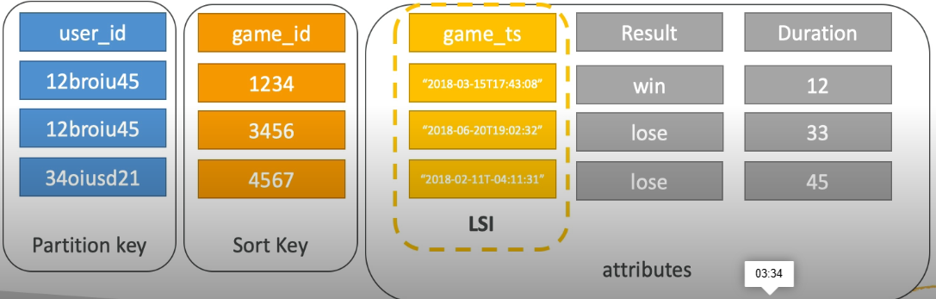

DYNAMO DB – GSI (GLOBAL SECONDARY INDEX)
- Purpose: A Global Secondary Index (GSI) helps you quickly query data based on non-key attributes.
- Structure: A GSI includes a partition key and optionally a sort key.
- Index is like a table: The GSI acts as a separate table where you can copy (or project) specific attributes from the main table:
  - KEYS_ONLY: Only the primary key (partition key + sort key) of the main table is included in the index.
  - INCLUDE: You can include extra attributes in addition to the primary key.
  - ALL: All attributes from the main table are included in the index.
- RCU/WCU for GSI: You need to allocate read and write capacity units (RCU/WCU) for the GSI separately.
- Flexible: You can add or modify a GSI at any time (unlike an LSI, which must be defined at table creation).
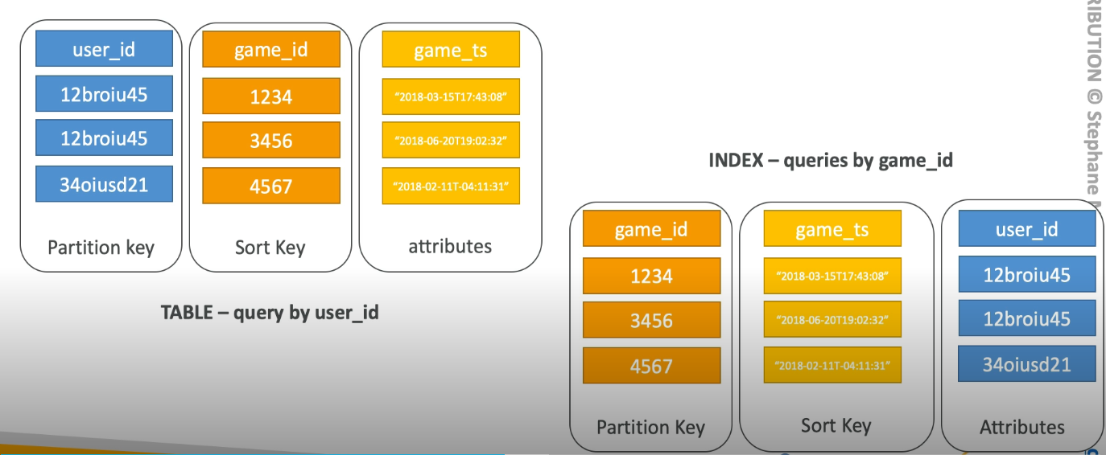
Use Case of GSI (Global Secondary Index):
- When to Use:
  - You need to query data based on attributes that are not the primary key of the main table.
  - You require a different partition key and/or sort key than the main table.
- Why Use GSI:
  - Allows querying on multiple data access patterns.
  - Offers flexibility as it can be created or modified after table creation.
  - Enables global scope queries, meaning you can access data across all partitions of the main table.
- Example:
  - Main Table: Partition key = UserID, Sort key = OrderID
  - GSI Use Case: Query based on ProductCategory (a non-key attribute).

Use Case of LSI (Local Secondary Index):
- When to Use:
  - You need to query data within the same partition key as the main table but with a different sort key.
- Why Use LSI:
  - It enables you to query more flexibly within a partition without needing to create a separate table.
  - Data is local to the partition key, meaning LSI queries are focused on a specific partition, reducing scope and improving efficiency for that partition.
- Example:
  - Main Table: Partition key = UserID, Sort key = OrderDate
  - LSI Use Case: Query the same UserID for orders based on OrderStatus.
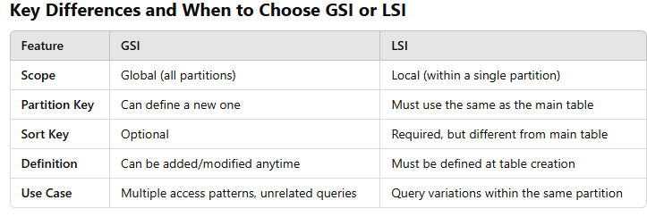
Choose GSI if:
- You need to query data across all partitions.
- You want the flexibility to add or modify indexes later.
- You want to query based on attributes that are not in the primary key.
Choose LSI if:
- You need to query within a single partition but with a different sort key.
- You know your indexing needs at table creation time.

DYNAMO DB – DAX
DAX is a caching layer for DynamoDB that helps improve the performance of your applications by speeding up reads and queries. Let’s break each point down:

1. DAX – DynamoDB Accelerator
- DAX is a caching service specifically designed for DynamoDB.
- It acts as a middle layer between your application and DynamoDB to store frequently accessed data temporarily (cache), so the database doesn't have to be queried repeatedly.

2. Seamless Cache for DynamoDB, No Application Rewrite
- You can use DAX without making major changes to your application.
- It integrates smoothly with DynamoDB’s existing APIs, so your application still uses the same commands for read and write operations.
- You don’t need to modify your code significantly to add DAX.

3. Writes Go Through DAX to DynamoDB
- When you write data (like adding or updating information), it first passes through DAX and is then written to DynamoDB.
- This ensures consistency between the cached data and the database.

4. Microsecond Latency for Cached Reads and Queries
- DAX speeds up read operations because it stores commonly accessed data in memory (RAM), which is much faster than querying the database.
- Cached reads (data already stored in DAX) are returned in microseconds, which is much faster compared to milliseconds for a database query.

5. Solves the Hot Key Problem
- The Hot Key Problem occurs when one item in the database is accessed repeatedly by many users at the same time, which can slow down performance.
- DAX helps by caching that item in memory so subsequent reads don’t need to hit the database, reducing load and improving speed.

6. 5 Minutes TTL for Cache by Default
- TTL (Time-to-Live): This is the time data stays in the cache before it is considered outdated and removed.
- By default, DAX keeps data for 5 minutes, after which it fetches fresh data from DynamoDB if needed.

7. Up to 10 Nodes in the Cluster
- DAX can have up to 10 nodes in a single cluster, which helps handle more traffic and provides high availability.
- Nodes are individual servers that work together to store and serve cached data.

8. Multi AZ (3 Nodes Minimum Recommended for Production)
- Multi AZ (Availability Zone): DAX supports deploying nodes in multiple availability zones to ensure fault tolerance and high availability.
- For production environments, having at least 3 nodes is recommended to prevent service interruptions if one node fails.

9. Secure (Encryption at Rest with KMS, VPC, IAM, CloudTrail)
- DAX provides several security features:
  - Encryption at Rest: Data stored in DAX is encrypted using KMS (Key Management Service) to protect it.
  - VPC (Virtual Private Cloud): DAX can run in a private network, isolated from public access.
  - IAM (Identity and Access Management): You can control who has access to DAX using IAM roles and policies.
  - CloudTrail: Logs all access and activity in DAX for monitoring and auditing.

Summary of Benefits
- Faster Reads: By caching frequently accessed data, DAX reduces response times to microseconds.
- Hot Key Problem Solved: Reduces load on the database by serving frequently accessed items from the cache.
- Seamless Integration: Works with DynamoDB without requiring major code changes.
- High Availability: Multi-node clusters and multi-AZ support prevent downtime.
- Security: Ensures data is encrypted and access is controlled.

What Does Cache Mean?
Cache refers to a temporary storage area where data is stored so it can be quickly accessed when needed, instead of fetching it repeatedly from the main source (e.g., a database or hard drive). It’s like a "shortcut" to data that helps improve the speed and efficiency of systems.

Simple Example
Imagine you frequently visit a website. The first time you open it, your browser downloads the data (like images, text, and files). Instead of downloading the same files every time you visit, your browser caches the data by storing it temporarily. When you visit the site again, it loads much faster because it retrieves data from the cache.

Use Case of DAX in DynamoDB
DAX (DynamoDB Accelerator) is used to improve the performance of read-intensive workloads by caching frequently accessed data. It is ideal for applications requiring ultra-fast response times with high read throughput.

When to Use DAX
- Read-Heavy Workloads:
  - If your application performs many read operations compared to write operations, DAX helps reduce the latency by serving data from its cache.
- Hot Key Problem:
  - When a specific partition key is queried excessively (hot key), DAX reduces the load on DynamoDB by serving those queries from the cache.
- High-Speed Applications:
  - For use cases like real-time gaming, ad serving, or recommendation systems where response time is critical (microsecond latency).
- Frequent Repeated Reads:
  - If your application queries the same data repeatedly (e.g., user profiles, product catalogs), DAX avoids redundant database queries.
- Cost Optimization:
  - By offloading read requests from DynamoDB, DAX reduces the need for high Read Capacity Units (RCUs), saving costs.

Why Use DAX?
- Performance Boost: DAX provides microsecond latency for cached data, making applications much faster.
- Seamless Integration: Works as a caching layer for DynamoDB without requiring changes to the application code.
- Solves Hot Key Problem: Handles high-frequency queries to specific items without overloading the database.
- Secure: Supports features like encryption, IAM roles, and Multi-AZ deployments for reliability and security.

Key Scenarios for DAX:
- E-Commerce Applications: Quickly retrieve product or inventory data for online stores.
- Social Media Platforms: Fetch frequently accessed user or post data in real time.
- Gaming Leaderboards: Display high scores or rankings with ultra-low latency.
DAX is a powerful caching layer for DynamoDB, making it ideal for applications with high read demand and performance-critical requirements!

DYNAMO DB – STREAMS
- Changes in DynamoDB (CREATE, UPDATE, DELETE) Can End Up in DynamoDB Stream:
  - When you add, update, or delete items in DynamoDB, these changes are automatically captured and stored in something called a DynamoDB stream.
  - The stream keeps track of all changes made to the data in the table, so you can use this information later.
- This Stream Can Be Read by AWS Lambda:
  - AWS Lambda is a service that allows you to run code in response to events. DynamoDB Streams can trigger AWS Lambda to execute code automatically when there are changes in the data.
- What You Can Do with Streams Using Lambda:
  - React to Changes in Real-Time Data:
For example, when a new user signs up (CREATE), you can automatically send them a welcome email.
  - Create Derivative Tables or Views:
You can use the stream to create new views or tables based on the changes. For example, you might want to create a summary table or aggregate data in a different format.
  - Insert into ElasticSearch:
You can automatically push updates from DynamoDB to ElasticSearch (a search engine service) to make data searchable in real-time.
- Cross-Region Replication Using Streams:
  - Cross-region replication means copying data from one region to another in AWS. Streams allow you to replicate changes made in DynamoDB tables across different regions, ensuring data is consistent in multiple places.
- Stream Has 24 Hours of Data Retention:
  - The stream will keep the changes (data) for 24 hours. After 24 hours, the data is deleted, so you need to process it within that time frame.
- Configurable Batch Size (Up to 1000 Rows, 6 MB):
  - When reading the stream, you can set how many changes (rows) you want to process at a time. You can choose to process up to 1000 rows or 6 MB of data in a single batch.
  - This helps you control how much data you process in each operation, balancing performance and cost.

Summary
DynamoDB Streams helps you track changes (CREATE, UPDATE, DELETE) in your data, and you can use AWS Lambda to take action based on these changes. It's helpful for tasks like sending emails, creating new data views, or pushing data to search engines. The stream retains changes for 24 hours and allows you to process data in batches for efficiency.
- There are 2 choices to consume DYNAMO DB Stream, either through AWS Lambda or Dynamo DB Streams Kinesis Adapter.

DYNAMO DB – TTL (TIME TO LIVE)
What is TTL (Time to Live)?
TTL is a feature in DynamoDB that automatically deletes expired data from your table after a set period of time. It helps keep your database clean by removing data that is no longer needed without requiring you to do it manually.

How Does TTL Work?
- Expiration Timestamp:
  - You set an expiration timestamp for each item in your table. This timestamp is a specific point in time when the item will expire (and be deleted).
  - The expiration is based on a Unix timestamp (the number of seconds since January 1, 1970).
- Setting TTL Attribute:
  - You create a specific attribute (column) in your table, often named something like TTL, to store the expiration timestamp for each item.
  - The value of the TTL attribute should be a timestamp (in seconds) representing when you want the item to expire.
- Automatic Deletion:
  - Once the current time exceeds the TTL value you set, DynamoDB automatically deletes the item from the table.
  - No need for manual intervention or cron jobs to clean up the expired data!

Key Points About DynamoDB TTL
- Set TTL at Item Level:
  - You can set TTL individually for each item in the table by assigning an expiration time to that item. Each item can have a different TTL value.
- Impact on Cost:
  - Expired items are deleted automatically, reducing the storage used, and saving costs on your DynamoDB storage fees.
- TTL Only Deletes, Not Modifies:
  - TTL will delete items once they expire, but it doesn’t modify or update any data.
- Grace Period Before Deletion:
  - Even though an item expires at the set TTL time, there’s a slight grace period (usually a few minutes) before DynamoDB deletes it. During this period, the item is still visible in your table.
- Can’t be Changed After Deletion:
  - Once an item is deleted by TTL, it can’t be recovered unless you have backups.
- Automatic Processing:
  - TTL works in the background. Once set, DynamoDB automatically handles the expiration and deletion process. You don’t need to do anything manually after configuring it.
- Enable TTL for the Table:
  - To use TTL, you must enable it for the entire table in the DynamoDB console by specifying the TTL attribute (the name of the column that will store expiration timestamps).

Use Cases of DynamoDB TTL
- Session Management:
  - If you store user session data (like login sessions), you can set a TTL to automatically delete expired sessions after a specific time.
- Temporary Data:
  - For storing temporary data such as logs, cache data, or temporary application states, TTL can help clean up after the data is no longer needed.
- Data Retention Policies:
  - If you have a policy that data should only be stored for a certain amount of time (e.g., storing user activity data for 30 days), you can set the TTL to 30 days and DynamoDB will automatically manage the data deletion.
- Automating Cleanup:
  - If you want to automatically remove outdated data like invoices, orders, or messages that are no longer needed, TTL helps automate the process.

Things to Keep in Mind About TTL
- Data Deletion Can Be Delayed:
  - TTL deletion is not immediate. DynamoDB does it asynchronously in the background, and it might take up to 48 hours for an expired item to be removed completely.
- No Impact on Queries:
  - Items that are expired but haven’t been deleted yet can still appear in query results until they are actually deleted.
- No Expiration for Non-TTL Items:
  - If you don't set a TTL for an item, it will never expire. DynamoDB will keep it forever unless manually deleted.
- Cannot Set TTL for DynamoDB Streams or Indexes:
  - TTL works only on the base table items, not on the DynamoDB Streams or indexes.

Enabling TTL in DynamoDB
- Define the TTL Attribute:
  - Create a column (attribute) in your DynamoDB table that will store the expiration timestamp for each item.
- Enable TTL in the DynamoDB Console:
  - Go to the DynamoDB console, select your table, and enable the TTL feature.
  - Specify the name of the TTL attribute.
- Add TTL Values to Items:
  - When adding data to your table, make sure you include the TTL value (expiration timestamp) in the item’s attributes.
  - Example: For a user session, you could set the TTL to 3600 seconds (1 hour from creation).

Summary of TTL Benefits
- Automatic Cleanup: TTL helps automatically delete expired data.
- Cost Savings: Reduces storage costs by removing old, unneeded data.
- No Manual Effort: DynamoDB handles all the deletion automatically in the background.
- Time-Based Data Management: Perfect for scenarios like session management, temporary data, and data retention policies.
In short, TTL in DynamoDB helps you automatically manage the lifespan of your data, saving you time, effort, and storage costs!

DYNAMO DB – SECURITY & OTHER FEATURES
I. Security Features
DynamoDB takes security seriously to ensure your data is safe and accessible only by authorized users. Here's how it does this:
- VPC Endpoints:
  - Think of a VPC (Virtual Private Cloud) as your private, secure internet space.
  - DynamoDB lets you connect to it through a VPC Endpoint so you can access it without using the public internet, making it safer.
- Controlled Access with IAM:
  - IAM (Identity and Access Management) allows you to control who can use DynamoDB and what actions they can perform.
  - Example: You can give permissions to a specific user to only "read" or "write" data.
- Encryption at Rest (Data Stored):
  - When your data is stored in DynamoDB, it's protected using KMS (Key Management Service).
  - Encryption ensures that even if someone gets unauthorized access to the storage, they can't read your data without the encryption key.
- Encryption in Transit (Data Moving):
  - Whenever data is being sent to or retrieved from DynamoDB, it's encrypted using SSL/TLS.
  - This makes sure that your data can't be intercepted or read by hackers while it's being transmitted.

II. Backup and Restore Features
DynamoDB has built-in features to ensure your data is safe and can be restored if needed:
- Point-in-Time Restore:
  - This works like a "time machine" for your database.
  - You can restore your table to a specific time in the past (up to 35 days ago), just like you do in RDS (Relational Database Service).
  - Example: If you accidentally delete data today, you can recover it by restoring the table to yesterday’s state.
- No Performance Impact:
  - When you create backups or restore data, it doesn’t slow down your database.
  - Your applications can keep running smoothly while the backup or restoration process is happening in the background.

III. Global Tables
Global Tables are a powerful feature for applications that need high availability and quick access worldwide:
- Multi-Region Replication:
  - Your data is automatically copied to multiple regions around the world.
  - This ensures that if one region goes down, your data is still accessible from another region.
- Fully Replicated:
  - Every region has a complete copy of your database, so users experience the same performance no matter where they are.
- High Performance:
  - Global Tables ensure fast access to data globally by letting users access the nearest region instead of waiting for data to travel across the world.

IV. Database Migration Service (DMS)
Amazon DMS (Database Migration Service) makes it easy to move data from other databases to DynamoDB:
- Migration:
  - You can migrate data from many sources like MongoDB, Oracle, MySQL, or even data stored in Amazon S3 to DynamoDB.
  - Example: If you're using MongoDB today and want to switch to DynamoDB for its scalability, DMS helps you move all your data easily.

V. Local DynamoDB for Development
DynamoDB provides a local version for developers to test and build applications without connecting to the live cloud database:
- Why Use Local Dynamo DB?:
  - It’s useful for development and testing. Developers can simulate how their apps will interact with DynamoDB without incurring costs or requiring an internet connection.
- How It Works:
  - You install DynamoDB locally on your computer, and it behaves just like the real service.
  - Once your application is tested and ready, you can connect it to the actual DynamoDB in AWS.

Key Takeaway
DynamoDB is a secure, high-performance, and developer-friendly NoSQL database. Whether you’re storing sensitive data, replicating data globally, or building locally, it offers all the features to make your data management easy, safe, and scalable.

DYNAMO DB – STORING LARGE OBJECTS
- Max size of an item in Dynamo DB = 400 KB.
- For large objects, store them in S3 and reference them in Dynamo DB
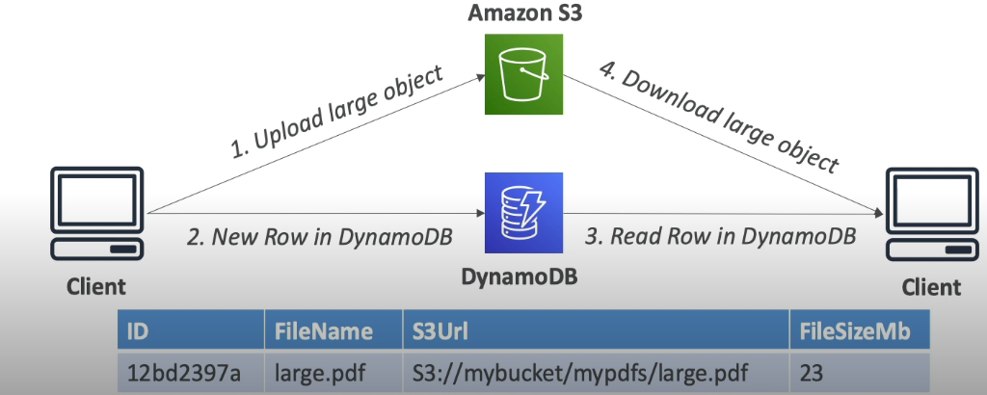

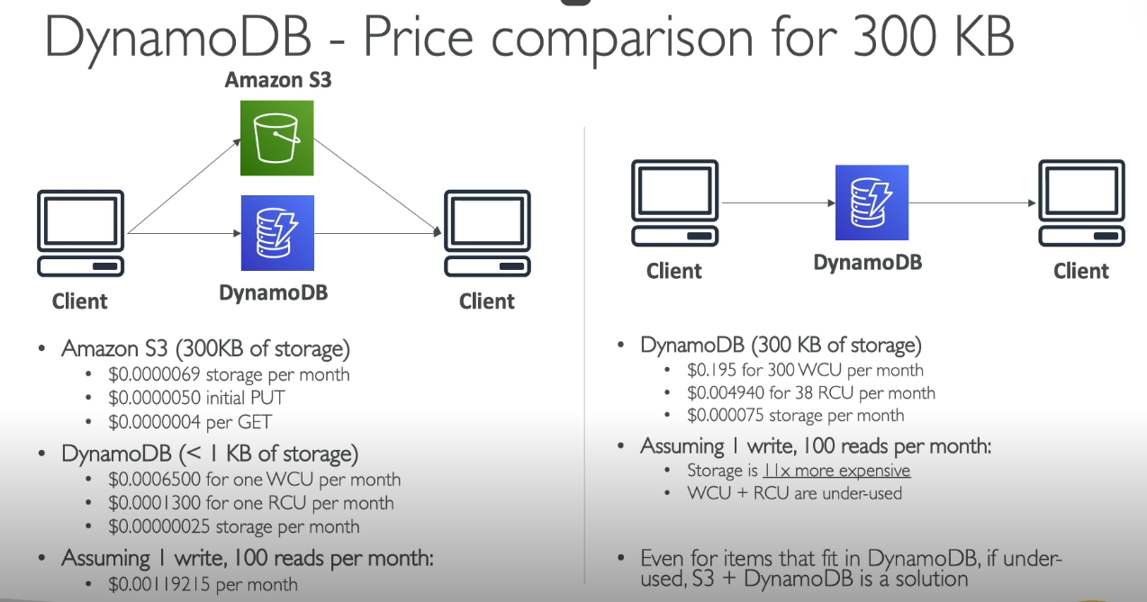
Explanation of this image is:
This image compares the pricing of storing and accessing 300 KB of data between Amazon S3 (Simple Storage Service) and Amazon DynamoDB. Let me explain every point in simple language, covering all details:

Amazon S3 (300 KB of storage)
Amazon S3 is a simple and cost-effective cloud storage solution. Here's the breakdown for 300 KB of data:
- Storage Cost per Month:
  - S3 charges $0.00000069 per month for storing 300 KB.
  - This means storing data in S3 is very cheap.
- Cost for Initial PUT (Upload):
  - S3 charges $0.00000050 for the initial action of uploading the data.
  - A PUT is the action of saving or uploading data to S3.
- Cost for a GET (Download):
  - S3 charges $0.0000004 per action to retrieve (download) the stored data.
  - Every time you access your data from S3, you are charged this small amount.
Key Takeaway: S3 is designed for storing data at a low cost, especially when data access frequency is low.

DynamoDB (<1 KB of storage)
DynamoDB is a NoSQL database where storage and actions (reads/writes) are charged differently. Here's how costs are structured for less than 1 KB of data:
- Cost for a Write Capacity Unit (WCU):
  - A WCU lets you write (store) data in DynamoDB.
  - For less than 1 KB of data, a WCU costs $0.0006500 per month.
- Cost for a Read Capacity Unit (RCU):
  - An RCU lets you read (retrieve) data from DynamoDB.
  - For less than 1 KB of data, an RCU costs $0.0001300 per month.
- Storage Cost per Month:
  - Storing less than 1 KB of data in DynamoDB costs $0.00000025 per month.
Scenario: If you assume 1 write and 100 reads per month, the total cost would be $0.00119215. This is because you are being charged for the WCUs, RCUs, and storage together.

DynamoDB (300 KB of storage)
If you store 300 KB of data in DynamoDB, here’s what the costs look like:
- Write Capacity Unit (WCU):
  - Writing (saving) this much data requires 300 WCUs, costing $0.195 per month.
- Read Capacity Unit (RCU):
  - Reading this data (e.g., retrieving the 300 KB) requires 38 RCUs, costing $0.00494 per month.
- Storage Cost per Month:
  - Storing 300 KB of data in DynamoDB costs $0.000075.
Assuming 1 Write and 100 Reads per Month:
- Total costs would include storage, WCUs, and RCUs.
Observation:
- Storage Costs: DynamoDB is 11 times more expensive for storage compared to S3.
- WCU + RCU Usage: These are often underutilized unless you have frequent reads/writes.

When Should You Combine S3 and DynamoDB?
- If you have data that doesn’t change often or is rarely accessed:
  - It’s better to store it in S3 (cheaper for storage).
  - For occasional database-like use, you can combine S3 for storage and DynamoDB for efficient reads/writes.

Conclusion from Image
- S3 is highly cost-effective for storing large amounts of data with infrequent access.
- DynamoDB becomes expensive for storage but is useful when you need quick reads/writes and real-time database functionalities.
- For efficient usage, use S3 + DynamoDB together if your use case fits this hybrid approach.

Partition Key (Also called Hash Key)
- The partition key is like an address that tells DynamoDB where to store your data.
- Every piece of data you add to DynamoDB must have a unique partition key.
- DynamoDB takes this key, runs a formula (called a hash function), and decides which "partition" (or storage area) will hold your data.
- Think of it like organizing a library:
  - Books are sorted into different shelves (partitions) based on a unique number (partition key).
Example:
Imagine you're storing customer data in a database:
- Partition key: CustomerID (e.g., "12345").
- DynamoDB uses "12345" to place the customer's data on the right partition.

Sort Key (Also called Range Key)
- The sort key is an optional second key used when you want to store multiple items with the same partition key but need to organize them in a specific order.
- It helps you retrieve related data quickly.
How It Works:
- Items with the same partition key are stored together but are arranged by the sort key.
- Think of it as sorting books on a shelf by the author’s name or publication year.
Example:
If you're storing order data for customers:
- Partition key: CustomerID (e.g., "12345").
- Sort key: OrderDate (e.g., "2024-01-01").
- This way, you can retrieve all orders for CustomerID "12345," sorted by date.

Why Use Partition Key and Sort Key Together?
- Partition key ensures data is distributed evenly and stored efficiently.
- Sort key organizes related data, making retrieval faster and more precise.

Real-Life Example
Let’s say you're tracking orders for a shopping app:
- Partition Key: UserID (e.g., "user123").
- Sort Key: OrderID (e.g., "order456").
DynamoDB will:
- Store all orders for "user123" in one place (partition).
- Sort these orders by OrderID (or another field like date or item).
This combination ensures that:
- Data is stored efficiently.
- Queries are faster when looking for a user’s orders in a specific order.

- Go to the Tables section in the DynamoDB dashboard and select the table you just created.
- Click Explore Table Items in the navigation menu.
- Click Create Item:
  - A JSON editor opens.
  - Add data in JSON format. For example:

PROCESSING
AWS LAMBDA (SERVERLESS DATA PROCESSING)

WHAT IS LAMBDA?
AWS Lambda is a service provided by Amazon that allows you to run code without managing servers. Let’s break it down point by point.

1. A Way to Run Code Snippets “in the Cloud”
Lambda lets you execute small pieces of code in the cloud. Think of it like running a program on your computer, but instead of using your computer, you’re using Amazon’s servers.
Why is this useful?
You don’t need to set up or maintain any hardware (no physical servers, no virtual machines).
It’s ready to use whenever you need it.

What does “Serverless” Mean?
With Lambda, you don’t have to worry about the servers running your code. Amazon manages everything for you.
You focus only on writing the code, and AWS takes care of:
Provisioning servers.
Scaling resources.
Maintenance and updates.
Example:
Imagine you have a small script that processes uploaded files. Instead of setting up a full server to run the script, you upload it to Lambda, and it will automatically run whenever needed.

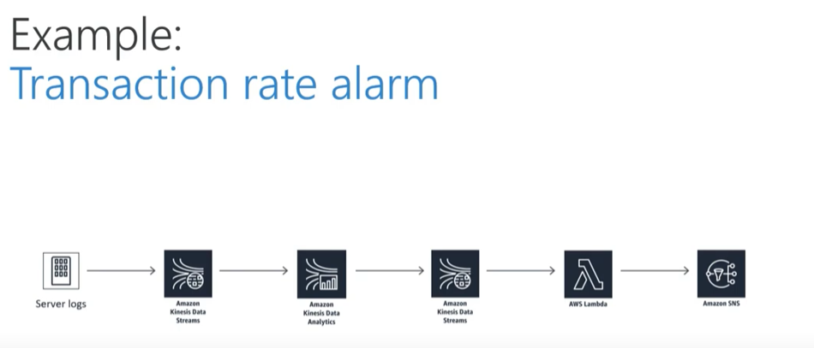

WHY NOT JUST RUN SERVER?
- Server management (patches, monitoring, hardware failures, etc.)
- Servers can be cheap, but scaling gets expensive really fast.
- You don’t pay for processing time, you don’t use.
- Easier to split up development between front – end and back – end.
What is Continuous Scaling?
Lambda can automatically adjust the number of instances running your code based on demand.
If one user triggers your function, it runs once. If 1000 users trigger it at the same time, it runs 1000 times without any extra effort from you.
Example:
Let’s say you run a website that generates thumbnails from uploaded images. If 10 people upload images simultaneously, Lambda will handle all 10 requests at the same time.

2. Often Used to Process Data as It’s Moved Around
Lambda is excellent for tasks where data flows between systems and needs to be processed quickly.
How does it process data?
Lambda can automatically run when something happens, like:
- A file is uploaded to an Amazon S3 bucket.
- Data is added to a DynamoDB table.
- A user interacts with an API.
Example 1:
When a user uploads a file to S3, Lambda can resize the image, compress it, or scan it for viruses before saving it.
Example 2:
If your app receives a new user request, Lambda can process the request, validate data, and forward it to another system.

Why Use AWS Lambda?
Cost-Effective: You only pay for the time your code runs (milliseconds). If your function isn’t running, there are no charges.
Quick Execution: Your code runs almost instantly when triggered.
Flexibility: You can write Lambda functions in multiple programming languages (Python, JavaScript, Java, etc.).
AWS Lambda simplifies running small tasks or automating workflows in the cloud without requiring you to maintain servers.

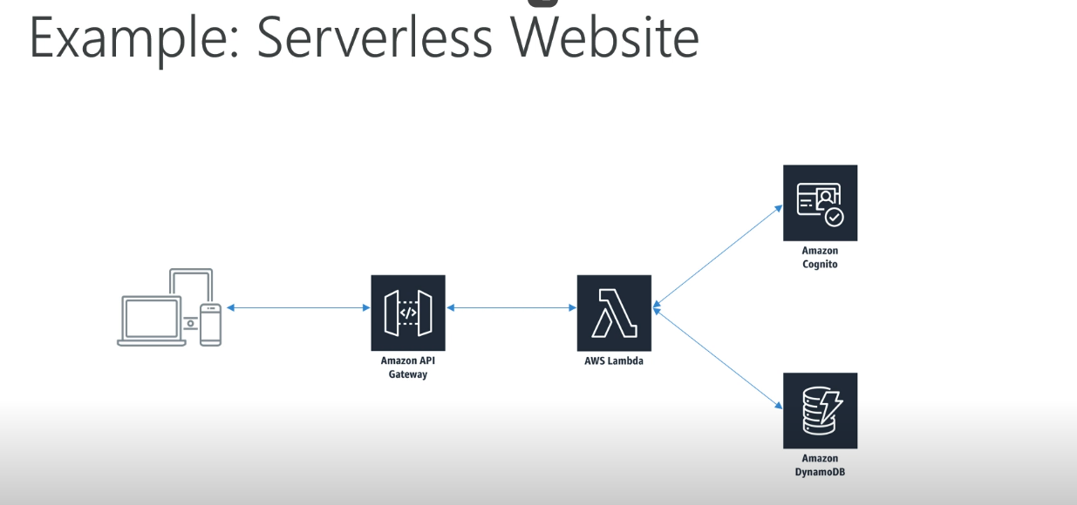
This diagram explains how a serverless website works using AWS services like Lambda, API Gateway, Cognito, and DynamoDB. Here’s a simple explanation of each component and how they interact:

1. Devices (Client Side)
- The website can be accessed from various devices like laptops, tablets, or phones.
- Users interact with the website by sending requests (e.g., submitting a form, retrieving data).

2. Amazon API Gateway
- Acts like a "traffic controller" for your website.
- It receives the user requests and decides where to send them (like routing requests to AWS Lambda).
- Example: When a user clicks a button on the website, API Gateway forwards that request to the right service.

3. AWS Lambda
- AWS Lambda is where your code runs in response to user requests.
- It processes the request received from API Gateway. For example:
  - If a user wants to log in, Lambda checks the login details.
  - If a user wants data, Lambda fetches it from the database.
- It is "serverless," meaning you don’t manage any servers—Lambda scales automatically to handle multiple requests.

4. Amazon Cognito
- Handles user authentication (checking who the user is).
- Ensures that only authorized users can access the website or its features.
- Example: When a user logs in, Cognito checks their username and password and verifies their identity.

5. Amazon DynamoDB
- DynamoDB is a database that stores the website’s data.
- It holds information like user profiles, website content, or any other data needed by the site.
- Example: If a user submits a form, DynamoDB saves that information.

How It All Works Together (Flow):
- User Action: A user accesses the website and performs an action (e.g., submits a form or logs in).
- API Gateway: Sends the user’s request to AWS Lambda.
- AWS Lambda:
  - If the request involves user authentication, Lambda interacts with Cognito to verify the user.
  - If the request requires accessing or saving data, Lambda communicates with DynamoDB.
- Response: After processing, Lambda sends the result back through API Gateway to the user’s device.

Benefits of this Setup:
- Serverless: No need to manage or maintain servers.
- Scalable: Can handle increasing traffic without extra effort.
- Secure: Uses Cognito for user authentication.
- Efficient: DynamoDB ensures fast and reliable data storage.

AWS Lambda is like a helper that runs your code only when something happens, so you don’t need to keep servers running all the time.
Simple Use Cases:
- Reacting to file uploads: Automatically resize a photo when you upload it to a folder (like in Google Drive).
- Sending notifications: Send an email or message when someone fills out a form.
- Data updates: Fix or clean data automatically when it changes in a database.
- Building chatbots: Process messages and respond quickly without managing a server.
It saves time and money because it works only when needed!

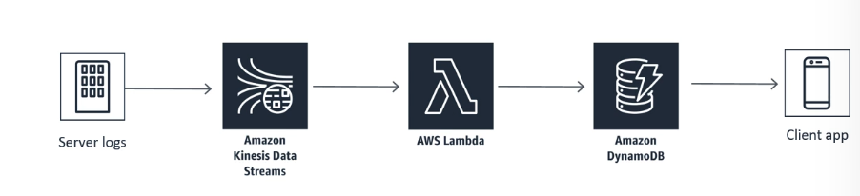
This diagram shows how AWS Lambda can work with other AWS services to handle and process data. Here’s a simple breakdown:

Step-by-Step Explanation
- Server Logs (Input Data):
  - Logs (like website activity or server performance data) are generated and sent somewhere for analysis.
- Amazon Kinesis Data Streams (Data Stream):
  - The logs are sent into Kinesis, which works like a pipeline for continuously streaming large amounts of data in real time.
- AWS Lambda (Processing Logic):
  - Lambda automatically picks up the data from Kinesis and processes it.
  - For example, Lambda can:
    - Filter the logs.
    - Analyze them for specific patterns or errors.
    - Prepare the data for storage.
- Amazon DynamoDB (Storage):
  - The processed data is saved in DynamoDB, a database service.
  - It’s like storing only the useful information from the logs for future use.
- Client App (Final Output):
  - The saved data can be accessed by an app (like a mobile app or dashboard).
  - For example, a client app could display the server's health status or show alerts based on the logs.

How AWS Lambda Fits In
- AWS Lambda is the brain of this workflow. It does the actual work of analyzing or transforming the raw data (logs) into something meaningful before saving it.

Real-World Example
Imagine you run an online store:
- Server Logs track customer activity.
- Kinesis streams the activity in real time.
- Lambda processes the data to find popular products or issues.
- DynamoDB stores the processed data for reports.
- Client App shows these insights to you in a dashboard.
AWS Lambda helps automate the entire process without needing servers!

MAIN USE OF LAMBDA
- Real – time file processing
- Real – time stream processing
- ETL
- Cron Replacement
- Process AWS events

1. Real-Time File Processing
- What it means: Automatically perform actions when a file is uploaded, changed, or deleted in storage like Amazon S3.
- Example:
  - Resize images when uploaded (like creating thumbnails for profile pictures).
  - Convert video formats (e.g., from AVI to MP4).
  - Extract data from uploaded CSV files.

2. Real-Time Stream Processing
- What it means: Handle and process data that flows continuously in real time from services like Amazon Kinesis or DynamoDB Streams.
- Example:
  - Analyze live data from stock market prices to detect trends.
  - Process IoT device data (like smart thermostats) as it streams.
  - Detect fraud by analyzing transactions in real time.

3. ETL (Extract, Transform, Load)
- What it means: Extract data from one source, transform it into a usable format, and load it into another system.
- Example:
  - Collect raw data from a database, clean or process it, and save the processed version into a data warehouse like Amazon Redshift.
  - Combine data from different sources (e.g., sales from one system and marketing leads from another) into a single report.

4. Cron Replacement
- What it means: Run tasks on a schedule (like every hour or every day), similar to a cron job in traditional systems.
- Example:
  - Send daily reminders or reports via email.
  - Backup your database automatically at midnight.
  - Clean up unused files or logs every week.

5. Process AWS Events
- What it means: Automatically respond to events in AWS services (like S3, DynamoDB, or CloudWatch) without manual intervention.
- Example:
  - When a new object is uploaded to S3, trigger Lambda to validate or analyze the file.
  - When someone logs into your system, log the event for security tracking.
  - Auto-scale or adjust resources when an alert is triggered in CloudWatch.

In Summary
AWS Lambda is a tool that helps automate repetitive or real-time tasks like file processing, data analysis, and scheduled jobs. It’s cost-effective because it runs only when needed and doesn’t require you to manage servers.

SUPPORTED LANGUAGES
- Node.js
- Python
- JAVA
- C
- Go
- PowerShell
- Ruby

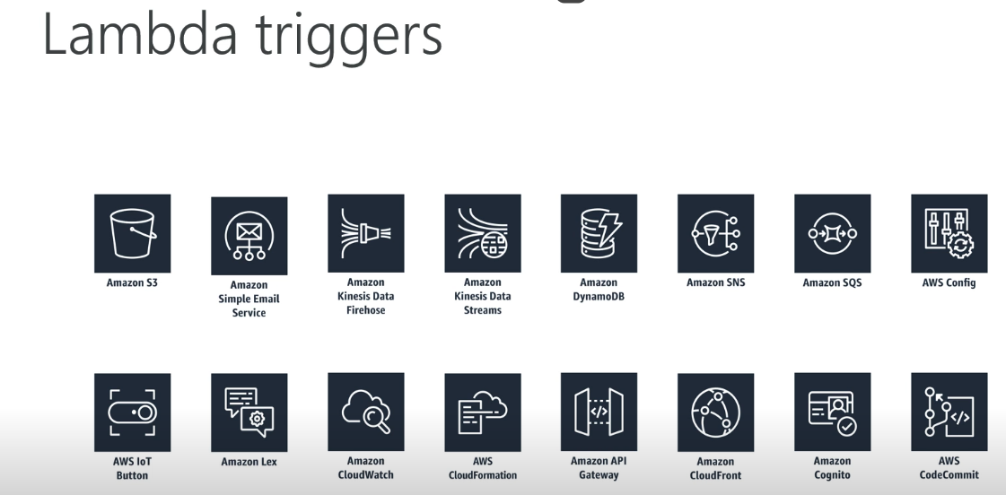
What are AWS Lambda Triggers?
Lambda triggers are events or actions that automatically "trigger" (start) a Lambda function in AWS.
- Lambda Function: Think of it as a small piece of code that performs a specific task.
- Trigger: It tells Lambda when to run this code. For example:
  - If a new file is added to an S3 bucket (like a folder), the Lambda function starts automatically to process that file.
In Simple Words:
Lambda triggers are like alarms or alerts for Lambda functions. When something happens (like a file upload, message arrival, or user action), it "triggers" the Lambda function to run and perform the desired task automatically.

Use Cases of Lambda Triggers
Here are some simple examples for each trigger:
- Amazon S3 (File Upload):
  - What happens: When you upload a file to an S3 bucket, Lambda starts.
  - Example:
    - Upload an image → Lambda resizes the image for different formats (small, medium, large).
- Amazon Simple Email Service (SES):
  - What happens: Lambda gets triggered when an email is received.
  - Example:
    - Lambda processes emails and stores them in a database.
- Amazon Kinesis Data Firehose/Streams:
  - What happens: Lambda processes real-time streaming data.
  - Example:
    - Live monitoring data (like sensor data or website clicks) is sent to Lambda for processing.
- Amazon DynamoDB:
  - What happens: Lambda starts when there is a change in a DynamoDB table.
  - Example:
    - If new customer information is added, Lambda updates other systems with this information.
- Amazon SNS (Notification Service):
  - What happens: Lambda gets triggered when an SNS notification is sent.
  - Example:
    - Send a notification to users if there is a system alert.
- Amazon SQS (Message Queue):
  - What happens: Lambda processes messages from the queue.
  - Example:
    - If there are too many orders on an e-commerce site, Lambda processes them one by one.
- AWS Config:
  - What happens: Lambda reacts to changes in AWS resource configurations.
  - Example:
    - Check if security settings on AWS services have changed and fix them automatically.
- AWS IoT Button:
  - What happens: Lambda starts when the IoT button is pressed.
  - Example:
    - Press the button → Lambda orders pizza or sends an email.
- Amazon Lex (Chatbot):
  - What happens: Lambda starts when the chatbot needs information.
  - Example:
    - A user asks a chatbot for their account balance → Lambda fetches and returns the details.
- Amazon CloudWatch:
  - What happens: CloudWatch logs an event that triggers Lambda.
  - Example:
    - If the CPU usage of a server is too high, Lambda starts an alarm or fixes the issue.
- AWS CloudFormation:
  - What happens: Lambda runs when AWS infrastructure is created or changed.
  - Example:
    - When a server is set up, Lambda ensures it is secure.
- Amazon API Gateway:
  - What happens: Lambda runs when someone accesses an API.
  - Example:
    - If someone makes a request on your app's login page, Lambda verifies their credentials.
- Amazon CloudFront:
  - What happens: Lambda triggers when content is requested through CloudFront.
  - Example:
    - Lambda customizes responses (like showing content based on a user’s location).
- Amazon Cognito:
  - What happens: Lambda triggers when a user logs in or signs up.
  - Example:
    - After a user signs up, Lambda sends them a welcome email.
- AWS CodeCommit:
  - What happens: Lambda runs when code is updated in CodeCommit.
  - Example:
    - Lambda triggers automated testing when new code is added.

How Does Lambda Triggers Work? (Simple Diagram)
- Event: Something happens → Example: You upload a file to S3.
- Trigger: The "alarm" detects the event → Lambda is triggered.
- Lambda Function: The small piece of code starts and performs a task.
- Output: Lambda finishes the task → Example: It resizes the image and stores it back in S3.

Example Flow (File Upload to S3 Trigger):
- Event: A user uploads a picture to an S3 bucket.
- Trigger: S3 bucket sends an event to Lambda.
- Lambda Function: Lambda resizes the image into different formats (small, medium, large).
- Output: The resized images are saved back to the S3 bucket.

Benefits of Lambda Triggers:
- Automation: Tasks run automatically when an event happens.
- No Servers: You don’t need to manage or worry about servers.
- Scalable: It can handle many events at the same time.
- Cost-Effective: You only pay when the Lambda function runs.

In simple terms, Lambda triggers help you automate tasks. When something happens (an event), Lambda detects it and performs the task you set, saving time and effort.

A Lambda trigger is something that automatically starts (or "triggers") your AWS Lambda function when an event happens.

Simple Explanation:
Think of it as a doorbell:
- Trigger: Someone presses the doorbell (an event happens).
- Lambda Function: The sound plays (your code runs).

Examples of Lambda Triggers:
- When a file is uploaded to S3:
  - Trigger Lambda to resize the image or analyze the file.
- When new data is added to a database (DynamoDB):
  - Trigger Lambda to process or store the data in a different system.
- When someone visits your website:
  - Trigger Lambda to log their activity or send a notification.
- On a schedule:
  - Trigger Lambda to run automatically at a set time (like sending daily reports).

AMAZON AND LAMBDA ELASTIC SEARCH
Let’s understand ElasticSearch (now called Amazon OpenSearch Service) in relation to AWS Lambda with a simple example and explanation:

What is ElasticSearch?
ElasticSearch is like a super-fast search engine and a data analyzer. It stores your data (like logs or user activity) and lets you search, filter, and analyze it quickly.

What is Lambda’s Role?
AWS Lambda is the "worker" that processes your data and sends it to ElasticSearch. It triggers automatically when something happens, like:
- A file is uploaded to an S3 bucket.
- Logs are created by your application.
- An event occurs in your database.

How They Work Together (Simple Explanation):
- Data Event Happens: Something triggers AWS Lambda, such as:
  - A new file is uploaded.
  - Log data from a server is generated.
  - User activity is recorded (e.g., search queries or clicks).
- Lambda Processes Data:
  - Lambda cleans, formats, or enriches the data.
  - For example, it extracts useful information like timestamps or error codes.
- Lambda Sends Data to ElasticSearch:
  - Once processed, Lambda sends the data to ElasticSearch for storage and indexing.
  - ElasticSearch organizes the data so you can search or analyze it easily.
- You Search or Analyze the Data:
  - Use ElasticSearch tools (like OpenSearch Dashboards or Kibana) to:
    - Search for errors.
    - Monitor user activity.
    - Visualize trends or patterns.

Example: Website Logs and Errors
Imagine you have a website, and you want to monitor user activity and server errors.
- Logs are Created:
  - Your website creates logs (like "User visited this page" or "Server error occurred").
- Lambda Processes the Logs:
  - Lambda automatically picks up the logs, extracts useful information (e.g., time, user ID, error code), and formats them.
- Logs Sent to ElasticSearch:
  - Lambda sends the cleaned logs to ElasticSearch.
- Use ElasticSearch for Monitoring:
  - In ElasticSearch, you can:
    - Search for specific errors (e.g., “Show me all errors from today”).
    - Visualize trends (e.g., “When are errors most frequent?”).

Why Use Lambda with ElasticSearch?
- Automation: Lambda handles the heavy lifting, processing data as soon as it’s available.
- Real-Time Insights: ElasticSearch gives you instant access to search and analyze your data.
- Scalability: Both Lambda and ElasticSearch handle large amounts of data automatically.

In Simple Words:
- Lambda: Prepares and sends data (like logs or events).
- ElasticSearch: Stores and lets you search or analyze that data.
Together, they make it easy to handle large amounts of data, automate processing, and get meaningful insights in real time.

LAMBDA AND DATA PIPELINE
A Data Pipeline is like a series of steps or a process that automatically moves data from one place to another, processes it, and sometimes stores or analyzes it. Think of it as a conveyor belt that moves data through different stations (steps) for transformation, storage, or analysis.
Now, when AWS Lambda is part of a data pipeline, it helps automate specific tasks and processes without requiring you to manage servers. Let's break this down in simple language.

How Does AWS Lambda Fit into a Data Pipeline?
- Data Collection:
  - First, you collect data from different sources. This could be:
    - User activity data from a website.
    - Log files from servers.
    - Data from social media, sensors, or databases.
- Lambda Triggers:
  - Lambda is triggered automatically by an event, like when new data is created or uploaded. For example:
    - A file is uploaded to Amazon S3.
    - A new record is added to a database (e.g., DynamoDB).
    - A new message is placed in a queue (e.g., Amazon SQS or SNS).
- Data Processing by Lambda:
  - Once triggered, AWS Lambda processes the data:
    - It might filter out unnecessary information.
    - It could transform the data into a specific format (e.g., changing JSON to CSV).
    - It might enrich the data (like adding extra details or labels to the data).
- Data Storage or Further Action:
  - After Lambda processes the data, it sends it to the next stage in the pipeline. This could be:
    - Storing the processed data in a database like Amazon DynamoDB.
    - Sending data to Amazon ElasticSearch for real-time search and analysis.
    - Writing to a data warehouse like Amazon Redshift for deeper analysis and reporting.
- Final Step:
  - After Lambda does its job, you can use other services to:
    - Visualize data (e.g., in Amazon QuickSight).
    - Trigger alerts (e.g., when certain data thresholds are met).
    - Share or report the data to stakeholders.

Simple Example of a Data Pipeline with Lambda:
- Data Collection: You have a website, and every time someone visits, their activity is logged (e.g., what page they visited, when, etc.).
- Lambda Triggers: Every time a user visits your website, AWS Lambda is triggered. It automatically runs whenever new logs are created.
- Data Processing by Lambda: Lambda processes the log:
  - It extracts the relevant info, like the time, user’s IP address, and visited pages.
  - It might clean or format the data (e.g., changing the date format to a standard one).
- Data Storage: Lambda then stores this processed log in a database like Amazon DynamoDB for future access or analysis.
- Result: You can later query this data to get insights like:
  - How many users visited your site today.
  - What pages are the most popular.

Why is Lambda Useful in a Data Pipeline?
- No Servers to Manage: You don’t need to worry about managing servers. Lambda runs automatically and scales as needed.
- Automation: Lambda helps automate the data processing part, so you don't have to manually process data every time something new comes in.
- Cost-Effective: You only pay for the time Lambda runs, not for idle server time.
- Scalability: Lambda can handle large volumes of data without you needing to worry about scaling it manually.

Summary:
A Data Pipeline with AWS Lambda helps automate and streamline the process of collecting, processing, and storing data. Lambda triggers the processing tasks when new data is available, allowing you to focus on using the data rather than managing servers or infrastructure.

LAMBDA AND REDSHIFT
Amazon Redshift is a cloud data warehouse service that helps store large amounts of data and perform fast queries on it. Think of Redshift as a big, super-fast database designed to analyze huge amounts of data quickly.
AWS Lambda, as we know, is a service that runs code without managing servers. It automatically triggers and executes tasks based on specific events.
Now, let's understand how AWS Lambda works with Amazon Redshift in a data pipeline:

How Does AWS Lambda Work with Redshift?
- Data Collection & Triggering Lambda:
  - Imagine you have some new data (like sales data or customer activity) coming from different sources, such as an app, website, or IoT devices.
  - When this new data is generated, it triggers an AWS Lambda function. This could happen when:
    - New data is uploaded to Amazon S3 (a storage service).
    - New records are added to a database like DynamoDB.
    - Events from other services like SNS (Simple Notification Service) or Kinesis (for real-time data streams).
- Data Processing by Lambda:
  - Lambda runs and processes this data. For example:
    - It might clean or transform the data (e.g., making sure the date format is the same or removing unnecessary columns).
    - It could also filter the data or enrich it with additional details (like adding location info to a customer's purchase record).
- Loading Data into Amazon Redshift:
  - After Lambda processes the data, it then loads this cleaned and transformed data into Amazon Redshift.
  - This is done by:
    - Using the Redshift Data API to insert data directly into Redshift tables.
    - Or using Amazon S3 as an intermediary. Lambda could place processed data into S3, and Redshift can automatically load data from there.
- Querying & Analyzing the Data:
  - Once the data is in Amazon Redshift, you can run fast SQL queries to analyze it. For example, you can quickly find:
    - Total sales by region.
    - Customer behavior patterns.
    - Trends over time.
Redshift is optimized for this type of analysis on large datasets.
- Result:
  - By integrating Lambda with Redshift, you can automate the process of getting fresh, real-time data into your data warehouse for analysis, without having to manually upload or transform the data.

Why Use Lambda with Redshift?
- Automation: Lambda automates the task of moving data into Redshift. You don't need to manually intervene every time new data comes in.
- Serverless: Lambda is serverless, meaning you don’t have to worry about managing or scaling infrastructure to process and load data.
- Real-time Data Processing: Lambda can process and load data into Redshift in real time. This is great for applications that require up-to-date data analysis, like monitoring sales or user activity.
- Scalability: Lambda automatically scales to handle large amounts of data, so even if your data grows, you don't have to worry about it.
- Cost-Effective: Lambda charges only for the time it runs, making it a cost-effective way to process and move data to Redshift.

Example Scenario:
Imagine you have a retail store, and you’re tracking every customer's purchase. This data is collected in real-time on your website and stored temporarily in Amazon S3.
- Lambda Trigger: Every time new purchase data is uploaded to S3, it triggers AWS Lambda.
- Lambda Processing: Lambda cleans and formats the purchase data (e.g., changing currencies to a standard one, adding product categories).
- Load into Redshift: Lambda then loads the clean, structured data into Amazon Redshift, where you can run complex queries to analyze sales trends.
Now, with Redshift, you can instantly get answers to questions like:
- "How much total revenue did we make this week?"
- "Which product category is most popular?"

Summary:
- Amazon Redshift is a cloud data warehouse that stores and analyzes large datasets.
- AWS Lambda automates the process of moving data into Redshift, processes it, and ensures the data is ready for analysis.
- The combination of Lambda and Redshift allows you to quickly and cost-effectively store and analyze large amounts of data in real time, without managing any servers.
By using Lambda to trigger and automate the data loading process, you can ensure that your Redshift data warehouse is always up-to-date with the latest information, ready for analysis whenever you need it.
Role of DynamoDB in Connection Between AWS Lambda and Redshift
DynamoDB can play a supporting role in the connection between AWS Lambda and Redshift, though it is not mandatory. Its role is typically to store metadata, configuration, or intermediate data that helps AWS Lambda manage and coordinate the data transfer to Redshift.
Let’s break this down in simple language with clear examples:

Where Does DynamoDB Fit in This Workflow?
DynamoDB is a NoSQL database that stores key-value pairs. It can be used to store information that helps Lambda organize, manage, and track the task of moving data between S3 and Redshift.
Here are the main roles of DynamoDB:

1. Store Metadata or Status Information
When Lambda processes data, it can use DynamoDB to store metadata (details about the file or process), such as:
- File names
- File upload timestamps
- Processing status (e.g., “Pending”, “In Progress”, “Completed”)
- Redshift table name where the file is loaded
- Error logs or retry attempts
This metadata helps to track the progress of Lambda’s tasks.
Example Workflow:
- A file (e.g., sales.csv) is uploaded to S3.
- Lambda is triggered and starts processing.
- Before or after processing, Lambda updates a DynamoDB table with:
  - File Name: sales.csv
  - Status: In Progress
- Once Lambda successfully loads the file into Redshift, it updates the table:
  - Status: Completed
  - Timestamp: [date and time]
This makes it easier to monitor and debug the workflow.

2. Configuration Storage
DynamoDB can store configuration details that Lambda needs when interacting with Redshift.
For example, instead of hardcoding sensitive information into Lambda’s code, you can store configuration in DynamoDB:
- Redshift table names
- S3 bucket names
- IAM Role ARNs (permissions for data transfer)
- Batch size or file processing limits
Why is this helpful?
- You can update configurations in DynamoDB without changing Lambda’s code.
- It makes the system more dynamic and easy to manage.

3. Track Processed Files (Avoid Duplicate Processing)
DynamoDB helps Lambda ensure that a file is not processed twice.
Example:
- Lambda checks DynamoDB when triggered:
  - “Has this file been processed already?”
- If Yes → Skip processing.
- If No → Process the file and store its details in DynamoDB.
This avoids duplicate loading of data into Redshift.
How it works:
File Name | Status | Timestamp
sales.csv | Completed | 2024-06-15 10:30 AM
sales2.csv | Pending | 2024-06-16 09:00 AM

4. Retry Management
If the Lambda function fails (e.g., connection to Redshift times out), DynamoDB can:
- Keep track of retry attempts.
- Help Lambda decide when to retry processing the file.
For example:
- If retry_count is less than 3 → Retry the task.
- Otherwise → Mark as “Failed” in DynamoDB and log the error.
This improves the system’s reliability.

Example Workflow: S3 → Lambda → DynamoDB → Redshift
Let’s see a simple flow that includes DynamoDB:
- File Uploaded:
  - A file (sales.csv) is uploaded to S3.
- Lambda Trigger:
  - S3 triggers AWS Lambda.
- Check DynamoDB:
  - Lambda checks DynamoDB to see if the file has already been processed.
  - If not, it adds a new entry with Status = In Progress.
- Process the File:
  - Lambda reads the file from S3.
  - Lambda loads the data into Redshift.
- Update DynamoDB:
  - Lambda updates the file’s status in DynamoDB:
    - Status = Completed
    - Timestamp = [current time]
- Error Handling (if needed):
  - If something fails, Lambda updates the retry count in DynamoDB.

Why Use DynamoDB with Lambda and Redshift?
Here’s why DynamoDB is helpful:
- Tracking: Track file processing status and avoid duplicate work.
- Configuration: Store dynamic configurations (like table names or permissions).
- Logging: Log errors, retries, and progress.
- Scalability: DynamoDB scales automatically to support high numbers of files or tasks.

Summary
DynamoDB acts as a helper to AWS Lambda when transferring data from S3 to Redshift. It is used to:
- Track processing status and metadata.
- Avoid duplicate processing of files.
- Store configuration details.
- Manage retries and errors.
By integrating DynamoDB, the workflow becomes more reliable, organized, and easy to monitor.

LAMBDA WITH KINESIS
1. Lambda Receives a Batch of Stream Records
- Kinesis is a service that collects and processes large amounts of real-time data streams (like videos, logs, social media posts, etc.).
- AWS Lambda is used to run code in response to events, like when new data arrives in Kinesis.
- When data is added to Kinesis, Lambda can automatically process it in batches (groups of records). You can choose the size of the batch, and this is done when you set up Lambda’s trigger.
Details:
- Batch size: You can set a batch size up to 10,000 records. This means Lambda will process these records in groups, instead of one by one.
- Why batch size matters: A larger batch size is good because it allows Lambda to process many records at once, improving performance. However, if the batch is too large, it might cause timeouts (errors that occur if Lambda takes too long to process the data).
Limitations:
- If the batch is too large, Lambda might take too long to process it, resulting in timeouts.
- The payload limit (the amount of data Lambda can handle) is 6 MB. If your batch exceeds this size, Lambda might split the batch into smaller parts.
2. Lambda Retries the Batch Until It Succeeds or Data Expires
- Retries: If Lambda encounters an error while processing the batch, it doesn’t just give up. Instead, Lambda will retry the batch processing until it succeeds, or the data expires (after a set time).
- Impact of retries: If errors keep happening during retries, it can stall the data. This means the Kinesis shard (the part of Kinesis that holds the data) may not move forward.
Tip:
- You should handle errors carefully in your code to make sure retries don’t cause data processing to stop completely.
- If you have more shards in Kinesis, data can continue processing while errors are handled in other shards. This prevents one problem from blocking everything.
3. Using More Shards to Avoid Stalling
- Kinesis divides the data into shards, which are smaller chunks of data.
- If there’s an error in processing one shard, Lambda can still process data from other shards.
- More shards allow better distribution of data, which helps prevent delays if one shard has an issue.
4. Lambda Processes Shard Data Synchronously
- When Lambda processes data from Kinesis, it does it in synchronous mode. This means that Lambda will:
  - Process one batch of records at a time in order.
  - Wait until it finishes processing the current batch before moving on to the next one.
This helps ensure that Lambda handles the data correctly but also means it can be slow if the batch size is large.

Summary of Key Concepts:
- Kinesis is a service that collects real-time streaming data.
- Lambda processes the data when new records arrive in Kinesis.
- Lambda processes data in batches, and the size of the batch can be set (up to 10,000 records).
- If there’s an error in processing, Lambda will retry until it succeeds or the data expires.
- Shards are used to split data, and more shards allow better handling of errors.
- Lambda processes data synchronously, meaning it handles each batch one by one.
Simple Example:
Imagine you are tracking the number of people visiting a website every second and sending this data to Kinesis. You set up a Lambda function to process this data:
- Kinesis collects website visit data every second and stores it in shards.
- Lambda is triggered when new data arrives in Kinesis. It processes data in batches (e.g., 100 records at a time).
- If Lambda encounters an error while processing, it retries the batch until the data is successfully processed or expires.
- If you have multiple shards in Kinesis, Lambda can process data from other shards while errors in one shard are being handled.
- Lambda processes the data synchronously, meaning it handles each batch in sequence.
Yes, both Amazon Kinesis and Amazon Redshift are designed to handle large amounts of data, but they serve different purposes in data processing and storage. Let me explain in simple terms:

Amazon Kinesis
- Purpose: Streaming and real-time data processing.
- What it does: Kinesis collects, processes, and analyzes large streams of data in real time.
- Data type: Mostly raw, continuous, or event-based data (like logs, IoT sensor data, clickstreams, etc.).
How Kinesis works with large data:
- Kinesis is designed to handle massive amounts of incoming data (millions of records per second).
- However, it is typically used as a temporary storage for data streams because its primary purpose is to process and move the data quickly to other services like S3, Redshift, or DynamoDB.
Key Point:
Kinesis is for real-time data streams and short-term storage. It does not store data permanently.

Amazon Redshift
- Purpose: Data warehousing and analytics.
- What it does: Redshift is used to store large amounts of structured data for long-term storage and for performing complex queries and analytics.
- Data type: Structured, processed, and well-organized data (like data tables from sales, customer records, etc.).
How Redshift works with large data:
- Redshift can store petabytes of data (1 petabyte = 1,000 terabytes).
- It is optimized for analytical workloads using SQL queries, helping you analyze historical data efficiently.
- Data is typically stored permanently in Redshift for reporting, dashboards, and decision-making.
Key Point:
Redshift is for long-term data storage and running analytics on large structured datasets.
How They Work Together
- Kinesis collects and processes raw, real-time data.
- The processed data is stored in Amazon S3 or directly loaded into Amazon Redshift.
- Redshift stores this data for long-term analysis and allows you to run queries to generate insights.

Simple Example
Imagine you are collecting website traffic data:
- Kinesis streams real-time user click data (millions of events per second).
- Lambda processes this data and stores it in Amazon Redshift.
- In Redshift, you run queries to analyze trends like “What products are most clicked this month?”
In summary:
- Use Kinesis to process real-time data.
- Use Redshift to store and analyze large volumes of historical data.
How Long Can an AWS Lambda Function Run?
AWS Lambda functions have a maximum runtime of 15 minutes (900 seconds). This is the upper limit, and you can configure it to run for any duration between 1 second and 15 minutes.
- If a Lambda function takes longer than the specified timeout, AWS automatically stops the execution, and the function fails.
- Default Timeout: 3 seconds
- Maximum Timeout: 15 minutes

How Does This Affect AWS Kinesis?
Amazon Kinesis and AWS Lambda often work together for real-time data streaming and processing. AWS Lambda processes the records sent to it by Kinesis.
Here’s how Lambda’s 15-minute runtime limit affects Kinesis:

1. Processing Kinesis Data
- Kinesis delivers a continuous stream of data records (e.g., log data, event data) to Lambda.
- Lambda processes these records in batches.
- Each batch of records must be processed within the Lambda timeout period (maximum 15 minutes).
2. If Lambda Times Out
If the Lambda function fails to process a batch of Kinesis records within 15 minutes:
- The batch of data is not marked as processed.
- Kinesis will retry sending the batch to the Lambda function until the data is successfully processed or the record reaches the maximum retention period (default is 24 hours in Kinesis Streams).

3. Impact on Throughput
- If the Lambda function takes too long to process each batch, the incoming data in Kinesis might pile up, leading to delays in processing.
- This can cause a bottleneck in the data pipeline, especially for high-throughput Kinesis streams.

4. Handling the Timeout Issue
To avoid problems with long Lambda execution times in Kinesis, consider these best practices:
- Optimize the Code: Ensure the Lambda function processes data quickly. Use efficient code and libraries.
- Parallelize Processing: Break down large workloads into smaller batches that Lambda can handle faster.
- Reduce Batch Size: Kinesis allows you to configure the batch size of records sent to Lambda. Smaller batches are easier to process within the timeout limit.
- Monitor and Scale: Use AWS CloudWatch to monitor function execution time and Kinesis data delays. Adjust as needed.
- Use Multiple Lambda Functions: Divide the work across multiple Lambda functions to reduce execution time.

Example
- Kinesis Scenario: Let’s say a Kinesis stream continuously sends data logs to a Lambda function.
- Timeout Set: The Lambda function timeout is set to 5 minutes.
- If the Lambda function processes 1,000 records in 4 minutes, it succeeds.
- If the processing takes more than 5 minutes (timeout), the batch fails, and Kinesis retries sending the data.

Summary
- AWS Lambda Limit: Functions can run for a maximum of 15 minutes.
- Impact on Kinesis: Lambda must process each batch of Kinesis records within the timeout limit. Otherwise, processing delays and retries occur.
- Best Practice: Optimize processing time, reduce batch size, and monitor function performance to prevent failures and delays.
AWS Lambda Cost Model
AWS Lambda pricing is based on a pay-as-you-go model, where you are charged only for the resources your function uses. The cost primarily depends on two key factors:
- Number of Requests
- Function Execution Duration
Let’s break this down step-by-step in simple terms:

1. Cost Based on Requests
AWS Lambda charges for every invocation of your function.
- Cost: $0.20 per 1 million requests.
- The first 1 million requests per month are free under the free tier.
For example:
- If your function is invoked 2 million times in a month, the cost for requests will be:
(2M - 1M) x $0.20 = $0.20 (for 1M additional requests).

2. Cost Based on Execution Duration
You are also charged for the execution time of the Lambda function. AWS calculates execution time in milliseconds.
Formula for Duration Cost:
sql
Copy code
Duration Cost = Execution Time (in GB-seconds) x Memory Configured x Cost per GB-second
- Cost: $0.00001667 per GB-second
- Memory Range: You can allocate memory from 128 MB to 10,240 MB (10 GB).
- Lambda's cost increases as you allocate more memory because it directly impacts the GB-seconds consumed.

Understanding GB-seconds
- GB-seconds measure the time a function runs multiplied by the memory allocated to it.
For example:
- If your Lambda function runs for 2 seconds with 512 MB (0.5 GB) of memory allocated:
GB-seconds = 2 seconds x 0.5 GB = 1 GB-second.
The cost will be:
1 GB-second x $0.00001667 = $0.00001667 per invocation.

3. Free Tier
AWS Lambda offers a free tier every month:
- 1 million requests are free.
- 400,000 GB-seconds of execution time are free.

Additional Costs
- Data Transfer:
  - If your Lambda function interacts with the internet or transfers data across AWS services, standard AWS data transfer rates apply.
- Provisioned Concurrency:
  - If you use Provisioned Concurrency to keep functions "warm" for faster response times, you are charged for the time the concurrency is provisioned.
  - Cost: $0.0000041667 per GB-second of provisioned concurrency.
- Additional Services:
  - If your Lambda function integrates with other AWS services like S3, DynamoDB, Kinesis, or API Gateway, you will incur additional charges for using those services.

Example Cost Calculation
Suppose:
- You invoke a Lambda function 3 million times in one month.
- Each invocation takes 1 second and uses 512 MB (0.5 GB) of memory.
Step 1: Calculate Requests Cost
- Free Tier: 1M requests are free.
- Paid Requests: 3M - 1M = 2M requests.
- Cost: 2M requests x $0.20 / 1M = $0.40.
Step 2: Calculate Duration Cost
- GB-seconds per invocation: 1 second x 0.5 GB = 0.5 GB-seconds.
- Total GB-seconds: 3M invocations x 0.5 GB = 1.5M GB-seconds.
- Free Tier: 400,000 GB-seconds are free.
- Paid GB-seconds: 1.5M - 400K = 1.1M GB-seconds.
- Cost: 1.1M GB-seconds x $0.00001667 = $18.34.
Total Monthly Cost:
Requests Cost ($0.40) + Duration Cost ($18.34) = $18.74.

Summary
AWS Lambda pricing is based on:
- Requests: $0.20 per 1 million requests.
- Execution Time: $0.00001667 per GB-second.
- Free Tier: 1 million requests and 400,000 GB-seconds are free each month.
To optimize costs:
- Reduce function execution time.
- Allocate appropriate memory (not too high or too low).
- Monitor usage using AWS CloudWatch to avoid unexpected charges.
This makes Lambda cost-efficient for applications with variable workloads and short execution times.

Explanation of the Image Related to AWS Lambda
This slide highlights the promises or benefits of AWS Lambda, a serverless compute service provided by Amazon. It talks about three key aspects of AWS Lambda: High Availability, Unlimited Scalability, and High Performance. Let’s break each part down in very simple language.

1. High Availability
AWS Lambda ensures that your function (code) is always ready to run when needed. Here’s what it means:
- No Scheduled Downtime: Your functions are available 24/7, and there’s no planned interruption.
- Retries Failed Code 3 Times: If your function fails, AWS Lambda will try to run it again automatically up to 3 times. This improves reliability.
Example: If you write a function to process a file from S3, and the function fails, AWS Lambda will retry it up to 3 times without you needing to do anything.

2. Unlimited Scalability
AWS Lambda can scale up to handle a lot of requests or executions automatically.
- Safety Throttle: There’s a limit of 1,000 concurrent executions per region. This means up to 1,000 functions can run at the same time in one region.
What does this mean?
- If many people or systems call your function at the same time, AWS Lambda will automatically create copies of the function to process everything.
- The 1,000 concurrent executions is a safety limit, so your account doesn’t get overwhelmed.
Example: If you have a website that suddenly gets thousands of visitors, AWS Lambda will handle requests for all of them without slowing down.

3. High Performance
AWS Lambda is designed to run code quickly and efficiently. Here’s how:
- New Functions Callable in Seconds: You can call (trigger) a new Lambda function almost instantly.
- Events Processed in Milliseconds: When your function is triggered, it starts processing the task very quickly (within milliseconds).
- Code is Cached Automatically: AWS Lambda keeps your function ready to run by caching it, so there’s no delay in execution.
Timeout
- You need to set a timeout for how long your function can run.
- Maximum Timeout: 900 seconds or 15 minutes.
Why Timeout is Important:
If your code takes too long, it could affect performance or even fail. Setting a limit ensures your function doesn’t run forever and cost too much.
Example: If your Lambda function is processing a big file, you need to make sure it finishes in less than 15 minutes.

Summary of the Slide
AWS Lambda is reliable, scalable, and fast:
- High Availability: Always ready to run with automatic retries.
- Unlimited Scalability: Can handle many requests at once but limited to 1,000 parallel executions.
- High Performance: Starts quickly, runs fast, and has a timeout limit of 15 minutes.
This makes AWS Lambda perfect for tasks like:
- Processing files automatically.
- Handling sudden spikes in website traffic.
- Running code without worrying about servers.

ANTI – PATTERNS
In simple terms, anti-patterns refer to common mistakes or poor practices in software development. These practices can lead to inefficient or difficult-to-maintain solutions. Let's break down the three anti-patterns related to AWS Lambda, which is a serverless computing service that automatically runs your code without the need to manage servers:

I. Long-Running Applications
- What this means:
A long-running application refers to processes that take a significant amount of time to execute, such as complex calculations, big data processing, or any task that could take several minutes or hours.
- Lambda in this case:
AWS Lambda is designed to run tasks quickly (in seconds or minutes). Lambda functions have a maximum execution timeout (15 minutes as of now). If your application requires running tasks that take longer than this, Lambda may not be the best solution.
- Why it’s an anti-pattern:
Using Lambda for tasks that need to run for a long time can lead to failures, performance issues, or unnecessary complexity. In such cases, instead of Lambda, it's better to use other services like EC2 (Elastic Compute Cloud). EC2 provides full server control, allowing you to run long processes without worrying about the timeout limitations of Lambda.
- Recommendation:
For long-running applications, use EC2 instances where you can have full control over the execution time and resources.

II. Dynamic Websites
- What this means:
A dynamic website is a website that relies on real-time data or interactive content, such as a blog where posts are updated regularly or an e-commerce website that displays live product availability and pricing.
- Lambda in this case:
While Lambda can be used to serve content for web applications, especially those that are "serverless" (without traditional web servers), it might not be the best fit for dynamic websites that require frequent interactions with a backend database.
- Why it’s an anti-pattern:
Although Lambda can run on-demand functions like APIs for AJAX calls (client-side interactions), it's not ideal for handling frequent, complex user interactions typical of dynamic websites. Lambda doesn’t maintain persistent connections or sessions, which is important for dynamic content that constantly changes based on user actions.
- Recommendation:
While Lambda can be used for lightweight, serverless websites, dynamic websites with frequent real-time updates might benefit more from other services like EC2 or AWS Elastic Beanstalk to handle more complex server-side logic.

III. Stateful Applications
- What this means:
A stateful application is one where the system needs to keep track of the state or data between user interactions. For example, if you're working on an app where a user is making multiple requests that need to "remember" past actions (like shopping carts, game sessions, or user preferences).
- Lambda in this case:
AWS Lambda is stateless, meaning that once a Lambda function completes its task, it doesn't remember anything about previous requests or sessions. It can process requests independently but does not retain data between executions.
- Why it’s an anti-pattern:
If you try to use Lambda for a stateful application, you'd face challenges because Lambda doesn’t keep track of session information or other data between invocations. For state management, you would need to rely on external storage systems like databases or storage services.
- Recommendation:
To handle state in a Lambda-based architecture, use services like DynamoDB (a fast NoSQL database) or S3 (object storage) to store and retrieve state information. By combining Lambda with these services, you can effectively manage state without compromising the serverless architecture.

Summary:
- Long-running applications should use EC2 instead of Lambda because EC2 can handle longer execution times.
- Dynamic websites might not be well-suited for Lambda due to frequent interactions and the need for session persistence.
- Stateful applications need external storage solutions like DynamoDB or S3 to keep track of data since Lambda doesn’t retain state between invocations.
By recognizing these anti-patterns, you can design more efficient and scalable solutions that take full advantage of AWS Lambda's capabilities while avoiding its limitations.

WHAT IS GLUE?
AWS Glue is a fully managed, serverless service provided by Amazon Web Services (AWS) for handling data integration. Its primary purpose is to prepare, clean, transform, and move data across different data stores, making it ready for analysis or storage in a data lake.
It simplifies working with data by automating many tasks like discovering the data structure, defining the schema, and creating ETL (Extract, Transform, Load) workflows.

Explanation of the Key Features:
1. Serverless Discovery and Definition of Table Definitions and Schema
AWS Glue helps you discover and organize your data, making it easier to work with.
- What does it mean?
Glue can look at your raw data, automatically figure out its structure (like tables and columns), and create a schema that describes the data.
- Where does Glue work?
Glue can connect to various data sources:
  - S3 “data lake”:
If your data is stored in Amazon S3 (a storage service), Glue can scan this data and understand its format.
  - RDS (Relational Database Service):
It can analyze data in AWS-managed databases like MySQL or PostgreSQL hosted on RDS.
  - RedShift:
Glue integrates with Amazon RedShift, which is a data warehouse, to process and organize data.
  - Most other SQL Databases:
Glue supports a variety of other SQL-based databases like SQL Server, Oracle, etc.

2. Custom ETL Jobs
- What is ETL?
ETL stands for Extract, Transform, Load. Glue allows you to:
  - Extract data from your sources (like S3, RDS, etc.).
  - Transform data (clean, reshape, or enrich it as needed).
  - Load the cleaned data into a target system (like RedShift or another S3 bucket).
- Customizable Jobs: Glue allows you to create custom ETL workflows using either Python or Scala. You can modify the logic based on your requirements.
- Trigger-Driven ETL: Glue ETL jobs can be triggered:
  - On a schedule: For example, every hour or every day, Glue can run ETL jobs automatically.
  - On-demand: You can manually trigger Glue jobs whenever you need them.

3. Fully Managed
AWS Glue takes care of the infrastructure for you:
- No Servers to Manage:
You don’t have to set up or maintain any servers for running ETL jobs or managing your data pipelines.
- Automatic Scaling:
Glue automatically scales the compute resources required for your ETL jobs. Whether you're processing a small file or a massive dataset, Glue adjusts resources dynamically.

Example Use Case
Imagine you are a data engineer working with an e-commerce company:
- Your raw sales data is stored in an S3 bucket in formats like JSON or CSV.
- You need to clean the data (remove duplicates, standardize formats, etc.) and combine it with customer data stored in an RDS database.
- Finally, you want to store the cleaned data in RedShift for analysis by your team.
Using AWS Glue:
- It will scan and discover the schema of your sales and customer data.
- You can create a custom ETL job to process, clean, and transform the data.
- The job can run automatically every day to keep your RedShift data updated.

Why Use AWS Glue?
- Saves Time: Automates schema discovery and job scheduling.
- Simplifies Complex Workflows: Integrates easily with multiple AWS services.
- Cost-Effective: Pay only for the resources you use.
AWS Glue is a powerful tool for managing large-scale data workflows without worrying about underlying infrastructure!

GLUE CRAWLER / DATA CATALOG
- Glue Crawler scans data in S3, creates schema.
- It can run periodically.
- Populates the Glue Data Catalog
- Stores only table definition
- Original data stays in S3.
- Once, catalogued, you can treat your unstructured data like structured
- Redshift spectrum
- Athena
- EMR
- Quick sight
Explaining Glue Crawler and Data Catalog in Simple Language
AWS Glue is a managed service that helps prepare and transform your data for analytics. Let’s break down Glue Crawler and Glue Data Catalog with the pointers you provided, step by step.

1. Glue Crawler Scans Data in S3 and Creates a Schema
- A Glue Crawler is like a "data inspector."
- It scans the data stored in Amazon S3 (a storage service for files and data) to understand its structure.
  - For example, it looks at your data files and figures out what kind of data they contain (e.g., text, numbers, dates).
- Based on its scan, it creates a schema (a structured representation of the data). Think of a schema as a blueprint or a table of contents for your data.
  - For instance, if your data file contains customer information, the schema might look like:
    - Column 1: Name (Text)
    - Column 2: Age (Number)
    - Column 3: Join Date (Date)

2. Glue Crawler Can Run Periodically
- You don’t need to manually run the Glue Crawler every time new data is added.
- You can schedule the crawler to run periodically (e.g., daily or hourly) to:
  - Check for new data or changes in the data structure.
  - Update the schema if needed.
This is useful when you are regularly adding new data to S3 and want the catalog to stay up to date.

3. Glue Populates the Glue Data Catalog
- When the Glue Crawler finishes scanning your data, it populates the Glue Data Catalog.
  - The Data Catalog is a central repository or "index" where all the information about your data (like schemas and metadata) is stored.

4. Glue Data Catalog Stores Only Table Definitions
- The Data Catalog does not store the actual data.
  - It only stores the table definitions (the schema or blueprint of the data).
  - Example: If the Glue Crawler scans a file containing customer data, the catalog will store information like:
    - Table Name: Customers
    - Columns: Name, Age, Join Date
    - File Location: S3 bucket path
- The original data stays in S3. Glue doesn’t move or duplicate your data.

5. Treat Unstructured Data Like Structured Data
- Once the data is cataloged, you can query and analyze it as if it were in a database—even if it’s just raw files in S3.
- This works with AWS tools like:
  - Redshift Spectrum: Allows you to query the data directly from S3 using SQL queries.
  - Athena: A serverless service where you can write SQL queries to analyze your S3 data without needing a database.
  - EMR (Elastic MapReduce): Used for big data processing and machine learning workflows.
  - QuickSight: A business intelligence tool to create visualizations and reports based on the data.
For example:
- Let’s say your data in S3 is just a bunch of raw CSV files.
- After Glue Crawler runs, you can use Athena or QuickSight to run SQL queries or make charts without having to clean or structure the data manually.

What is Glue Crawler?
A Glue Crawler is an automated tool that:
- Inspects your data: Looks at your files in S3 or other sources and identifies the structure (schema).
- Creates a catalog entry: It adds metadata (details about your data, like columns, data types, and locations) to the Glue Data Catalog.
- Keeps it up-to-date: If you add new files or make changes, the crawler can update the catalog automatically.

What is Glue Data Catalog?
The Glue Data Catalog is like a "map" or "index" of all your data.
- It doesn’t store the actual data.
- Instead, it stores information about the data, like:
  - File locations (e.g., S3 bucket paths).
  - Schema (columns, data types).
  - Table names.
- This helps you manage and search for your data across your storage systems.

How Does Glue Crawler and Data Catalog Work Together?
- Step 1: You set up a Glue Crawler and point it to your data in S3.
- Step 2: The crawler scans the files to detect the structure and data types.
- Step 3: The crawler updates the Glue Data Catalog with the schema and metadata.
- Step 4: Once cataloged, you can query and analyze the data using AWS tools.

Example in Simple Terms
Imagine you have a folder of CSV files in S3 with sales data:
- Step 1: Run the Glue Crawler on the folder.
- Step 2: The crawler reads the files and figures out the columns, such as Product Name, Price, and Sales Date.
- Step 3: It creates a "table definition" in the Glue Data Catalog, telling you:
  - Where the data is stored (S3 path).
  - What columns exist (Product Name, Price, Sales Date).
- Step 4: Now, you can use Athena or QuickSight to run SQL queries or create dashboards directly from the cataloged data, without moving it from S3.

Why is This Useful?
- Automation: Glue Crawler automatically organizes your data, saving time.
- Centralized Metadata: Glue Data Catalog gives you a single place to track all your data schemas.
- Flexibility: Even if your data is unstructured or messy, you can query it like a database using tools like Athena and Redshift Spectrum.
- Scalability: Works seamlessly with large datasets stored in S3.
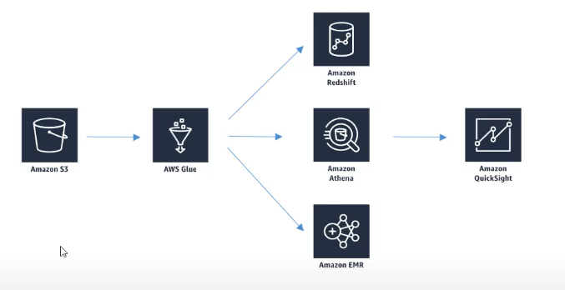

GLUE & S3 PARTITIONS
- Glue crawler will extract partitions based on how your S3 data is organized.
- Think up front about how you will querying your data lake in S3.
- Example: Devices send sensor data every hour.
- Do you query primarily by time ranges?
  - If so, organize your buckets as yyyy/mm/dd/device.
- Do you query primarily by Device?
  - If so, organize your buckets as device/yyyy/mm/dd.

Understanding Glue and S3 Partitions in Simple Terms
AWS Glue and S3 work together to efficiently manage large datasets. One way to optimize your data storage and retrieval in S3 is by using partitions, which help organize your data for faster queries.
Let’s break down the points and understand how Glue and S3 partitions work.

What Are Partitions in S3?
- Imagine you have a huge library of books. To find a specific book quickly, you organize the library by sections (e.g., Fiction, History), then by year, then by author. This makes finding the right book much faster.
- Similarly, S3 partitions are a way to organize your data in a structured manner so you can retrieve it efficiently.
  - Instead of storing all your data in one folder, you organize it into subfolders based on attributes like time, region, or device.

1. Glue Crawler Extracts Partitions Based on S3 Data Organization
- A Glue Crawler is smart enough to recognize how your data is organized in S3.
- If your S3 bucket has subfolders (partitions) like:
bash
Copy code
s3://my-datalake/2024/12/10/deviceA/
  - The crawler will detect the folder structure and treat "2024," "12," and "10" as partition keys for your data.
Why is this important?
- Glue uses this partitioning information to make queries faster and more efficient.
- When you run a query (e.g., "Show me data from December 10, 2024"), Glue can skip over irrelevant folders and go directly to the right partition.

2. Think Upfront About How You Will Query Your Data Lake in S3
- Before you start uploading data to S3, plan how you’ll query it.
- Organizing your S3 bucket structure properly upfront saves time and effort later.
- If your data is messy or unorganized, Glue will have a harder time creating partitions, and queries will be slower.

3. Example: Devices Send Sensor Data Every Hour
Imagine you have IoT devices sending sensor data every hour.
- You want to store this data in S3 so that it’s easy to query and analyze.

4. Organizing Buckets Based on Query Patterns
How you organize your S3 folders depends on how you’ll query the data most often.
Scenario 1: You Query Primarily by Time Ranges
- If most of your queries look like:
  - "Show me all data from December 2024."
  - "Get me sensor data for the week of Dec 10-16, 2024."
- Then, organize your S3 folders by time:
ruby
Copy code
s3://my-datalake/yyyy/mm/dd/device
For example:
bash
Copy code
s3://my-datalake/2024/12/10/deviceA/
s3://my-datalake/2024/12/11/deviceB/
- Here:
  - yyyy = Year
  - mm = Month
  - dd = Day
  - device = Device name or ID
Why does this help?
- Glue Crawler will detect the year, month, and day as partition keys.
- When you query "Give me data from Dec 10, 2024," Glue skips all other years, months, and days and retrieves only the relevant folder.

Scenario 2: You Query Primarily by Device
- If most of your queries look like:
  - "Show me all data for DeviceA for the past month."
  - "Give me sensor data for DeviceB for the last week."
- Then, organize your S3 folders by device:
ruby
Copy code
s3://my-datalake/device/yyyy/mm/dd
For example:

Copy code
s3://my-datalake/deviceA/2024/12/10/
s3://my-datalake/deviceB/2024/12/11/
- Here:
  - device = Device name or ID
  - yyyy/mm/dd = Year, month, and day
Why does this help?
- Glue Crawler will detect the device name as a partition key.
- When you query "Show me data for DeviceA," Glue skips all other devices and retrieves only the relevant folder.

How Glue and S3 Partitions Work Together
- Organizing Data in S3:
  - You organize your data in a structured way (e.g., by time or device).
- Glue Crawler Detects Partitions:
  - When you run a Glue Crawler on your S3 bucket, it recognizes the folder structure and creates partitions in the Data Catalog.
- Faster Queries with Partitions:
  - Partitions help AWS services like Athena, Redshift Spectrum, or EMR to skip irrelevant data and go directly to the folder that matches your query.

Why Partitions Are Important
- Faster Query Performance: Partitions help narrow down the search space, so queries don’t have to scan the entire dataset.
- Cost Efficiency: Querying smaller partitions reduces the amount of data scanned, saving costs.
- Scalability: Helps manage large datasets by breaking them into smaller, logical chunks.

Key Takeaways
- Glue Crawlers can automatically detect partitions if your S3 data is well-organized.
- Plan your S3 folder structure based on how you’ll query the data:
  - By time (e.g., yyyy/mm/dd/device) for time-based queries.
  - By device (e.g., device/yyyy/mm/dd) for device-based queries.
- Partitions help AWS tools query your data faster and more efficiently.
By thinking ahead and organizing your S3 data properly, you make it easier for Glue to work its magic and optimize your data analytics workflows!

GLUE + HIVE
- Hive lets you run SQL like queries from EMR.
- The Glue data catalog can serve as a Hive “metastore”
- We can also import Hive metastore into Glue.
Understanding AWS Glue and Hive in Simple Terms
Hive and Glue often work together in data processing environments, especially when you’re managing and analyzing large datasets. Let’s break down the concepts and the key points step by step.

What Is Hive?
- Introduction to Hive:
  - Imagine Hive as a tool that allows you to interact with large datasets stored in distributed systems (like Hadoop or S3) using SQL-like queries.
  - SQL is a familiar language for querying databases, and Hive brings the same ease to big data.
- Where Does Hive Run?
  - Hive runs on EMR (Elastic MapReduce) or other distributed systems.
  - EMR is an AWS service that helps process huge amounts of data using tools like Hive, Spark, and Hadoop.
- Why Use Hive?
  - If you have a massive dataset in S3 or Hadoop, writing traditional code to analyze it can be slow and complex.
  - With Hive, you can use SQL commands to retrieve and analyze your data, making it much easier and faster for analysts.

Key Features of Hive
- SQL-Like Queries: You can use familiar SQL commands like SELECT, WHERE, GROUP BY, etc.
- For Big Data: Designed for very large datasets in distributed storage systems.
- Batch Processing: It processes data in batches, which is useful for reporting and summarizing data.

How Does Glue Work with Hive?
Glue and Hive are complementary because Glue provides a data catalog that acts as a "map" or "directory" for your data, and Hive uses this catalog to run its SQL-like queries.

1. Hive Lets You Run SQL-Like Queries from EMR
- Hive allows you to analyze large datasets stored in S3 or Hadoop using SQL-like syntax.
  - For example, if your dataset is in S3, you could run a query like:
sql


  - Hive will process the query, retrieve the data from S3, and return the results.
- Hive typically runs on EMR, which is a service designed for processing massive datasets.

2. Glue Data Catalog Can Serve as a Hive “Metastore”
- To understand this, let’s break it into two concepts:
  - What Is a Hive Metastore?
    - Hive needs to know the structure (schema) of your data before running queries.
    - For example, it needs to know:
      - What are the column names in your dataset?
      - What is the data type for each column (e.g., string, integer)?
    - This information is stored in the Hive Metastore—a repository that stores all the metadata (data about your data).
  - How Does Glue Replace the Hive Metastore?
    - Glue’s Data Catalog acts as the metastore for Hive.
    - Instead of setting up a separate Hive Metastore, you can use the Glue Data Catalog to store your data’s metadata (table structure, schema, partitions, etc.).
    - Hive queries on EMR can directly use the Glue Data Catalog as their metastore.
    - This eliminates the need for managing a separate Hive Metastore, making the system simpler and more integrated with AWS.

3. You Can Also Import Hive Metastore into Glue
- If you already have a Hive Metastore (perhaps from an on-premises system or another cloud), you don’t need to recreate it manually in Glue.
- Glue provides tools to import your existing Hive Metastore into its Data Catalog.
- Once imported, Glue can work seamlessly with Hive on EMR, allowing you to:
  - Run Hive queries.
  - Use Glue Crawlers to keep the metadata up to date.
  - Enable other AWS services (like Athena or Redshift) to use the same Data Catalog.

Why Use Glue and Hive Together?
- Simplifies Metadata Management:
  - With Glue, you don’t need a separate Hive Metastore. The Glue Data Catalog handles it.
- Seamless Integration with AWS Services:
  - Glue’s Data Catalog works not just with Hive but also with other AWS services like Athena, Redshift Spectrum, and QuickSight.
- Reuse Existing Metadata:
  - If you already have a Hive Metastore, you can import it into Glue to avoid starting from scratch.

Summary of Each Point
- Hive Lets You Run SQL-like Queries from EMR:
  - Hive allows you to query and analyze large datasets in S3 or Hadoop using SQL commands.
  - It runs on EMR, which processes these queries on distributed systems.
- Glue Data Catalog Can Serve as a Hive Metastore:
  - Glue Data Catalog acts as a "map" for your data.
  - Hive on EMR can use this catalog to know the structure (schema) of your data.
- We Can Also Import Hive Metastore into Glue:
  - If you already have a Hive Metastore, you can import it into Glue to avoid duplicating work.
  - This allows Hive and Glue to work together seamlessly.

Why Is This Important?
- Glue and Hive are powerful tools for handling big data efficiently.
- Hive lets you query massive datasets easily using SQL.
- Glue makes metadata management simpler and integrates with other AWS services, making it a central hub for your data workflows.

GLUE ETL
- Automatic code generation.
- Scala or Python
- Encryption
- Server – side (at rest)
- SSL (in transit)
- Can be event – driven
- Can provision additional “DPUs” (Data Processing Units) to increase performance of underlying spark jobs
- Enabling job metrics can help you understand the maximum capacity in DPUs you need.
- Errors reported to CloudWatch.
- Could tie into SNS for notification.

- Transform, clean and enrich data (before doing analysis).
- Generate ETL code in Python or Scala, you can modify them.
- Can provide your own spark or PySpark scripts.
- Target can be S3, JDBC (RDS, RedShift), or in Glue Data Catalog.
- Fully manged, cost effective, pay only for the resources consumed.
- Jobs are run on serverless spark platform.
- Glue scheduler to schedule the jobs.
- Glue Triggers to automate job runs based on “events”.
Explaining AWS Glue ETL (Extract, Transform, Load) in Simple Terms
AWS Glue is a fully managed ETL (Extract, Transform, Load) service that helps you automate the process of preparing your data for analytics. It simplifies tasks like discovering data, cleaning and transforming it, and loading it into data warehouses or data lakes.
Now, let’s break down the different features and points related to Glue ETL:

1. Automatic Code Generation
- What It Means:
  - AWS Glue makes it easy to create code for transforming your data using an automatic code generation feature.
  - You don’t have to manually write all the code for extracting, transforming, and loading (ETL). Glue can generate much of the code for you based on your data sources and your transformation logic.
- How It Works:
  - For instance, when you set up an ETL job in Glue, it scans your data sources (like S3, RDS, or DynamoDB), detects their structure, and automatically creates the basic code required to perform data transformations on them.
  - You can still customize the code if needed, but the auto-generated code saves you time by providing a starting point.

2. Scala or Python
- What It Means:
  - AWS Glue supports two programming languages for writing your transformation logic: Scala and Python.
- How It Works:
  - Scala is a powerful, functional programming language that is often used for big data processing, especially with Spark.
  - Python is a simpler, popular language for data analysis and transformation tasks. It is more commonly used by data analysts and scientists.
  - You can choose either language when creating your Glue jobs based on what you are comfortable with or what fits your use case.

3. Encryption
- What It Means:
  - AWS Glue allows you to protect your data using encryption at various stages to ensure it stays secure.
- Types of Encryption:
  - Server-side encryption (at rest):
    - This ensures that your data is encrypted when it is stored, like in an S3 bucket or a data warehouse.
    - When the data is not actively being processed but is simply stored on the disk, it is encrypted to prevent unauthorized access.
  - SSL encryption (in transit):
    - SSL (Secure Sockets Layer) is used to encrypt the data while it’s being transferred over the network, protecting it from interception during communication between AWS services or between your systems and AWS.
- Why It’s Important:
  - Encryption ensures that your sensitive data is protected both when it is stored and when it is being transmitted, keeping it secure from potential attacks or unauthorized access.

4. Event-Driven
- What It Means:
  - AWS Glue jobs can be triggered based on specific events happening within your environment.
- How It Works:
  - For example, you can set up Glue to run automatically whenever new data is uploaded to an S3 bucket or when a specific event occurs, like a data change in a database.
  - This makes Glue very flexible because it can work in real-time or on a schedule without you having to manually trigger it.
- Why It’s Useful:
  - Automating ETL workflows based on events saves time and effort and ensures your data is always up to date without manual intervention.

5. Provision Additional “DPUs” (Data Processing Units)
- What It Means:
  - In AWS Glue, a DPU is a unit of computing power used to run Spark jobs, which handle data processing.
- How It Works:
  - If you need more computing power for your ETL jobs (especially for larger datasets), you can increase the number of DPUs. More DPUs mean faster processing and more capacity to handle bigger jobs.
  - You can scale the number of DPUs depending on the size and complexity of the job.
- Why It’s Useful:
  - If you have more data or if your transformations are computationally expensive, adding more DPUs can improve performance and speed up your processing jobs.

6. Enabling Job Metrics to Understand DPU Needs
- What It Means:
  - By enabling job metrics, you can monitor how your Glue jobs are performing in real-time.
  - These metrics give you insights into the capacity used and how much of your DPU resources are being utilized.
- How It Works:
  - You can track job metrics like the duration of the job, the amount of data processed, and the resources used.
  - This information helps you figure out if you need to scale up your DPUs or if you can reduce the resources for cost optimization.
- Why It’s Important:
  - Understanding the capacity requirements of your jobs helps ensure you aren’t over- or under-provisioning DPUs, allowing for cost efficiency and better performance management.

7. Errors Reported to CloudWatch
- What It Means:
  - AWS Glue integrates with Amazon CloudWatch, a monitoring service, to track and report any errors that occur during the execution of ETL jobs.
- How It Works:
  - If there is an issue with a job (such as a failure during data extraction, transformation, or loading), Glue will send error messages to CloudWatch.
  - You can then monitor the CloudWatch logs to diagnose and fix any issues in your ETL process.
- Why It’s Important:
  - Real-time error tracking allows you to quickly identify issues in your data pipeline, ensuring minimal downtime and smoother operation of your jobs.

8. Can Tie into SNS for Notification
- What It Means:
  - AWS Glue can integrate with Amazon SNS (Simple Notification Service) to send notifications about job statuses.
- How It Works:
  - You can set up SNS to send notifications (like emails or text messages) when specific events happen, such as:
    - A job is completed.
    - A job fails.
  - This ensures that you are always informed about the status of your ETL jobs.
- Why It’s Useful:
  - Notifications can help you stay on top of your jobs without constantly monitoring them. This is especially useful for automating alerting and ensuring timely action when needed.

Summary:
AWS Glue is a powerful ETL service that automates the process of extracting, transforming, and loading data. Here’s a quick recap of the features:
- Automatic Code Generation: Helps you create ETL code without having to write everything manually.
- Scala or Python: You can choose between Scala or Python to write your transformation logic.
- Encryption: Ensures that your data is secure both at rest (when stored) and in transit (when being transferred).
- Event-Driven: Glue jobs can be triggered by specific events, making the ETL process more automated and responsive.
- Provision Additional DPUs: You can scale the number of computing units (DPUs) for better performance when processing larger datasets.
- Job Metrics: Helps you track job performance and scale your resources appropriately.
- Errors Reported to CloudWatch: Errors during job execution are logged, making troubleshooting easier.
- SNS Notifications: You can integrate SNS to receive notifications about job success or failure.
These features make AWS Glue a powerful tool for managing large-scale data transformations in the cloud with minimal effort and high flexibility.

GLUE – ETL TRANSFORMATIONS
- BUNDLED TRANSFORMATIONS:
- Drop fields, Drop Null fields – remove null fields
- Filter: Specify a function to filter records.
- Join: To enrich data
- Map: Add fields, delete fields, perform external lookups.
- MACHINE LEARNING TRANSFORMATIONS
- FindMatches ML: Identify duplicate or matching records in your database, even when the records do not have a unique identifier and no fields match exactly.
- Format Conversions: CSV, Json, Avro, Parquet, ORC, XML.
- Apache spark transformations (ex. K – Means).

AWS GLUE DEVELOPMENT ENDPOINTS
- Develop ETL scripts using a notebook.
- Then create an ETL job that runs your script (Using spark and Glue).
- Endpoint is in a VPC controlled by security groups, connect via:
- Apache Zeppelin on local machine
- Zeppelin notebook server on EC2 (via Glue Console).
- SageMaker Notebook
- Terminal Window
- PyCharm Professional edition.
- Use Elastic IP to access a private endpoint address
Explaining AWS Glue Development Endpoints in Simple Language
AWS Glue provides Development Endpoints that help you create and test your ETL (Extract, Transform, Load) scripts before running them in a production environment. These endpoints allow you to develop, debug, and test your Glue scripts interactively.
Let’s break down each of the points you mentioned:

1. Develop ETL Scripts Using a Notebook
- What It Means:
  - A notebook is an interactive development environment where you can write and run your ETL scripts. In the case of AWS Glue, you typically write your code using Apache Spark or Python to process large amounts of data.
- How It Works:
  - You write your ETL code in a notebook interface (which is a user-friendly environment) to perform tasks like extracting data, transforming it, and then loading it into a database or data lake.
  - Once you’ve written and tested your code in the notebook, you can convert it into an ETL job that will run the script automatically at scale.
  - You can use tools like Apache Zeppelin or Jupyter notebooks to interact with the data and write your code.

2. Create an ETL Job That Runs Your Script (Using Spark and Glue)
- What It Means:
  - After developing your ETL script, you need to create an ETL job in AWS Glue. This job will run your code in a more automated way on larger datasets.
  - Glue uses Apache Spark to perform data processing, which is great for handling big data and parallel processing.
- How It Works:
  - Once your script is developed in a notebook (like Apache Zeppelin or SageMaker Notebook), you can turn it into an ETL job.
  - Glue will run the script on Spark, which distributes the workload across multiple compute nodes for fast data processing.
  - The ETL job handles everything, from extracting data from sources to transforming it and loading it into storage.

3. Endpoint Is in a VPC Controlled by Security Groups
- What It Means:
  - The Development Endpoint is located in a Virtual Private Cloud (VPC), which is like a secure private network in the cloud. This network is controlled by security groups, which act as firewalls that control access to resources.
- How It Works:
  - Your development endpoint (where you write and test your code) is securely isolated within a VPC to ensure data safety.
  - Security groups help manage which devices or users can access your endpoint, ensuring that only authorized users or machines can interact with your Glue job or data.

4. Connect Via:
- AWS Glue provides several ways to connect to the development endpoint for writing and testing your ETL code. You can use any of the following tools:
- Apache Zeppelin on Local Machine:
  - Apache Zeppelin is an open-source web-based notebook that supports interactive data analytics. You can install it locally (on your computer) and connect it to the Glue development endpoint to write and run your ETL scripts.
- Zeppelin Notebook Server on EC2 (via Glue Console):
  - You can also host the Apache Zeppelin notebook on an EC2 instance (a virtual machine on AWS) and connect it to AWS Glue. This allows you to use Zeppelin in the cloud to develop and run your scripts without needing to install anything locally.
- SageMaker Notebook:
  - Amazon SageMaker is a service for building and training machine learning models. You can use SageMaker Notebooks, which are Jupyter-like notebooks, to write ETL scripts. SageMaker can also connect directly to your Glue development endpoint.
- Terminal Window:
  - You can use the Terminal (or command line) on your local machine to interact with the Glue development endpoint. This would involve connecting through a secure SSH connection and running commands directly to manage and run your ETL jobs.
- PyCharm Professional Edition:
  - PyCharm is a powerful code editor for Python development. The Professional edition allows you to develop Python scripts that interact with AWS services like Glue. You can use PyCharm to connect to the Glue development endpoint and run your ETL code.

5. Use Elastic IP to Access a Private Endpoint Address
- What It Means:
  - Elastic IP is a static (unchanging) IP address that you can associate with your AWS resources. When you have a private Development Endpoint, it’s not accessible from the public internet. To access it, you can associate an Elastic IP address, which will give you a fixed, public IP to reach your private endpoint.
- How It Works:
  - If you need to access the development endpoint from your local machine (especially if it's behind a VPC and not directly accessible), you can use an Elastic IP to securely connect to it.
  - The Elastic IP serves as a gateway to access the private development endpoint from outside the VPC.

Summary of Key Points:
- ETL Scripts: Develop your ETL scripts using tools like notebooks (e.g., Apache Zeppelin, SageMaker).
- ETL Jobs: After testing in notebooks, create an ETL job in AWS Glue to run the script automatically using Spark.
- VPC and Security Groups: Glue development endpoints are located in a private VPC, and access is controlled using security groups to ensure only authorized users can interact with them.
- Connection Options: You can connect to the Glue endpoint using various tools like Apache Zeppelin, SageMaker, EC2, Terminal, or PyCharm.
- Elastic IP: If the endpoint is private, use an Elastic IP to access it securely from outside the VPC.
These development endpoints allow you to securely and interactively build and test your Glue ETL scripts before scaling them up for larger data processing tasks.

RUNNING GLUE JOBS
- Time – based schedules (Cron style).
- Job Bookmarks
- Persist state from the job run.
- Prevents reprocessing of the old data
- Allows you to process new data only when re-running on the schedule.
- Works with S3 sources on the variety of formats.
- Works with relational database via JDBC (if PKs are in sequential order)
- Only handles new rows, not updated rows.
- CloudWatch events
- Fire off a lambda function or SNS notification when SNS succeeds or fails.
- Invoke EC2 run, sent event to Kinesis, activate a Step function.
Let's break down the pointers you mentioned in simple language and explain each one in the context of AWS Glue Jobs.
1. Time-Based Schedules (Cron Style)
- What It Means:
  - AWS Glue allows you to set your jobs to run at specific times, similar to Cron jobs (a Unix/Linux scheduling system).
  - Cron style is a way of specifying the schedule using a simple format (like “run every day at midnight” or “run every hour”).
- How It Works:
  - You can configure your Glue jobs to run automatically at regular intervals by setting up a Cron-style schedule. For example, you might want the job to run every day at 2 AM or every 5 minutes.
  - This feature is useful for automating your ETL process without needing to manually trigger the jobs each time.

2. Job Bookmarks
- What It Means:
  - Job Bookmarks are used to remember the state of the job the last time it ran. This means it tracks where the job left off so that it doesn't reprocess the same data again.
- How It Works:
  - Persisting state means Glue saves information about the last job run (for example, the latest data it processed). The next time the job runs, it knows where to start and only processes new data.
  - This feature is especially helpful when you're processing large datasets and want to avoid repeating work.
  - If you have data in S3 (like CSV, JSON, or Parquet files), Glue will remember the last file it processed. Similarly, if you're using a relational database (via JDBC), it can track the last processed record if the data has a primary key (PK) in sequential order.
- Benefits:
  - Prevents reprocessing old data: This ensures that Glue does not process the same data multiple times.
  - Works with various data sources: It works with S3 in multiple formats and relational databases if the primary keys are sequential (like ID numbers that go up by 1).
- Important Note: Job Bookmarks only track new rows. If a row has been updated in the source, Glue won’t reprocess it.

3. CloudWatch Events
- What It Means:
  - CloudWatch Events allows you to monitor Glue job runs and take actions based on whether the job succeeds or fails.
  - For example, if your Glue job finishes successfully or encounters an error, you can trigger other actions like sending notifications, running additional processes, or invoking other services.
- How It Works:
  - Fire off a Lambda function or SNS notification: You can configure AWS CloudWatch to trigger a Lambda function (a piece of code that runs automatically) or send a notification via SNS (Simple Notification Service) when the Glue job succeeds or fails. This can be used to alert you if something goes wrong.
  - Invoke EC2 run or Kinesis stream: If you want to do more complex tasks like running another EC2 instance (a virtual server) or sending data to Kinesis (a stream for real-time data), CloudWatch can trigger these actions.
  - Activate a Step Function: A Step Function is a service that coordinates multiple AWS services into serverless workflows. When your Glue job finishes, you can have CloudWatch trigger a Step Function to automate further processing or tasks.

Summary of Key Points:
- Time-Based Schedules (Cron Style): Schedule Glue jobs to run at regular intervals (e.g., every day, every hour) using Cron-style timing.
- Job Bookmarks: Keep track of the last processed data to avoid reprocessing old data. It helps Glue know where to start the job and only process new data, especially when dealing with S3 or relational databases.
- CloudWatch Events: Set up actions based on the success or failure of Glue jobs, such as sending notifications (SNS), running additional functions (Lambda), or triggering other services (like EC2 or Kinesis).
Example Scenario:
Imagine you have a job that processes sensor data stored in S3. You want this job to run every day at midnight. With Time-Based Schedules, you can set it up to automatically run daily. When the job runs, it uses Job Bookmarks to only process new sensor data collected since the last run, avoiding duplication. If the job succeeds or fails, CloudWatch Events can notify you via SNS or run additional processes to handle the data further.
This way, AWS Glue makes it easier to automate and manage data processing tasks with minimal manual intervention.

GLUE COST MODEL
The Glue Cost Model works like this:
- You pay for the time you use Glue for tasks like crawling data or running ETL (Extract, Transform, Load) jobs, calculated by the minute.
- The first million data objects stored and accessed in the Glue Data Catalog are free of charge.
- If you use a development environment to write and test ETL code, you also pay for the time you use it, again calculated by the minute.

GLUE ANTI – PATTERNS
- Multiple ETL Engines
- Glue ETL is based on spark
- If you want to use other engines (Hive, Pig etc.) Data Pipeline EMR would be better fit.
NO LONGER AN ANTI – PATTERN: STREAMING
Streaming in Glue ETL is no longer considered a bad practice. Here's why:
- Since April 2020, Glue ETL can handle real-time streaming data without needing servers.
- It can take data directly from Kinesis or Kafka, clean it, and transform it instantly as it flows through.
- The processed data can then be saved in S3 or other storage systems.
- It uses Apache Spark's Structured Streaming technology to do all this efficiently.

AWS GLUE STUDIO
AWS Glue Studio makes working with ETL (Extract, Transform, Load) jobs easy by providing a simple, visual interface. Here's what it offers:
- Visual Job Editor: You can design and manage ETL workflows visually, like drawing a flowchart.
  - It lets you connect to data sources like S3, Kinesis, Kafka, and databases (via JDBC).
  - You can clean, sample, and join data during the process.
  - The processed data can be saved to S3 or added to the Glue Data Catalog, with support for dividing data into partitions for better organization.
- Visual Job Dashboard: Gives a clear overview of your jobs, their current status, and how long they take to run.
It simplifies ETL tasks so you don’t have to write code for everything!

AWS GLUE: AWS Glue is the fully managed, serverless ETL service.
ETL Stands for EXTRACTION, TRANSFORMATION, LOAD
EXTRACTION: It is the process of fetching / retrieving data from various data sources and load it into a staging area for further use.
TRANSFORMATION: It is the process of performing operations like cleansing, mapping, re-formatting and more on the extracted data. The objective is to prepare and optimize the data which can be easily consumed by the end processes like Data Analytics, ML, etc.
LOADING: It is the process of inserting the transformed data into the target database, data warehouse, data store from where the users and various processes can consume it.
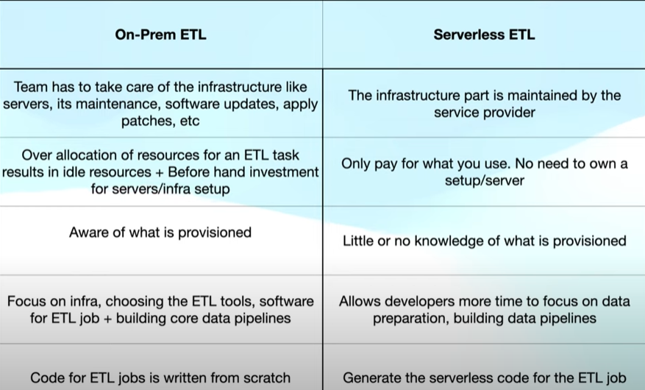

AWS GLUE
- AWS Glue is the fully managed, serverless ETL tool.
- Used to discover the data, transform it and prepare it for analytics.
- AWS Glue provides all the capabilities for data integration via visual and code – based interfaces.
- It consists of central Metadata Repository known as AWS Data Catalog.
- Apache Spark ETL engine

COMPONENTS OF AWS GLUE
AWS Glue is a serverless data integration service that helps you prepare, transform, and move data for analytics. Here's a detailed explanation of its main components in simple language:

1. AWS Glue Data Catalog
Think of it as a library of information about your data. It keeps track of:
- Data sources (like files in S3 or databases).
- Schemas (structure of the data, like column names and types).
- Metadata (details about the data, like where it’s stored).
This helps Glue and other AWS services (like Athena and Redshift) find and understand your data quickly.

2. Crawler
A crawler is like a data detective.
- It scans your data sources (like S3 or databases).
- Figures out its structure and format (e.g., CSV, JSON, or Parquet).
- Automatically creates or updates tables in the Data Catalog with this information.

3. ETL Jobs
ETL stands for Extract, Transform, Load. Glue can run ETL jobs to:
- Extract data from one or more sources (like S3 or on-prem databases).
- Transform it (clean, filter, enrich, or join it).
- Load the processed data into a target (like another S3 bucket, Redshift, or a database).
Glue handles these jobs serverlessly, so you don’t need to manage any infrastructure.

4. Job Authoring Tools
AWS Glue provides tools to create ETL jobs:
- Visual Interface (Glue Studio): Design ETL workflows by dragging and dropping components without coding.
- Script Editor: Write or modify Python or Scala scripts for more control.

5. Glue Triggers
Triggers are like timers or alerts for your ETL jobs.
- You can schedule jobs to run at specific times (e.g., daily at midnight).
- Set them to run when another job finishes or when a new file appears in S3.

6. Development Endpoints
Development endpoints are like playgrounds for testing your ETL code.
- You can connect your own tools (like Jupyter Notebooks) to test and debug Glue scripts before running them in production.

7. Glue Workflow
A workflow helps you organize and manage a series of related jobs.
- It lets you chain multiple jobs together.
- You can create dependencies (e.g., Job B only runs after Job A finishes).
This makes it easy to handle complex data pipelines.

8. AWS Glue Studio
Glue Studio is a visual tool that simplifies creating ETL workflows:
- Drag and drop components to design data flows.
- Test and preview your transformations.
- Monitor your jobs in a dashboard.

9. Dynamic Frames
Dynamic Frames are Glue’s special data structure for handling data:
- More flexible than DataFrames (used in Apache Spark).
- Makes it easier to handle semi-structured or messy data, like JSON files with inconsistent fields.

10. AWS Glue Streaming
This lets you process real-time data streams from sources like Amazon Kinesis or Apache Kafka.
- You can clean and transform data as it flows in.
- Store the processed data in S3 or other storage for immediate use.

Summary
AWS Glue combines all these components to automate and simplify working with data. Whether you need to catalog your data, clean it up, move it to another location, or analyze it, Glue provides all the tools you need in one place—without worrying about managing servers or infrastructure.

AWS GLUE WORKFLOW
- Define crawler to populate the Data Catalog.
- Create the ETL job.
- AWS Glue generate the script for the ETL job or you can also provide / write one.
- Run the job on-demand or define the scheduler or Trigger.
- Extract the data from DS, transform it and load it into the Data Target.
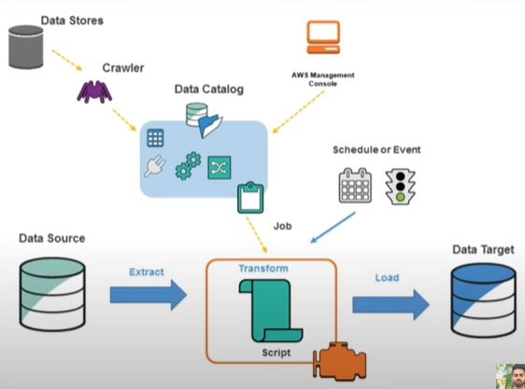
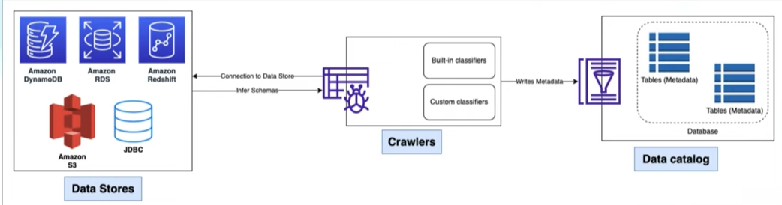
This diagram shows how AWS Glue populates the Data Catalog, which stores metadata (information about your data). Let’s break it down into simple steps:
1. Data Stores (on the left)
- These are the places where your data is stored, like:
  - Amazon S3 (for files like CSV or JSON).
  - DynamoDB or Redshift (databases).
  - RDS (relational databases).
  - JDBC (other databases that Glue can connect to).
- Glue connects to these data stores to gather information about your data.

2. Crawlers (in the middle)
- A crawler is like a tool that scans your data.
- It uses:
  - Built-in classifiers (pre-made rules for common data formats like CSV or JSON).
  - Custom classifiers (your own rules for special data formats).
- The crawler connects to the data store, examines the data, and infers the schema (structure of the data, like column names and types).

3. Data Catalog (on the right)
- After the crawler figures out the structure of your data, it writes this information as metadata into the Glue Data Catalog.
- The catalog stores the metadata in tables, which other AWS services (like Athena or Redshift) can use to query or analyze the data.

Summary
- Glue crawlers connect to your data sources, inspect the data, and automatically create or update metadata tables in the Data Catalog.
- This process helps you manage and understand your data without manually defining schemas or metadata.

AWS GLUE DATA BREW
AWS Glue DataBrew is a tool that helps you clean, prepare, and transform data for analysis, without needing to write any code. It's like an assistant that helps you organize and format your data, making it ready for use in reports, analytics, or machine learning, all through a simple, visual interface.
Here’s everything you need to know about AWS Glue DataBrew in simple language:
1. What Does It Do?
- Data Cleaning & Transformation: It helps you clean messy data (e.g., missing values, incorrect formats) and change it into the format you need for analysis. For example, you can fix dates, split or combine columns, and remove unnecessary rows.
- No Coding Required: You don't need to write complex code! You just drag and drop different options on the screen to manipulate the data.
- Pre-built Tools: It has over 250 ready-made tools that you can use to change your data, like removing duplicates, formatting dates, or replacing values.
2. Where Can You Get Data from?
- You can easily connect AWS Glue DataBrew to various data sources:
  - Amazon S3 (where you store data files like CSV or Excel)
  - Amazon Redshift (data warehouse)
  - RDS (Relational Databases) like MySQL, PostgreSQL, etc.
  - Other external databases like Google BigQuery or Snowflake.
3. How Does It Help You?
- Data Profiling: It shows you a preview of your data and helps you spot any issues like missing or duplicate values, so you can fix them easily.
- Visual Interface: You can see your data and the transformations happening in real-time, which makes the process of cleaning and preparing data much easier.
- Interactive Previews: As you make changes, you can see how your data looks at each step, so you know exactly what the final result will be.
4. What Can You Do with It?
- Transform Your Data: You can clean and modify your data with just a few clicks, like:
  - Removing duplicate rows
  - Fixing dates or numbers
  - Changing text in the data
  - Filling in missing values or removing them
  - Merging or splitting columns
- Create Custom Rules: If the pre-built tools don't cover your needs, you can create your own custom transformations.
5. How Does It Connect with AWS Glue?
- Glue Integration: After preparing your data in DataBrew, you can easily push your work to AWS Glue, which is a service that runs your data workflows automatically.
- Glue Jobs: You can save your data preparation work as a Glue job, which can be scheduled to run at certain times or triggered by events. This helps you automate your data processing tasks.
6. Collaboration
- You can share your data preparation recipes with team members, making it easier for others to use your work.
7. How Much Does It Cost?
- The pricing for AWS Glue DataBrew depends on how much data you process and the number of jobs you run. You are billed based on the amount of data processed (measured in Data Processing Units, or DPUs).
Summary:
AWS Glue DataBrew makes data preparation simple and fast, allowing anyone (even without coding skills) to clean, format, and transform data for analysis. You can connect to various data sources, use pre-built tools, and easily export your work to other AWS services for further processing or analysis.

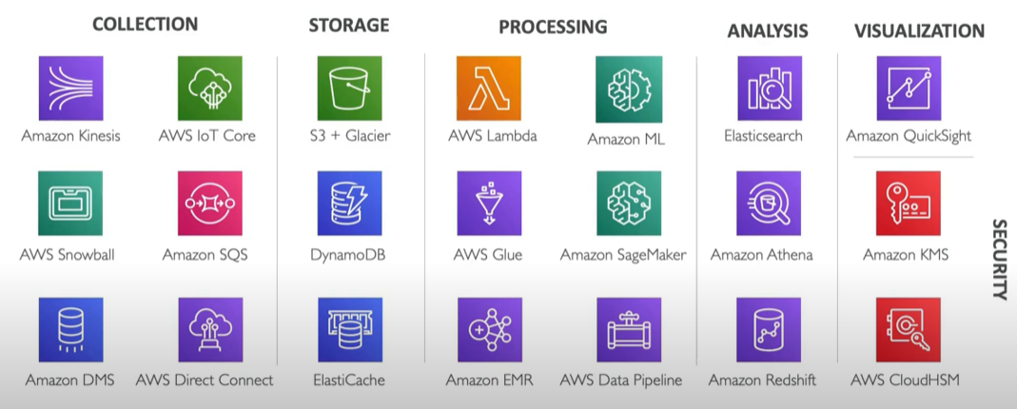

COLLECTION
- REAL TIME – IMMEDIATE ACTION
- Kinesis Data Stream (KDS)
- Simple Queue Service (SQS)
- Internet of Things (IoT)
- NEAR – REAL TIME – REACTIVE ACTIONS
- Kinesis Data Firehose
- Database Migration System
- BATCH – HISTORICAL ANALYSIS
- Snowball
- Data Pipeline

Detailed Explanation of EC2 Configuration

1. Instance Type
What is an Instance Type in EC2?
An instance type in Amazon EC2 is like choosing the hardware for your virtual machine. It decides how much CPU (processing power), memory (RAM), storage, and network speed your instance will have. AWS gives you many instance types, each suited for specific kinds of tasks like running websites, processing data, or training AI models.

Categories of Instance Families
General Purpose:
Balanced machines with a good mix of CPU, memory, and networking.
Examples:
t3.micro: For low-cost, small-scale projects like personal websites.
m5.large: For medium workloads like app hosting.
Compute Optimized:
Powerful CPU-focused machines for tasks needing a lot of calculations.
Use: Gaming servers, scientific simulations, or video encoding.
Example: c5.large.
Memory Optimized:
Machines with lots of RAM, ideal for tasks that process large amounts of data in memory.
Use: Big databases or real-time data processing.
Example: r5.large.
Storage Optimized:
Machines with fast and large storage for tasks needing high disk performance.
Use: Big Data analysis, data warehousing, or file systems.
Example: i3.large.
Accelerated Computing:
Machines with GPUs or other hardware accelerators for tasks like AI model training or 3D rendering.
Use: Machine learning, high-performance computing, and video rendering.
Example: p3.2xlarge.

What Comes with an Instance Type?
vCPU Count:
- The "brain" of the instance.
- More vCPUs = Faster processing and multitasking.
Memory (RAM):
- Allows your instance to handle larger and more complex tasks.
- More RAM = Better performance for memory-hungry applications.
Network Bandwidth:
- Determines how fast your instance can send and receive data over the internet.
- Higher bandwidth = Faster data transfers.
EBS Throughput:
- Affects how quickly your instance can read from or write to its storage volumes.
- Important for applications that frequently access storage, like databases.

Use Cases for Instance Types
Websites or Small Apps:
- Use t3.micro or t2.micro for lightweight apps or small-scale websites.
- Example: Personal blogs or test servers.
AI and Machine Learning:
- Use p3.2xlarge for tasks like training neural networks.
- Example: Building an AI model for image recognition.
Databases:
- Use r5.large for running memory-heavy databases like MySQL or Redis.
- Example: A business needing fast data processing.
Big Data Processing:
- Use i3.large for systems analysing massive datasets.
- Example: Running Hadoop or Spark for data analytics.

In Short: The instance type determines how much computing power, memory, and storage your EC2 instance has. Choosing the right type depends on the kind of task you want to perform, whether it's running a simple website, training AI models, or analyzing large datasets.

What is a Key Pair?
A key pair is a method AWS uses to securely log in to your EC2 instance. Instead of typing a password, AWS uses a combination of two keys to allow access:
- Public Key: This is stored inside your EC2 instance by AWS.
- Private Key: You download this key (e.g., my-key.pem) when you create it, and it stays with you. You use it to log in to the instance securely.
Think of the public key as a lock installed on your EC2 instance and the private key as the key to unlock it. Without the private key, no one can log in.

How Key Pairs Work (Step-by-Step):
- When launching an EC2 instance, AWS asks you to choose or create a key pair.
- You download the private key file (e.g., my-key.pem) to your computer.
- The public key is automatically stored inside the EC2 instance.
- To log in to your instance (via SSH), you use the private key file.
- AWS checks if your private key matches the public key on the instance. If it matches, you are allowed to log in.

Things Included Under Key Pair
- Key Creation:
  - AWS allows you to create a new key pair when launching an EC2 instance.
  - You must download and save the private key securely. AWS does not let you download it again.
- Secure Storage:
  - Keep the private key safe because if you lose it, you won’t be able to log in to the EC2 instance.
  - If the private key is shared or stolen, someone can misuse it to log in to your instance.
- Access Control:
  - Instead of passwords, key pairs provide a more secure way to log in.
  - Only people with the private key can access the instance.
- Multiple Keys:
  - You can create different key pairs for multiple users.
  - Each user will have their own private key file to log in.

How to Give Access to Multiple Users
If multiple people need to log in to the same EC2 instance, you can assign different key pairs to them by following these methods:
Option 1: Adding Public Keys to the Instance (Manual Method)
- Create Multiple Key Pairs: Each user generates their own key pair and downloads the private key.
- Share the Public Key: Each user shares their public key with you.
- Add Public Keys to the Instance:
  - Log in to the EC2 instance using your private key.
  - Open the file /home/ubuntu/.ssh/authorized_keys (for Ubuntu instances).
  - Copy and paste each user’s public key into this file.
Example:
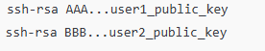
- Users Log In: Each user can now log in using their own private key.

Option 2: Using a Shared Key Pair (Easier but Less Secure)
- Create a Single Key Pair: Generate one key pair during instance launch.
- Share the Private Key: Give the private key file (e.g., my-key.pem) to team members who need access.
- Users Log In: All team members can use the same private key to log in.
Important: Sharing the private key file is not recommended because if someone leaves the team, you’ll need to replace the key pair for security.

Use Cases of Key Pairs
- Secure Login:
  - Developers use the private key file to log in to the EC2 instance for deploying or managing applications securely.
- Shared Access for Teams:
  - Multiple team members working on the same instance can use separate key pairs.
  - This ensures everyone has access without compromising security.
- Automated Access:
  - Key pairs are used with tools like Ansible, Terraform, or automated scripts to set up and log in to instances without manual effort.

Summary
- A key pair is like a lock and key system. The public key is stored in your EC2 instance, and the private key is with you.
- You log in securely using the private key file.
- For multiple users, you can add their public keys to the instance, or share one key pair (less secure).
By using key pairs, AWS avoids passwords and provides a more secure way to log in to your instances.

3. Network Settings
What are Network Settings?
Network settings define how your EC2 instance connects to the internet, your private network, or other AWS services. It includes:
- VPC (Virtual Private Cloud): A private, isolated network in AWS for your resources.
- Subnets: Logical subdivisions within a VPC. You can have public subnets (connected to the internet) and private subnets (isolated from the internet).
- Elastic IPs: Static IP addresses that can be assigned to instances.
- Security Groups: Virtual firewalls controlling incoming and outgoing traffic for the instance.
- Route Tables: Determines how traffic is directed within the network.
Things Included Under Network Settings:
- Internet Gateway: For public-facing instances.
- NAT Gateway: Allows private instances to access the internet securely.
- Firewall Rules (Security Groups): Control access (e.g., allow port 22 for SSH, 80 for HTTP).
- DNS Settings: Manage domain name resolution for instances.
Use Cases:
- Public Web Application: Place the instance in a public subnet, assign a public IP, and configure security groups to allow HTTP (port 80) and HTTPS (port 443) traffic.
- Private Backend Database: Place the instance in a private subnet with no internet access.
- Custom VPN Setup: Use a VPC to create a secure VPN tunnel between your on-premises data centre and AWS.
- Server Clusters: Use security groups to allow internal communication between instances but block external traffic.

4. Configure Storage
What is Configure Storage?
This refers to the disk space attached to your EC2 instance. AWS uses Elastic Block Store (EBS) volumes for instance storage, which can be configured based on performance and size requirements. You can choose the volume type and size while launching an instance or attach additional volumes later.
Types of EBS Volumes:
- General Purpose SSD (gp3 or gp2): Balanced performance for everyday workloads.
- Provisioned IOPS SSD (io1 or io2): High-performance storage for databases.
- Throughput Optimized HDD (st1): For large files requiring sequential data processing.
- Cold HDD (sc1): Low-cost storage for infrequent access.
Things Included Under Configure Storage:
- Root Volume: The primary disk where the operating system is installed.
- Additional Volumes: For storing application data or logs.
- Volume Size: Measured in GB (e.g., 8 GB, 100 GB).
- Snapshots: Create backups of your data at specific points in time.
Use Cases:
- Web Server: Use a general-purpose SSD with 30 GB storage for system files and website content.
- Big Data Analytics: Use high-throughput HDDs (e.g., st1) for batch processing of large datasets.
- Database: Attach provisioned IOPS SSDs for high-performance read/write operations.
- Backups: Create snapshots of your storage volume for disaster recovery.

End-to-End Example Use Case
Scenario:
You want to set up a machine learning training server on AWS.
- Instance Type:
Choose a compute-optimized instance like p3.2xlarge with GPU support for faster ML model training.
- Key Pair (Login):
Create a key pair to securely log in to the instance using SSH. Save the private key (my-ml-server.pem) on your local system.
- Network Settings:
  - Use a public subnet for direct internet access.
  - Configure a security group to allow:
    - Port 22 (SSH) for admin access.
    - Port 8888 for Jupyter Notebook (used for ML development).
- Configure Storage:
  - Use a 50 GB SSD (gp3) for the operating system and application files.
  - Add an additional 200 GB SSD (io2) volume to store large datasets for ML training.
This configuration allows you to:
- Log in securely.
- Work on your ML project with sufficient compute and storage resources.
- Access the server and tools like Jupyter from your local machine.

Firewall (Security Groups)
What is a Security Group?
A Security Group in EC2 acts as a virtual firewall to control inbound (incoming) and outbound (outgoing) traffic to and from your EC2 instance. It defines what types of traffic are allowed or denied for your instance based on rules that you specify.
Security Groups operate at the instance level (not the subnet level) and are stateful, which means:
- If you allow inbound traffic, the response traffic for that connection is automatically allowed, even if no outbound rule is defined.

Things Included Under Security Groups:
- Rules:
  - You can define multiple rules to allow specific types of traffic.
  - Rules consist of:
    - Protocol: Type of network communication (e.g., TCP, UDP, ICMP).
    - Port Range: Specific port numbers (e.g., 22 for SSH, 80 for HTTP).
    - Source/Destination IP: IP addresses or ranges (e.g., 0.0.0.0/0 means any IP can connect).
- Direction of Traffic:
  - Inbound Rules: Define traffic allowed to your EC2 instance.
    - Example: Allow SSH (port 22) for system administrators.
  - Outbound Rules: Define traffic your instance can send out.
    - By default, all outbound traffic is allowed.
- Association:
  - You can associate multiple security groups with an EC2 instance.
  - One security group can be applied to many instances.
- Default Behaviour:
  - By default, all inbound traffic is blocked.
  - All outbound traffic is allowed.

Use Cases of Security Groups:
- Web Server (Public Instance):
  - Inbound Rules: Allow traffic on port 80 (HTTP) and 443 (HTTPS) from 0.0.0.0/0 (anywhere).
  - Outbound Rules: Allow all traffic for the instance to download updates or reach the internet.
Example: Hosting a website on Apache.
- SSH Access for Admins:
  - Inbound Rule: Allow SSH (port 22) only from specific IP addresses (e.g., your office IP, 123.456.789.0/32) for secure access.
  - This prevents unauthorized access.
- Private Backend Database:
  - Inbound Rule: Allow MySQL (port 3306) only from specific security groups or internal subnets.
  - Outbound Rule: Allow traffic to a front-end server.
- Load Balancers and Multiple Instances:
  - Use security groups to allow instances to communicate internally via ports like 8080 but block external access.

Important Notes:
- You cannot deny traffic using security groups; you can only allow specific traffic.
- If no rules are specified, all traffic is denied by default (except outbound traffic).
- Changes to a security group apply immediately to all associated instances.

Configure Storage
What is Configure Storage?
When launching an EC2 instance, you configure Elastic Block Store (EBS) volumes, which act like virtual hard drives for your instance. These storage volumes store the operating system, application data, or logs.
You can configure:
- Root Volume: The main storage for the operating system (e.g., 30 GB for Ubuntu or Windows Server).
- Additional Volumes: Attach extra EBS volumes for storing databases, logs, or data files.
- Volume Type: AWS offers different types of EBS volumes based on performance and cost.

Types of EBS Volumes:
Volume Type | Performance | Use Case
gp3 / gp2 (General Purpose SSD) | Balanced performance (3,000 IOPS baseline). | Web servers, development environments.
io2 / io1 (Provisioned IOPS SSD) | High IOPS (up to 64,000 IOPS). | Databases (e.g., Oracle, MySQL).
st1 (Throughput Optimized HDD) | High throughput for sequential reads. | Big data processing, log storage.
sc1 (Cold HDD) | Lowest cost, lower performance. | Archiving, backups, rarely accessed data.

Things Included Under Configure Storage:
- Size:
  - Specify the volume size in GB (e.g., 30 GB, 500 GB).
  - You can later increase the size without downtime.
- Volume Type:
  - Choose from SSD (for speed) or HDD (for cost-effectiveness).
- Encryption:
  - Encrypt volumes to protect sensitive data.
  - AWS manages the encryption keys.
- Snapshots:
  - Take snapshots (backups) of your volumes for disaster recovery or cloning volumes.
- Multiple Volumes:
  - You can attach multiple EBS volumes to one EC2 instance.
- Delete on Termination:
  - Choose whether to delete the volume when the EC2 instance is terminated.

Use Cases of Storage Configuration:
- Web Server Storage:
  - Use a gp3 (General Purpose SSD) volume of 30 GB for a small website running Apache or Nginx.
- Database Storage:
  - Use a Provisioned IOPS SSD (io2) volume with high IOPS and low latency for databases like MySQL or Oracle.
- Big Data Processing:
  - Use st1 (Throughput Optimized HDD) for storing large datasets like logs or analytics data.
- Backup Storage:
  - Use Cold HDD (sc1) to store rarely accessed files, like backups or archives.
- Snapshots and Data Recovery:
  - Regularly take snapshots of your EBS volumes to ensure you can recover data in case of failure.
- Scaling Storage Dynamically:
  - Start with a smaller volume (e.g., 50 GB) and increase the size as your data grows without impacting the application.

Combined Example Use Case
Scenario: Hosting a Secure Web Application with a Database
- Security Groups (Firewall):
  - Inbound Rules:
    - Allow HTTP (port 80) and HTTPS (port 443) for the web application.
    - Allow SSH (port 22) only from your office IP (123.456.789.0/32).
  - Outbound Rules:
    - Allow all outbound traffic so the instance can download updates or connect to APIs.
- Storage Configuration:
  - Root Volume: 30 GB gp3 (SSD) for the operating system and application files.
  - Additional Volume:
    - Attach a 100 GB io2 (Provisioned IOPS SSD) for the database to ensure high performance.
Outcome:
- The web server is public-facing but secure, with controlled access via security groups.
- The database runs efficiently with dedicated, high-performance storage.
- The storage volumes are backed up regularly using snapshots.

By understanding these components—security groups and storage configuration—you can build secure, scalable, and cost-effective EC2 solutions for any use case.

MY FIRST INSTANCE SUMMARY DETAILS
- Instance ID:
  - i-06deefdd1b39010fa
  - This is a unique identifier for your EC2 instance, like its serial number. AWS uses this ID to track your instance.
- Public IPv4 Address:
  - 13.203.86.194
  - This is the internet-accessible IP address of your instance. You can use this to connect to your server from anywhere via the internet.
- Private IPv4 Address:
  - 172.31.9.54
  - This IP is for internal communication within the AWS network. It’s not accessible from the internet.
- Instance State:
  - Running
  - Indicates that your instance is currently active and operational.
- Public IPv4 DNS:
  - ec2-13-203-86-194.ap-south-1.compute.amazonaws.com
  - This is the public DNS name of your instance, which maps to its public IP address. You can use it to access the instance instead of the IP.
- Hostname Type:
  - IP name: ip-172-31-9-54.ap-south-1.compute.internal
  - This is your instance's internal hostname. It's used for internal communication between instances in the same AWS network.
- Instance Type:
  - t2.micro
  - This is the type of instance you chose. It has:
    - 1 virtual CPU (vCPU)
    - 1 GB of memory (RAM)
    - Ideal for low-traffic websites or lightweight workloads.
- Elastic IP Addresses:
  - None assigned
  - Elastic IPs are fixed IPs that remain constant even if you stop and restart your instance. Since none is assigned, your public IP may change if the instance is restarted.
- VPC ID:
  - vpc-05254aea8b1de442c
  - Your instance belongs to this Virtual Private Cloud (VPC), which is like your own private network within AWS.
- IAM Role:
  - None assigned
  - IAM Roles allow your instance to securely access AWS services without hardcoding credentials. No role is attached here.
- Subnet ID:
  - subnet-0a9b379729cfcc61e
  - Your instance is placed within this subnet, which is a part of your VPC. A subnet groups resources into smaller network segments.
- AMI ID:
  - ami-053b12d3152c0cc71
  - This is the ID of the Amazon Machine Image (AMI) used to launch your instance. The AMI determines your operating system and software configuration.
- AMI Name:
  - ubuntu/images/hvm-ssd-gp3/ubuntu-noble-24.04-amd64-server-20241109
  - You selected an Ubuntu 24.04 Linux server as the operating system for your instance.
- Launch Time:
  - Wed Dec 18 2024 04:35:48 GMT+0530
  - The date and time when your instance started.
- Key Pair:
  - pranay-demo
  - The key pair is used for securely logging into your instance. You likely downloaded the private key (.pem file) when you created this key pair.
- Instance Type Credit Specification:
  - Standard
  - t2.micro uses "burstable" performance, meaning it accumulates CPU credits when idle and uses them during high-demand periods.

Other Details
- Monitoring:
  - Disabled
  - Monitoring tracks metrics like CPU usage, memory, and disk performance. Enabling it incurs additional costs.
- Termination Protection:
  - Disabled
  - If enabled, it prevents accidental termination of the instance.
- Stop Protection:
  - Disabled
  - If enabled, it prevents the instance from being stopped accidentally.
- Elastic Block Store (EBS) Details (Storage):
  - The instance likely uses an EBS volume for its storage, specified during setup.
- Tenancy:
  - Default
  - This means your instance runs on shared hardware with other AWS customers.
- Virtualization Type:
  - HVM
  - This type of virtualization is optimized for modern hardware and provides better performance.

Key Use Cases
- Public IPv4 Address:
  - Used for connecting to your instance from outside the AWS network (e.g., accessing your web application).
- Private IPv4 Address:
  - Useful when setting up internal communication between multiple instances in the same VPC (e.g., database access from a web server).
- Security Groups:
  - Control who can access your instance and which services are exposed.
- AMI ID/Name:
  - Defines the operating system and software installed on the instance.
- Key Pair:
  - Enables secure SSH access to your instance without using passwords.
By understanding these details, you can better manage your instance and troubleshoot issues effectively. Let me know if you’d like clarification on any specific part!
In EC2, inbound and outbound rules are part of the Security Groups, which act like virtual firewalls for your instance. These rules control the traffic that can come into or leave your EC2 instance. Let’s break it down:

Inbound Rules
- What it does:
Inbound rules decide what kind of traffic is allowed to enter your EC2 instance.
For example, if you want to access your EC2 instance using SSH (port 22) or allow users to visit your website (port 80 for HTTP or 443 for HTTPS), you need to configure inbound rules for those ports.
- Key Components:
  - Protocol:
Specifies the type of communication protocol allowed (e.g., TCP, UDP, or ICMP). Common protocols include:
    - TCP: For SSH, HTTP, HTTPS, etc.
    - ICMP: For pinging the instance.
  - Port Range:
Defines the specific port(s) allowed for incoming traffic.
    - Example:
      - SSH uses port 22.
      - HTTP uses port 80.
  - Source:
Specifies who is allowed to send traffic to your instance. This could be:
    - A specific IP address (e.g., 192.168.1.1/32 allows only that IP to connect).
    - Anywhere (0.0.0.0/0): Allows everyone on the internet to connect. Be cautious with this setting.
    - Another Security Group: Allow traffic from instances in a specific group.
Use Cases of Inbound Rules:
- Allow SSH Access:
Rule: TCP, Port 22, Source: Your IP Address (203.0.113.1/32)
  - Use this if you want to log into your server securely using a terminal or SSH client.
- Host a Website:
Rule: TCP, Port 80, Source: 0.0.0.0/0
  - Use this to make your website accessible to anyone on the internet.

Outbound Rules
- What it does:
Outbound rules decide what kind of traffic is allowed to leave your EC2 instance.
For example, if your instance needs to download updates from the internet or send API requests to another server, you configure outbound rules for those activities.
- Key Components:
  - Protocol:
Specifies the type of communication protocol allowed (e.g., TCP, UDP, or ICMP).
  - Port Range:
Defines the specific port(s) allowed for outgoing traffic.
    - Example:
      - Port 443 is used for secure HTTPS connections.
  - Destination:
Specifies where the instance can send traffic.
    - Anywhere (0.0.0.0/0): Allows the instance to send traffic to any destination on the internet.
    - A specific IP or domain: Restrict outgoing traffic to certain systems.
Use Cases of Outbound Rules:
- Download Software Updates:
Rule: TCP, Port 443, Destination: 0.0.0.0/0
  - Use this if your instance needs to access software repositories or download files securely.
- Send API Requests:
Rule: TCP, Port 443, Destination: IP of the API server
  - Use this if your instance communicates with a specific external server or service.

How Inbound and Outbound Rules Work Together
- Example Scenario:
  - You set an inbound rule to allow HTTP traffic (port 80) from anyone (0.0.0.0/0).
  - Your website responds to the visitor, and the response is sent out using an outbound rule that allows traffic on port 80 to any destination (0.0.0.0/0).
- By Default:
  - Inbound Rules: Start with no access. You must explicitly allow traffic.
  - Outbound Rules: Allow all traffic by default.

Best Practices
- Be Specific:
Only allow traffic from trusted IPs or sources. Avoid setting "Anywhere (0.0.0.0/0)" unless absolutely necessary.
- Use Least Privilege:
Only open ports that you need for your application. Close unused ports to improve security.
- Test Your Configuration:
After setting rules, verify that you can access your instance and services properly.

What is a Default Availability Zone?
In Amazon Web Services (AWS), an Availability Zone (AZ) is a physical location within a region that has its own power, cooling, and networking to ensure reliability and redundancy.
An Availability Zone helps ensure that your cloud resources, like EC2 instances, are not affected by local outages or failures in one area. By spreading resources across different Availability Zones, you can make your applications more reliable.
Default Availability Zone
The default Availability Zone is the one that AWS automatically selects for your resources (like EC2 instances) if you don't specify a different one. Each AWS region (such as ap-south-1 for Mumbai) consists of multiple Availability Zones.
For example:
- The Mumbai region (ap-south-1) has multiple Availability Zones like ap-south-1a, ap-south-1b, and ap-south-1c. When you launch an EC2 instance in this region and don’t choose a specific AZ, AWS will automatically place it in the default Availability Zone.
Why Does it Matter?
- Fault Tolerance: If one Availability Zone goes down, AWS automatically tries to keep your resources running by shifting traffic to other AZs.
- Resource Distribution: Even though you can let AWS choose the AZ for you (the default), you can manually choose an AZ if you want to control where your resources are placed.
- Cost-Effective: Sometimes, choosing a specific AZ might have cost or latency implications depending on how close the AZ is to your target users or other services.
Example Use Case:
- If you're running a website with EC2 instances, you may choose to distribute instances across multiple Availability Zones to ensure that if one AZ goes down, your website stays up by serving traffic from other zones.
In Simple Terms:
- Availability Zone: Think of it like a data center where AWS stores its resources.
- Default AZ: If you don’t pick a specific data center (AZ) when creating your resources, AWS will automatically place your resources in the default one for you.
What is a Firewall Security Group?
In AWS, a security group acts like a virtual firewall for your EC2 instances. It controls the inbound (incoming) and outbound (outgoing) network traffic to and from your instances. You can set specific rules in a security group to allow or deny certain types of traffic, ensuring the security of your instance.

Parts of a Security Group
A security group consists of two main components:
1. Inbound Rules
- These rules define what kind of traffic is allowed into your instance (e.g., users connecting to your web server or logging in via SSH).
- Examples:
  - Allow SSH traffic so you can log in to your instance.
  - Allow HTTP or HTTPS traffic to make your website accessible.
2. Outbound Rules
- These rules define what kind of traffic is allowed to leave your instance (e.g., your instance downloading updates from the internet).
- By default, all outbound traffic is allowed in AWS security groups.

Key Components of Security Group Rules
- Protocol
  - Defines the type of communication allowed, such as:
    - TCP (Transmission Control Protocol): Commonly used for web traffic (HTTP/HTTPS), SSH, etc.
    - UDP (User Datagram Protocol): Used for less common tasks like gaming or streaming.
    - ICMP (Internet Control Message Protocol): Used for ping commands (checking network connectivity).
- Port Range
  - Specifies the specific port or range of ports to allow or deny traffic.
  - Examples:
    - Port 22: For SSH (remote login).
    - Port 80: For HTTP (web traffic).
    - Port 443: For HTTPS (secure web traffic).
- Source/Destination
  - Defines where the traffic is coming from (inbound) or going to (outbound).
    - 0.0.0.0/0: Allows traffic from anywhere on the internet.
    - Specific IP address: Restricts traffic to/from a specific computer or network (e.g., your office IP).
- Description (Optional)
  - You can add a note explaining what the rule does, making it easier to understand later.

How Security Groups Work
- Default Behavior
  - Inbound traffic: Denied by default. You must create rules to allow traffic.
  - Outbound traffic: Allowed by default. You can create rules to restrict it.
- Stateful
  - Security groups are stateful, meaning:
    - If you allow inbound traffic, the response is automatically allowed outbound (and vice versa).
- Applied to Instances
  - You assign a security group to an EC2 instance when you launch it. Multiple instances can share the same security group.

Example Security Group Rules
Example 1: A Web Server
To make a web server accessible on the internet:
- Inbound Rules:
  - Allow HTTP (Port 80) from 0.0.0.0/0 (anyone on the internet can access the website).
  - Allow HTTPS (Port 443) for secure web traffic.
  - Allow SSH (Port 22) only from your IP address for secure login.
- Outbound Rules:
  - Allow all traffic so the server can connect to the internet.
Example 2: A Database Server
To secure a database that should only be accessed by a web server:
- Inbound Rules:
  - Allow MySQL (Port 3306) traffic only from the web server’s IP.
- Outbound Rules:
  - Allow all traffic for updates or connections to other services.

Best Practices for Security Groups
- Restrict Access
  - Use specific IP addresses or ranges instead of 0.0.0.0/0 wherever possible to limit access.
- Use Separate Security Groups
  - Assign different security groups for different roles (e.g., one for web servers and another for databases).
- Audit Rules Regularly
  - Periodically review and remove unused or overly permissive rules.
- Keep SSH Secure
  - Avoid allowing SSH access from 0.0.0.0/0. Use your specific IP address instead.
- Minimize Open Ports
  - Only open the ports necessary for your application or service.

Summary
- A security group in AWS controls the flow of traffic to and from your EC2 instance.
- Inbound rules govern what traffic is allowed to reach your instance.
- Outbound rules control what traffic your instance can send out.
- You can customize these rules by specifying the protocol, ports, and IP ranges to ensure the security of your resources.
You said:

Use Cases of AWS Security Groups
Security groups are essential for defining and controlling network access to your AWS resources, such as EC2 instances. Below are common use cases for security groups, along with examples of how they are applied.

1. Hosting a Web Server
Use Case:
You want to host a website or web application on an EC2 instance.
Configuration:
- Inbound Rules:
  - Allow HTTP traffic (Port 80) from 0.0.0.0/0 to make the website accessible publicly.
  - Allow HTTPS traffic (Port 443) from 0.0.0.0/0 for secure website access.
  - Allow SSH traffic (Port 22) only from your IP (e.g., 192.168.1.1/32) for secure instance management.
- Outbound Rules:
  - Allow all outbound traffic so the instance can download updates or connect to APIs.
Example:
- Users access the website using a browser.
- The developer logs in via SSH for maintenance.

2. Database Server Access
Use Case:
You have a database server (e.g., MySQL or PostgreSQL) running on an EC2 instance, and only your web server should be able to access it.
Configuration:
- Inbound Rules:
  - Allow MySQL traffic (Port 3306) only from the web server's private IP address (e.g., 10.0.0.5).
- Outbound Rules:
  - Allow all traffic to enable the database server to communicate with other services or update itself.
Example:
- The web server queries the database to fetch or store user data.
- No external devices can directly access the database.

3. Load Balancer for a Scalable Application
Use Case:
You have multiple EC2 instances running behind an Elastic Load Balancer (ELB) for scalability and redundancy.
Configuration:
- Inbound Rules:
  - Allow HTTP (Port 80) and HTTPS (Port 443) traffic from 0.0.0.0/0 to the load balancer.
  - Allow traffic on a custom application port (e.g., Port 8080) only from the load balancer’s private IP or security group.
- Outbound Rules:
  - Allow all outbound traffic from instances behind the load balancer to send responses back.
Example:
- Clients access the load balancer, and the load balancer routes requests to the backend EC2 instances securely.

4. Secure File Transfer (SFTP Server)
Use Case:
You want to set up an EC2 instance as an SFTP server for users to securely upload or download files.
Configuration:
- Inbound Rules:
  - Allow SFTP traffic (Port 22) only from trusted IP addresses (e.g., 203.0.113.10/32).
- Outbound Rules:
  - Allow all outbound traffic to enable the server to upload files to storage services like S3.
Example:
- Only employees or partners with specific IPs can connect to the server for file transfers.

5. Internal Application Access (Microservices)
Use Case:
You have a microservices-based architecture where services running on different EC2 instances need to communicate with each other.
Configuration:
- Inbound Rules:
  - Allow application-specific ports (e.g., Port 5000, 8000) only from the IPs or security groups of the other services.
- Outbound Rules:
  - Allow all outbound traffic for service communication.
Example:
- A payment service communicates with an order service, both hosted on separate EC2 instances.

6. VPN Access for Private Resources
Use Case:
You want to allow employees to securely access internal systems hosted on EC2 instances over a Virtual Private Network (VPN).
Configuration:
- Inbound Rules:
  - Allow VPN traffic (e.g., Port 1194 for OpenVPN) only from trusted IP ranges.
  - Allow specific application ports (e.g., Port 8080) only from VPN client IPs.
- Outbound Rules:
  - Allow all outbound traffic so users can access necessary resources.
Example:
- Employees log in to the VPN and access private applications without exposing them to the internet.

7. Restricting Outbound Traffic for Compliance
Use Case:
You need to comply with regulations that restrict certain outbound traffic (e.g., preventing data leaks or access to unauthorized domains).
Configuration:
- Inbound Rules:
  - Define access as required (e.g., web, database access).
- Outbound Rules:
  - Block outbound traffic to certain IP ranges or ports.
  - Allow only necessary outbound traffic (e.g., updates, internal communication).
Example:
- A financial services company ensures its instances cannot connect to public websites, limiting data exposure.

8. Running a Private API
Use Case:
You have an internal API that should only be accessed by your team or other applications within your VPC.
Configuration:
- Inbound Rules:
  - Allow API traffic (e.g., Port 3000) only from trusted IPs or private subnet ranges.
- Outbound Rules:
  - Allow outbound traffic for API responses.
Example:
- Developers within your organization use the API without exposing it to the internet.

9. Real-Time Monitoring Applications
Use Case:
You are running a real-time monitoring tool like Prometheus or Grafana, which should be accessible only by administrators.
Configuration:
- Inbound Rules:
  - Allow traffic on the monitoring port (e.g., Port 9090 for Prometheus or 3000 for Grafana) only from trusted IPs.
- Outbound Rules:
  - Allow all outbound traffic to enable alerts and updates.
Example:
- Only administrators access the monitoring dashboard.

10. Secure Bastion Host
Use Case:
A bastion host is used as an intermediate server to securely log in to instances in private subnets.
Configuration:
- Inbound Rules:
  - Allow SSH (Port 22) only from your trusted IP (e.g., 192.168.1.1/32).
- Outbound Rules:
  - Allow traffic only to private instances.
Example:
- Use the bastion host as the single entry point for administrative tasks on private instances.

Summary
Security groups provide fine-grained control over traffic to and from your AWS resources. Use cases like hosting web servers, running private APIs, setting up VPNs, or securing databases highlight how security groups enhance network security while allowing necessary traffic flow.

Shell Script in EC2: A Simple and Detailed Explanation

What is a Shell Script?
A shell script is a text file containing a series of commands written in a shell programming language (e.g., Bash). These commands are executed one by one in sequence. Shell scripts are widely used in EC2 instances to automate tasks like installing software, configuring the server, or running applications.

Why Use Shell Scripts in EC2?
Shell scripts in EC2 are primarily used for automation and configuration. Instead of manually typing commands each time, you can write a shell script that EC2 runs automatically when the instance launches or later when needed.

Where Are Shell Scripts Used in EC2?
- User Data (at the time of instance launch):
  - User data is a script you can provide to EC2 to automatically configure the instance at startup.
  - For example, installing software or starting a web server as soon as the instance launches.
- Manually Executed Scripts:
  - After an instance is running, you can manually log in and execute a shell script for additional setup or updates.

How to Use Shell Scripts in EC2?
1. Using User Data for Automatic Setup
When launching an EC2 instance, you can add a shell script in the User Data section. This script runs automatically the first time the instance starts.
Steps to Add Shell Script to User Data:
- Go to the Launch Instance page in AWS Management Console.
- Scroll to the Advanced Details section.
- In the User Data text box, add your shell script.

Example: Shell Script to Install and Start a Web Server
Here’s a simple script to install and start an Apache web server on an Ubuntu EC2 instance:
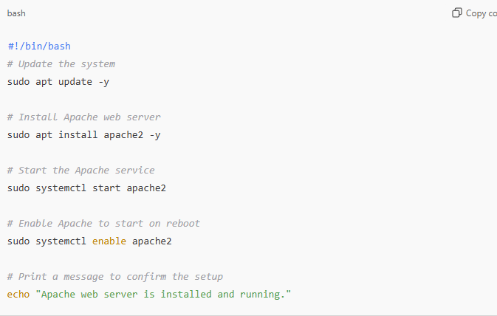
What It Does:
- Updates the system: Ensures all system packages are up-to-date.
- Installs Apache: Downloads and installs the Apache web server.
- Starts Apache: Immediately starts the Apache service.
- Enables Apache: Ensures Apache starts automatically after a system reboot.
- Displays a message: Prints confirmation to the console.

2. Running a Shell Script Manually
After launching your EC2 instance, you can upload a shell script and run it.
Steps to Execute a Shell Script Manually:
- Connect to the EC2 instance using SSH.
- Upload the script to the instance using tools like scp or copy-paste.
- Make the script executable:
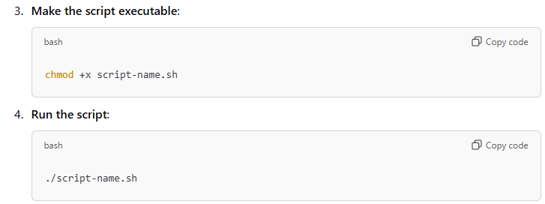
Common Use Cases for Shell Scripts in EC2
- Software Installation:
  - Automatically install required software, e.g., web servers, databases, or programming languages.
Example: Installing MySQL on launch:
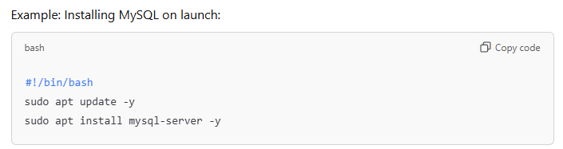
Configuring Firewalls:
- Set up firewall rules with iptables or ufw.
Example: Allowing HTTP and SSH traffic:
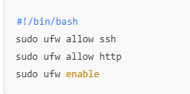
Starting Applications:
- Launch your application automatically when the instance starts.
Example: Starting a Node.js app:
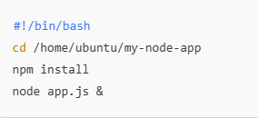
Data Backup:
- Automate backups to an S3 bucket.
Example: Syncing a directory to S3:
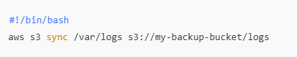
Scaling and Load Balancing:
- Configure scripts to register EC2 instances with an Elastic Load Balancer (ELB).

Important Tips for Using Shell Scripts in EC2
- Start with #!/bin/bash:
  - The first line of a shell script specifies the interpreter (Bash, in this case).
- Test Locally:
  - Test your script on a local Linux machine or another instance before using it in EC2.
- Add Logging:
  - Use echo statements to add logs so you can debug if something fails.
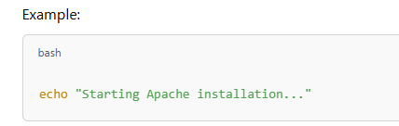
- Use sudo for Elevated Privileges:
- Most administrative commands require sudo in EC2.
- Handle Errors:
- Add error handling to ensure your script doesn’t fail silently.
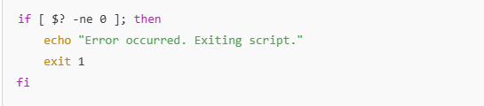
Advanced Topics
- Using Environment Variables:
  - Pass environment variables to your script for dynamic configurations.
Example:
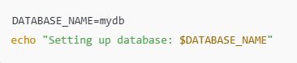
- Combining with CloudFormation:
- Use shell scripts as part of a CloudFormation template to automate infrastructure deployment.
- Using Scripts with AWS CLI:
- Automate tasks like uploading files to S3, launching instances, or retrieving logs.
Example:
Conclusion
Shell scripts in EC2 are powerful tools for automation. They help save time, reduce errors, and ensure consistency in setup. By understanding how to use shell scripts effectively, you can simplify and enhance your cloud operations.

RESOURCES OF EC2
1. Instances (Running)
- What is it?
An EC2 instance is like a virtual computer in the cloud. It runs your applications, websites, or other services.
- "Running" means:
The virtual machine (EC2 instance) is active and ready to perform tasks.
- Example:
If you launch a web server or an application, the instance is "running."

2. Auto Scaling Groups
- What is it?
An Auto Scaling Group is a group of EC2 instances that automatically adjust (increase or decrease) based on demand.
- Why use it?
  - To handle high traffic automatically.
  - To save costs during low traffic by shutting down extra instances.
- Example:
If your website gets a lot of traffic at night, Auto Scaling will launch more instances to handle the load. Once the traffic reduces, it shuts down the extra instances.

3. Capacity Reservations
- What is it?
A Capacity Reservation reserves EC2 capacity (virtual machines) for you in a specific region.
- Why use it?
To ensure that you get EC2 instances when you need them, especially during peak times.
- Example:
You can reserve 10 instances in advance so they are always available for your important applications.

4. Dedicated Hosts
- What is it?
A Dedicated Host is a physical server just for you. No other AWS customers can use it.
- Why use it?
  - To meet security or compliance requirements.
  - To avoid sharing resources with others for performance.
- Example:
If you run sensitive workloads or applications that require a separate server, you can use a Dedicated Host.

5. Elastic IPs
- What is it?
An Elastic IP is a static (fixed) public IP address that you can attach to an EC2 instance.
- Why use it?
  - To have a fixed IP for your EC2 instance.
  - Useful if your server restarts and needs the same IP.
- Example:
If you host a website, you want the IP address to stay the same so users can access it consistently.

6. Instances
- What is it?
This is the overall list of EC2 instances you have launched, including running, stopped, or terminated instances.
- Why is it important?
To manage and monitor all your virtual machines.

7. Key Pairs
- What is it?
A Key Pair is a combination of a public and private key used to securely log in to your EC2 instance.
- Why use it?
  - To provide secure access to your EC2 instances.
  - Instead of passwords, keys are used for login.
- Example:
You download a private key (.pem file) when creating the instance. You use it to log in securely using SSH.

8. Load Balancers
- What is it?
A Load Balancer distributes incoming traffic across multiple EC2 instances to ensure no single instance is overloaded.
- Why use it?
  - To improve application performance.
  - To ensure high availability.
- Example:
If 1000 users visit your website, a load balancer will send some traffic to Instance 1, some to Instance 2, and so on.

9. Placement Groups
- What is it?
A Placement Group lets you control how EC2 instances are placed on AWS servers for better performance or fault tolerance.
- Types:
  - Cluster Placement: Instances are close together for low-latency communication.
  - Spread Placement: Instances are spread across hardware to reduce risks of failure.
- Example:
If you need super-fast communication between servers, use a Cluster Placement Group.

10. Security Groups
- What is it?
A Security Group acts as a virtual firewall for your EC2 instance. It controls incoming and outgoing traffic.
- Why use it?
  - To allow only specific IP addresses and ports to access the instance.
  - To block unwanted traffic.
- Example:
  - Allow only HTTP (port 80) and SSH (port 22) traffic to your instance.
  - Deny everything else.

11. Snapshots
- What is it?
A Snapshot is a backup of your EBS (Elastic Block Store) volumes.
- Why use it?
  - To create a backup before making changes.
  - To restore data if the system fails.
- Example:
Before updating software, take a snapshot of your data disk. If something goes wrong, you can restore the snapshot.

12. Volumes
- What is it?
A Volume is a virtual hard disk (storage) attached to your EC2 instance. AWS calls it an EBS (Elastic Block Store) volume.
- Why use it?
  - To store operating systems, application data, and backups.
  - You can increase the storage size anytime.
- Example:
Your EC2 instance needs 50 GB of space. You attach a 50 GB EBS volume to it.
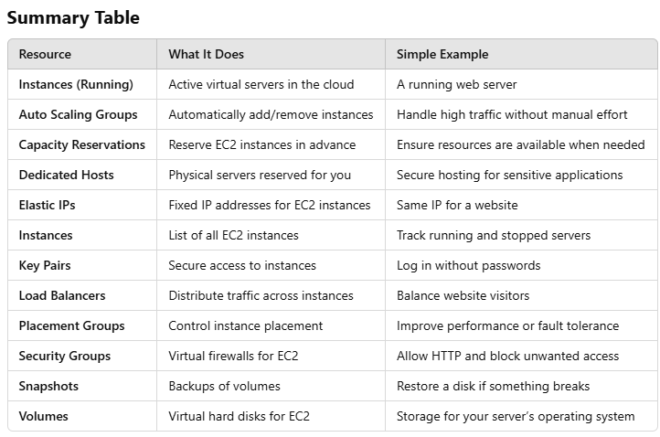

CLOUD – INIT
Cloud-Init is like a helper tool for setting up and preparing virtual computers (called "instances") in the cloud or private servers. When you create a virtual machine in the cloud, Cloud-Init ensures that it’s ready to use with the settings and software you need. It works across different platforms like AWS, Azure, Google Cloud, and even private servers.

What Does Cloud Instance Initialization Mean?
When you launch a virtual machine in the cloud, it’s like starting a new computer for the first time. But before you can use it, the computer needs to be set up. This setup is called cloud instance initialization. It’s like preparing the virtual computer with the correct settings, files, and programs.

How Does Cloud Instance Initialization Work?
When a new virtual machine starts, it uses two things to get ready:
- A Disk Image
This is like a base template of an operating system (e.g., Windows, Linux).
- Instance Data
These are instructions that customize the virtual machine for your specific needs.
The instance data is divided into three main types:
1. Meta-data
- Information about the virtual machine, like its name, size, or the network it’s connected to.
- Example: The IP address or instance ID of the machine.
2. User-data
- Special instructions or a script you provide.
- It’s often used to install software or configure the machine automatically.
- Example: If you want the machine to install Apache (a web server) as soon as it starts, you can include a script for that in the user-data.
3. Vendor-data
- Additional setup instructions provided by the cloud provider (e.g., AWS or Azure).
- Example: It might include tools or utilities that the provider wants to pre-install.

Example: How User-Data Works
Imagine you want to set up a virtual machine that automatically becomes a web server when it starts. You can provide a user-data script like this:
bash
Copy code
#!/bin/bash
sudo apt update
sudo apt install apache2 -y
sudo systemctl start apache2
When the machine boots up, Cloud-Init reads this script and runs it, so you don’t have to install Apache manually.

Why is Cloud-Init Useful?
- Saves Time: Instead of setting up each virtual machine manually, you can automate the process.
- Consistency: Every virtual machine you create can have the same setup, reducing errors.
- Cross-Platform: Works with major cloud providers (AWS, Azure, Google Cloud) and private servers.

Summary in Simple Words
- Cloud-Init is a tool to prepare virtual machines when they start.
- It uses a disk image (basic computer template) and instance data (instructions).
- You can use it to automatically install software, set up networks, or customize machines.
- It’s like an automatic setup wizard that saves you time and effort.

WHAT IS EC2
Amazon EC2 is like renting a computer in the cloud. Instead of buying and setting up your own physical computer (or server) to run your applications, websites, or software, you can use EC2 to get a virtual computer that you can control over the internet.

Breaking it Down:
- Virtual Server in the Cloud:
Imagine you need a computer to run your work, but instead of having it in your office, Amazon lets you borrow one from their massive data centres. This "borrowed" computer is what we call an EC2 instance.
- Highly Flexible:
You can choose how powerful your EC2 computer should be. Need a simple one for basic tasks? Or a super-powerful one for big jobs like running a website or analyzing data? You can pick exactly what you need.
- Resizable:
What if you need more power later? No problem! EC2 lets you resize your computer. You can increase or decrease its power based on what your application needs at any time.
- Quick to Launch:
Setting up a physical server could take days or even weeks. But with EC2, you can have a new virtual server running in just a few minutes. It’s fast, easy, and ready to use almost instantly.
- Pay for What You Use:
With EC2, you only pay for the time you use it. If you need it for a few hours, you’ll pay for just those hours. No need to spend money on buying expensive servers upfront.
- Used by Many AWS Services:
Behind the scenes, many other AWS services rely on EC2. For example, when you store data or run apps in AWS, chances are EC2 is doing the heavy lifting in the background.

Why Use EC2?
- Hosting Websites: You can run websites or apps on EC2.
- Running Applications: Perfect for software that needs a reliable and flexible computer.
- Data Processing: Analyze large amounts of data quickly.
- Testing and Development: Create and test software without needing physical hardware.

Real-Life Example:
Let’s say you want to start a website. Instead of buying a big, expensive computer to host the site, you use EC2 to "borrow" a computer in the cloud. You set it up to handle traffic to your site. If your website becomes popular and gets more visitors, you can easily make your EC2 instance more powerful to handle the load. If traffic goes down, you can shrink it to save money.

In simple words, EC2 is like having a virtual computer that you can quickly rent, use, and customize however you want, and you only pay for the time you use it.

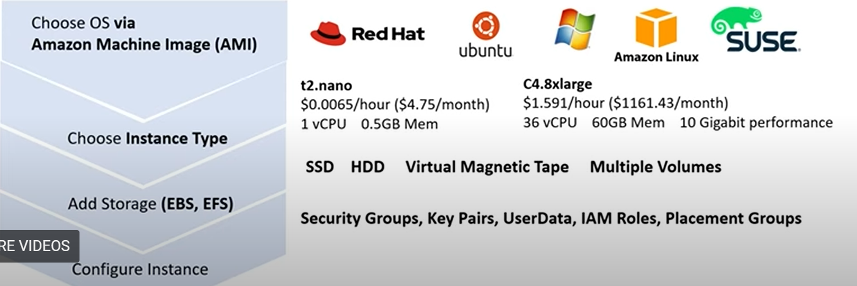
This image provides an overview of the steps and components involved in setting up an Amazon EC2 instance, along with some examples of instance types and pricing. Let me break it down in simple terms:

1. Choose OS via Amazon Machine Image (AMI):
- What it means:
You start by selecting the operating system (OS) you want on your virtual computer (instance). The OS is provided in the form of an Amazon Machine Image (AMI).
- Options shown in the image:
You can choose from popular operating systems like:
  - Red Hat Linux
  - Ubuntu (a Linux-based OS)
  - Windows
  - Amazon Linux (AWS’s custom OS)
  - SUSE (another Linux OS)

2. Choose Instance Type:
- What it means:
After selecting the OS, you decide the power and size of your virtual computer. This is called the "instance type."
Instances vary in terms of:
  - vCPU (virtual CPU): How much computing power it has.
  - Memory: How much RAM (random access memory) it has.
- Examples shown in the image:
  - t2.nano: A very small and cheap instance.
    - Price: $0.0065 per hour (roughly $4.75 per month).
    - Specifications: 1 virtual CPU and 0.5 GB of RAM (very basic).
  - C4.8xlarge: A very powerful instance.
    - Price: $1.591 per hour (about $1161.43 per month).
    - Specifications: 36 virtual CPUs, 60 GB RAM, and high-speed networking (10 gigabit performance).

3. Add Storage (EBS, EFS):
- What it means:
Now you decide how much storage space (like a hard drive) you need and the type of storage.
  - EBS (Elastic Block Store): Like a hard drive for your instance. Fast and reliable for regular tasks.
  - EFS (Elastic File System): Shared storage that multiple EC2 instances can access at the same time.

4. Configure Instance:
- What it means:
The final step is to configure the security and settings for your instance. This ensures your instance is safe and works the way you need.
- Components shown in the image:
  - Security Groups: Like a firewall to control who can access your instance.
  - Key Pairs: A way to securely log in to your instance using a private key.
  - User Data: Scripts or commands you want to run automatically when the instance starts.
  - IAM Roles: Permissions to access other AWS resources (like S3 or DynamoDB) securely.
  - Placement Groups: For advanced users who want to control how their instances are grouped in AWS's data centers.

Summary:
The image shows the steps to set up an EC2 instance and explains how you:
- Pick an operating system (using AMI).
- Choose the size and power of your virtual computer (instance type).
- Add storage for your files.
- Configure security and other settings.
It also provides examples of two instance types:
- t2.nano (cheap and basic for small tasks).
- C4.8xlarge (expensive and powerful for heavy workloads).

FEATURES OF AMAZON EC2
- Persistent storage volumes for your data using Amazon Elastic Block Store (Amazon EBS).
- Multiple physical locations for your resources such as, instances and Amazon EBS volumes, known as regions and Availability zones.
- A firewall that enables you to specify the protocols, ports and source IP range that can reach your instances, also called security groups.
- Option of having Static IPv4 addresses for dynamic cloud computing known as Elastic IP addresses.
- Metadata, known as tags, that you can create and assign to your Amazon EC2 resources.
- Various sizes and capacity of servers.

Here’s a simple and detailed explanation of the features of Amazon EC2:

1. Persistent Storage with Amazon Elastic Block Store (EBS):
- What it means:
When you run an EC2 instance, you need storage for your data (like a hard drive for your computer).
Amazon EBS provides persistent storage, which means your data stays safe even if you stop or restart the EC2 instance.
For example:
  - If you’re running a web server, all the files and configurations for the website can be stored in EBS, and they’ll remain available.

2. Regions and Availability Zones (Multiple Physical Locations):
- What it means:
Amazon EC2 resources (like instances or storage) are distributed across different physical locations worldwide to improve performance and reliability.
  - Regions: Think of these as different areas of the world, like North America, Europe, or Asia.
  - Availability Zones: These are smaller areas within a region. For example, a region like "US-East" might have 3 separate data centers.
Why it’s useful:
  - You can deploy your EC2 instances closer to your users for faster service.
  - If one location goes down, your service can still run from another zone for high availability.

3. Security Groups (Firewall for Your Instance):
- What it means:
A security group acts like a shield or a firewall for your EC2 instance. It controls:
  - Protocols: Which types of communication are allowed (e.g., HTTP, SSH).
  - Ports: Specific channels for communication (e.g., Port 80 for websites, Port 22 for remote access).
  - Source IPs: Which computers or networks are allowed to connect.
Example:
  - You can allow only your office network to access your EC2 instance for security.
  - Or, you can open a port to allow users to access your website.

4. Elastic IP Addresses (Static IPv4 Addresses):
- What it means:
Normally, an IP address (like the address of your house) for your EC2 instance might change when you restart it.
But if you need a static IP address (an IP that never changes), you can use an Elastic IP address.
Why it’s useful:
  - Helpful for applications where the same IP is required, like a domain name pointing to your server.
  - You can attach or detach Elastic IP addresses to instances as needed.

5. Tags for Organization (Metadata):
- What it means:
You can create tags (like labels) to organize and manage your EC2 resources.
A tag is made up of:
  - Key: A category like "Project" or "Environment."
  - Value: A specific label like "Website" or "Development."
Example:
  - Tag one EC2 instance as Key: Project, Value: Website.
  - Tag another instance as Key: Project, Value: Analytics.
This helps you easily identify what each instance is being used for.

6. Various Sizes and Capacities of Servers:
- What it means:
Amazon EC2 offers instances (virtual servers) of different sizes and power levels, so you can choose what fits your needs.
  - Small instances: For lightweight tasks (e.g., t2.micro for a small website).
  - Large instances: For heavy-duty applications (e.g., machine learning or large databases).
Why it’s useful:
  - You pay only for what you need.
  - You can upgrade or downgrade as your requirements change.

Summary:
Amazon EC2 is like renting a computer in the cloud, and it comes with these powerful features:
- Storage (EBS): Keeps your data safe even if you stop the instance.
- Global Reach: Deploy resources in different parts of the world.
- Firewall (Security Groups): Control who can access your instance.
- Static IPs (Elastic IP): Use fixed IPs for reliable connections.
- Tags: Label and organize your resources easily.
- Flexible Sizes: Choose from small to large servers based on your needs.
These features make EC2 flexible, secure, and suitable for a wide range of tasks!
EC2 LIFECYCLE
- Launch EC2
- Reboot / Start
- Stop EC2 (like shutdown)
- Hibernate EC2 instance
- Terminate EC2 (release forever).
- Start EC2 (if stopped)

DIFFERENCE BETWEEN WHAT HAPPEN IF WE REBOOT, STOP, TERMINATE, HIBERNATE INSTANCES
1. Reboot an Instance
What happens:
- When you reboot, the operating system inside the EC2 instance restarts (like restarting a computer).
- The instance remains running, and the instance ID does not change.
- All data on the attached storage (like Amazon EBS volumes) remains intact.
- The public IP address (if not using an Elastic IP) may remain the same but could change in certain cases (depending on your instance type or settings).
Use Case:
- When to use:
If your instance becomes unresponsive or you need to restart services or apply updates to the operating system without stopping or shutting it down.
- Example:
Restarting the instance to apply a software update or fix a temporary issue.

2. Stop an Instance
What happens:
- When you stop, the instance is powered off completely.
- The instance no longer incurs hourly charges, but the storage (EBS volumes) is still charged because the data is preserved.
- The instance ID remains the same when restarted, but the public IP address changes (unless using an Elastic IP).
- Data stored on the root volume (EBS) persists, but any data stored on instance store volumes is lost (because instance store is temporary).
Use Case:
- When to use:
When you want to temporarily shut down an instance but plan to use it again later.
Useful to save costs when the instance is not needed but the data is required.
- Example:
Stopping an instance over the weekend for a testing environment to save money while keeping the configuration intact.

3. Terminate an Instance
What happens:
- When you terminate, the instance is permanently deleted.
- The attached root EBS volume is also deleted (unless configured otherwise). Any data on that volume is lost.
- Instance store volumes are always deleted.
- The instance ID is no longer valid, and the instance cannot be restarted.
Use Case:
- When to use:
When you no longer need the instance and want to avoid incurring any charges.
Ideal for shutting down environments you don’t plan to reuse.
- Example:
Terminating an EC2 instance used for a temporary project after the project is complete.

4. Hibernate an Instance
What happens:
- When you hibernate, the instance is paused, and its current state (RAM contents) is saved to the root EBS volume.
- When restarted, the instance resumes exactly where it left off.
- Data on the root volume and RAM is preserved, but instance store volumes are not.
- The public IP address changes unless you're using an Elastic IP.
Use Case:
- When to use:
Hibernate is useful when you want to quickly resume work from the exact state where you left off (like sleep mode for a laptop).
It’s especially helpful for long-running processes or sessions.
- Example:
Pausing an analysis job during non-business hours and resuming it later without restarting the job.

Key Differences at a Glance:
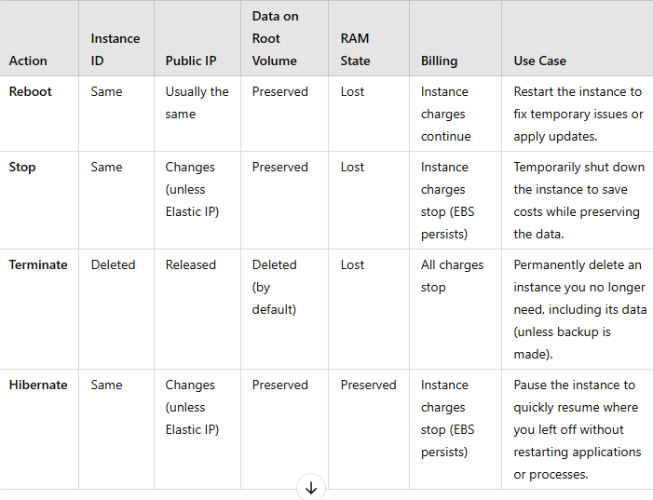
Real-Life Example Scenarios:
- Reboot:
  - Your web server is unresponsive due to a minor software issue. Instead of stopping and restarting the instance, you reboot it to resolve the issue quickly.
- Stop:
  - You run a development environment on weekdays but want to save costs over the weekend. You stop the instance Friday evening and start it again on Monday morning.
- Terminate:
  - You created a temporary EC2 instance for testing a new application. Once testing is complete, you terminate the instance as it’s no longer needed.
- Hibernate:
  - You’re running a machine learning model that’s halfway through processing a dataset. You hibernate the instance to pause the job overnight and resume the processing the next day.
By understanding these differences, you can manage your EC2 instances effectively to balance cost, performance, and data availability!

THERE ARE 2 KINDS OF EC2 STORAGE
    - Instance Store: Hard disk is in the host machine. You lose data if EC2 instance is shut down.
    - EBS Storage: EBS stands for Elastic Block Storage. EBS is one of the two types of storage in AWS. EBS is basically independent of EC2 and is like a network drive. You can terminate (release forever an EC2) and still saves EBS volumes and use it later.
EC2 PRICING MODEL
- On Demand Instance: Rent it for few seconds/hours/days etc. Pay as you go.
- Reserved Instance: Pay upfront for 1 – 3 years and save a lot.
- Spot Instance: You bid on them if available. May terminate with 2 min notice. Upto 90% cheaper than On Demand instance.

1. On-Demand Instances (Flexible and Convenient)
Additional Details:
- Billing Granularity:
  - Charges are calculated per second, with a minimum of 1 minute.
  - You’re billed for compute time only—when the instance is running.
- No Startup/Shutdown Fees:
  - You’re only charged for the time the instance is active. Starting or stopping doesn’t incur any additional charges.
- No Capacity Reservations:
  - Resources are allocated based on availability, meaning you don’t have a guaranteed instance unless explicitly reserved.
Advanced Use Cases:
- Burst Workloads: Applications that experience sudden spikes in traffic, such as running a flash sale or responding to high website traffic during events.
- Proof of Concept (PoC): Ideal for testing a new architecture or application in a production-like environment without long-term commitments.
- Short-Term Projects: Like university research, hackathons, or temporary data pipelines.

2. Reserved Instances (Cost-Efficient for Predictable Workloads)
Additional Details:
- Payment Plans:
  - All Upfront: You pay the entire cost upfront for maximum savings.
  - Partial Upfront: You pay a portion upfront and the rest monthly, balancing cost and cash flow.
  - No Upfront: You pay entirely monthly but still save compared to On-Demand.
- Convertible Reserved Instances:
  - Offers flexibility to change instance types (e.g., from m5.large to m5.xlarge) or families (e.g., from m5 to t3) during the reservation period.
  - Slightly more expensive than Standard Reserved Instances but adaptable to changing workloads.
- Regional Reserved Instances:
  - Tied to a specific region rather than an availability zone, offering flexibility in launching instances across zones.
Advanced Use Cases:
- Always-On Servers: Running a web application or SaaS product that requires consistent uptime.
- Database Hosting: Hosting a database like MySQL, PostgreSQL, or MongoDB for continuous read/write operations.
- Long-Term Projects: Projects lasting for at least a year, like a large-scale video streaming platform or analytics pipeline.

3. Spot Instances (Low-Cost but Interruption-Tolerant)
Additional Details:
- Spot Pricing Mechanics:
  - Spot prices fluctuate based on demand and supply of EC2 capacity.
  - Prices are usually much lower during off-peak times or in less-utilized regions.
- Interruption Behavior:
  - Two-Minute Warning: Amazon notifies you 2 minutes before terminating your instance.
  - Checkpoints and Save States: Use Elastic Block Store (EBS) or S3 to save progress and handle interruptions seamlessly.
- Spot Fleet:
  - You can create a Spot Fleet, a collection of Spot Instances managed automatically to maintain your application’s capacity.
  - Spot Fleet also balances between Spot and On-Demand Instances for reliability.
Advanced Use Cases:
- Big Data Processing: Running Hadoop jobs or Apache Spark for data analytics pipelines.
- Rendering and Media Processing: Video rendering, animation projects, or transcoding large files.
- Training Machine Learning Models: Running compute-intensive deep learning jobs using TensorFlow, PyTorch, or similar frameworks.
- CI/CD Pipelines: Continuous integration and delivery processes that can resume after interruption.

Additional Pricing Features Across All Models
1. Savings Plans:
- A more flexible alternative to Reserved Instances. You commit to a consistent amount of compute usage (e.g., $100 per month) over 1–3 years.
- Applies to EC2, AWS Lambda, and Fargate usage, regardless of instance type, size, or region.
2. Spot Block:
- Lets you reserve a Spot Instance for a fixed duration (1–6 hours).
- Prevents interruptions within this period, useful for critical short-term workloads.
3. Dedicated Hosts and Dedicated Instances:
- Dedicated Hosts: Physical servers fully dedicated to you, often for regulatory or compliance needs.
- Dedicated Instances: Similar to On-Demand Instances but runs on hardware dedicated to you.
4. Free Tier:
- AWS provides 750 hours of free EC2 usage per month for new accounts for one year (t2.micro or t3.micro instance types).
- Perfect for small-scale applications or learning/testing AWS services.

Choosing the Right Pricing Model: Decision Flow
- Is the workload short-term or unpredictable?
  - Use On-Demand Instances for flexibility.
- Is the workload steady and predictable for 1–3 years?
  - Use Reserved Instances for maximum savings.
- Can the workload tolerate interruptions?
  - Use Spot Instances for cost-efficiency.
- Do you have a mix of steady and flexible workloads?
  - Combine Reserved Instances for the steady part and Spot Instances for the flexible part.
- Do you have compliance or security needs?
  - Use Dedicated Hosts for complete control of physical hardware.

Conclusion: Choosing the Right Pricing Model
Each pricing model fits specific needs:
- On-Demand Instances: Best for new users or unpredictable workloads.
- Reserved Instances: Long-term, stable usage at reduced costs.
- Spot Instances: Cost-sensitive tasks that can tolerate interruptions.
For maximum cost optimization, AWS allows mixing these models in your architecture. For example, you can use Reserved Instances for baseline capacity and Spot Instances for handling additional, bursty workloads.
By understanding the pricing models and matching them with your workload needs, you can optimize costs without sacrificing performance!

EC2 TENANCY: ARE VIRTUAL MACHINES ON SHARED HOST OR NOT?
- Dedicated (Needed for compliance and sensitive needs)
- Dedicated Instance (Your EC2 stays on a host that is only used by you. Host hardware may change).
- Dedicated Host (You literally get a physical machine reserved).
- Multi – Tenant Type (cheap and usually secure)

EC2 Tenancy determines whether your virtual machines (EC2 instances) share the underlying physical server hardware with other customers or are exclusively reserved for you. AWS offers different tenancy options based on cost, compliance, and security needs.

1. Multi-Tenant Type (Shared Host)
Explanation:
- How It Works:
  - Your EC2 instance runs on hardware shared with other AWS customers. The physical server is divided into multiple virtual machines, each isolated from others.
  - AWS uses hypervisors (a technology that creates and manages virtual machines) to ensure security between tenants, so no one can access another's data.
- Cost:
  - This is the cheapest option, as multiple customers share the same physical server, reducing AWS's costs.
- Security:
  - Despite being shared, instances are highly secure through strong isolation. AWS ensures that no one can access your data or workloads.
Use Case:
- Cost-Sensitive Applications:
  - Startups or small businesses hosting websites or blogs with limited traffic.
  - Running applications like a simple CRM (Customer Relationship Management) tool for internal use.
- Development and Testing:
  - Great for non-production environments, such as testing new software or running staging environments before deployment.
Example:
- If you launch an EC2 instance without explicitly selecting dedicated tenancy, it will default to a multi-tenant type. For example, running a t3.micro instance for $0.01/hour on a shared host.

2. Dedicated Instances (Exclusive Hardware, Flexible Use)
Explanation:
- How It Works:
  - Your EC2 instance runs on a physical server exclusively used by you, but AWS manages the hardware for you.
  - The actual physical machine used for your instance may change over time when AWS performs maintenance or upgrades.
- Cost:
  - More expensive than multi-tenant instances but cheaper than a Dedicated Host.
- Security and Compliance:
  - Suitable for applications requiring strong isolation for compliance reasons (e.g., HIPAA, GDPR) but without needing control of the physical hardware.
Use Case:
- Compliance Needs:
  - Hosting healthcare applications that require HIPAA compliance.
  - Running financial services workloads with strict regulatory requirements.
- Sensitive Data:
  - Storing or processing sensitive customer data that mandates dedicated resources.
Example:
- A bank may choose Dedicated Instances for their customer data processing system to comply with regulations, ensuring no other customers share the hardware.

3. Dedicated Hosts (Complete Control of Physical Hardware)
Explanation:
- How It Works:
  - You get a physical server fully reserved for your use, giving you control over the hardware.
  - Unlike Dedicated Instances, the physical machine stays the same unless you manually stop using it.
  - You can control how instances are placed on the server (e.g., assigning specific VMs to specific cores).
- Cost:
  - The most expensive tenancy option, as you are renting the entire physical server.
- Security and Compliance:
  - Ideal for the highest level of isolation and control.
  - Useful when you need to bring your own software licenses (e.g., Windows Server, SQL Server) due to specific licensing requirements.
Use Case:
- License Management:
  - When you have software licenses tied to physical machines, such as Microsoft or Oracle applications.
- Advanced Security Needs:
  - Hosting highly sensitive government or defence systems.
- Performance Consistency:
  - Running applications that demand consistent performance and cannot tolerate the slight variances caused by resource sharing.
Example:
- A defence contractor might use a Dedicated Host to run critical applications requiring full control over server hardware to meet government security standards.

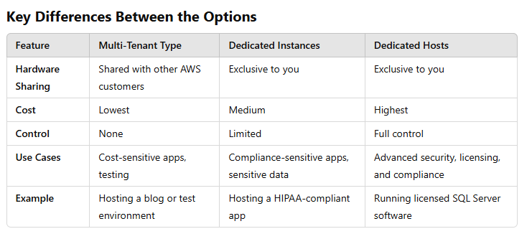
Choosing the Right Tenancy
- Multi-Tenant Type:
  - Use it if your workloads are cost-sensitive, and there are no strict compliance or isolation needs.
  - Example: A startup hosting its company website.
- Dedicated Instances:
  - Choose this for workloads with regulatory compliance needs but where full hardware control isn't necessary.
  - Example: A financial services firm processing customer transactions.
- Dedicated Hosts:
  - Best for highly sensitive workloads, licensing constraints, or when complete control over the hardware is required.
  - Example: A government agency running secure defence applications.

Conclusion
EC2 Tenancy options allow you to balance cost, performance, security, and compliance needs:
- Multi-Tenant is the go-to choice for cost-effectiveness.
- Dedicated Instances add a layer of isolation for sensitive workloads.
- Dedicated Hosts give complete control over hardware, perfect for compliance-heavy or performance-critical applications.

WHEN AN EC2 INSTANCE IS STOPPED
- Private IP remains with the EC2 instance.
- Public IP may change when you restart a stopped instance.
- The underlying host (Physical machine) may change

EC2 PUBLIC IP ADDRESS AND ELASTIC IP
Elastic IP (EIP) are static (persistent) IP’s that you can create on demand. They are different then the Public IP which you get when you launch an EC2 instance (if public IP is enabled). You can attach EIP to an EC2 instance.
Elastic IP’s stay with an instance, even when the instance is stopped. This is in contrast to the default Public IP given to instance which is released after an instance is stopped.
You always for EIP if its not attached to a running EC2. So if EC2 is stopped and has Elastic IP, you pay for the EIP.

Understanding Public IP and Elastic IP in Amazon EC2
Amazon EC2 provides two types of IP addresses for instances: Public IP and Elastic IP (EIP). Both have different properties and use cases. Let's break this down step by step.

1. Public IP Address
- What is it?
  - A temporary IP address automatically assigned to an instance when you launch it (if enabled).
  - This allows your instance to communicate with the internet.
- Key Properties:
  - Public IP is dynamic, meaning it changes:
    - If you stop and start your instance, the IP address will change.
    - Public IP is released when the instance is stopped.
- Use Case:
  - Public IP is suitable for temporary or non-critical use, such as testing or short-term tasks where IP persistence isn't required.

2. Elastic IP Address (EIP)
- What is it?
  - A static (persistent) IP address that you can allocate and associate with your EC2 instance.
  - The IP address does not change, even if you stop and start your instance.
- Key Properties:
  - Elastic IP is yours as long as you allocate it.
  - It remains attached to your instance until you decide to detach or release it.
  - If your instance is stopped, the Elastic IP remains assigned to the instance.
  - You are charged for an Elastic IP if it is not attached to any instance (to prevent waste of IPs).
- Use Case:
  - Use Elastic IP when you need a consistent public-facing IP address for applications, such as a website or a server, where the IP should not change.

Problem: What Should You Do If You Don’t Want Your Public IP to Change?
If you don’t want the IP address to change when the instance is stopped or restarted, follow these steps:

Step-by-Step Solution
1. Allocate an Elastic IP
- Go to the AWS Management Console → EC2 Dashboard.
- Select Elastic IPs from the left menu.
- Click Allocate Elastic IP Address to create an Elastic IP.
2. Associate the Elastic IP to Your Instance
- After allocating the Elastic IP, associate it with your EC2 instance:
  - Select the Elastic IP you just created.
  - Click on Actions → Associate Elastic IP Address.
  - Choose the instance you want to associate it with and click Associate.
3. Test the Elastic IP
- After associating the Elastic IP, test it by stopping and starting your instance:
  - The Elastic IP will stay the same, unlike a public IP that changes.
4. Manage Elastic IPs Properly
- If you no longer need the Elastic IP, release it to avoid unnecessary charges:
  - Detach the Elastic IP from your instance.
  - Go to the Elastic IP section, select it, and click Release Elastic IP Address.

Example Scenario
Without Elastic IP:
- You launch an EC2 instance with a default public IP address.
- After stopping the instance and restarting it later, the public IP changes.
- This causes issues if you're hosting a website, as visitors can’t reach your server using the old IP.
With Elastic IP:
- You allocate and associate an Elastic IP with your instance.
- Even after stopping and restarting the instance, the Elastic IP remains the same.
- This ensures consistent access for your users.

Key Advantages of Using Elastic IP
- Consistency:
  - The Elastic IP doesn’t change, making it ideal for hosting websites, servers, or applications.
- Flexibility:
  - You can reassign the Elastic IP to another instance if needed, allowing flexibility in case of scaling or instance replacement.
- Avoid DNS Issues:
  - Since the IP doesn’t change, you don’t have to frequently update DNS records.

Important Notes About Elastic IP
- Costs:
  - Elastic IPs are free if associated with a running EC2 instance.
  - You are charged for unused Elastic IPs (not attached to any instance), so always manage them properly.
- Best Practices:
  - Avoid creating Elastic IPs unnecessarily to minimize costs.
  - Use them only for applications where consistent public IPs are essential.

Conclusion
If you want your instance to always have the same public-facing IP address, you need to use an Elastic IP. It ensures that your IP remains consistent even if the instance is stopped or restarted. While Public IPs are dynamic and suitable for temporary use, Elastic IPs provide persistence, making them ideal for hosting services that require reliable and unchanging access.

How to Prevent EC2 Instances from Being Terminated (Accidentally or Intentionally)
Sometimes, you might accidentally terminate an important EC2 instance, leading to data loss or downtime. To prevent this, AWS provides a feature called "Termination Protection." Let's break it down in simple terms:

What Happens When an Instance is Terminated?
- Termination means the EC2 instance is permanently deleted, and:
  - The data stored on the instance's root volume is also deleted (unless you have a backup or have enabled "Delete on Termination" as false).
  - Any configurations, software, or connections associated with the instance are lost.

How to Prevent Termination?
The best way to stop an instance from being terminated is by enabling Termination Protection.
What is Termination Protection?
- A setting in EC2 that prevents an instance from being terminated, even if someone tries to terminate it accidentally or intentionally.
- If Termination Protection is enabled, AWS will block any termination request until you explicitly disable the protection.

How to Enable Termination Protection
Follow these simple steps:
While Launching an Instance:
- Go to the AWS Management Console.
- Start launching a new EC2 instance.
- In the "Configure Instance Details" section:
  - Scroll down to find the option "Enable Termination Protection."
  - Select Yes.
- Complete the setup and launch your instance.
For an Already Running Instance:
- Open the EC2 Dashboard.
- Select the instance you want to protect.
- Click Actions → Instance Settings → Change Termination Protection.
- In the dialog box, select Enable Termination Protection and save the changes.

How Termination Protection Works
- When you or someone else tries to terminate the instance, AWS checks if Termination Protection is enabled.
- If enabled, the termination request is denied, and an error message is displayed.
- You must first disable Termination Protection to delete the instance.

Example Scenario
Without Termination Protection:
- You mistakenly click Terminate on an important production server.
- The instance is deleted immediately, and critical data is lost.
With Termination Protection:
- You try to terminate the instance.
- AWS blocks the termination request and shows an error: “Termination Protection is enabled.”
- This gives you a chance to review and stop accidental deletion.

Additional Measures to Prevent Data Loss
- Backups:
  - Always take regular snapshots of your instance's storage (Amazon EBS volumes). This ensures that you can recover your data even if the instance is terminated.
- IAM Policies:
  - Use AWS Identity and Access Management (IAM) to control who can terminate instances.
  - Create permissions that restrict termination actions to specific users or roles.
- Alerts and Monitoring:
  - Set up AWS CloudWatch alarms to monitor instance states. If someone tries to terminate an instance, you’ll get notified.
- Automation and Locking:
  - Use AWS Config rules to check if Termination Protection is enabled.
  - Configure automation scripts to re-enable Termination Protection if it gets disabled.

When Should You Enable Termination Protection?
- Critical Instances:
  - Servers hosting production environments, databases, or applications where uptime and data are critical.
- Development Instances:
  - For environments where accidental termination might cause inconvenience or loss of important configurations.
- Shared Projects:
  - Instances used by teams, where multiple users have access, increasing the risk of accidental termination.

What Termination Protection Does NOT Protect
- It only protects against termination. You still need to:
  - Prevent accidental stopping if stopping your instance disrupts operations.
  - Regularly backup your instance to protect against data loss due to disk corruption or other failures.

Summary
- Termination Protection is a simple yet powerful tool to prevent accidental deletion of EC2 instances.
- Always enable it for critical instances to ensure that no one (including yourself) can delete them without consciously disabling the protection first.
- Combine it with IAM policies, backups, and monitoring to create a robust safeguard for your EC2 resources.

EC2 MONITORING
CLOUDWATCH services provides basic monitoring for various EC2 instance metrics like
CPU Utilization, Network In / Out Packets In / Out Disk Read / Writes.
But does does not provide metrics like Memory (RAM) utilization. You can create custom metrics for things like Memory Utilization and disk usage monitoring.

EC2 Monitoring Simplified
When you use Amazon EC2 (Elastic Compute Cloud) to run your applications, monitoring its performance and health is essential. AWS provides a service called CloudWatch to help monitor EC2 instances. Here's an easy-to-understand breakdown:

1. What is EC2 Monitoring?
EC2 monitoring means keeping track of how well your virtual servers (EC2 instances) are performing. It helps you know if they are working efficiently or facing issues.

2. What is CloudWatch?
CloudWatch is like a monitoring tool provided by AWS that keeps an eye on your EC2 instances and collects important data about their performance.

3. Metrics Monitored by Default
AWS CloudWatch automatically tracks certain basic metrics for your EC2 instances. These include:
- CPU Utilization
  - Measures how much of the instance's processing power (CPU) is being used.
  - Example: If the CPU is close to 100%, your server is working too hard.
- Network In and Out
  - Tracks the amount of data being received (Network In) and sent (Network Out) by your instance.
- Disk Read and Write
  - Monitors the amount of data being read from or written to the storage disks attached to your instance.
- Status Checks
  - Checks if the instance is healthy and functioning properly.

4. What's Missing in Basic Monitoring?
One important metric not included by default is Memory (RAM) utilization.
- This means you can’t see how much of your server’s memory is being used unless you create a custom metric.

5. Custom Metrics for More Insights
If you want to track things like:
- Memory usage (how much RAM is being used),
- Disk usage (how full your storage is),
You need to:
- Install the CloudWatch Agent on your EC2 instance.
- Configure it to send custom metrics (e.g., memory usage data) to CloudWatch.

6. Monitoring Levels
AWS provides two levels of monitoring for EC2:
- Basic Monitoring (Free):
  - Data is collected every 5 minutes.
  - Includes the default metrics like CPU, Network, and Disk.
- Detailed Monitoring (Paid):
  - Data is collected every 1 minute.
  - Provides more granular performance information.

7. Why is Monitoring Important?
Monitoring helps you:
- Troubleshoot Problems:
  - If your application is slow, you can check if the CPU or memory is overused.
- Optimize Performance:
  - Avoid wasting resources or paying for unused capacity.
- Set Alerts:
  - Create alarms (e.g., "Notify me if CPU is above 80% for 5 minutes") to respond quickly to issues.

8. Setting Up Alerts (CloudWatch Alarms):
You can configure CloudWatch to:
- Send a notification (via email or SMS) if a metric crosses a set threshold.
  - Example: "Alert me if CPU utilization goes above 90% for 5 minutes."

9. Use Cases of EC2 Monitoring
- Monitoring your application’s performance.
- Scaling your infrastructure automatically (via Auto Scaling) when resources are overused.
- Ensuring critical systems stay online and function smoothly.
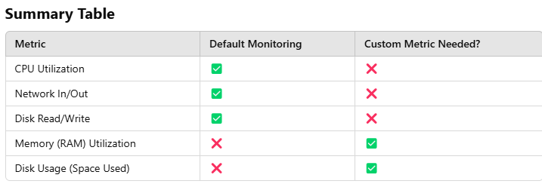
In short, EC2 Monitoring helps you keep your virtual servers running smoothly by tracking their performance. CloudWatch provides basic monitoring out of the box, and you can extend it to include custom metrics for advanced insights.
To monitor whether an EC2 instance is working properly using CloudWatch, you rely on key metrics and alarms to track its performance and health. Here's a step-by-step guide:

1. Key Metrics to Monitor
CloudWatch collects and displays metrics that indicate the health and performance of your EC2 instance. Pay attention to the following:
Basic Metrics:
- CPU Utilization:
  - Measures how much of the CPU is being used.
  - A very high percentage could mean the instance is overloaded.
- Disk Read/Writes:
  - Tracks how much data is being read from or written to storage.
  - Sudden spikes might indicate unusual activity.
- Network In/Out:
  - Monitors the amount of data being received and sent over the network.
  - Consistently low or no traffic could mean your application is not being accessed.
- Status Checks:
  - Two types of checks ensure the instance is working properly:
    - System Status Check: Verifies AWS infrastructure (hardware, network, etc.) is functioning.
    - Instance Status Check: Ensures the instance's OS is running correctly.

2. Use CloudWatch Alarms
To automate the monitoring process, you can create CloudWatch Alarms that notify you if something goes wrong. Here's how:
- Go to the CloudWatch Console:
  - Navigate to the AWS Management Console > CloudWatch.
- Create an Alarm:
  - Select the metric you want to monitor (e.g., CPU Utilization or Status Check Failed).
  - Define thresholds:
    - Example: "CPU Utilization > 80% for 5 minutes" or "Status Check Failed > 0."
- Set Notifications:
  - Choose how to be alerted (e.g., send an email, SMS, or trigger an action like rebooting the instance).
- Action if Alarm is Triggered:
  - Example: Automatically restart or terminate the instance using an EC2 action.

3. Visualize Metrics in Dashboards
You can set up a CloudWatch Dashboard to monitor multiple EC2 instances at a glance.
- Add Widgets:
  - Include key metrics like CPU Utilization, Disk Usage, and Network Traffic.
- Real-Time Monitoring:
  - View live data or analyze trends over time to spot anomalies.

4. Troubleshoot with Logs
If basic metrics don't show the issue, use CloudWatch Logs for deeper insights:
- Enable Detailed Monitoring:
  - Install the CloudWatch Agent on your EC2 instance to track additional metrics like memory and disk space.
- Log Analysis:
  - Check logs (e.g., application logs or system logs) to identify errors or unusual activity.

5. Example Monitoring Plan
Scenario: Web Application on EC2
- CPU Utilization:
  - Monitor spikes > 80% (might indicate heavy load).
  - Set an alarm to trigger Auto Scaling if needed.
- Status Checks:
  - Ensure both system and instance checks are passing.
  - If status check fails, receive an immediate alert.
- Network In/Out:
  - Monitor network traffic to ensure the application is accessible.
  - Low traffic for an extended period might indicate downtime or low demand.

6. Automating Actions
You can use AWS Auto Scaling and Event Rules with CloudWatch:
- Auto Scaling: Automatically add or remove instances when metrics like CPU Utilization cross thresholds.
- Event Rules: Trigger actions like restarting or stopping an instance when an alarm goes off.

Summary of Steps to Monitor EC2 in CloudWatch:
- Go to the CloudWatch console and view EC2 metrics like CPU, Disk, Network, and Status Checks.
- Set up CloudWatch Alarms to notify you of issues.
- Use a CloudWatch Dashboard for real-time visualization.
- Analyze logs via CloudWatch Logs for detailed troubleshooting.
- Automate responses using alarms, auto-scaling, and event rules.
By setting up these mechanisms, you can ensure that your EC2 instance is working properly and address issues proactively.

IAM ROLES: ATTACH TO EC2
ROLES: ADD PERMISSION TO EC2
Understanding IAM Roles for EC2 Instances
When you launch an EC2 instance, it runs in isolation. By default, it cannot access other AWS services like S3 (storage), DynamoDB (database), or Lambda (functions). To give the EC2 instance permissions to interact with these services, you need to securely provide credentials. Here's how it's done in simple terms:

1. Why Not Use Hardcoded Credentials?
One way to provide access is by manually adding Access Key ID and Secret Access Key to your application running on the EC2 instance. However, this is a bad practice because:
- If someone finds the credentials, they can misuse them.
- Credentials are static and must be manually updated if changed.

2. What Are IAM Roles?
IAM (Identity and Access Management) Roles are like temporary "access cards" for your EC2 instance. They allow the instance to access AWS services securely without requiring hardcoded credentials. Roles work with temporary credentials that are automatically managed by AWS.

3. How IAM Roles Work with EC2?
When you attach an IAM Role to an EC2 instance:
- The instance gets temporary credentials via a secure AWS service called the Instance Metadata Service (IMDS).
- These temporary credentials allow the instance to access specific AWS services (e.g., S3 or DynamoDB) based on the permissions defined in the role.
- AWS automatically rotates and manages these temporary credentials.

4. Steps to Attach an IAM Role to EC2
Here’s how you can securely allow EC2 to access other AWS services using IAM Roles:
Step 1: Create an IAM Role
- Go to the IAM Console in AWS.
- Create a new role and choose AWS Service as the trusted entity.
- Select EC2 as the service that will use the role.
- Attach a policy that defines the permissions (e.g., "AmazonS3ReadOnlyAccess" to allow read access to S3).
Step 2: Attach the Role to the EC2 Instance
- Launch an EC2 instance or go to an existing one in the EC2 Console.
- Under Actions, choose Modify IAM Role.
- Attach the role you created to the instance.
Step 3: Use the Role in Your Application
- Your application running on the EC2 instance can now access the AWS services directly without hardcoding credentials.
- For example, in Python (using boto3), the instance will automatically use the role to interact with AWS services.

5. Example Use Case
Scenario: Accessing S3 from EC2
You want your EC2 instance to read files from an S3 bucket.
- Create an IAM role with the AmazonS3ReadOnlyAccess policy.
- Attach this role to the EC2 instance.
- Your application (e.g., a Python script) can now read files from S3 without requiring hardcoded credentials.
Example Python code:
python
Copy code
import boto3

# Automatically uses the IAM Role
s3 = boto3.client('s3')
response = s3.list_buckets()
print("S3 Buckets:", response['Buckets'])

6. Why Is This Safer?
- Temporary Credentials: IAM roles provide temporary credentials that are automatically rotated by AWS.
- No Hardcoding: No need to store sensitive credentials in your code or configuration files.
- Least Privilege Access: You can give the role only the permissions it needs, reducing security risks.

7. Key Benefits
- Secure Access: Roles eliminate the need for hardcoded credentials.
- Automation: AWS manages the temporary credentials for you.
- Flexibility: You can modify the role’s permissions anytime without touching your code.

Summary
- By default, EC2 instances cannot access AWS services.
- Avoid hardcoding credentials. Instead, use IAM Roles.
- Create an IAM Role, attach it to the EC2 instance, and AWS will manage temporary credentials automatically.
- Your application can securely interact with AWS services like S3, DynamoDB, or Lambda without worrying about credential management.

SNAPSHOTS: BACKUP DATA THAT LIVES ON EBS VOLUMES
When you use Amazon EC2, your data is stored on EBS volumes, which are like virtual hard drives. To protect this data or save a copy, you can take a snapshot.
What is a Snapshot?
- A snapshot is like a photograph of your data at a specific point in time.
- It captures all the information on your EBS volume so you can restore it later if needed.
Key Points:
- Backups: Snapshots are backups of your EBS volume data. If something goes wrong (like data loss or corruption), you can use the snapshot to recreate the volume and get your data back.
- Incremental: After the first snapshot, which saves all the data, later snapshots only save the changes since the last one. This saves storage space and time.
- Stored in S3: Snapshots are stored in Amazon S3 (a separate storage service) for durability and security.
- Easy Restoration: You can use a snapshot to create a new EBS volume and attach it to your EC2 instance, bringing your data back to life.
Example:
- Imagine you're working on a project and save a backup of your work every evening. If your computer crashes, you can restore the latest backup to continue where you left off. Similarly, snapshots let you restore EBS volumes to a specific state.
This makes snapshots a convenient way to keep your data safe in EC2 instances!

CUSTOM AMI: YOU CAN CREATE CUSTOM AMI (PRE-BAKED)
What is an AMI?
An AMI (Amazon Machine Image) is like a "blueprint" for launching a virtual server (EC2 instance). It includes:
- The operating system (e.g., Windows, Linux).
- Pre-installed software.
- Any settings or configurations.
What is a Custom AMI?
A Custom AMI is a personalized version of this blueprint that you create yourself. It’s "pre-baked," meaning it comes ready with everything you need for your specific requirements.
Why Create a Custom AMI?
- Imagine setting up a new EC2 instance. You install software, configure settings, and customize it to your liking. Instead of doing this every time, you can take a "snapshot" of this setup and save it as a Custom AMI.
- Later, you can launch new EC2 instances directly from this AMI, and they’ll be ready to use without extra work.
Example:
- Let’s say you have an application that requires specific software (e.g., Python, Java) and settings (e.g., user accounts, firewall rules).
- You set up an EC2 instance with all of these and save it as a Custom AMI.
- Now, whenever you need a new server for your app, you just use this AMI, and it’s all set up instantly.
Benefits:
- Saves Time: No need to repeat the setup process for every new server.
- Consistency: All servers launched from the Custom AMI have the same configuration.
- Scalability: Quickly launch multiple identical instances when needed (e.g., during high traffic).
In short, a Custom AMI is like baking a cake in advance, so every time you need one, you don’t have to start from scratch!

Understanding Interfaces in EC2
In the context of Amazon EC2 (Elastic Compute Cloud), interfaces refer to the ways an EC2 instance interacts with networks and other AWS services. Let’s break this down into simple concepts:

1. What is an Interface?
Think of an interface as a "connector" that allows your EC2 instance to:
- Communicate with other instances.
- Access the internet or AWS services.
- Interact with private networks.

2. Types of Interfaces in EC2
a. Elastic Network Interface (ENI)
- What is it?
ENI is a virtual network card attached to your EC2 instance.
Just like a network card in your computer connects it to a network, ENI connects your EC2 instance to your VPC (Virtual Private Cloud).
- Key Features:
  - Each ENI has an IP address.
  - It allows communication within the VPC or with the internet (if configured).
  - An instance can have multiple ENIs for advanced networking setups (like separating traffic).
- Use Case:
If you need your EC2 instance to handle multiple network connections (e.g., one for the internet and another for internal traffic).

b. Public IP and Elastic IP
- What is it?
  - A Public IP is assigned to your EC2 instance by default if it needs internet access.
  - An Elastic IP is a static IP you can associate with your instance for a consistent address.
- Use Case:
  - A web server running on EC2 that needs to be accessible via the internet.

c. Private IP
- What is it?
A Private IP is an address used for communication within the VPC.
- Use Case:
  - Internal services like databases or backend servers that don't need internet access.

d. Virtual Private Gateway and Internet Gateway
- What is it?
  - Internet Gateway: A gateway that allows traffic between the internet and your EC2 instance.
  - Virtual Private Gateway: Used to connect your VPC to your on-premises network through a VPN.
- Use Case:
  - Internet Gateway for public-facing applications.
  - Virtual Private Gateway for hybrid cloud setups.

e. VPC Endpoints
- What is it?
A way to connect your EC2 instance to AWS services (like S3 or DynamoDB) privately without using the internet.
- Use Case:
  - If you want to secure communication between your instance and AWS services without exposing the traffic to the internet.

f. Elastic Fabric Adapter (EFA)
- What is it?
A network interface designed for high-performance computing (HPC) applications.
It provides low latency and high throughput.
- Use Case:
  - Applications requiring fast communication, such as scientific simulations.

3. How Do Interfaces Work Together?
Here’s how these interfaces typically interact in a real-world setup:
- An EC2 instance uses its ENI to connect to the VPC.
- It may use a Public IP or Elastic IP to communicate with the internet.
- It uses a Private IP to talk to other instances or databases in the same VPC.
- For AWS services, it might use a VPC Endpoint to avoid public internet exposure.

4. Real-Life Example
Let’s say you’re running a web application on EC2:
- The instance has an Elastic IP to allow users to access the website over the internet.
- It uses a Private IP to connect securely to a database instance in the same VPC.
- It uses a VPC Endpoint to fetch data from S3 without using the public internet.

5. Why Are Interfaces Important?
- Security: Control which networks your instance can access.
- Scalability: Handle different traffic types with multiple ENIs.
- Flexibility: Choose between public or private communication as needed.
- Performance: Use specialized interfaces like EFA for demanding applications.

Summary
- Interfaces in EC2 are the connectors that enable communication between the instance, networks, and AWS services.
- Key interfaces include Elastic Network Interface (ENI), Public/Private IPs, VPC Endpoints, and specialized adapters like EFA.
- They provide flexibility, security, and performance for your EC2 instances to interact efficiently with the cloud environment.

Understanding Interfaces to Interact with EC2
In AWS, interfaces are the tools or methods you can use to interact with EC2 instances. These interfaces make it easy to create, manage, and control EC2 resources. Let’s explain them in simple terms:

1. AWS Management Console
- What is it?
A web-based interface you access through a browser.
It's like a control panel where you can manage all your AWS resources, including EC2.
- Features:
  - Easy to use, with buttons, menus, and visual options.
  - Allows you to launch EC2 instances, monitor them, or make changes without writing code.
- Use Case:
Best for beginners or those who prefer a user-friendly visual interface to manage EC2.
- Example Task:
Launch an EC2 instance by selecting the instance type, AMI (Amazon Machine Image), and other configurations using a step-by-step wizard.

2. AWS CLI (Command Line Interface)
- What is it?
A command-line tool to manage AWS services using typed commands.
You install it on your computer and use it through the terminal or command prompt.
- Features:
  - Faster than using the console for repetitive tasks.
  - Useful for automation through scripts.
- Use Case:
Great for advanced users who want to automate tasks or prefer command-line interaction.
- Example Command:
Launch an EC2 instance:
aws ec2 run-instances --image-id ami-12345678 --count 1 --instance-type t2.micro --key-name MyKeyPair --security-group-ids sg-12345678

3. AWS CloudFormation
- What is it?
A template-based interface for managing AWS resources.
You write templates (JSON or YAML files) that describe the resources you want, and CloudFormation creates them for you.
- Features:
  - Automates infrastructure creation and management.
  - Allows you to define and replicate environments consistently.
- Use Case:
Ideal for teams managing large setups or needing repeatable infrastructure deployment (e.g., creating multiple EC2 instances with specific configurations).
- Example Template (YAML):
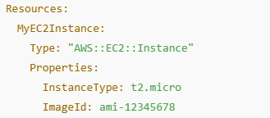
4. AWS SDKs (Software Development Kits)
- What are they?
SDKs are libraries for programming languages (like Python, JavaScript, Java) that let you interact with AWS services programmatically.
- Popular SDKs:
  - Boto3: Python SDK
  - AWS SDK for Node.js: JavaScript SDK
  - AWS SDK for Java: Java SDK
- Features:
  - Integrate AWS services directly into your application.
  - Perform complex operations through code.
- Use Case:
Perfect for developers building applications that need EC2 (e.g., launching instances or analyzing data).
- Example with Boto3 (Python):
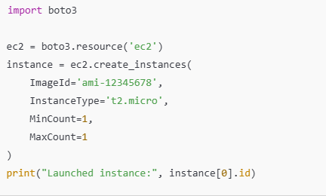
5. AWS REST API
- What is it?
A direct interface that allows you to interact with AWS services by making HTTP requests.
You send requests to AWS servers using methods like GET, POST, PUT, or DELETE.
- Features:
  - Lightweight and can be used with any programming language.
  - Direct access to all AWS services.
- Use Case:
Used in custom applications or when an SDK is unavailable for a specific language.
- Example HTTP Request (Using curl):
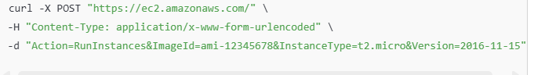
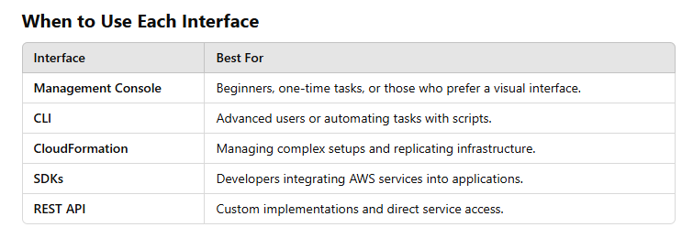
Summary
AWS provides multiple interfaces to manage EC2 instances:
- AWS Management Console: A user-friendly web interface.
- AWS CLI: A command-line tool for faster management.
- AWS CloudFormation: A template-based system for automation.
- AWS SDKs: Programming libraries for building applications.
- AWS REST API: A lightweight, flexible way to interact with AWS directly.
Choose the interface based on your technical skills, use case, and need for automation!

EC2 AUTOSCALING: INCREASED PERFORMANCE AND AVAILABILITY
What is EC2 Auto Scaling?
EC2 Auto Scaling is a feature in Amazon EC2 that helps automatically adjust the number of servers (instances) you have running to handle changes in demand.
It ensures your application:
- Performs well by adding servers when needed.
- Saves money by removing extra servers when they’re not needed.
How Does It Work?
You create an Auto Scaling Group (ASG), which is like a team of EC2 instances that Auto Scaling manages.
- You define rules based on your app's needs.
- Auto Scaling watches your app and follows the rules to adjust the team size.
Key Features:
1. Dynamic Scaling
- Adds or removes servers automatically based on demand.
- Example: If traffic to your website spikes, it adds more instances. When traffic drops, it scales down to save costs.
2. Scheduled Scaling
- Adjusts the number of servers at specific times you set.
- Example: Scale up in the morning when you expect high usage and scale down at night.
3. Health Checks
- Regularly checks if your servers are healthy.
- If a server has issues, Auto Scaling replaces it with a new one.
4. Minimum and Maximum Limits
- You set a minimum number of instances so your app always has a baseline level of servers.
- You also set a maximum to control costs and prevent over-scaling.
Benefits of EC2 Auto Scaling:
- High Performance:
Your app always has enough servers to handle user traffic, preventing slowdowns or crashes.
- Cost Efficiency:
You only pay for what you need. Auto Scaling removes unnecessary servers during low usage periods.
- Better Availability:
Even if a server fails, Auto Scaling ensures new ones are launched, keeping your app running smoothly.
- Scalability:
Quickly adjusts to handle unexpected traffic spikes, like during a sale or product launch.
Example:
- Imagine you run an online store. During the holiday season, traffic increases. Auto Scaling automatically adds more servers to handle the load. After the holidays, it reduces the number of servers, saving you money.
Summary:
EC2 Auto Scaling is like having a smart assistant that ensures your app always has the right number of servers—no more, no less—helping you achieve better performance, availability, and cost savings.

